BASCO Foundation
House no.78, Pashu Hospital Para
Sayabithi Road, Magura, Bangladesh.
Email : bascofoundation@gmail.com
Website : www.baacobd.org
Youtube : https://www.facebook.com/bascofoundation
Project title : Distribution free educational materials to children.
Rural area in Bangladesh drop-out of child education is a normal issue due to their poorness. BASCO Foundation has taken an initiative to provide pre-primary and primary education from 2005 and assisting of the drop-out children of Preprimary (child) up to class-V (five). Among those most of the children are girls. Children have come from disadvantage and poor family. BASCO Foundation operates 350 NFPE school centre and 420 teachers involve this school. All teachers are female. There are near about 10,000 children are learning.
BASCO Foundation wants to supplies all educational materials (notebook, pen, pencil, rubber cutter, School bag, etc) with free of cost among the 10,000 (Then thousand) children. For this reason children will be get best opportunity to complete their primary education.
Budget for 10,000 Children
Sl. no | Purchase description of materials | Price | Taka (BDT) | US  Dollar
1. | Notebook  (Khata Bangla, English, Mathematics) | 50,000 piece ×30 BD Tata | 17,70,000 | 14,508
2. | Pen | 20,000 piece×10 BD Tata | 200,000 | 1,640
3. | Slate | 4,000 piece× 50 BD Tata | 200,000 | 1,640
4. | Scale | 2,000 piece×30 BD Tata | 60,000 | 492
5. | Erasure | 7,000 piece×15 BD Tata | 105,000 | 860
6. | Pencil cutter | 7,000 piece×15 BD Tata | 105,000 | 860
Total : |  |  | 24,40,000 | 20,000

Exchange rate : I US dollar = 122.00 BD Taka.

BASCO Foundation`s School and Children
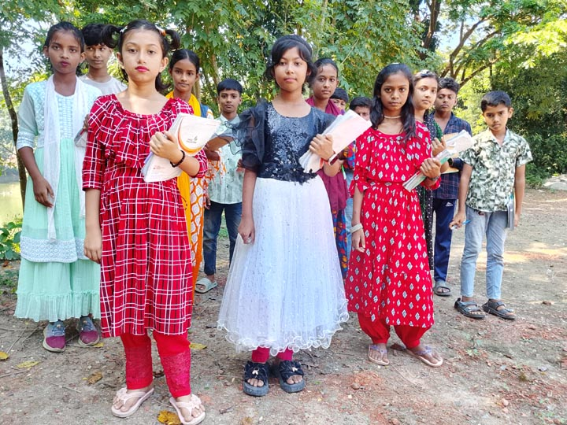 | 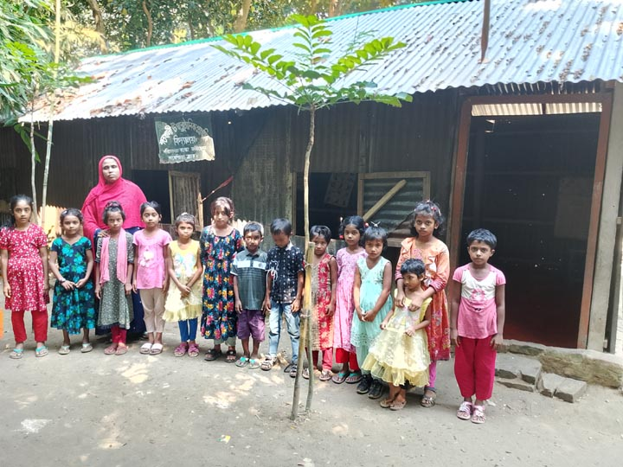
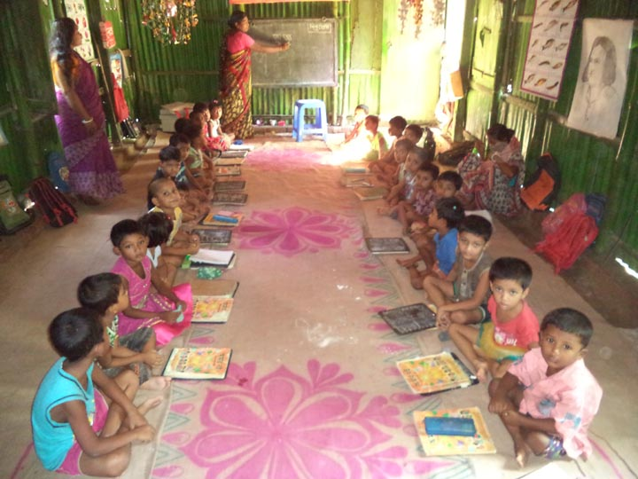 | 