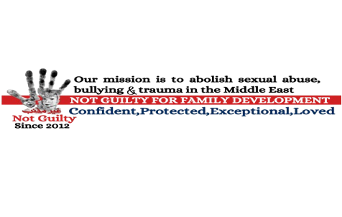

War Trauma & Anti-Sexual Abuse Recovery Project

A Holistic Healing Program for Adult Sudanese Refugees in Egypt
Implementing Organization: Not Guilty
Proposed Timeline: January 2026 – November 2026
Location: Greater Cairo (with potential outreach to Alexandria and 6th of October refugee communities)

Project Overview
War leaves invisible wounds that cut deep into the hearts of survivors. Many Sudanese adults in Egypt have endured violence, displacement, and sexual abuse, carrying trauma that manifests as depression, anxiety, and hopelessness. This project aims to restore dignity, strengthen resilience, and build healing communities among adult Sudanese refugees through a three-pronged approach that combines training, therapy, and group healing.

Objectives
- Equip refugee caregivers and community leaders with tools to identify and address trauma in adults affected by war and abuse.
- Empower parents and spouses to rebuild safe, nurturing family environments after displacement and violence.
- Provide direct trauma therapy and follow-up group sessions to promote lasting recovery and community resilience.

Three-Pronged Approach

1. Training 100 Refugee Caregivers on Adult Trauma Healing
- Deepen understanding of the psychological and spiritual impact of war and sexual violence on adults.
- Introduce trauma-informed care principles for community-based interventions.
- Explore holistic healing that integrates mental, emotional, physical, and spiritual restoration.
- Teach caregivers how to recognize trauma symptoms, facilitate safe conversations, and provide referrals.
Outcome: Caregivers gain skills to plan and implement trauma-recovery interventions while maintaining their own emotional health.

2. Training 100 Refugee Parents and Spouses on Family Rebuilding After War
- Address how trauma disrupts family communication, trust, and parenting.
- Provide tools for emotional regulation, conflict resolution, and family resilience.
- Promote safe, faith-based rebuilding of family and community life.
Outcome: Parents and spouses learn practical strategies for restoring stability and emotional safety at home.

3. Direct Trauma Therapy for 50 Adult Survivors
- Conduct trauma-focused therapy and small-group counseling.
- Offer safe spaces for survivors to process trauma using culturally relevant approaches—art, storytelling, and faith reflection.
Outcome: Adults experience measurable improvements in self-worth, trust, and psychological stability.

Follow-Up Component: Group Therapy & Peer Support Circles
After the therapy phase, participants join structured group therapy sessions facilitated by trauma counselors. These sessions:
- Encourage shared healing through storytelling and empathy.
- Build peer networks to reduce isolation and prevent relapse.
- Include modules on sexual-abuse recovery, forgiveness and identity restoration, and spiritual resilience.
- Empower participants to become “healing ambassadors” who extend care to others.
Duration: Monthly circles from September – November 2026.

Methodology
- Phase 1: Training Workshops (Jan – Apr 2026)
Interactive participatory learning, role-plays, and case studies.
- Phase 2: Counseling & Therapy (May – Aug 2026)
Individual and small-group sessions applying trauma-focused cognitive and narrative therapy.
- Phase 3: Group Therapy & Peer Support (Sep – Nov 2026)
Facilitated group circles to reinforce healing and self-care skills.
Evaluation will include pre-/post-assessments, participant feedback, and counselor reports.

Expected Outcomes (200 words)
This project equips caregivers and community leaders with trauma-healing tools while directly supporting survivors. Participants will:
- Recognize trauma, abuse, and PTSD symptoms in adults and families.
- Apply trauma-informed, culturally sensitive care models.
- Strengthen family resilience through empathy and communication.
- Engage in structured therapy promoting emotional regulation and spiritual renewal.
- Participate in group therapy, fostering community trust.
- Maintain caregiver well-being through self-care practices.
By November 2026, the project will have trained 200 community members, provided direct therapy to 50 survivors, and established peer-support circles that continue beyond the project period. Ultimately, this initiative aims to heal trauma and restore dignity, hope, and faith within the Sudanese refugee community in Egypt.

