Amenuveve SIV Organization
Activity Name: Menstrual Hygiene Education to Mark the International Day of the Girl Child
Date: 11th October 2024
Location: Adaklu Torda D/A Basic School and Adaklu Kpodzi E.P Junior High School, Adaklu District – Volta Region
ACTIVITY REPORT
On the 11th of October 2024, the Amenuveve SIV Organization joined the global community to celebrate the International Day of the Girl Child by organizing a menstrual hygiene education program at Adaklu Torda D/A Basic School and Adaklu Kpodzi E.P Junior High School in the Adaklu District of the Volta Region. The event was held under the global theme, “Girls’ Vision for the Future,” and aimed to raise awareness on menstrual hygiene management while inspiring young girls to remain focused on their academic and personal development.
The session brought together over 150 girls from both schools who were taken through comprehensive menstrual health education and empowerment dialogues. Miss Roberta Donkor, the Manageress of Volta Pad, facilitated the main education session and provided practical, age-appropriate guidance on how to maintain good menstrual hygiene. She emphasized the importance of staying clean, using safe sanitary products, managing menstruation in school settings, and seeking support when needed. Her message was clear and uplifting. She said ‘’menstruation is natural, and with the right knowledge and preparation, no girl should feel ashamed or miss school during her period’’.
To further empower the girls, Madam Ivy Bedi, the Advisory Board Member of the Amenuveve SIV Organization, delivered a motivational talk centered on the theme of the celebration. She encouraged the girls to remain chaste, focused, and committed to their academic goals, reminding them that education is a powerful tool that can shape their future. In a particularly compassionate moment, she addressed the issue of teenage pregnancy with empathy and grace, urging girls who were already pregnant not to lose hope but to continue pursuing their dreams regardless of the challenges they may face. Her words of encouragement were met with strong emotional responses from the students, many of whom expressed a renewed sense of determination.
The event also featured an interactive question-and-answer segment where girls had the opportunity to anonymously submit their concerns and curiosities around menstrual health, puberty, and peer pressure. These questions were answered with care and honesty by the facilitators, helping to demystify many misconceptions the girls held.
The activity was not only informative but also deeply transformative. Teachers and school staff expressed gratitude for the initiative, citing its relevance in tackling the silent struggles many girls face. The participating girls described the program as eye-opening and confidence-building, stating that it made them feel valued, understood, and hopeful.
In conclusion, the menstrual hygiene education program organized by Amenuveve SIV Organization in celebration of the International Day of the Girl Child was a resounding success. It served as both an educational intervention and a platform for emotional support and empowerment. By addressing menstrual health and promoting academic focus among girls, the organization reaffirmed its commitment to the well-being and future of young girls in the Adaklu District.
Link to the media report; https://www.modernghana.com/news/1348819/girls-urged-to-take-pride-in-menstruation-and-focu.html
Below are some activity pictures;
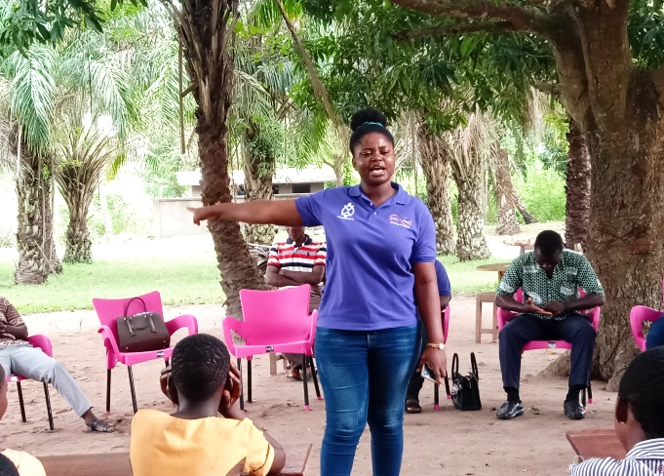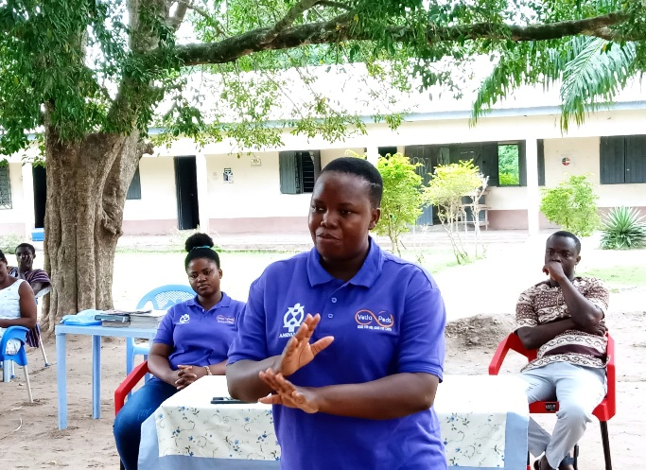
The Manageress of Volta Pad facilitating The Advisory Board Member Facilitating

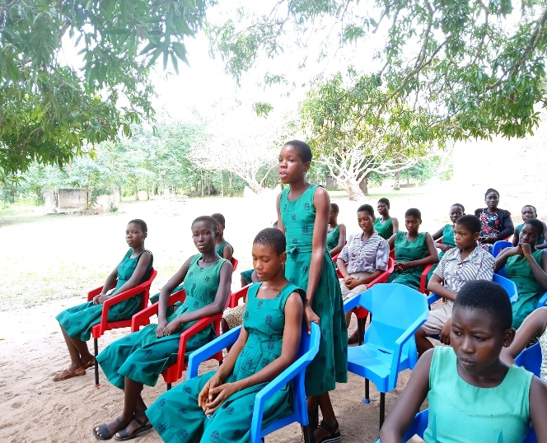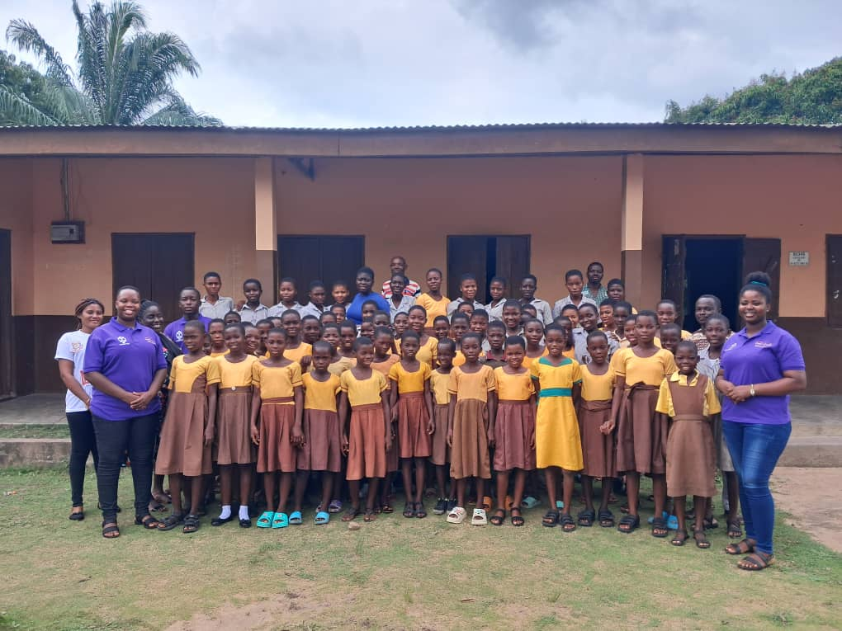
A Student asking question A group picture with the students

