Beneficiary Story: Mrs. Chikondi’s Journey to Better Health

At 72 years old, Mrs. Chikondi carries more responsibility than most people her age. Living in a small community in Blantyre, she cares for her grandchildren, two of whom live with disabilities. Despite her age and daily struggles, she remains the main pillar of support for her family.

Before Elderly Mobile Health Check-up Project reached her community, Mrs. Chikondi had a very limited access to health services. She often felt weak and tired, her mobility had become increasingly difficult. Like many older people in her community, she rarely had opportunity to receive regular health monitoring or medical advice.

During one of our home outreach visits, volunteer doctor and a nurse from EAN Conducted a health check-up for Mrs. Chikondi. The team measured her blood pressure and sugar levels and identified signs of malnutrition and other health concerns that required attention. She was referred for further medical assessment and received guidance on nutrition and self-care.

Since that visit, Mrs. Chikondi has been receiving continued monitoring and support from the EAN caregiving team. With improved health awareness and regular follow-up visits, she has begun to regain strength and confidence in managing her health.

For Mrs. Chikondi, this support means more than just medical care. It means the ability to continue caring for her grandchildren and living with dignity.

Her story reflects the reality faced by many older people in our communities – individuals who have spent their lives caring for others but now need support themselves.

Through this project 119 older people were reached with health check-ups and essential care services. For beneficiaries like Mrs. Chikondi, these visits are not just check-ups – they are a lifeline.

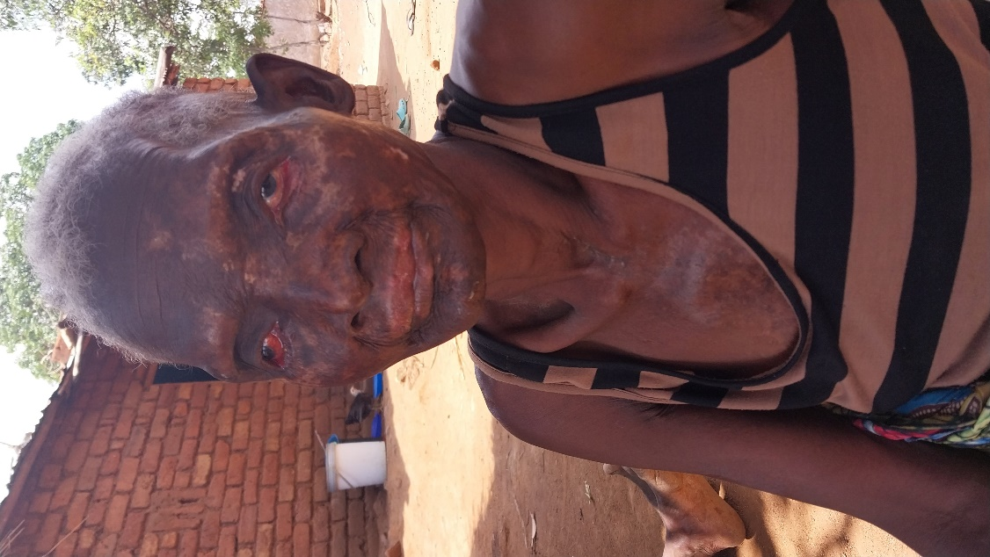
Mrs Chikondi before receiving health screening from Elderly Health Check-up Project

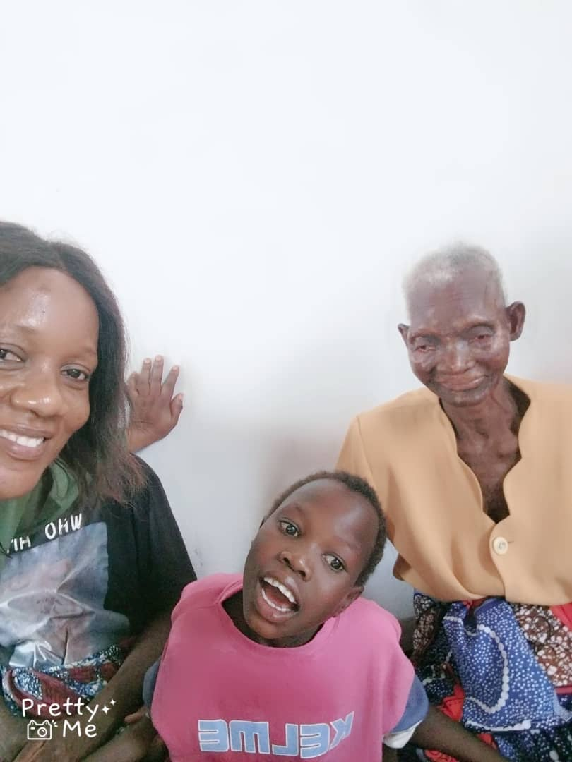
Mrs Chikond, her grandchild, & caregiver during the follow up visit after receiving health screening and caregiver support

Top of Form
Bottom of Form

