Family Literacy Initiative (FLI)
Women Economic Empowerment Pilot

Report 2025

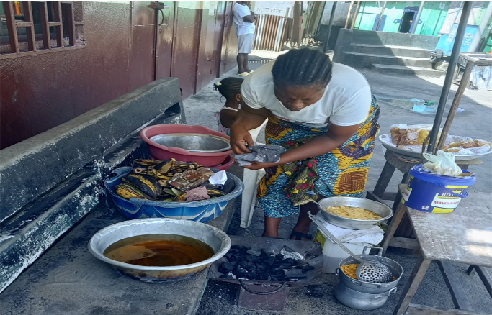

Background
WE-CARE Foundation and her partners Friends of Liberia (FOL) and Homeschool Instruction for Parents and Preschool Youngsters International (HIPPY International) has remained focus on the promotion of intergenerational literacy through the Family Literacy Initiative (FLI), a home-based early childhood education program, that strengthens parents’ capacity to be the child’s first teacher. FLI develops the parent’s foundational literacy skills through structured curriculum delivered through roleplay during home visits with the parent that serves as the child home teacher.
The program has an adult literacy component that came about when low-literate parents expressed their desire to improve their literacy skills to better teach their children. The Adult Literacy Program (ALP) component targets parents in the FLI program as primary beneficiaries and extends to low-literate adults in the program communities. Learners’ foundational literacy and practical skills are strengthened and lessons from the contextualized HIPPY home visit curriculum are reinforced to improve parents’ skills for better learning outcomes of their children.
ALP works across three counties in all five of FLI communities and extends to WE-CARE’s Nurturing Care Integrated Services Model (NCISM) program community in Liberia.

Over the years, despite gains in literacy and school readiness of children completing the FLI 3-year program, the challenge of school enrollment and retention of FLI graduates remains. A tracking study conducted for six cohorts found that more than 20% of FLI graduates were not enrolled in formal school, largely due to financial constraints within households. A survey of FLI families showed that 90% of primary caregivers and home teachers are women and they are responsible for providing for their children’s education, nutrition and household well-being. This gave rise to the FLI Women Economic Empowerment (FLIWEE) component that combines literacy and financial training with collateral free, interest free microloans to low-income, low literacy women participants of the FLI program.
By strengthening women’s literacy, income-generating capacity, and decision-making power, the program will reduce poverty, increase school enrolment, readiness and retention among children, and foster community resilience. The revolving loan fund and embedded peer support structures ensure sustainability beyond the grant period, creating lasting pathways for women’s empowerment and family stability.

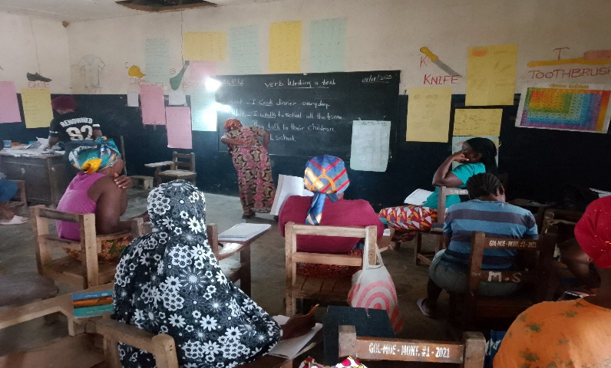
Introduction
The Adult Literacy Program implemented its sixth year of program activities over a period of nine months, March - November 2025. The program worked in three counties across six low-income rural and urban communities. The FLI Women Economic Empowerment component was introduced during the second quarter of the program year as a means of addressing the economic challenges of families. The goal of this component is to address the interconnected challenges of low literacy, poverty, and limited economic opportunities facing women caregivers in the FLI program in Liberia. Increasing household income will improve FLI children’s enrolment and retention in formal school and family wellbeing.
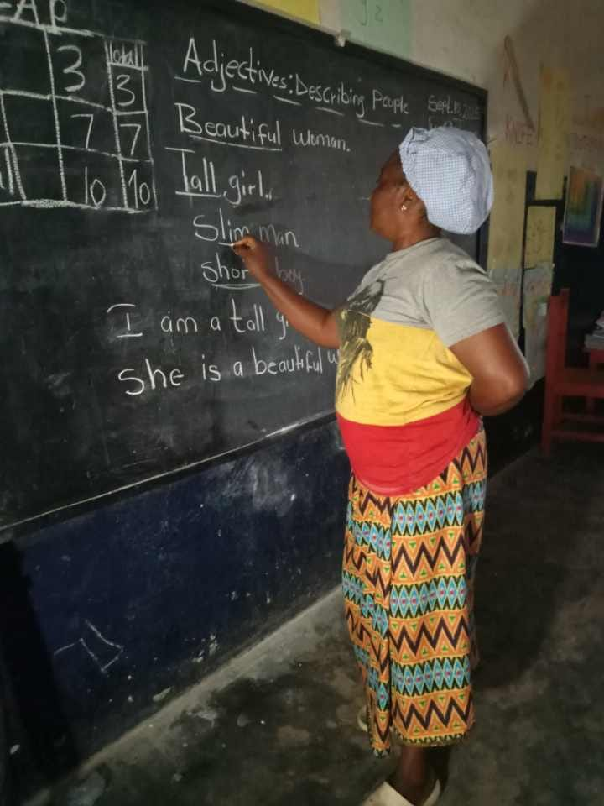
A roadmap was developed and implemented in September 2025, across the five FLI communities of West Point, Caldwell, Neezoe, Careysburg (Nyemah and Marchee towns) and Dauzon. Lessons on practical application of financial literacy covering book keeping for small business, budgeting and completing loan requirements were developed and added to the ALP curriculum. ALP facilitators trained in financial management delivered these lessons during regular classes as the activity unfolded on the collateral free, interest-free loan and small business development training. In the pilot, a total of 67 women enrolled in the ALP benefitted from the FLIWEE over the three-month period.
This report presents the FLIWEE pilot successes, challenges faced, as well as recommendations.

Piloting of the FLI Women Economic Empowerment
Needs Assessment
A baseline survey on the livelihood, cell phone ownership and use of learners was conducted at the beginning of the pilot. The outcome of the assessment indicated that about 90% of caregivers of FLI families are women and about 79% were single parents, supporting their families by doing small-scale trading (waiter market). Coupled with the finding of more than 20% of children being out of school from the FLI tracking study, the need for economic empowerment activity was clear.

Beneficiaries
A total of 67 women were selected and became direct beneficiaries. 40 women received hands-on vocational skills training, and 27 women received cash to start or expand small businesses. Training manual was developed; engagement meetings were held and lessons on small business were provided before awarding of the loan.
Community | Intervention | Beneficiaries
West Point | Cash for business | 6 women
Nyemah Town | Cash for business | 9 women
Marchee Town | Cash for business | 12 women
Neezoe | Skill: Liquid & Iron soap making | 14 women
Duazon | Skill: Liquid & Iron soap making | 12 women
Caldwell | Skill: Bag & Slippers designing | 14 women
Total |  | 67 women

Pilot Activities
Program Planning
A co-development and roadmap meeting was held. This was followed by a stakeholders’ introductory engagement meeting in the communities.
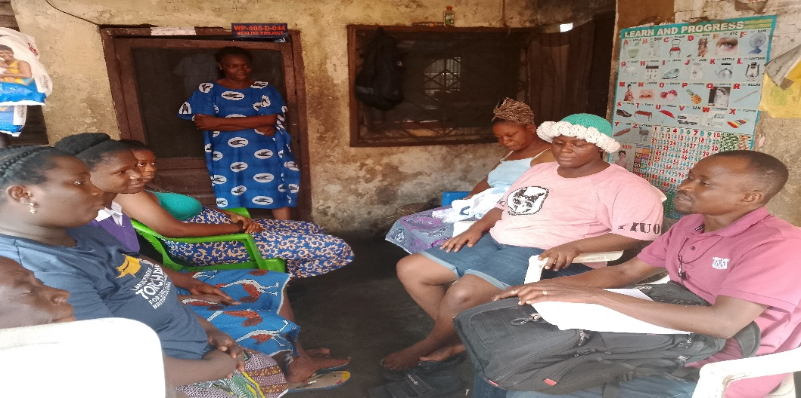
Co-development Meeting
Formation of Peer Support Groups
Participants formed groups of three and chose a leader. The groups provided mutual support, guidance and encouragement, guaranteed each other’s loans and adhering to repayment schedule.
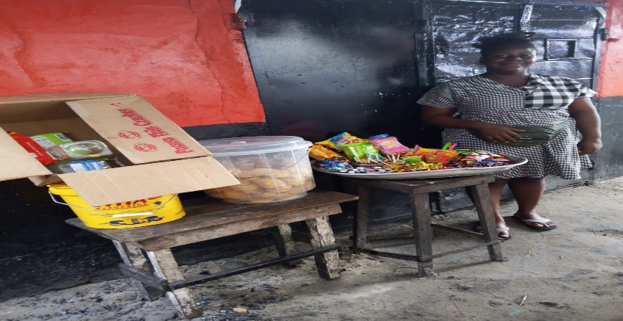
Cash Disbursement and Repayment
Cash beneficiaries in their self-selected groups of three operated under a co-guarantor model. Prior to disbursement, all beneficiaries were profiled to collect personal information, document their livelihoods, and assess projected business profits and repayment capacity. The profiling process revealed that most participants could not maintain records of business transactions, calculate monthly
A loan recipient with small business
earnings, or track profits from sales. This finding highlighted a significant gap in financial management skills and informed the integration of financial literacy lessons into the Adult Literacy Program curriculum. Topics such as budgeting, bookkeeping, profit calculation, savings, and loan management were introduced to strengthen participants' ability to effectively utilize and manage their loans while improving business performance.

A total of USD$848.70 was disbursed to 27 women operating small businesses across three communities. Repayment performance was exceptionally strong, with beneficiaries demonstrating commitment to the program and responsible loan utilization. By the end of the activity cycle, all funds had been repaid resulting in 100% repayment rate.

Summary of Loan Disbursements and Repayments
Community | Beneficiaries | Type | Amount per Person | Total Disbursed | Total Repaid | % of repayment
West Point | 6 | Small business | $52.78 | $316.68 | $316.68 | 100%
Nyemah Town | 9 | Small business | 52.78 | 475.02 | 475.02 | 100%
Marchee Town | 12 | Small business | Group | 57.00 | 57.00 | 100%
Total | 27 |  |  | $848.70 | $848.70 | 100%

Skills Training
In addition to direct business loans, the pilot supported vocational skills development through group-based training activities. A total of 40 women participated in practical skills training in soap production, handbag making, and slippers making. Funds were provided to purchase training materials and pay the trainers.
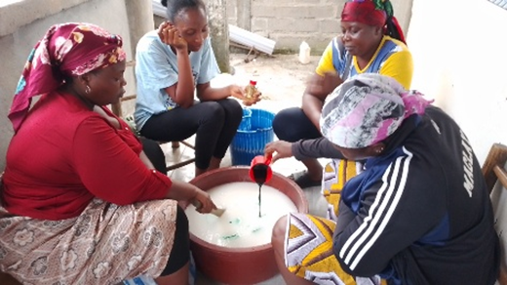
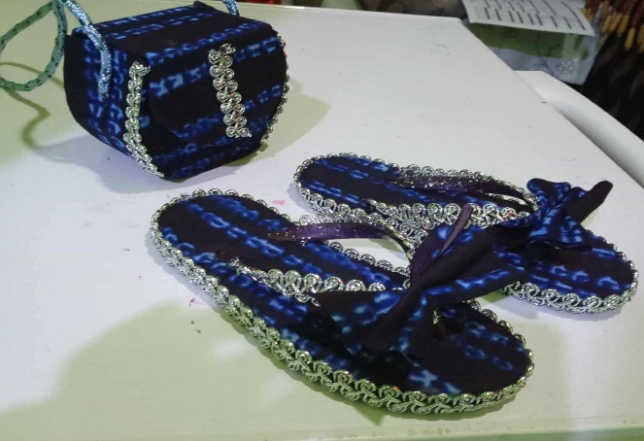
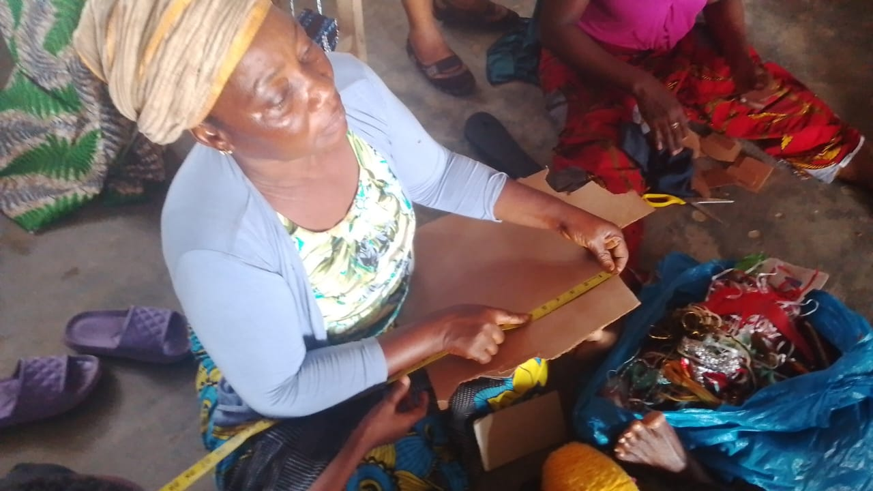
Financial Literacy Training
Lessons on small business management were developed and integrated into the regular literacy classes. Topics such as budgeting, bookkeeping, sales calculation, savings, and loan management were introduced to strengthen participants' ability to effectively utilize and manage their loans while improving business performance. Trained ALP facilitators delivered these lessons.

Summary of Cash for Skill Training
Community | Beneficiaries | Activity | Group Support
Caldwell | 14 | handbag & Slipper production | US$122.00
Neezoe | 14 | Liquid & bar Soap making | 91.00
Duazon | 12 | Liquid & bar Soap making | 91.00
Total | 40 |  | US$304.00

Monitoring and Mentoring
Continuous monitoring was done on learners’ participation in classes, use of the loan to improve livelihood, business performance, children’s school enrollment and loan repayment progress throughout the activity period. Quantitative and qualitative data was collected to show the changes at the beginning and end of the activity.

Successes
The pilot was implemented within the timeframe and learners showed significant gains within the short period.
- The activity increased learners’ retention and participation in ALP classes. Increase in learners’ earnings was seen.
- Learners showed improvements in mathematical literacy using measurement instruments when making soap and designing slappers.
- Learners showed improvement in their digital literacy skill using their phones for simple calculations and lessons in class showed them how to keep record of their business.
- Loans are sustainable due to 100% repayment rate and will be used in the second cycle.
- Learners developed practical income generation skills that they can now use to increase trade as well as produce marketable products.
- Age-appropriate enrollment and retention of children in school increased to approximately 67% by the end of the program cycle.

Human Interest Stories
Kaymah Gardiner, a 44-year-old single mother of three children, depended on daily hired labor and credit for food. Kaymah used the interest-free loan to start a frozen food business. She has completed repayment, enrolled her children in school, and no longer relies on credit for survival. Her youngest child is now seven years old and is finally in school. She said this “I own business now to feed my children.”
Johnetta from WestPoint said “I added my market up. Now I can buy more plantains to sell during the week before going back to buy. I make more profit than when I had small market.”

Challenges
Few challenges were faced during the implementation.
- The pilot’s duration was short.
- Participants required additional mentoring to continue to effectively manage their businesses.
- Monitoring multiple communities requires logistics and support.
Recommendations
- Introduce economic empowerment activities earlier during the ALP cycle of implementation for learners to be better prepared.
- Strengthen learners’ bookkeeping skills.
- Increase the revolving loan fund to reach more women caregivers.
- Develop a brand and market linkage for products from skills training.

Conclusion
The FLI Women Economic Empowerment pilot demonstrated the potential of combining literacy education with economic empowerment to address barriers affecting children's school enrollment and retention. By strengthening women's financial literacy, vocational skills, and income-generating opportunities, the pilot contributed to improved women caregivers' capacity to support their children's learning and school enrollment.
The positive response from participants and the strong alignment with FLI's intergenerational learning model suggest that the initiative is a promising strategy for improving both educational and socioeconomic outcomes among vulnerable families in underserved communities in Liberia. Continued investment and expansion of the model will strengthen its contribution to family well-being, women's empowerment, and children's educational success.

