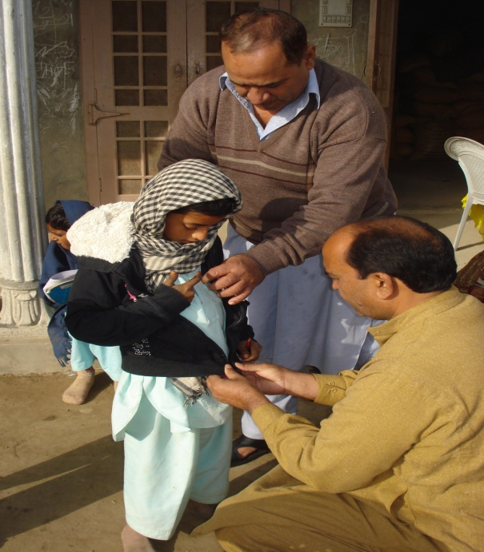

A Poor Child receiving a Warm Sweater
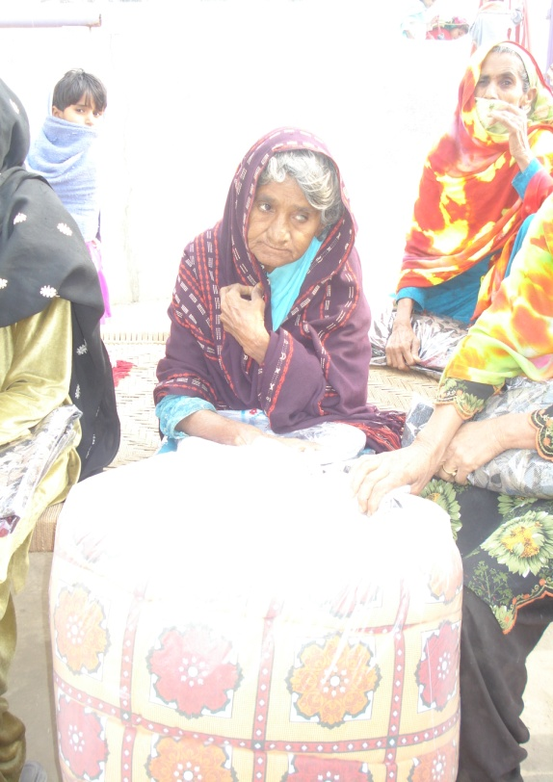

An Old Woman was given a Warm Quilt

