Dear Friends and Supporters,
BWC has been affiliated with Women’s Center International (WCI) but is now putting effort to independently securing funding.
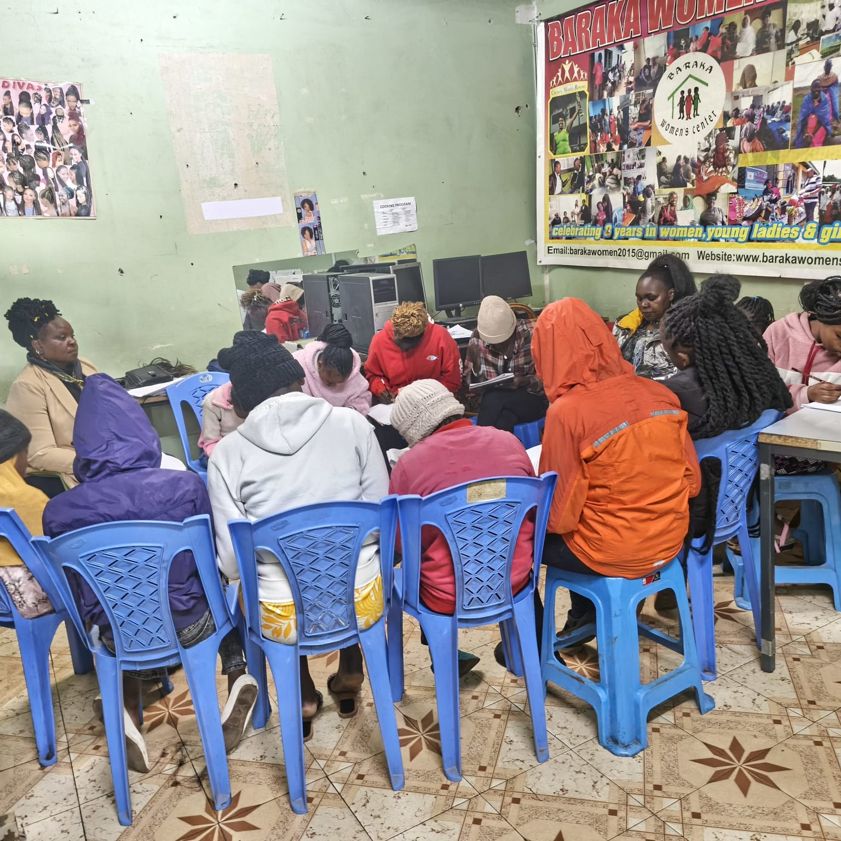
When a woman gains a skill, she gains so much more than knowledge. She gains agency, a voice, emotionally uplifted and a pathway to great opportunities to herself, family , community , nation and globally

When groups of women learn together, they build businesses, reshape food and economy systems, and strengthen themselves , their families ,communities and nations for generations.

Your donation will support and fuels the women leading real, meaningful change in Kenya Africa.

You're not donating to a charity; you're investing in resilience, leadership, and future generations. Support Baraka Women Center

Mark your calendars and follow along to become a Power Builder and join us on our mission.

. 72 women and young mothers are currently in training.The women and young mothers are being trained in visitational skills like tailoring /dress making , hairdressing/beauty therapy, computer skills , beadwork/craft and table banking and finance literacy .These helps them to keep their children in school , put food on the table , uplifts their and family livelihood . They also protect their girls from undergoing through female gentalia mutilation , allow them to access education and prevent them from early marriages . All these reduces sexual gender violence in the community hence bringing a conducive atmosphere in the families and community at large .
Please help them succeed by donating to BWC through our Global Giving campaign

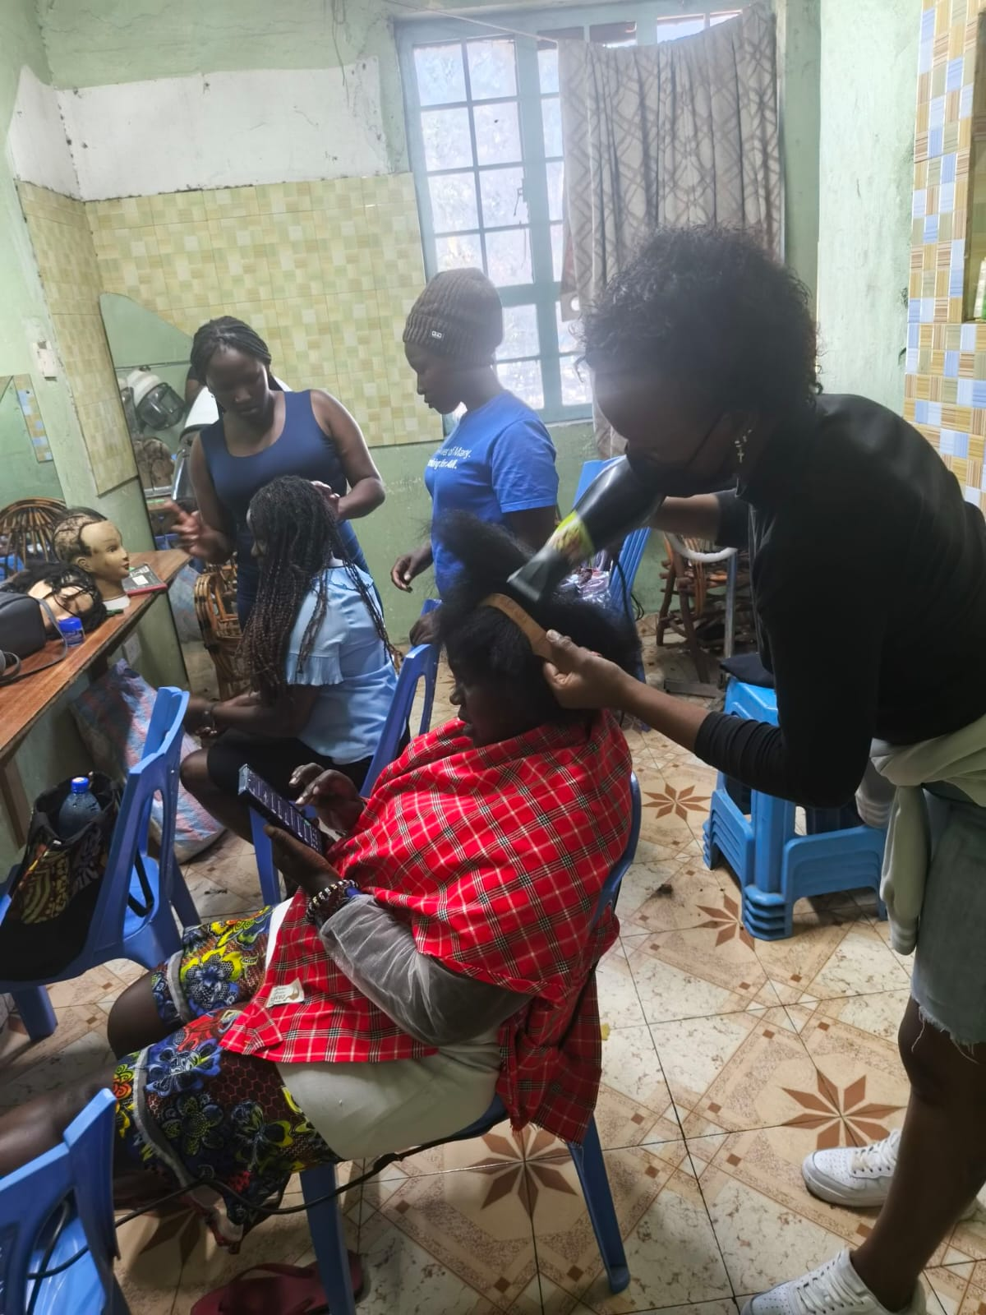

DONATE HERE

