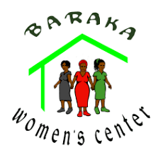 BARAKA WOMEN CENTER
Axe Business Center Plaza - Third floor Next to Equity Bank Building Ngara Tel: 0721381008 /0721417993 Email:barakawomen2015@gmail.com. Web. www.barakawomenscenter.com

BARAKA WOMEN/ GLOBAL GIVING - PROGRESS REPORT
SECTION 1 - GENERAL PROJECT INFORMATION
Name of Project: | Empowering Women | Name of Organization: | Baraka Women’s Center 2-Rumuruti
Contact Person: | Dr. Teresia Njora/Wanjiru Ngigi | Contact Details: | 0721417993/ 0721381008  wjnkngigi@gmail.com / barakawomen2015@gmail.com
Project Start Date: | 01/09/2025 | Report Date: | 28/02/2026
Project End Date: | 28/02/2026 | Reporting End Date: | 28/02/2026
Location: | Rumuruti, Kenya
Target Beneficiaries (description): | The socio-economic injustices faced by women are due to lack of education and cultural traditions of marginalization. The criteria for enrollment in the SED program are that the applicants:  - Reside in an impoverished settlement;  - Support school-age children;  - Are aged 17 through 60, the range of prime income-generating ability;  - Are literate to the level of standard 8 or willing to receive adult education from the center  - Agree to complete a full course of the training they select.  Women tend to be adept at saving and appreciate the value of help received.  They are highly motivated to succeed because of their commitment to improve the welfare of their children.
Summary of Project: | BWC is situated in an area where economic activities are limited to menial jobs; semi arid areas where the communities are pastoralists and marginalized . Many women have undergone female gentalia mutilation , forced to drop out of school and into early marriages where there are 2nd or 3rd wife . Sexual gender based violence is very common in this area and there is no rescue center nearby for women , girls and youths who undergo such harassment . Their poverty is enforced by traditional culture and beliefs (that Nomadic communities are livestock keepers and all women should give birth to as many children as possible because it’s a sign of wealth  Most of these people are domestic workers especially the young girls and mothers who drop out of school after female gentalia mutilation and forced to early marriages. Others go for casual jobs or herd their husbands animals .But as the result of BWC’s training, more are entering into small businesses such as hair dressing / beauty therapy, clothing and craft sales, tailoring, cyber / stationery business while others have been employed. However, these women still face a myriad of survival challenges. The women also lack a place to sell their bead products and other lack seed capital to start their small business  Women with small businesses account for as much as 70% of the total of the community’s income in Kenya. The majority are young mothers who are 2,3 or 4th wife, single moms or widows with an average of five children, making them vulnerable to rising costs and reduced livelihood options. Their poverty is enforced by:  - Under-education and underemployment  - Gender-based violence and substance abuse  - Lack of self-esteem  - Feelings of discouragement and despair  - A burden of poor health  - Lack of business or vocational skills and knowledge  - Lack of knowledge about where to go for help.  Entrepreneur women are more likely to join savings circle as a means of financing (table banking groups) their businesses and they use less start-up capital and or formal credit than men.  Women managing small businesses are more likely to rely on unpaid and unskilled help.  Their businesses are near their homes where they know and understand the market and can manage both home chores their business.  They are more likely to work in temporary structures and without utilities.  They are more likely to leave business for personal reasons rather than business failure.  Given their central role in the welfare of the children and families and their dual role as primary income producers, the effort to enhance their economic success is vital in both short and long term.  Goal  This program expands existing vocational training programs at Baraka Women’s Center and is aimed at ensuring that disadvantaged women and youth who’ve left school are engaged in economically viable and sustainable activities. All the trainees will be mentored and guided on table banking formation and management, business start-up and management, and livelihood life skills.  Objectives  The primary objectives are to empower women to compete profitably in the local business markets, improve their capacity to access formal credit institutions, build savings, and reduce or eliminate dependency on government aid.

SECTION 2 - KEY DEVELOPMENTS/CHALLENGES
An overview of the progress your project has made, the challenges you have faced and the lessons learned.
- Describe the progress or key achievements of your project this month.
SEP/OCT
      - Recruitment of trainees and interview has taken place
      - Out of all the trainees who came for interview 25 were taken for hair dressing/ beauty therapy, 20 for tailoring / dress making, 15 for Computer and 15 for bead work. Total number of trainees is 75.
      - Review of the four curriculums of the 4 vocational training courses has been done.
      - Purchase of the training materials done.
      - Orientation of each department to the trainees has taken place
      - Training of the 4 vocational skills has started.
      - 11 trainees have joined the existing table banking groups.
      - 5 of the new trainees have started their small business.
      - Some of the trainees can now share their life history with others after mentorship sessions
      - 18 business of the previous trainees have been mentored / monitored.

NOV/DEC

- The trainings in the 4 departments are progressing well
- During the group counseling therapy 14 the trainees have shared about their traumatizing on how they underwent female gentalia mutilation and their early marriages as the 3 or 4th wife.
- 7 of the trainees have started their business. 3 have started mobile hair dressing and beauty therapy , 2 have own machines hence making simple dresses and doing repair of dresses , and two of the young mothers are hawking boiled eggs and fruits respectively.
- 11 new business have been started by 2nd cohort group, 3 have been employed in salon and 2 in dress making.
- 15 business have been mentored and monitored this month of November.
- BWC has been invited for exhibition at Kenya International Conference Center (KICC) by Uwezo Fund to celebrate women /youths / persons abled differently SMEs and Rumuruti women have joined the Nairobi women to showcase their products
- Equity Bank has trained the table banking members on finance literacy , and importance of saving . 5 women have opened business accounts and 4 table banking groups have opened accounts.

- The BWC vocational training center has been featured by local media houses as a center of excellency in vocational training where young mothers get employed or start their own business

JAN/FEB
- All the trainees in the four department progressed with their trainings up to19th Dec
- 4 girls of the trainees have been rescued from undergoing Female gentalia mutilation and taken to a rescue center
- 8 trainees shared on their new change of life during the mentorship session
- 5 new business have been started by the new trainees.
- The mentors have mentored/ monitored 13 business this month.
- 2 of the table baking groups Kandutura / Kisiri women groups have added goats to their goat rearing projects.
- The table banking members received their end of the year dividends and education booster.
- BWC fashion and design accessories exhibited their products in Uganda,Tanzania, South Sudan and Bondo in Siaya County.
- 4 of the 7 business closed last month have been reopened after mentorship / refresher courses.
- 6 women who are in business have opened business accounts.
- 14 women who are still undergoing trainings have joined the existing table banking groups and started saving.
- The bead work group has started weaving African baskets which are being sold in exhibitions after adding value to them.

- Describe any challenges that your project faced in 6 months and how you dealt with these challenges.
Challenge(s) | Solution(s)
SEP/OCT  - Some of the trainees attend classes with their babies who keeps disrupting the training.  - Most of the young mothers are the bread earner in their families hence attend classes at different times.  - Some of the trainees attend classes late or few days due to the distances they cover.  - Illiteracy level of some trainees is affecting the training and delaying.  - Being a pastoralist/ nomadic area, the mothers have problems in feeding the babies / themselves hence affecting the trainings.  - Rains have started and usually falls in the morning hence affecting the trainees from attending classes on time.  - Being a pastoralist / nomadic area, many children follow the mother to BWC to be fed.  - When rains falls in the afternoon the trainees are unable to go back to their home.  - Some of the women who received seed capital in their table banking groups have defaulted as their families relocated from Rumuruti due to their pastoralist nature | - The trainees volunteer on daily to take care of the babies and cook for them porridge  - The trainers have grouped them according to their availability  - The trainees are arranged according to their locations and availability  - BWC engages the mentors to translate into their language and also adult education has continued for basic skills  - BWC directors have sourced for food from well-wishers for a feeding program  - The trainers train the trainees affected when available  - BWC buys porridge/ snacks with profit from the business to feed the babies / elderly  - BWC has bought mattresses and makes them to sleep in the computer room  - New members will be recruited as we wait for the defaulters to settle down
NOV/DEC  - Some trainees are missing classes for 3 days a week as their go for casual jobs  - Young mothers attend sessions with their babies who keep disrupting the trainings  - Some of the trainees are highly illiterate hence training in English or Kiswahili is difficulty  - Its holiday time hence most of the young school going children follow their parents to the center for the feeding program  - 7 of the business of the 1st and 2nd cohort graduates have been closed down  - The new premises where BWC relocated to is have problems of water | - The trainers create time for the trainees when they come for sessions are extend the training times  - The young mothers continue volunteering as care givers to the children  - Mentors are used to translate while training and to do adult education  - The volunteer of the day cooks for the children while BWC directors / well-wisher source for food  - The 7 graduates are being mentored by the mentors and given refresher courses in entrepreneurship skills  - BWC management is in the process of applying for water from the Ministry of water
JAN/FEB  - Majority of the young mothers were attending classes in the afternoon as go for casual jobs in the morning  - Most of the young mothers attend the classes with their children because schools are closed and expect a meal  - 5 business which had been opened by the previous graduates has been closed down | - Trainers have created time for them up to late in the evening according to their availability  - BWC contribute the food as the young mothers volunteers to cook and take care of the children  - The business owners are being mentored/ and given refresher courses in entrepreneurship to help them restart their business again
- Describe any lessons learned this month.
SEP/OCT
- Women in pastoralist/ nomadic areas are bread earners of their families
- Majority of the women have their phone lines registered under their husbands/ fathers
- 70% of the young mothers are single mothers either separated or got children out of wedlock
- All the trainees have undergone female gentalia mutilation
- Mentorship has started making the women to share about themselves
- 5 of the trainees have started business of selling second hand clothes, tomatoes and 2 are in hair dressing
NOV/DEC
- Young mothers are determined to change and better their livelihood through skills they are acquiring
- The women who have opened their business have registered their phone lines under their names
- Female gentalia mutilation is still happening as 14 girls have been rescued from the cut
- Mentorship is helping the women to change their dressing styles and also having confidence in themselves
- 11 business have been started by the 1st and 2nd cohort graduates
- 5 of the 2nd cohort graduates have been employed
- 3 of the 2nd cohort graduates have opened a business together of dress making and hair dressing in on partitioned room
- There is need of having a reproductive health program especially in family planning
- Men have started accepting the programs as no woman has been prevented from attending classes

JAN/FEB
- Mentorship is making the young mothers become very aggressive in life and become better parents
- 5 women have opened bank accounts and several have the phone lines registered under their names
- Female gentalia mutilation needs to be addressed and workshops carried on as 4 girls have been rescued
- 5 new business have been opened by the current trainees, 9 by 1st / 2nd cohort graduates while 3 graduates have been employed
- 13 business have been mentored and monitored
- With table banking’s being active , the women are able to start their projects through loans from the groups e.g Kandutura and Kisilili group which has
- Reproductive health training is key in the BWC programs

SECTION 3 - IMPACT INDICATORS
How have you measured the success and progress of your projects?
General Indicators | M1 | M2 | M3 | Q1 Total | Comments - e.g. Give reason(s) for any missing or incomplete data
Total number of direct beneficiaries | 75 | 70 | 70 | 70 | Sep/Oct- 75 have started the trainees  Nov/Dec- 5 trainees have stopped attending classes due to distances and others going for casual jobs  Jan/Feb- No trainee dropped this month
Total number of female direct beneficiaries | 72 | 69 | 69 | 69 | Sep/Oct- 72 females are in the training program  Nov/Dec- 3 females have dropped out of classes due to distance/ casual jobs  Jan/Feb- No trainee dropped in the month s of Jan/Feb
Total number of indirect beneficiaries | 570 | 697 | 1267 | 2534 | Explain who are indirect beneficiaries and how do they benefit from the project:  These are the family members of the trainees, women in table banking who attended in great number as they were receiving their dividends / education booster and other members who visit the center. They benefit in counselling, mentorship and also get trained in entrepreneurship/ leadership skills . Others visit the organization to seek advice/ information about the center , buying products / services from the center  Others are partners , government officers and friends of the organization
Output Indicators | M1 | M2 | M3 | Q1 Total | Comments
Number of Staff/Trainers | 5 | 5 | 5 | 5 | The staff number is the same
Number of Curriculum Topics Taught and Description | 16 | 16 | 14 | 46 | M1 Curriculum Description:  Tailoring/ Dress making  Sep/Oct  - Orientation to the course and equipment  - Introduction to the topics to be covered  - Making / sewing different types of stiches  - Introduction to mentorship / entrepreneurship/ leadership skills  Nov/ Dec  - Measuring / cutting a shirt , shirt collar / sleeves and sewing it  - Measuring / cutting and sewing a unisex short with elastic  - Measuring / cutting and sewing short sleaved dress  - Entrepreneurship – Vision/ mission/ goals development and marketing skills .Mentorship – Self-value/ Personal SWOT analysis / Parenting skills  Jan/ Feb  - Designing , measuring , cutting and sewing straight dresses  - Designing , measuring , cutting and sewing inverted pleats and with gathers dresses  - Designing , measuring and cutting boys / girls elastic trousers  - Entrepreneurship -5 Ps in business , Business communication and early stages of business plan development Mentorship – Leadership skills , stress management and parenting skills  Hair dressing/ Beauty Therapy  Sep / Oct/Nov  - Orientation to the course / equipment in hairdressing/ beauty therapy  - Career information on both courses  - Shampooing / conditioning of hair and skin types / treatment of skins in beauty therapy  - Introduction to mentorship and entrepreneurship / leadership skills  - Different designs of plaiting school going girls  - Braiding hair piece  - Pedicure / Manicure theory / practical’s  - Entrepreneurship- Vision, mission / goal development and business communication skills . Mentorship- Self-value/ Self- respect and parenting skills  Dec /Jan /Feb  - Twisting and crocheting hair piece  - Designing and fixing of weaves  - Facial therapy and designing / shaping eyebrows  - Entrepreneurship -5 Ps in business , Business communication and early stages of business plan development Mentorship – Leadership skills , stress management and parenting skills  Computer  Sep/Oct  - Orientation and introduction to the course / Computers  - Navigation of the window desktop  - File and folder management  - Introduction to mentorship and entrepreneurship / leadership skills  NOV/Dec  - Introduction to Microsoft word  - Typing and type setting / creating new word document  - Introduction to Microsoft excel / creating a spreadsheet / feeding information /formatting the spreadsheet  - Entrepreneurship – Vision/ mission/ goals development and marketing skills .Mentorship – Self -value/ Personal SWOT analysis / parenting skills  Jan / Feb  - More advanced typing and type setting  - Financial accounting in excel  - Inserting Pictures/ graphs in a document  - Entrepreneurship -5 Ps in business, Business communication and early stages of business plan development Mentorship – Leadership skills, stress management and parenting skills  Bead work  Sep/ Oct  - Orientation and introduction to beadwork  - Introduction to making of bangles both for men / women and simple necklaces  - Entrepreneurship introduction and importance . Mentorship introduction and self love  Nov/Dec  - Designing and making of different types of earrings  - Designing and making traditional Maasai women necklaces for events  - Entrepreneurship – Vision, mission and goal development , and business communication skills  - Mentorship – Self-love , Self-respect and Parenting skills  Jan/ Feb  - Designing and making of Maasai belts for men/ women using loom machine  - Designing and making Maasai men bracelets/ bangles  - Adding value to traditional dresses using beads/ shells  - Entrepreneurship -5 Ps in business, Business communication and early stages of business plan development Mentorship – Leadership skills, stress management and parenting skills
Remarks/Observations | M1: The trainees are eager to learn and start their business. Some of the trainees are semi-illiterate hence writing notes is a problem. 5 of the trainees have started their business
Remarks/Observations | M2: Trainees especially the young mothers have started small business after getting skills in entrepreneurship. 12 of the trainees have joined the existing table banking groups and have started saving to enable them buying equipment’s for their business. The mentors are bridging the gap of illiteracy while training and also mentoring business
Remarks/Observations | M3:Trainings have progressed well and 5 of the trainees have started their business and 14 joined the existing table banking groups. The mentors are assisting the women in book keeping , rebranding their business and personal development .Through loans got from the table banking group the business are boosted and women have improved their life styles .There is need for a seminar on reproductive health
Output Indicators | M1 | M2 | M3 | Q1 Total | Comments
Total Number of Women in Tailoring and Dressmaking | 20 | 18 | 19 | 19 | Sep/Oct- 20 trainees have registered for training in tailoring / dress making  Nov/Dec-2 have stopped attending classes due to distance and lack of fare  Jan/Feb 1 of the trainee who dropped out last month has rejoined the training
Total Number of Women in Hair Dressing | 25 | 23 | 23 | 23 | Sept/Oct – 25 trainees enrolled and started training  Nov/Dec - 2 have dropped out of classes due to the nature of their casual jobs  Jan/Feb– No trainee dropped out this month
Total Number of Women in Computer Training | 15 | 14 | 14 | 14 | Sep/Oct – 15 trainees enrolled in computer  Nov/Dec- 1 of the young men has stopped attending classes as he joined NYS  Jan/Feb – No trainee dropped out this month
Total Number of Women in Beadwork | 15 | 15 | 15 | 15 | Mainly these are young mothers and elderly women and have remained the same for the 3 months
Total Number of Participants in Mentorship | 75 | 70 | 71 | 71 | All the trainees receive mentorship / entrepreneurship training
Total number of Women in Table Banking Groups | 272 | 284 | 298 | 298 | 14 young mothers who are undergoing training have joined the existing table banking groups
Output Indicators | M1 | M2 | M3 | Q1 Total | Comments
Total Number of Table Banking Groups | 21 | 21 | 21 | 21 | 14 trainees have joined the existing table banking groups
Total Number of New Members this Month | 11 | 12 | 14 | 37 | 14 trainees have joined the existing table banking groups and in three months a total of 37 members have joined the groups
Total Number of Groups with Increased Savings This Month | 21 | 21 | 21 | 21 | All the groups have increased savings as members save monthly and also repay loans. New members also pay registration fees
Number of Mentoring / Entrepreneurship Topics Taught this month | 4 | 4 | 4 | 12 | Mentorship has become an eye opener to the trainees and turning around their lives to better
Number of Businesses Opened | 5 | 7 | 9 | 21 | These are the trainees who have started small business in 3 months
Impact | M1 | M2 | M3 | Q1 Total | Comments
Number of Women Who have Started a Business or are Employed after Vocational Training | 9 | 16 | 12 | 46  12 employment | Total number of the graduates who have started business in 3 months and employed is 46
Number of Women who are able to Pay Back Loans | 57 | 71 | 75 | 75 | These are the women with loans in the 21 groups and are able to repay
Examples of Personal Success | M1:  SUCCESS STORY OF GRACE LEKOPAN AND DAMARIS LEKORERE  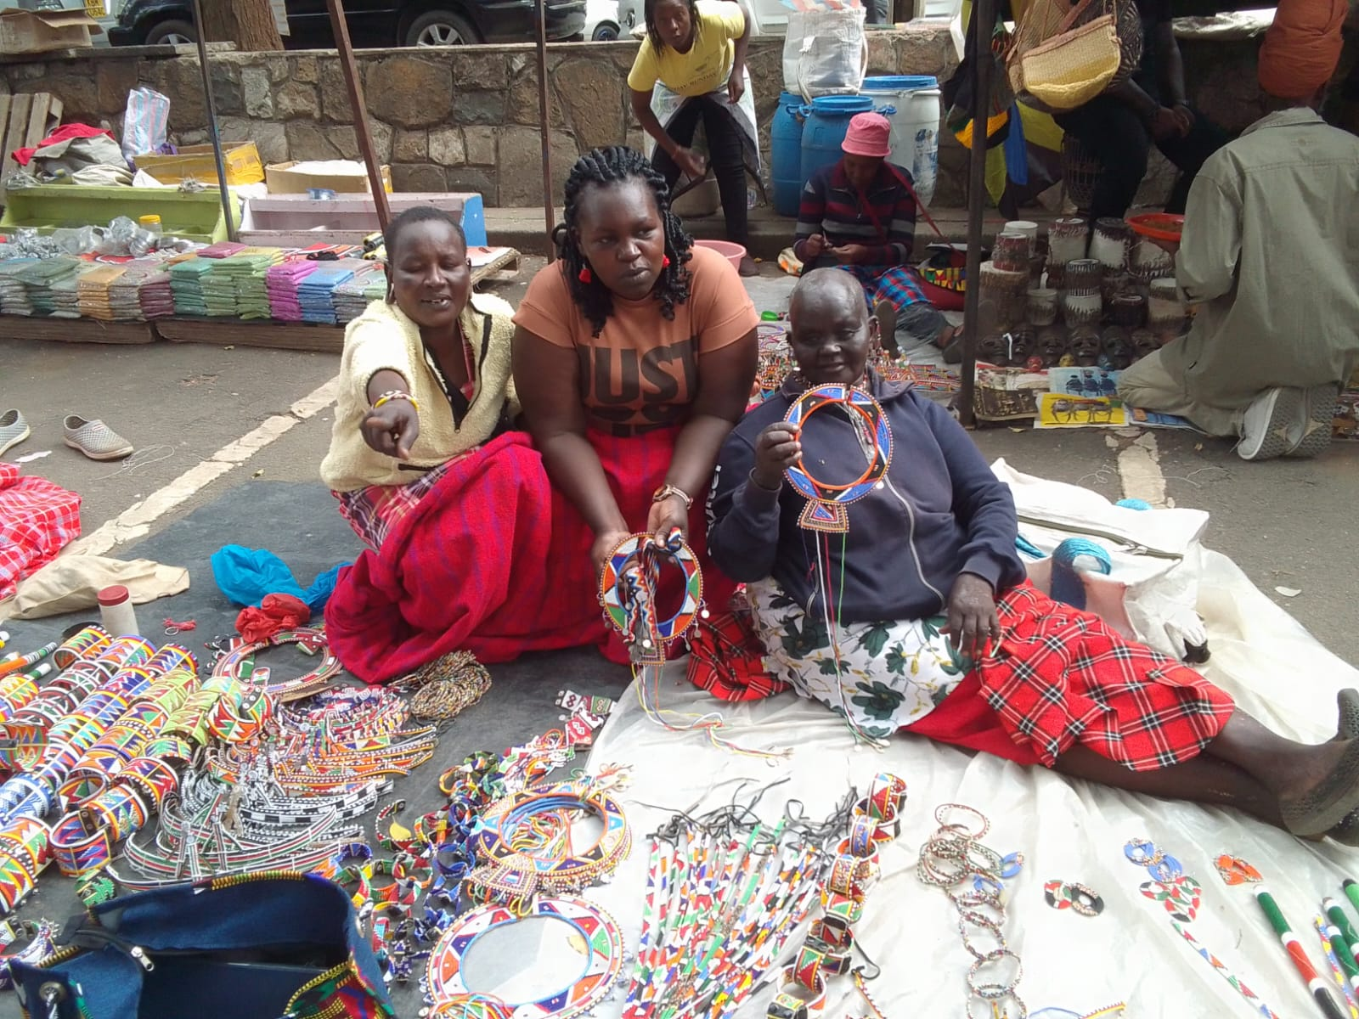  MISERY IN CHILDHOOD  My name is Grace Lekopan , a widow and a mother of 7 children. I was married of to my late husband as the 4th wife since my father had taken my dowry when I was 7 years old . I never attended any school and at the age of 10 years I was taken for initiation to adulthood . Female gentalia mutilation is not something to discuss because it inhuman and done in a very crude way to inflict pain. The more pain one feels and is able to endure determines the strength of the woman .  At the age of 12 years my husband came for me with his elderly wife who was meant to train me before he could start sleeping with me . I went with them and had no idea what was ahead of me . After 6 months of training my husband came for me and I was meant to join him in his hut . OMG…. This was a nightmare and its something I always shed tears when I remember. A girl of 12 years and a virgin having sex with a 60 year old man . It remains a nightmare when the man penetrated me without minding how I was feeling and went deep in tearing my fresh . It was so painful that I fainted but he did not stop . After he got satisfied he left me sleeping and when I woke up in the morning I found blood all over on the bedsheet . I got confused and thought I was sick hence went to my co- wife and informed her . She was happy that i was a virgin and reassured me it shall be well . This became the routine and after several months I conceived and after nine months gave birth to a baby boy .  I gave birth to my children every year so they are like staircase . It was rough bringing up 7 children who follow each other yearly . My husband would provide but I did everything for myself and also had to go to the field to graze the goats/ calves  WINDOWHOOD IS A MENANCE  One early morning we woke up as usual and I fed my children . Three of them are school going children so they joined the other children and left for school . I decided to go and check on my husband at my elder co- wife since he was meant to sleep there. My co-wife informed me that he did not come back from his drinking spree . We got concerned and as we were thinking of what to do , two of his friends came to our home stead . They informed us that our husband has been found dead on the road hence we should join them to report to the police station . We reported and later the police took him to the morgue to await post-mortem. Immediately, we started burial preparations which happened after 6 days . The post- mortem showed that his liver had been damaged by the alcohol . After the burial that’s when I realised I was on my own with my 7 children . I had to go for casual jobs to get money and buy food for my children . Life became so unbearable and we could sometimes go without super . It became a routine of eating one meal per day .My co-wives especially the elderly ones turned against me and gave me the least animals and the bad ones . Live became so impossible and unbearable and did not know who to turn too . Only my mother would stand with me and supported me where she could  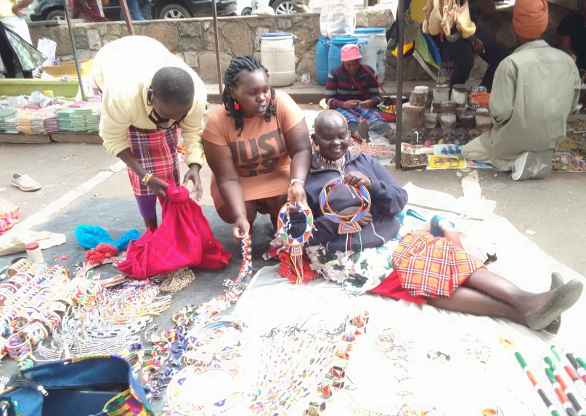  GOD HEARS MY PRAYERS AND MAKES US PILLARS IN OUR HOMES  When I was still doing casual jobs I came across my friend Damaris Lekorere who i used to go for casual jobs with . She informed me that God has heard our prayers through Baraka Women Center which is giving vulnerable / disadvantaged women/young mothers a platform of empowerment . Damaris is married and has 6 children and is the 2nd wife to her husband who does not provide for the family but expects food from his wives . She is always beaten by the husband when he drinks and sometimes chased away from the homestead  We decided to join BWC for training in beadwork as we felt we can be doing beadwork at home after our casual jobs and sell . We started our training and by the end of three months we our making products which we could sell and get something from our work . We were informed that the project was being funded by The Global Giving . After six months we had perfected and could make so many different products . It was during this time we joined other women and joined the Sossian Cooperative Society which helps us in marketing our products .  Damaris and I have also joined one of the table banking group where we save at least 200/ shillings per week . This group has helped us in saving and getting loans to buy materials for making bead work products . I have become a better mother and am able to provide my children with 3 meals per day , pay school fees, buy uniform and other clothes and also upgrade my house .  Baraka Women has also been mentoring me and have gained self-confidence as well as my self-esteem being raised . Damaris and I have been able to open each a bank account and we also do our saving there . This is not a common thig among the pastoralists community .  Damaris and I are grateful to Baraka Women and The Global Giving for empowering us with skills and seed capital to start our business. The entrepreneurship and leader ship skills have made us better business persons and have the skills of managing and marketing our business .  May the Almighty God bless The Global Giving and the donors who used this platform to support BWC . These has changed the lives of women in Rumuruti . Long live Global giving / Partners and BWC as we continue becoming better changed persons because of them .
Examples of Personal Success | M2: CATHERINE KESATO SUCCESS STORY  Being a Ugandan by birth didn’t prevent me from miseries and coming to foreign land which we referred as aboard . This didn’t weep away my tears or stop me from miseries .  Am Catherine Kesato and a Ugandan by birth. I never went very far in education because my parents were unable to keep me in School due to lack of school fees. My mother had 15 children and was a peasant farmer while my father was a watch man and alcoholic .  At the age of 14 years my mother informed me that my auntie was taking me to Kenya to work as a house help since I had dropped out of school at the age of 12 years. I had no objection as I thought life would be better in foreign land where I would be working  WHAT GLITTERS IS NOT GOLD ALWAYS  My assumption of good life abroad proved me wrong because my boss pretended to be good the first months but after three months, she became a beast. She would make me wake up at 4 am to do all the house chaos before they woke up to go to work and the children go to school . In the evening she would make me work until 11 pm when everybody had gone to bed . I was still a child and this became child labour. If I messed slightly, I would get good dogs beating and sometimes would go to bed without any food and made to wake up early in the morning .  It was during this time I met a man who showed love to me and got married almost immediately as I was looking for love and care  MARRIAGE LIFE  My husband was a carpenter and a good man who showed love and care . We immediately started our family and within 7 years of marriage I had 6 children. We had settled in Eldoret where his parents had a home but in 2007/2008 there were post-election violence which made us to relocate to Mai- Mahiu as we were chased away due to tribal classes. After two years in Mai Mahiu my husband bought a land in Rumuruti where we relocated and settled. My husband would leave me in the house doing house duties and would go with the children to work as he takes them to school . I would always beg him for money to buy what I needed in the house and this made me helpless and sometimes felt he was denying me money . This made me to start thinking outside the box and thought of what I can do to earn my own income  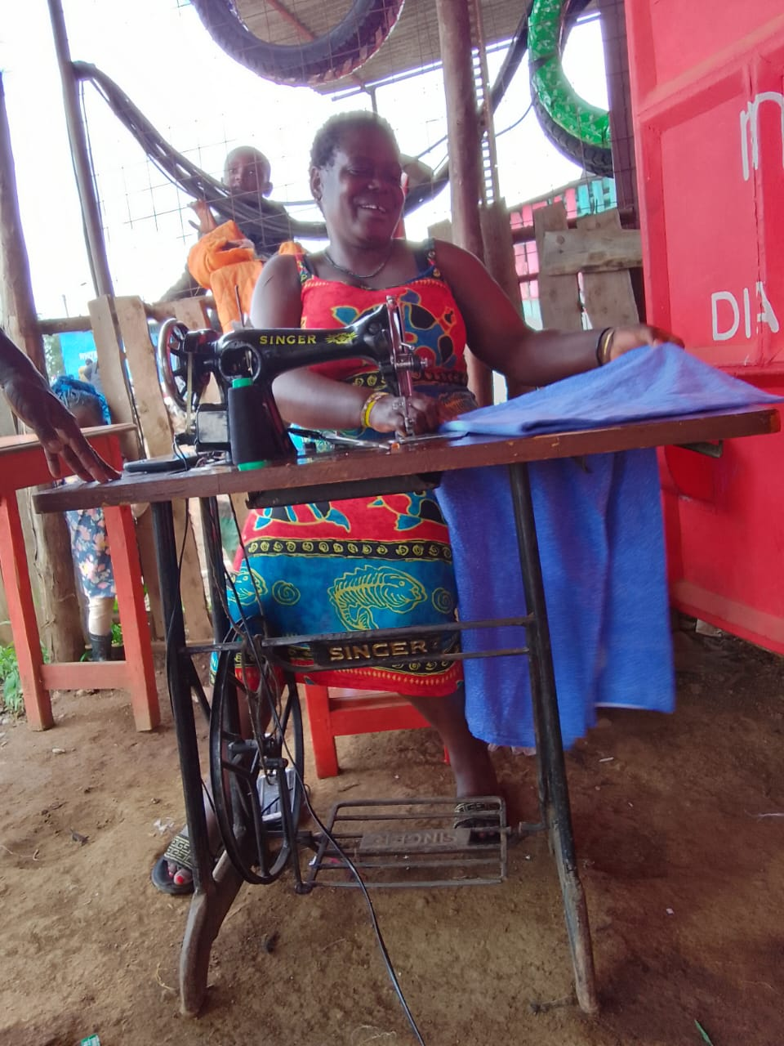  DRESS MAKING BUSINESS  I had already made new friends in this area and one day I was sharing with one of the women on what I was planning. I wanted to start dress making business and needed some skills in this . That’s when my friend informed me about Baraka Women Center which is supporting women / young mothers in acquiring vocational skills. She informed me she was a beneficiary of dress making class and that’s what enabled her to start her own business .  The following day she took me to the Center where I enrolled in tailoring / dress making class. In the evening I informed my husband and he was happy for me hence the following day I started my classes. This became very interesting because apart from dress making I also received the following trainings ;  - Entrepreneurship /Transformative leadership skills  - Mentorship/ Personal journal development  - Table banking / Finance literacy education  The entrepreneurship has equipped me with skills on starting a business , identifying the location of business , marketing , communication and management skills . This enabled me to develop my business plan for my dress making business  Mentorship session has helped me in discovering my personality, self-awareness which has raised my self-esteem/ confidence. My way of communicating improved and believed in myself  BWC also introduced us to table banking activities when we started saving as low as 20 shillings per day /week/or month. I joined one of the existing table banking groups and started saving.  All this prepared me for business and made me bold in all that I wanted to achieve in life  After completing the training I immediately started my dress making business. I requested my husband to support me and he agreed. I got a container when I paid for the rent and started my business. My husband bought me a second-hand sewing machine and also materials to make garments. The business started well and got customers who would bring old clothes for repair and also place order for new dresses. I started making at least 500 shilling per day and I stopped asking my husband for money to buy food . This made him very happy and always talked positively about the business.  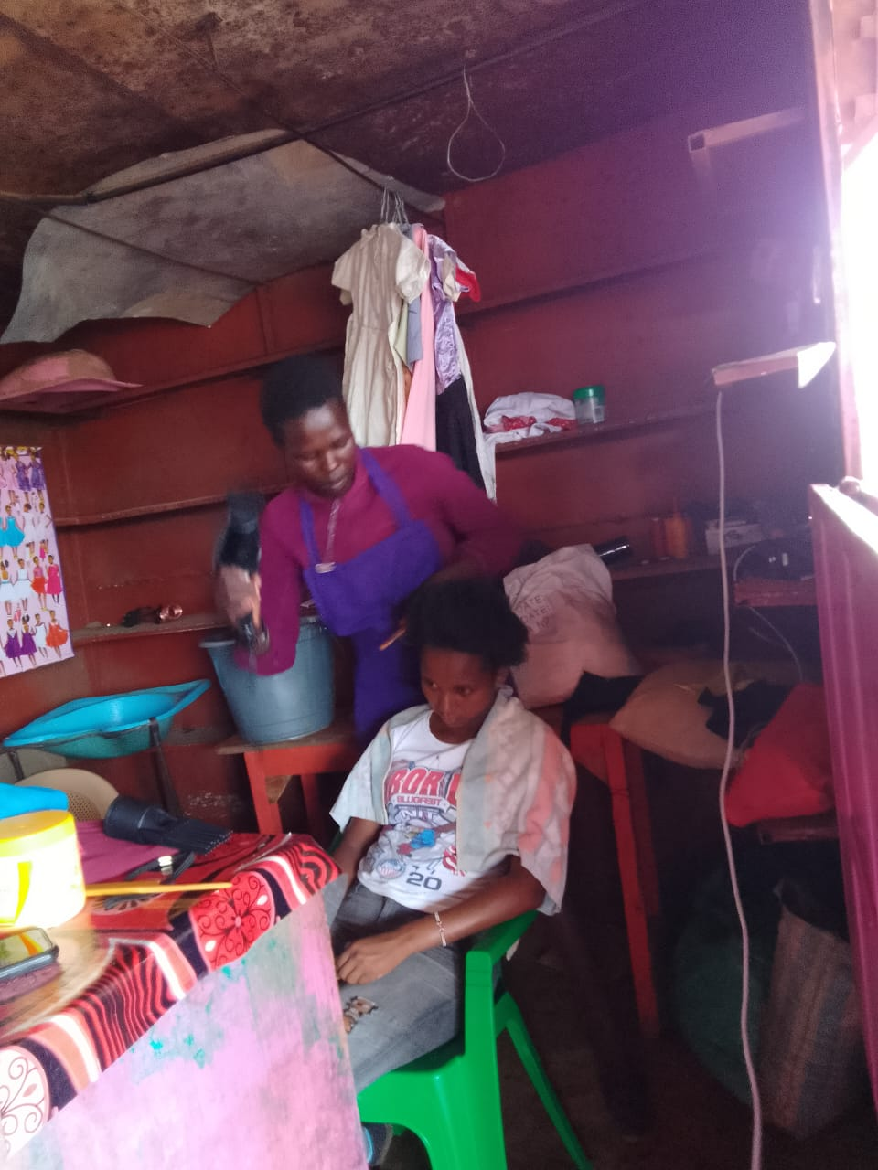  After two months in business I thought of rebranding the business by introducing new products hence I requested one of the vulnerable graduates Lucy Lemuria to come and start hairdressing business in my container. She agreed and this made me to partition the container into two. This attracted more customers and they got to learn more about my business of dress making. I also bought second hand clothes and shoes and  would sell them to the clients . My entrepreneurship skills helped in rebranding, marketing, and managing the business. My communication skills has improved so much.  NEW SELF  My business has grown and this has brought a new self out of me. I have changed my way of doing things where I have upgraded my house, bought a new cooker/ utensils, changed my wardrobe and my children’s and now saving at least 1000 shilling in the table banking per month . Through the table banking I have taken a small loan of 10,000 shilling and bought more materials to make clothes for my clients especially during this festive season.  This has brought happiness in my home and my husband nowadays can take the family for outings. This was history before and unheard off.  I remain grateful to The Global Giving which has made it possible for BWC to train and mentor us in all that we are doing. May the Almighty bless the two organization for bringing light to us. Am always humbled when I remembers where I have come from . Thanks Global Giving and BWC for lighting the candle  Catherine in her salon business
Examples of Personal Success | 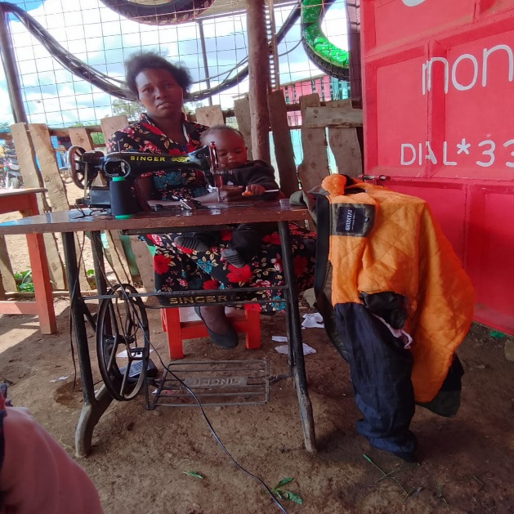  M3: STRENGTH OF A WOMAN – LUCY LEMURIA  Go back to your bed and dream again and write your Vision with bold letters ---those are the words of my mentor Wanjiru and sure enough they have come true  Lucy is my name and I got married immediately after dropping out of school in class seven since I had received the cut. My father could not continue educating me as I was a source of wealth to him hence needed the goats and cows which were to be brought as my dowry.  My husband was a young Maasai man who works in the District Commissioner’s office as a clerk. Immediately they paid my dowry I was married off and we started staying as man and wife .  After one year I had my first-born child and I was so happy to be a mother. My husband though he loved me he behaved like other Maasai men and expected me to do all that married women do . After 1 year I had another child and others followed year after year and they were like stair case.  CHANGE OF LIFE TO A TRAINEE  In a span of 7 years I had 5 children and this became a burden to my husband. I could see he was straining in feeding us and sending the children to school. It was during this time I suggested and requested him if I could start a small business at home so that I could assist him in buying food . He said it was ok but I should think carefully of what I want to do hence he told me to take my time .  I shared this with my friend and informed her I would want to become a dress maker so that I can open my own dress making come boutique and combine it with new clothes . My friend told me of Baraka Women Center which is training women in vocational skills and later mentoring them in starting their own business .  The following day we visited BWC and enrolled in dress/ tailoring class . That was last year and immediately we started our trainings . I registered in the following classes ;  - Tailoring and dress making class  - Entrepreneurship and leadership class  - Mentorship class  I got equipped in dress making/ tailoring and entrepreneurship skills . In the entrepreneurship I learnt how to manage , market and develop my business since I already had a business ideas . I also got equipped with customers communication skills  Mentor ship changed me to a better focused woman . My self esteem / confidence were raised through the self awareness / self love topics . I started appreciating myself and changing the way I dressed and related well with my family members until my husband said I had made the right decision in joining BWC . In mentorship our trainer emphasised we can dream again and have our vision written in bold letters . These are the words which kept ringing in my mind and I was ready to dream again  BWC also introduced us into table banking activities where we learnt how to save money , get loans and repay loans . This helped me in saving money to buy my equipment / materials to start business . I joined one of the table banking group and could save money as low as 100/- from the money my husband would give me to buy food . By the time we completed our training I had saved 5000/ and with this I could get a loan thrice of this amount  MY DREAM COME TRUE WHICH HAS CHANGED MY ENTIRE LIFE  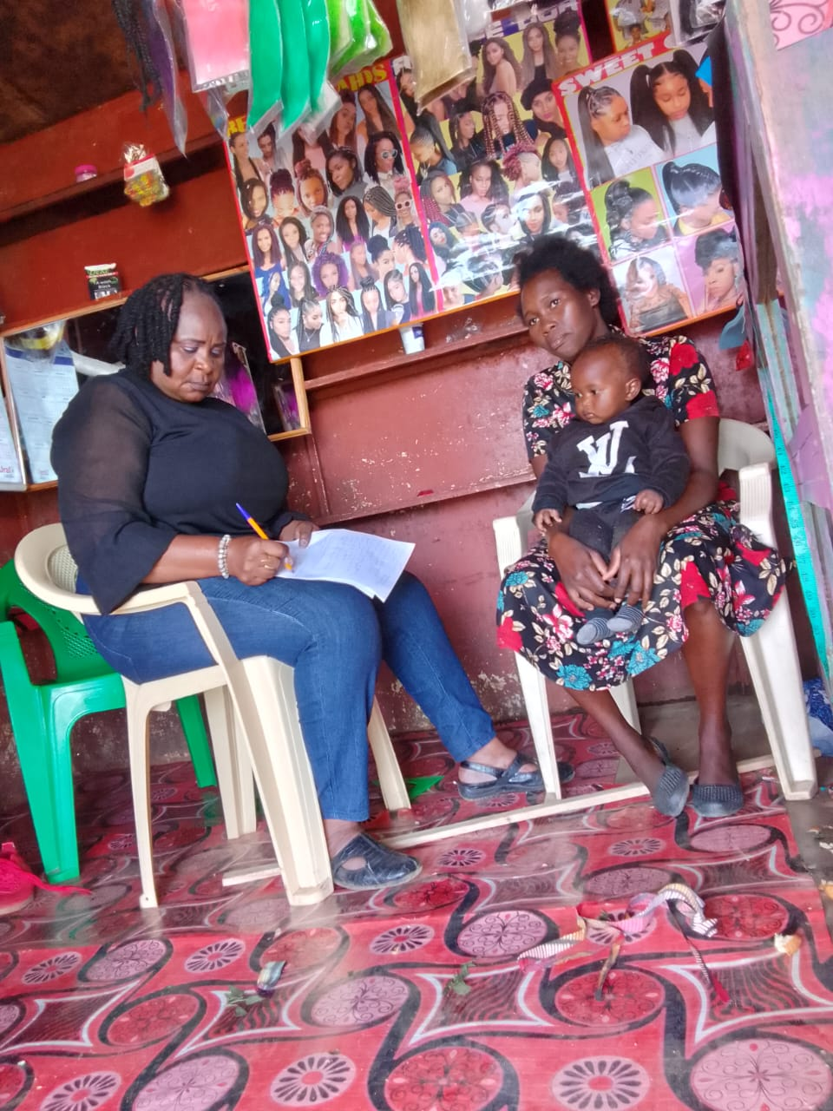  After we completed the course as I waited to graduate , my friend welcomed me into her tailoring business as she had two machines . She suggested that we can work together and be sharing payment of the rent , licences and electricity expenses . My husband agreed with the idea hence I applied for a loan from the table banking group and got 15000/ Kenyan shilling . I travelled to Nairobi and bought African materials and started making African traditional dresses . It was during this time that members of table banking group through a friend came and requested I make group uniform for them . They were twenty women and I charged them 2500/ per woman which they agreed to pay . In a week’s time I completed and I was paid 50,000 in cash . I was so happy and could not believe the boom was mine . When I informed my husband he advised me to pay the rent and other expenses , repay the loan partly and restock my business where I now added ready made products . He agreed to accompany me to Nairobi and when we purchased the items it went high with 7000/ which he offered to top up.  This has changed my life completely and feel proud of myself . I have opened my bank account , I now save 1000/ shillings per month with the table banking group , have bought a smart phone which am using to market my products and have bought new utensils for my kitchen.  The beauty is I don’t have to ask my husband for money to buy food and I always help in in paying some bills . OMG….am a changed woman and weekends I always take my children and my husband out . BWC and Global Giving have rejuvenated the girl in me . I have become unstoppable and surely I am going far . LONG LIVE Global Giving and BWC . This is a factory resetting for women

