SMILE OF A YOUNG EMPOWERED MAASAI GIRL

Every action fuels transformation whether it’s a one-time gift , becoming a monthly donor , or simply following and sharing our posts – you are helping young mothers get skills, start business , join and register in table banking groups and build financial power for their families and communities .
Be part of the mission. Together we multiply impact

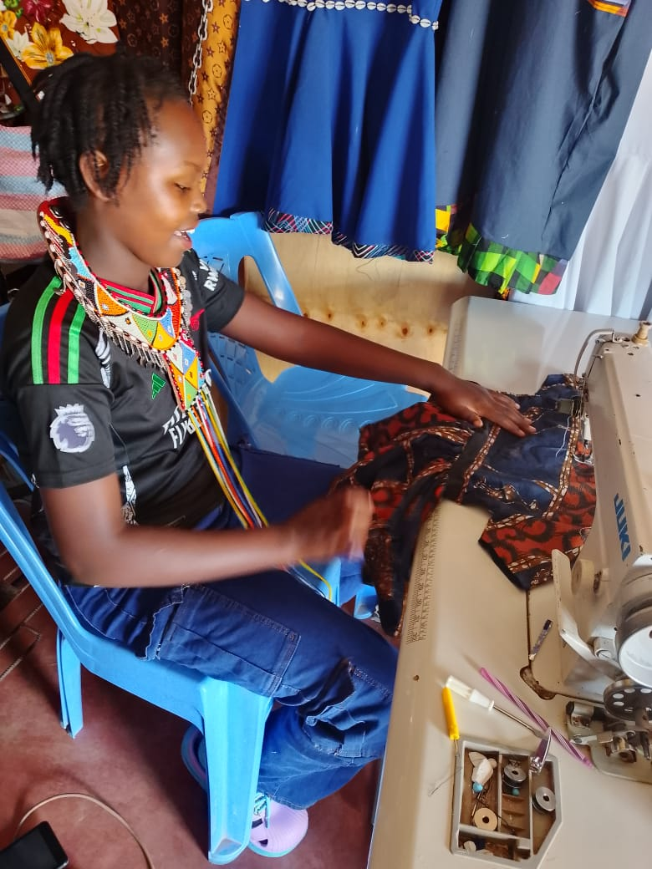
My name is Saina Lepere and born in Rumuruti in a polygamous family . I completed secondary school last year after being rescued from female gentalia mutilation by Baraka Women Center three years ago . This would have made my father to force me to drop out of school and into an early marriage . I remain grateful to the BWC TEAM
After my parents failed to take me to college due to lack of finances and having many children in school , I joined BWC for a tailoring /dress making course in August . I am being trained in tailoring and dress making as well as computer skills.
We are also receiving entrepreneurship and leadership training together with table banking group formation and management. Mentorship and one on one counselling happens every week and this has helped me in discovering myself, raising my self esteem , confidence as well as knowing how to repackage myself
We are in our last month of training and I have perfected in dress making. I now get materials from clients and make for them garments where they pay me . Every week I am making at least 1000/ Ksh where I give back to BWC 20% and the rest is mine . I have also joined one of the table banking groups where I do my saving of at least 1000/Ksh per month. I wish to save for 1 year and after get a loan to buy my own machine and tailoring material to start my own business in my rented shop .
Sometimes I think I am dreaming and pitch myself for awake up call but I have realised a dream has come true and completely changed my life style . Am grateful to Global Giving and BWC for changing my story from sad one to an inspiring story. Long live Global Giving and BWC.

POWER IN UNITY OR DO I SAY UNITY IS POWER
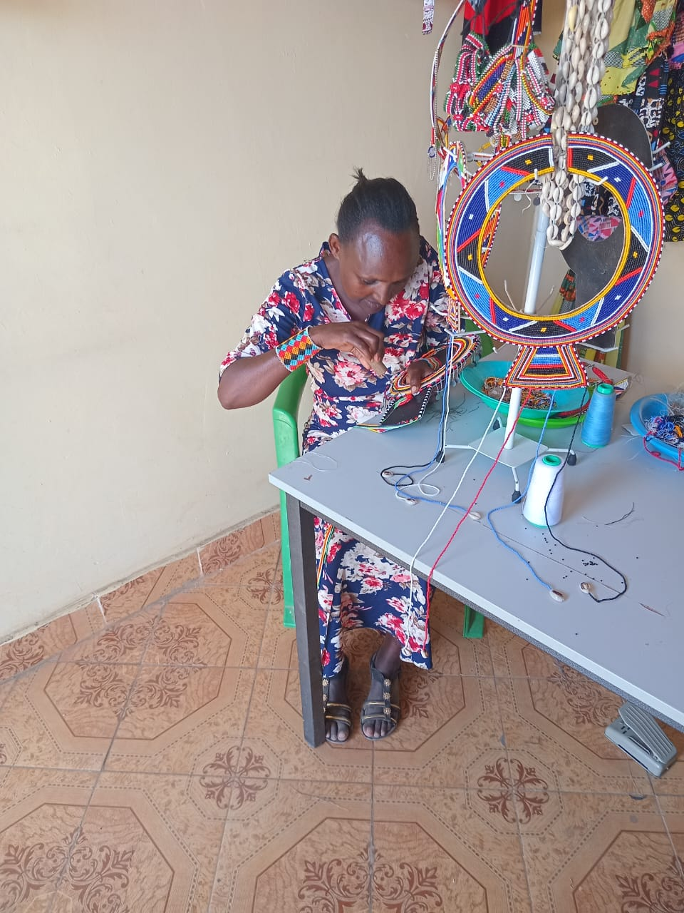
There is power in unity or should I say strength and two hands are better than one.
My name is Rosemary Lemosian and a graduate of beadwork at BWC. After I completed the course I partnered with four other trainees i.e Pamela Silat a young Maasai girl , Susan Letrogros, Susan Lemuli and Jennifer Etegela.
We started making bead products like different designs of Maasai necklaces, headgears, bracelets, bangles , earing’s, rings and Masai belts together . We usually sell them to Baraka Mtindo Fashion Accessories and to customers who have placed orders.
We usually do our work at BWC shop and this helps us to attract more customers and also to attract more trainees.
Rosemary busy working in beads

This is so encouraging as we are earning at least 10,0000/ per person per month . We have opened a joint account where we save each 1500/ for buying the working materials and also for emergency.
We have joined table banking group and we save at least 1000/ per person depending on each person’s monthly expenses
This business has changed my life and has made me to start thinking outside the box. I have bought new utensils for my kitchen, bought a small gas cooker and now planning to buy a new sofa set for my living room. I am supporting my husband in paying school fees for our children and buying medicines for my ailing father. I am always grateful to Global Giving and BWC and partly I volunteer in training other trainees

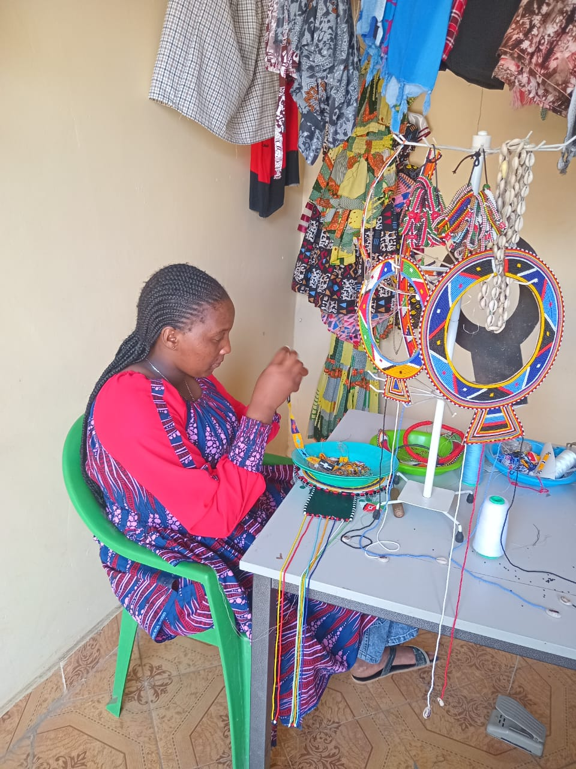
Pamela Silat

This side hustle business has boosted my monthly income. I usually save 1500/ in the group joint account, support my mother in feeding and paying fees for my siblings and also saving in the table banking group. With time I will save enough money to access loan and start my own dress making / boutique business

Pamela making the Maasai women necklace at BWC shop

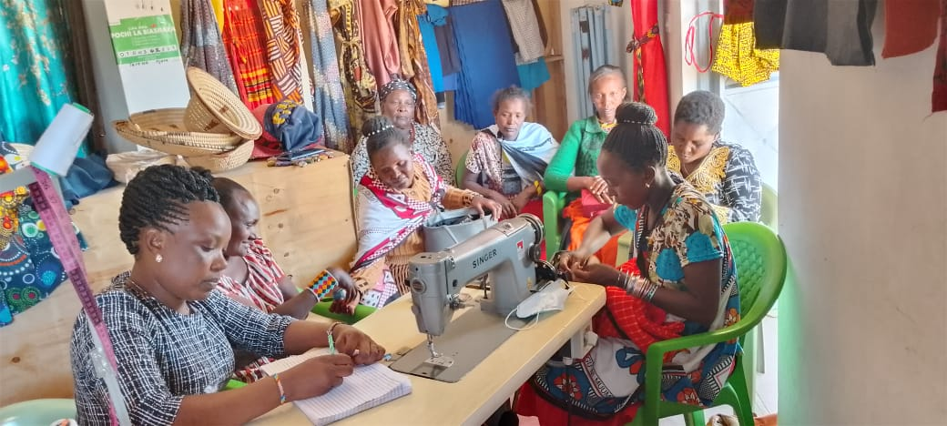
Susan Letorogros

Like my friends I feel empowered and financially independent because of this beadwork project. From my 10,000 I am financing the education of my sister and also

Susan Letrogros guiding the women in table banking

paying her rent. I am also supporting my parents in buying the food and their medicines as they are old
Am in a table banking group when I save at least 1000/ per month and planning to access a loan at the end of the year and start my own business of dress making
We remain grateful and appreciative to Global Giving and BWC . They have changed our lives and helped us to think outside the box . If it was not for Global Giving and BWC we would still be the oppressed women in Maasai land THE MONTH
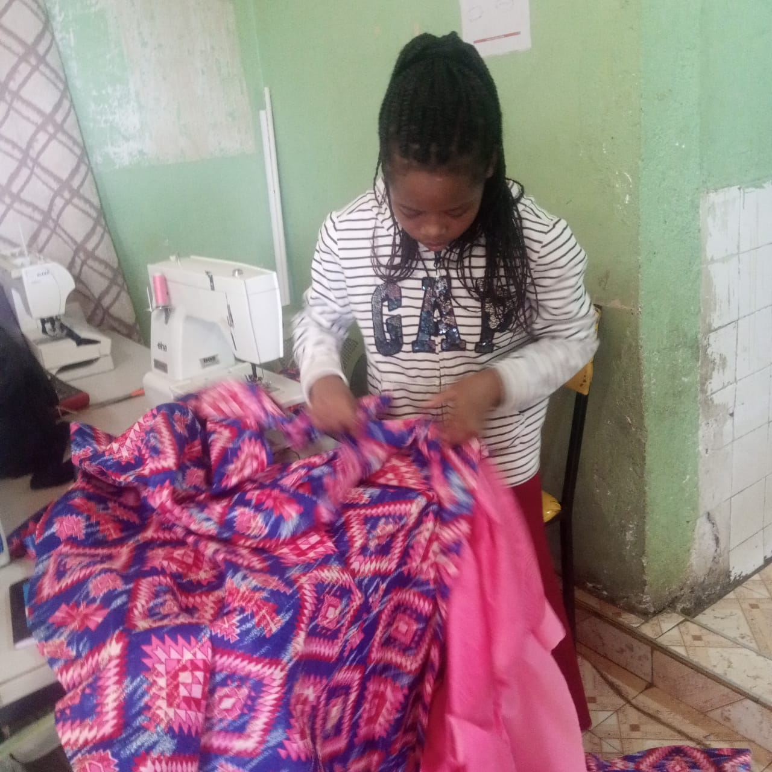
Brenda is my name and am 19 years old. We were born triplets to our mother who is a single parent. After completing primary school, she was unable to take us to high school hence we stayed at home and helped her in her business of washing peoples clothes . I was hopeless in life and always frustrated with what I did

Young Brenda doing the final stitching to her client dress

NEW DAWN IN MY LIFE
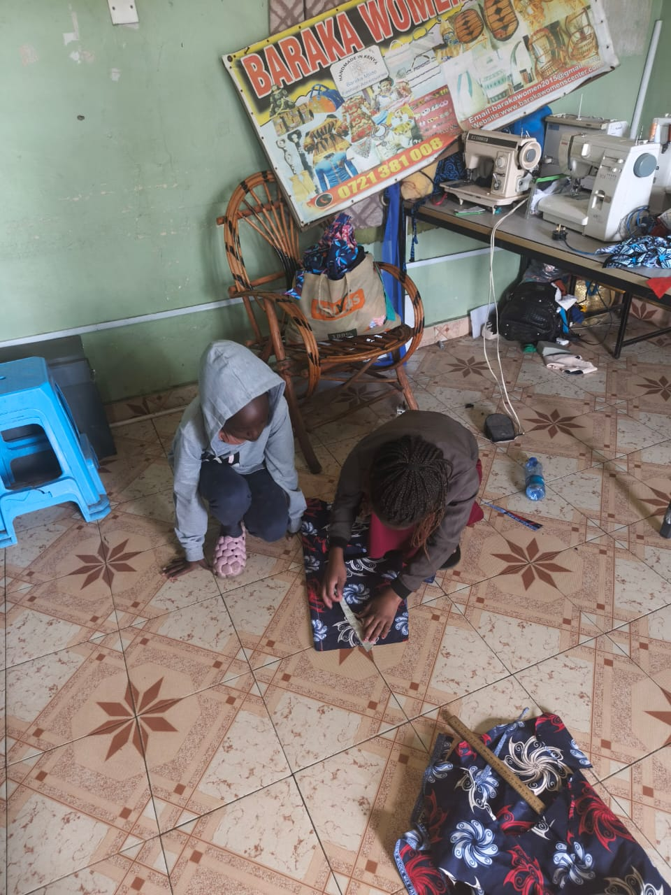
My mother was introduced to Baraka Women Center by her friend where they empower girls and young mothers with vocational and life skills. I was taken to the centre by my mother and got enrolled. I trained for 6 months and graduated with a NITA certificate (National Industrial Training Authority) in Dress making / Tailoring . I also got skills in entrepreneurship , finance literacy , leadership training and table banking formation , registration and management. Mentorship and counselling were daily routine
Brenda measuring / cutting a material as a trainee watches

which helped me in maturing and being able to navigate daily challenges.
Immediately after graduation I started making dresses and other attires at Baraka Women Centre for my clients. This is really perfecting me into a good tailor and helping me to save money to buy my own sewing machine and start my own business .

My future goals
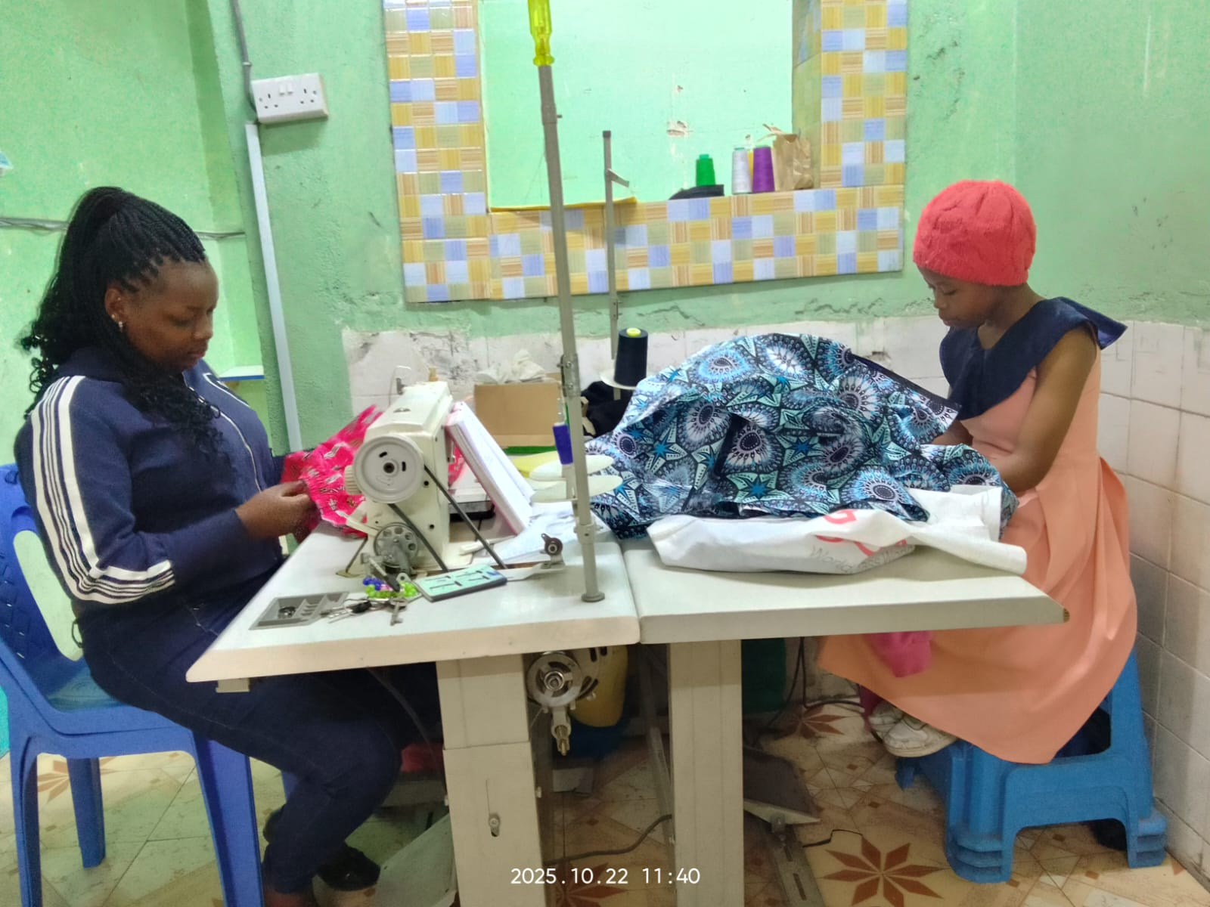
With the money I am making from my dress making business I have joined one of the table banking groups at BWC where I have been saving at least 1500/ ksh per month. I am saving so that at the end of two years I will take a loan and buy a good sewing machine and buy materials to start my own tailoring/dressmaking business . Am grateful to Global Giving and BWC who brought hope and light to my life after I had given up. As I write this success story I am helping my mother in buying food in our house for the family and also paying rent. Thanks to Global Giving and BWC for what you have done in my life and changing my life .
Brenda sewing African dress for her customer

