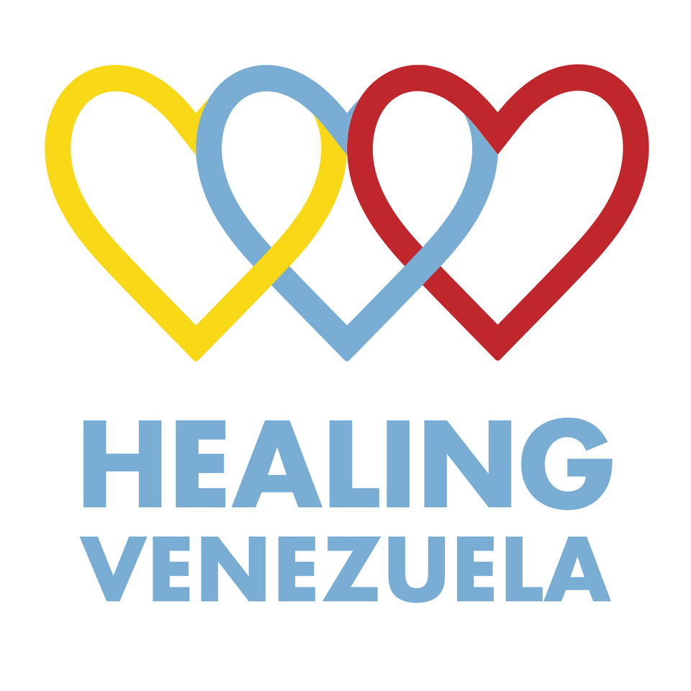
Junior Doctors Scholarship Programme – Overview
November 2025

Summary
The 2024 National Hospital Survey reveals that Venezuela’s public hospitals continue to operate under critical conditions, facing persistent shortages of medicines, supplies, and qualified staff. Despite this, junior doctors—resident physicians—remain the backbone of the public health system.
They keep emergency rooms, operating theatres, and ICUs functioning, often without essential resources or fair pay. While 30% of doctors have emigrated, these young professionals sustain care for millions of Venezuelans.
Healing Venezuela’s monthly scholarships provide crucial support that helps residents meet basic needs, allowing them to focus on saving lives. Since 2018, the programme has enabled access to healthcare for over 2 million patients.

Context
According to the UN Humanitarian Response Plan (2024–2025), 7.7 million people in Venezuela need humanitarian assistance, while an equal number have fled the country—one of the world’s largest displacement crises. With inflation projected at 269% (IMF, 2025), most Venezuelans live below the poverty line.
More than 40,000 doctors have emigrated since 2017, closing entire hospital wards. Those remaining earn $80–$100/month, while the basic food basket exceeds $500. Despite some reports of recovery, hospitals still face severe shortages of medicines, equipment, and reliable utilities.
Healing Venezuela—a volunteer-run charity registered in the UK, USA, and France—was founded to alleviate this crisis through high-impact health initiatives. Its Junior Doctors Scholarship Programme provides small monthly stipends to residents in public hospitals—the very doctors keeping the system alive.
Since 2018, over 300 residents have benefited. The programme’s attrition rate is under 1%, proving its effectiveness in retaining talent.

How the Programme Works
Hospital heads nominate candidates based on need and merit. Applications are verified by our local coordinator and approved by the UK board under the guidelines HV-11-V4-2024-ES.
Eligibility criteria:
• Low-income background and no other scholarship
• Nominated by the department head
• Academic average ≥15/20 (or justified exception)
• Commitment to remain two years in Venezuela post-training
Funds are transferred monthly via CONVERA (UK) to Finampyme (Venezuela), which deposits the stipend in local currency to each beneficiary’s account. Programme monitoring includes regular reports, invoices, and communication with recipients via WhatsApp and site visits.

Budget (2026)
To offset inflation, the projected budget is $67,000, covering scholarships, communications, monitoring, and part-time coordination.
61 doctors currently receive $80/month each. Fundraising events are planned to sustain and expand the programme.

Impact (2025)
Since 2018 to 2025, the programme has supported around 300 junior doctors training. The specializations can last 2 or 3 years, and when we take a junior doctor on board we make sure she/he will continue receiving the scholarships.
Only in 2025, we have:
1. Supported 61 junior doctors in their career development and retention of medical professionals.
2. Enabled an estimated 131,000 consultations in 2025, similar to 2024.
3. Maintained 8 hospitals operations amid crisis, with an estimate of 89% of 2023 alumni still practising in Venezuela.
The average cost per consultation in state hospitals—combining salaries and scholarships—is just $0.77 USD, highlighting exceptional value for impact.

Testimonials
“Healing Venezuela’s support lets me focus on my training without constant worry. It eases my family’s burden and gives me hope for the future.”
— HP, Internal Medicine, Hospital Vargas (Caracas)
“Healing Venezuela changed my life. Beyond financial help, it represents hope and solidarity.”
— FD, Gynaecology & Obstetrics, UCLA Hospital
“I was about to give up when Healing Venezuela appeared. Their support lifted me and reminded me that compassion still exists.”
— OS, Hospital Pedro García Clara (Zulia)

Conclusion
Healing Venezuela’s Junior Doctors Programme is a proven, transparent, and cost-effective intervention that keeps Venezuela’s public hospitals functioning and ensures that thousands of patients continue to receive care. With continued donor support, we can sustain these doctors—who, despite everything, remain committed to healing their country.

