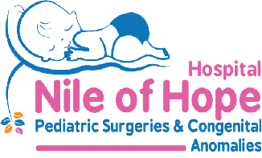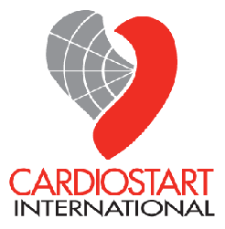
Pediatric Cardiac Surgery at Nile of Hope Hospital
Alexandria, Egypt
July 31st - August 8th, 2026
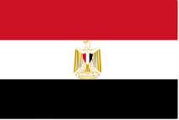
Alexandria is the second largest city and the largest on the Mediterranean Coast. It lies on the western edge of the Nile Delta, and was founded in 331 BC. It has a large tertiary referral base for the region and is located about 2.5 hours’ drive north-west of Cairo.
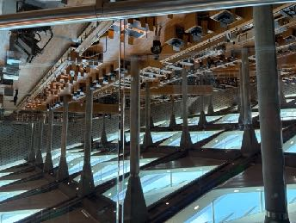
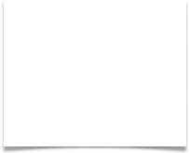
The city includes many historical treasures from its illustrious past, including the internationally famous Library of Alexandria. This was one of the largest in the world over two millennia ago, but was partially destroyed during Roman skirmishes. It has since recently been re-built. It has the capacity to house up to 8 million books although less than 1.5 million are currently in house.
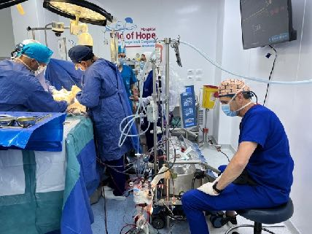
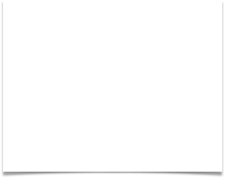
The Nile of Hope pediatric heart facility is a modern, well-equipped, not-for profit hospital supported by the government and by private donors. The hospital has excellent equipment and is supported by very well-trained, competent staff level. They are seeking extra help to handle the more challenging cases, fine tune their ICU management and to embrace the increasingly large volume of referrals. Dr. Mohamed Abdelmalak Abokandil, CEO, Nile of Hope Hospital, invited the CardioStart team to join a one-week mission, led by Dr. Sameh Said, an Egyptian born native, (now in NY, USA), who is a regular visitor there.
A team of 13 pediatric medical professionals and three outreach team members embarked on this first mission to Egypt. Children aged 2 months to 9 years received surgical procedures to treat congenital heart disease during the week.

Operations carried out
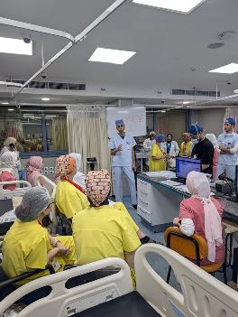

Pt. Initials | Procedure | Outcome
YTMZ | Sinus Venosis type ASD repair | Satisfactory
AMAH | Subaortic membrane resection | Satisfactory
FAHA | AV Canal repair | Satisfactory
HKHA | Ventricular Septal Defect repair | Satisfactory
AAFE | Partial anomalous Venous Connection repair | Satisfactory
SESE | Tetralogy of Fallot correction | Satisfactory
JAEN | Rastellii contegra failure -replacement with Pulmonary homograft (re-op) | CVA *
DMHS | Tricuspid Valve repair (re-op) | Satisfactory
MRNA | Ventricular Septal Defect repair | Satisfactory
HMMR | Complete Atrioventricular Canal Defect repair | Satisfactory
SAA | Ventricular Septal Defect repair | Satisfactory
HAG | Aortic Stenosis repair (failed angioplasty) Ross operation | Satisfactory
BBSH | Partial Atrioventricular Defect repair | Satisfactory
MAA | Aortic Coarctation repair (end-to-end oblique anastomosis) | Satisfactory
KKFA | Double Outlet RV/VSD/Fallot repair | CVA *
LAEI | Tetralogy of Fallot - correction | Satisfactory
MAMA | Double Outlet RV/VSD/TGA repair - (Double Switch) | Died post-op
YKES | Subaortic membrane - resection | Satisfactory
YEEG | Tetralogy of Fallot correction | Satisfactory
KMAA | Transposition -Arterial switch | Satisfactory
MISI | Total Anomalous Pulmonary Venous drainage -Re-direction | Satisfactory
NENA | Atrisal/Ventricular Septal Defect & Pulmonary stenosis - repair | Satisfactory
 | ** Alive but with a technical issue intra-operatively, delaying ICU recovery.

Education in the ICU
CardioStart Nurses from the USA provided bedside teaching with support of 2 US-based Pediatric Intensivist/Cardiologists. They found the local team very skilled, motivated and welcoming of new policies/procedures and protocols to help them provide care for advanced levels of care. After the mission CardioStart continue to reach out with tools and techniques to assist with developing skills. A heart-lung machine is being sent to the hospital from Ottawa, Canada, to assist with expanding case volume and safety assurance.
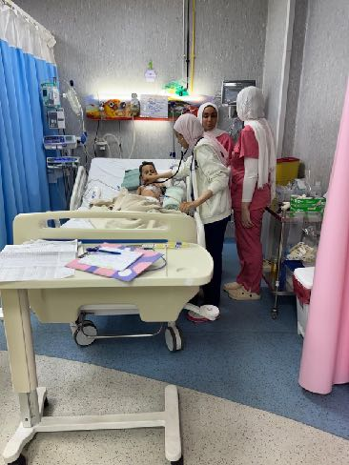


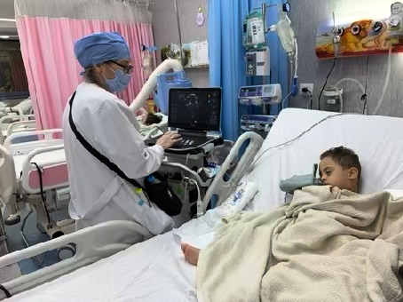
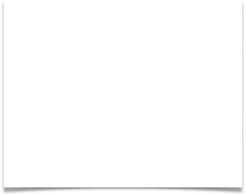
Members of the CardioStart Team
Name | Name | Home Country
Sameh Said, MD | CV Surgeon/ Mission Director | USA/Egypt
Aubyn Marath, MD | CV Surgeon & Mission Co-Director | UK/USA
Andy Lodge MD | CV Surgeon | USA
Akinola Akinyemi MD | Anesthesiologist | Nigeria
Parvin Dorostkar, MD | Cardiologist/Intensivist | USA
Barbara Ferdman, MD | Cardiologist/Intensivist | USA
Kyle Sieck CCP | Pediatric Cardiologist | USA
William Nicotra, CCP | Senior Perfusionist | USA
Bryn Davies RN | Pediatric ICU Nurse | USA
Kenna Murphy RN | Pediatric ICU Nurse | USA
Debbie Castle RDCS | Cardiac Sonographer | USA
Mina Tohid RDCS | Cardiac Sonographer & Coordinator | USA
Gwyneth Westover | Database coordinator | USA

Acknowledgements
CardioStart gratefully acknowledges the following donors who helped make this mission possible.
- Artivion Inc., Kennesaw, GA, USA, for previous donation of homograft valve conduits.
- Americares Inc., Essential medicines and two pulse oximeters.
- Bill Nicotra, Senior representative, Custodial cardioplegic preservation systems, Inc., for donating solutions, and perfusion related donations.
- Carrie Ochocki, Perfusionist, Brecksville, OH, USA for perfusion-related donations.
- CardioStart International, Administrative staff for logistical management of the mission.
- CardioStart Resale Thrift, Sisters, OR, USA, for financial support towards mission equipment costs.
Acknowledgements (continued)
- Children’s LifeLine International, Denver, CO, USA, for financial support for some essential medications.
- Mrs. Pam Harned, for surgical equipment donations.
- Lake Oswego Methodist church, patch doll making group for donations of stuffed dolls and hearts to assist post-operative patient recovery splinting and comfort.
- Rotary – Southtowne, Delta, & Springfield volunteers, Eugene, OR, USA, for equipment preparation, donation and logistics management.
- John Sanders & Dr. Jennifer Crown, for financial support towards mission equipment costs.
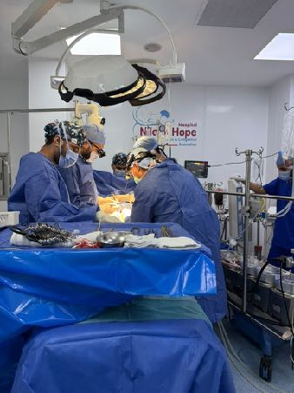


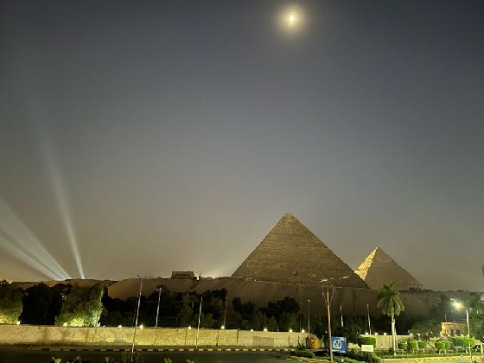

- Dr. Mohamed Malak Abokandil, Assistant and Strategic Management, Ms. Asmaa Fakry, the entire Nile of Hope Hospital staff, and visiting surgeons from Cairo University, for their collective collaboration and generous hospitality in support of the mission.
- Pape Inc, Eugene, OR, USA, for heavy equipment loan in facilitating logistical management.
- Tisgen Inc., Irvine, CA, USA, for their generous donation of novel pericardial membrane.
- Dr. Dan Woodwood, Portland, OR, USA, anesthesiologist supporting medication donations.
- Mr. Steven Yett, Eugene, OR, USA, for assistance with warehouse space for equipment donations.
- Perfusion department and Hospital Administration, Heart Institute, University of Ottawa, Canada, for donation of heart-lung machine.

