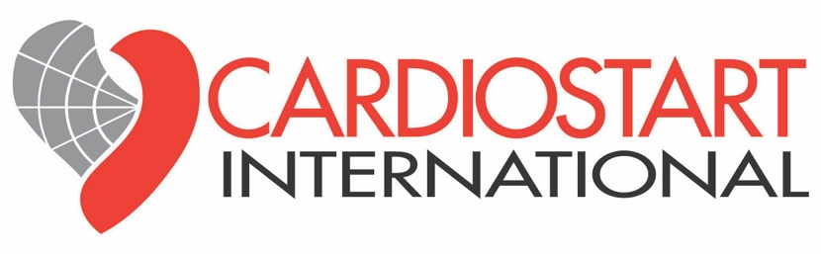
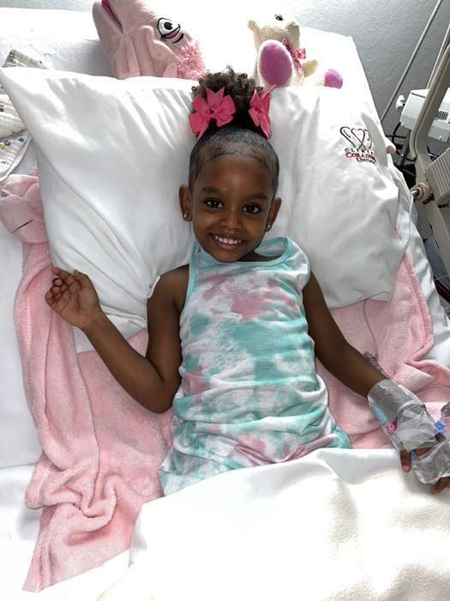
CARDIOSTART INTERNATIONAL
May 16-23, 2026, Mission
Santo Domingo, Dominican Republic

This one-week mission at Clinica Corazonas Unidos’s for Pediatric Congenital Heart surgery and Moderno MCA-Unidad Cardiovascular Hospital for Interventional Cardiology was a repeat visit after many years of pediatric and adult support. On this mission Interventional Cardiology completed 6 interventional cardiology cases in the catheterization lab under direction of Dr. Manfred Hermanni, Venezuela. All cases were successful and treated without the need for sternal incisions giving them a rapid recovery.

Dr. Sameh Said, dual citizen of New York, USA and Egypt led the surgical mission correcting congenital conditions for six children. The numbers of cases were impacted by local issues limiting numbers of cases. Dr. Ernesto Rivera held cardiology clinics doing screening echocardiograms on 24 children with anticipated cases for the Fall mission.
A 40-foot container was shipped by the CardioStart Oregon warehouse to assist with disposable medical supplies and equipment. GoMed warehouse located in PA sent interventional cardiology disposables to the Miami shipping port for Moderno MCA.
A highlight of the mission was the outreach support by Mastercard International local office in Santo Domingo. Led by CardioStart Board Member Nicola Entwistle, MBA, the local team paired up to support patients and families in the logistical needs daily. They were attentive to the physical, psychological and emotional needs of the children and parents as they journeyed through the surgical period. This was a significant help to Foundation Heartcare Dominica who funds and organizes the missions under the direction of Mary Carmen Mota.
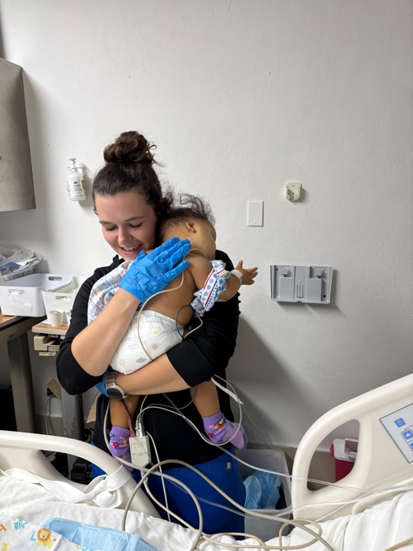
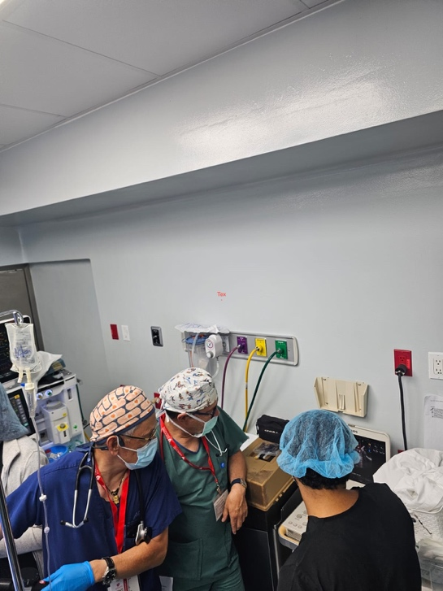
Team Members
Sameh Said, MD | Surgeon/Director | NY, USA & Egypt
Alexey Zubriskiy, MD | Surgeon | Australia
Kye Sieck, CCP | Perfusionist | Kansas, USA
Alberto Telleria, MD | Anesthesiologist | Spain
Ernesto Rivera, MD | Cardiologist | California, USA
Barbara Ferdman, MD | Cardiologist/Intensivist | New York, USA
Jennifer Townsend, RN | PICU Nurse | Minnesota, USA
Diana Klein, RN | PICU Charge Nurse | Washington, USA
Thabie Sibanda, RN | PICU Nurse | California, USA
Ellysa Bellah, RN | PICU Nurse | California, USA
Ashley Van-Veen, RRT | Respiratory Therapist | California, USA
Manfred Hermanni, MD | Interventional Cardiologist | Venezuela
Elka Maria Mercano, MD | Cardiologist | Venezuela
Nicola Entwistle, MBA | Mission Coordinator | Florida, USA

Mastercard Volunteers
Janet Banuchi
Gabriela Oller
Marielisa Mata
Jose’ Enrique Fernandez
Alejandro Soto
Michelle Periche
Laura Ramirez
Fernando Pepen
Eunice Cueto Bismark Gonzalez
Eileen Castillo
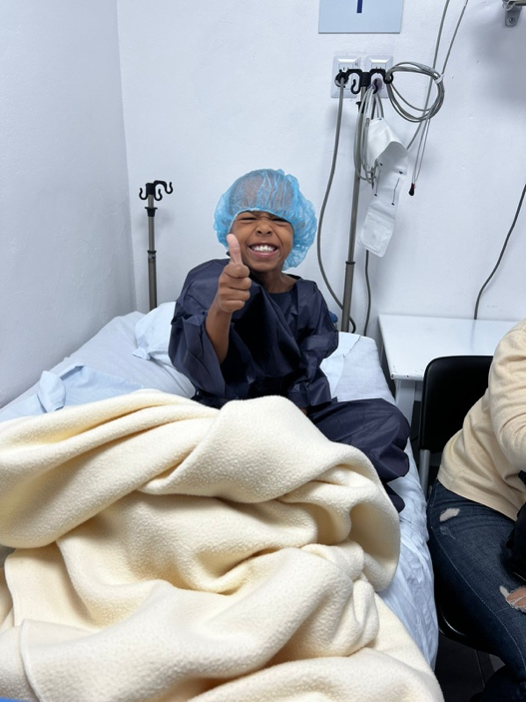
THANK YOU!
GoMed Pennsylvania Warehouse (Connor & Courtney).
Mastercard International
Tyler Larch, RN for CVICU Protocols
Mike Gelskey, CardioStart Board Member, donations to Sociedad Salesiana Orphanage
Fundacion Heart Care Dominicana-Mary Carmen Mota.

