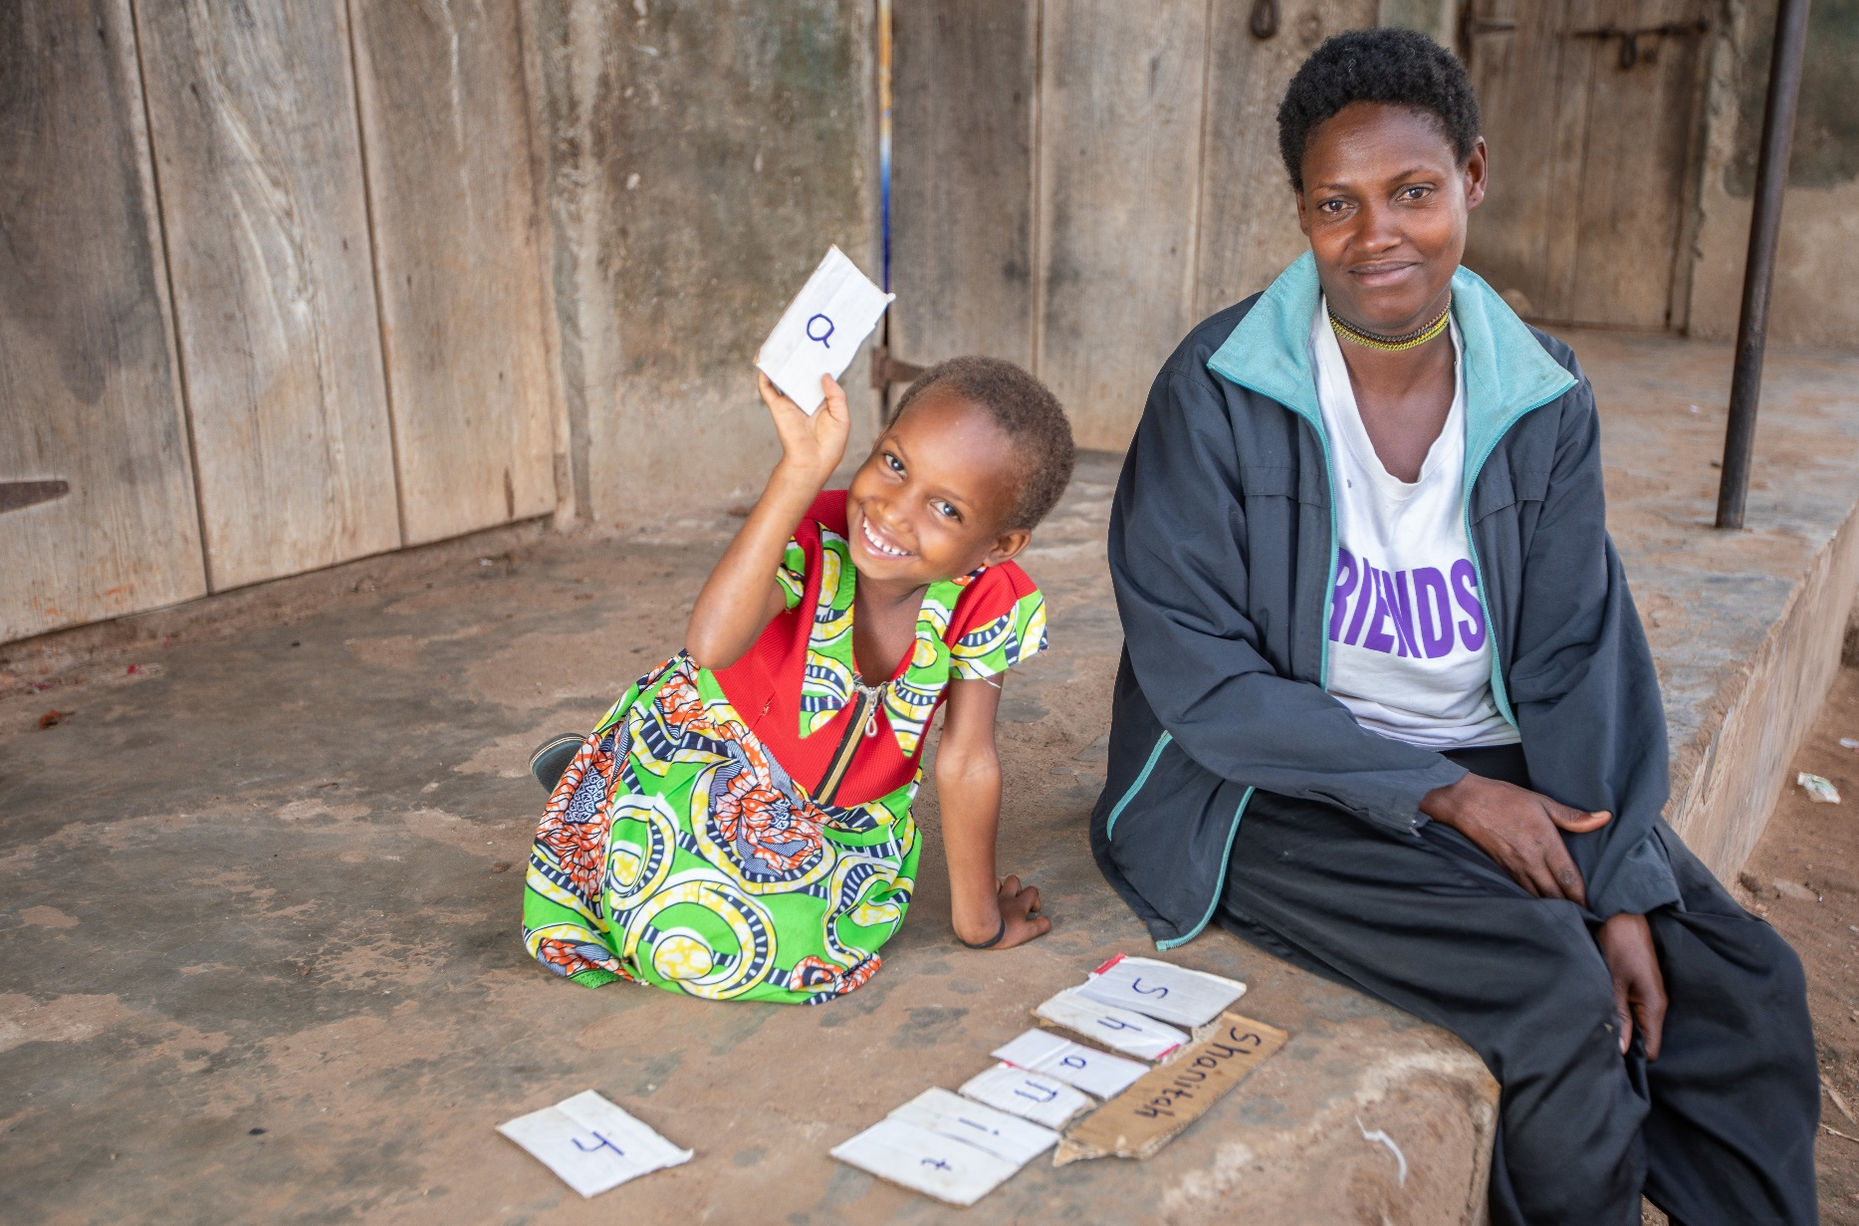

Donor Update on Our Global

COVID-19 Priority

Shanitah learns to spell her name using cards made by her mother, Justine. When Shanitah’s early childhood development center in Uganda closed because of the pandemic, we provided Justine and other parents with simple activities and ideas to help keep their children learning at home. *Save the Children Photo*

Safe Back to School:

June 2021

Thank You for Investing in Children

Safe Back to School is Save the Children’s three-year global commitment to reverse the damage the COVID-19 pandemic is inflicting on children’s education – damage that continues to mount and which will have repercussions in children’s lives for years to come.

Your generosity is powering our full-on international focus on Safe Back to School’s objectives of keeping children learning, making their schools safer as they return and making education systems more resilient.

**Progress Report: Safe Back to School is making a Difference**

Thanks to you and each donor, we are making great strides – from ensuring children can learn at home while schools are closed to rolling out innovations such as community-led “catch-up clubs.” We are making schools that are open cleaner and healthier places and training teachers to support children’s learning and well-being in this new context. Our role in national and community “back-to-school” campaigns strengthens awareness of the importance of education, especially for girls.

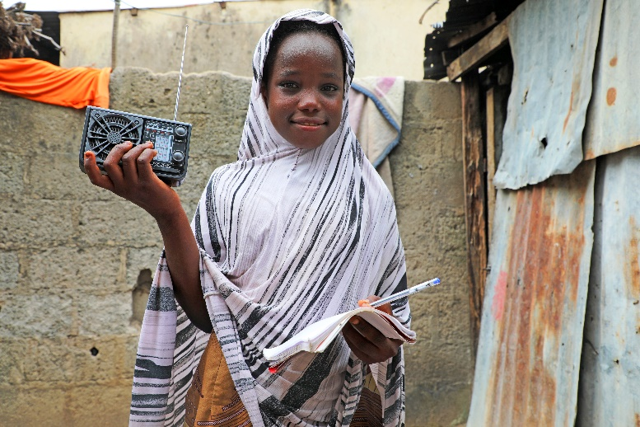

“When I got the radio set, I jumped to the sky. When our school was closed, we were doing nothing for months. I was unable to learn and I had almost forgotten everything I had learned.”

-- Amsau*, 12, who was among the Nigerian students who received radios and learning kits from Save the Children so they could participate in distance learning.

*Name changed to protect privacy

In the first quarter of this year, our 15 priority Safe Back to School countries reported supporting:

761,206 children with their remote, blended or accelerated learning needs . . .

21,146 teachers with pandemic-related training or activities focused on their well-being . . .

1,968 schools with handwashing facilities and soap so students and teachers could practice this essential step in disease prevention.

Our Country Teams at Work

Despite the coup in ***Myanmar***, we distributed home learning packs to over 56,000 children in 430 villages and 7 camps. Local reading clubs are helping children practice their literacy skills.

In ***Rwanda,*** our education team adapted children’s stories into 15-minute interactive audiobooks for children ages 3-9 and aired them over local radio stations. Announcements were also developed to raise parents’ awareness of steps they could take to help their children learn at home. Our team decided to use radio to reach children based on a recent national household survey that found 60% of all households owned a radio.

Our distance-learning program through radio ***in Burkina Faso*** (broadcasting curricula and providing radios to children) has enabled more than 10,000 children to continue their learning. We also provided facemasks, soap and handwashing kits to schools to ensure a safe learning environment.

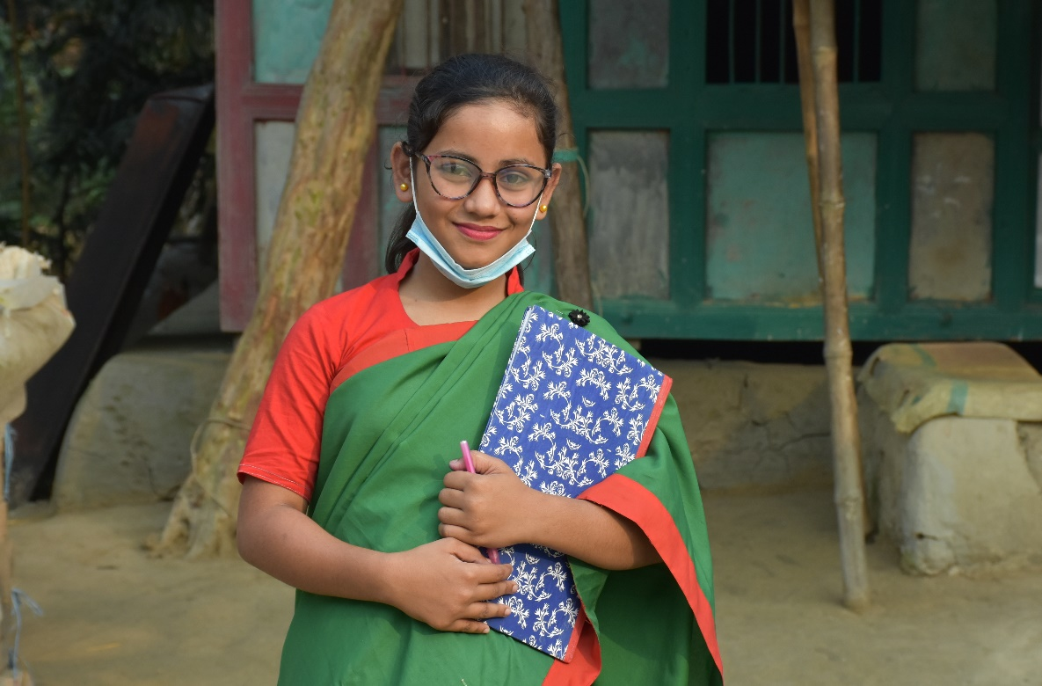An Android app our team in ***Bangladesh*** developed for children in grades 1-3 has 99 different exercises encompassing phonemic awareness, letter knowledge, vocabulary, fluency and comprehension. The exercises align with textbooks children would use if they were in the classroom. The free app can be downloaded from Google Play.

We are collaborating with the ***Somali*** Ministry of Education, Culture and Higher Education, the European Union and the Global Partnership for Education on **an online learning platform to reach just under 400,000 children in four states.** While remote learning technology cannot replace the classroom experience, this project will create classroom-like interaction between teachers and students.

Chadni hopes to become a teacher in Bangladesh. Our Safe Back to School priorities include ensuring that girls’ right to an education is recognized. *Save the Children Photo*

Making the places where children learn healthier is key to Safe Back to School. We delivered handwashing stations, digital thermometers and disinfectant supplies to 30 community centers for children in Cochabamba, ***Bolivia***. The stations’ design enables even the youngest to use them.

Reminding Parents that Schools are Open

With schools in ***Uganda*** set to welcome back children in the lowest primary grades in early June, our country team launched a national “back-to-school” campaign on May 26 to remind parents and children’s caregivers to give children the education they deserve. We have collaborated with the Ministry of Education and Sports on radio messages, TV commercials, posters, billboards and community caravans to help get the word out.

**We’re keeping the Focus**

**On Learning with Your Help**

Here are compelling reasons why it is so important that we continue Safe Back to School:

1. The pandemic is far from over in many places. In Nepal and Afghanistan, schools closed recently after surges of cases linked to migrant laborers leaving India when COVD-19 exploded there. In Cambodia, schools are closed for the rest of 2021, and only around 10% of students have access to continuous learning at home.
2. Schools in Yemen closed before the school year ended in 2021 due to a second wave of COVID-19.
3. Our 2021 assessment of students returning to Grade 8 in areas of South Sudan where we support schools found a high dropout rate of about 34% after schools reopened for exams.
4. According to a May blog from the Center for Global Development, the number of boys in private schools in Pakistan who are now working outside the home has increased from 9% to 15%.
5. In Nandi County, Kenya, a report from the health department indicated that some 6,000 girls had become pregnant while schools were closed and would not return to school.
6. Families who were hard-hit by COVID-19 will need years to recover lost earnings, depriving children of an education unless they have support – with girls and children with disabilities most at risk of losing out when families choose boys to be educated first.
7. As a result of the economic impact of COVID-19, we predict that an additional 2.5 million girls are at risk of child marriage by 2025.

We are grateful for your support and would welcome additional investments in Safe Back to School and children’s futures this year.

Opportunities for Teachers’

Professional Development

Nearly 400 teachers in ***Afghanistan*** participated in our virtual trainings on planning for remote learning, how to support struggling students and prevention of students from dropping out. We also created virtual teacher learning circles for sharing information and encouragement and provided mobile phones to female teachers. E-Learning modules for teachers are being piloted in the ***Democratic Republic of the Congo*** and ***Niger.*** Six modules and quizzes cover topics such as teaching literacy, a classroom code of conduct to make schools safer and more welcoming for all children, and the importance of girls’ education.

Influencing National Plans

On School Reopening

In ***Afghanistan, Nigeria*** and ***Nepal***, our teams have used a global *Safe Back to School Practitioner’s Guide* we helped to write in 2020 to advise Ministries of Education on standards for school reopening – standards which will impact millions of children’s experiences as they return to classrooms. In ***Afghanistan, Bangladesh, the Democratic Republic of the Congo, Iraq, Mozambique, Nepal,*** the ***West Bank and Gaza*** and ***Yemen***, we have used the Guide to influence and advice on work of other aid agencies.

Innovating and Piloting New Ideas

In July, our ***Uganda*** team will pilot a catch-up club project we have designed specifically for the COVID-19 crisis. Children will receive remedial instruction in reading and math and support if they are at risk of exploitation or abuse. Local facilitators will get instruction, access to a special app that guides them in delivering lessons, monitoring children’s attendance and tracking their progress, and tablets loaded with the catch-up-club curriculum.

We are piloting digital attendance tracking and dropout monitoring systems in ***Somalia, Lebanon***, and ***Colombia,*** where there are many internally displaced or refugee children who are largely invisible in national education statistics. This limits the ability of governments and stakeholders like us to identify and respond to children’s needs. Our system helps monitor children’s attendance patterns and provides guidance on interventions to prevent their dropping out.

Advocating for Children’s Right to Learn

Our staff in many countries are members of national education technical and coordination groups, giving them opportunities to influence government policy and programming. In ***South Sudan***, we mobilized stakeholders and ambassadors early this year to convince the Ministry of Education to reverse its decision not to hold school exams in nine opposition-held areas, ensuring that all children are treated equally. In ***Kosovo,*** a children’s advocacy group we founded met with the new minister of education to ask for improvements in distance learning during the lockdown. Internationally, research our ***Syria*** country office conducted on the impact of the pandemic on education in northwest Syria was cited in a presentation at the UN Security Council by Mark Lowcock, Under-Secretary-General for Humanitarian Affairs and Emergency Relief Coordinator at the Office for the Coordination of Humanitarian Affairs.

Integrating Safe Back to School into Livelihoods and Child Protection Work

Safe Back to School is not just responding to an education catastrophe, but one that also directly impacts human development. We are integrating Safe Back to School activities into other areas of our work, such as our livelihoods programs for very vulnerable families and protecting children from harm, to reach the most children possible. In ***Cambodia,*** initial findings from our distribution of cash transfers to pandemic-affected families indicate that the positive effects include improving families’ situations so that children do not have to work and can stay in school. With the added stress and pressures families everywhere are experiencing, our team in ***Nepal*** is reaching rural households with messages on positive parenting and protecting children from violence – using a “tuk-tuk” taxicab and megaphones around communities.

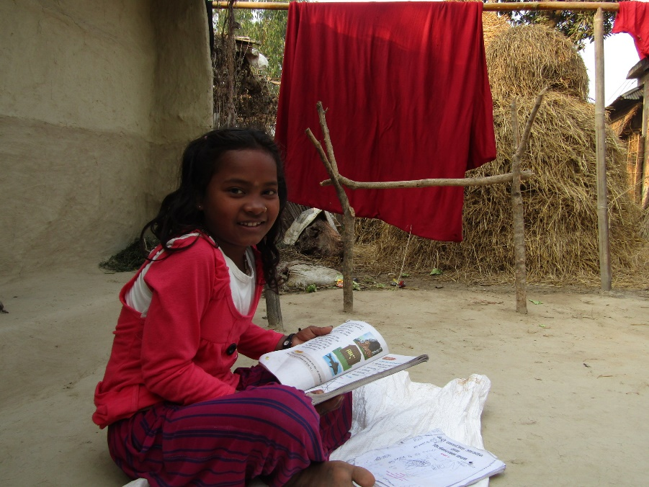

“One day, I received a self-learning activity book along with stationeries. I love this book ... it is better than my schoolbooks, and I can read from and write in this book. I have learned many things from it. If I don’t understand something, then my brother teaches me.”

--Nirmaya, 10, reflecting on her experience during Nepal’s nationwide lockdown