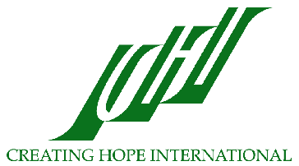
Creating Hope International
Empowering Communities Throughout the World
June 4, 2004

Mission and History

Creating Hope International’s (CHI) mission is to provide education and health assistance to the people in the world with the greatest needs. CHI works at the grassroots responding to community needs, fostering community participation, and empowering people through culturally sensitive education and training. Creating Hope International is a Michigan based non-profit organization with 501(c)3 status.

CHI primarily focuses on providing technical and financial assistance to those in need with the goal of empowering the recipients to ultimately be able to meet their own needs. In the past, CHI has been involved in such projects as:
- Providing technical assistance and training to Mexican villagers in building latrines as well as public, maternal, and child health services
- Training teachers in Pakistan and Afghanistan
- Raising funds to support refugees in Iran and Pakistan
- Designing and providing educational materials for teacher trainers
Currently, CHI staff members are directing their efforts toward four projects; the Afghan Project, the Tibetan Bon Project, the Public Education Project, and the Alternative Health Project.

Afghan Project

CHI has been helping Afghans for over 30 years, working in refugee camps, operating underground home schools for girls in Afghanistan, and helping indigenous groups of Afghans establish grassroots NGOs that will meet the health and educational needs of Afghans for years to come. CHI has a long history of empowering Afghans through health and educational services, community building, and culturally sensitive programs.

CHI has successfully introduced the NGO concept to Afghan communities and helped them develop and sustain these needed services through an NGO structure. CHI provides advice, training, technical assistance, and funding to the people of Afghanistan by working with the Afghan Institute of Learning (AIL), an Afghan women’s NGO. AIL is now one of the largest Afghan women-led NGOs and provides health and education services to 350,000 women and children annually. During 2003, CHI assisted AIL with strategic planning, advice regarding program operations, financial support, fundraising, grant writing, financial management, presentation and report preparation, marketing, donor relationship management, policy, training in financial management, and collaborative development of a finance manual. AIL’s 2003 summary of activities is attached.

Tibetan Bon Project

The Bon are a minority Tibetan ethnic group that fled to India when the Chinese invaded Tibet in 1959. In 1968, the Bon established a community in Dolanji, India on donated land. Today, 75 Tibetan Bon families (including 300 children) are settled there. The community has an orphanage, children’s hostel, school (to the 9th class), health center and community farm. CHI assists the Bon to meet their own needs by helping the leaders of the community to set up an administrative system and write grants to improve their water, sanitary, health, education and living conditions. Projects that CHI worked on with Bon community leaders during 2003 included fundraising for water tanks, a storage building, health facility equipment, a drinking water well, and public toilets. CHI has also provided funds to purchase a milk cow and improve water and living conditions. Now, CHI is working with Bon leaders to make secondary education possible for the community’s children through scholarships. CHI will also be helping Bon community leaders as they launch a new essential oils project to generate income for the community.

Public Education Project

In 1996, CHI launched its public education project to educate and inform the Western world about the health and educational needs of Afghans and women and children in other developing nations. Through the public education project, CHI has hosted educational forums and seminars, presented at schools, and participated in conferences held by others organizations. CHI staff members have also interviewed with radio, including National Public Radio and Equal Access Radio, television, and newspaper reporters to provide information to the public about the circumstances of women in developing countries. Executive Director Toc Dunlap and Vice President Sakena Yacoobi were both delegates to the United Nations Millennium Forum for NGOs in 2000. In 2003, they presented papers on their work at Harvard University. Also during 2003, Professor Yacoobi presented at the International Institute on Peace Education in South Korea. She was a guest lecturer at the Culture and Development Studies Program at Katholieke Universiteit in Leuven, Belgium and a discussant at the Women’s Learning Partnership Clash or Consensus? Gender and Human Security in a Globablized World conference at Johns Hopkins University in Washington, DC.

Alternative Health Project

Americans today expect to live longer than ever before. Unfortunately, increases in life expectancy also mean that people cope with chronic and terminal illnesses for years and even decades. This situation has prompted interest in healing alternatives to complement allopathic medicine. Creating Hope International (CHI) supports training of healers and has begun supporting the research and work of alternative healers who have helped and healed many people.

Future Directions

In addition to continuing its work on these important projects, CHI has begun work on a number of new projects. CHI staff is currently working on:
- Training modules to teach Afghan women basic counseling skills, so that they can provide relief and comfort to traumatized Afghan women
- A plan for assisting rural Afghans to begin and sustain their own, grassroots NGOs
- Fostering the leadership qualities of women in the United States and abroad.

With over 35 years of expertise in advancing the health and education of women and communities all over the globe, CHI board members, staff, volunteers, and constituents are enthusiastic about applying their skills and passion toward new projects as new needs and opportunities arise.
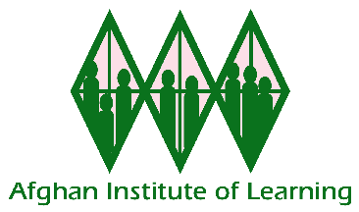
Afghan Institute of Learning
Final Report on Activities 2003

The Afghan Institute of Learning (AIL) has greatly expanded over the last year. After the fall of the Taliban at the end of 2001, AIL was able to bring its underground women’s and girls’ education and health programs into the open. The new political climate also made possible the expansion of these programs to reach even more women and girls with vital services. AIL was able to successfully develop and pilot its Women’s Learning Center, leadership and human rights workshops, and culturally sensitive health care and education programs in Afghanistan during 2002. Expanding these programs, which had already demonstrated success, was AIL’s main focus during 2003. With characteristic determination and adaptability, AIL expanded every aspect of its organization to serve new hard-to-reach rural locations and populations, to develop new services like midwifery training, and to secure new facilities like health centers and computer labs.

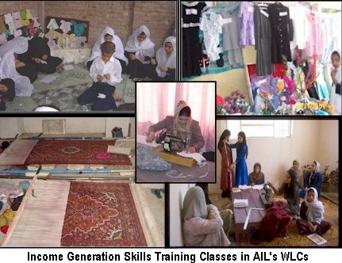
Women’s Learning Centers: AIL’s Women’s Learning Centers (WLCs) act as umbrella structures for all of AIL’s health and education programs in a region. These comprehensive service centers are developed in conjunction with local community members and designed to meet the multiple needs of Afghan women and children by providing services requested by the community. Through its Women’s Learning Centers in 2003, AIL:
- Reached over 350,000 Afghans with urgently needed health and education services, providing direct services to 260,111 people
- Offered a vast array of educational opportunities including literacy, fast track, calligraphy, drawing, math, Pushto, English, Dari, sewing, needlework, carpet weaving, craft-making, bead knitting, computer, Arabic, health, social science, science, logic, psychology, and art.
- Provided human rights and leadership training to 376 Afghan women that teach women about their rights and how to assert their rights in a culturally sensitive way. Women also learn to recognize their leadership potential and to become leaders within their families, communities, and country.
- Opened two new computer labs in Kabul and Herat, offered an intensive one-week training of 21 computer teachers, and instructed 223 computer students. Computer classes teach students basic computer skills as well as Windows, Word, Excel, and Access.
- Expanded the acclaimed pre-school programs, trained more kindergarten teachers, developed 19 curricular topics of instruction for pre-school, and used innovative methods to involve parents in their children’s education.
- Developed production sections for AIL’s WLC sewing and drawing classes that are beginning to generate some income to support AIL’s programs, an important step toward self-sufficiency.
- Began a Grassroots NGO Support Project to help other indigenous Afghan NGOs improve and sustain their efforts toward advancing education and health in Afghanistan. Since AIL began supporting one local, grassroots NGO in Kabul, called Seemay Shahid Educational Center, enrollment in classes has doubled, female enrollment has quadrupled, teachers have received training, and program quality has improved.

A fast track mainstream student in one of AIL’s WLCs said, “I am a 16 year old girl. I used to be a third grade literacy student in AIL WLC. I wished to join school. After I took the exam in a school in Kabul city, I passed the test. I was accepted as a fifth grade student in that school. I can’t express the feelings that I had at the moment when I heard I passed the test. I am very thankful to AIL for it was AIL who motivated me (an illiterate girl) to become a fifth grade student. We can make a great example of AIL for its great management, discipline, and hard work. I can doubtlessly say that none of the other educational centers can challenge AIL.”

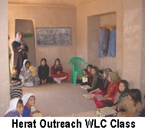
Rural Expansion: AIL is committed to serving all Afghan women and children, especially those with the most severe needs. For this reason, AIL expanded its Women’s Learning Center services to hard-to-reach, under-served rural areas of Kabul and Herat provinces during 2003.
- At the request of and in partnership with the villages of Mir Bacha Kot, AIL established Women’s Learning Center satellites in this community during 2003. These WLC satellite locations provided a mobile health clinic, home schools for girls and boys, advanced classes for boys, and literacy and sewing classes for women and girls.
- AIL also established outreach WLC satellites in the villages of Sar Asia and Darb-e-Iraq in Herat province at the request of those communities. Hundreds of women and girls in these communities who have historically had no access to education are taking advantage of these exciting new opportunities to learn. The Herat outreach WLCs provide an array of services including literacy, sewing, English, and enrichment classes.

Health Program: With the highest infant and maternal mortality rates in the world, Afghans are in desperate need of high-quality, culturally sensitive health and health education programs that are accessible to women and children in the communities where they live. In response to community requests, AIL has dramatically expanded its health programs during 2003. AIL worked to improve the health of Afghan women and children during 2003 by:
- Providing health education and health services to 161,356 Afghan women and children through its clinics, schools, and Women’s Learning Centers.
- Building a permanent health clinic in Mir Bacha Kot. This clinic is the first of its kind in these villages and will replace the mobile health clinic services that AIL provided to this community while the clinic was being built.
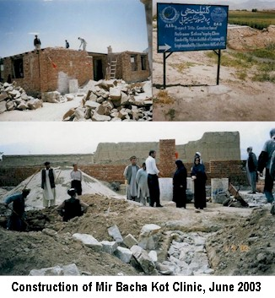
- Opening a much needed women’s and children’s health clinic in Herat which served more than 2,000 patients in its first month of operation and over 19,500 by the end of the year
- Providing health education and in-depth health workshops on contraception and reproductive health, historically controversial topics for Afghans. However, because of AIL’s reputation for safe, culturally sensitive programs, thousands of Afghan women at AIL’s WLC locations received important information about family planning and reproductive health as well as hygiene, nutrition, and disease prevention.
- Conducting AIL’s first midwifery training for 30 women to upgrade their skills and improve the health and safety of mothers and babies during birth.

On behalf of all the participants in the midwifery training, one said, ”We are very much grateful to these Health Educators who came all the way to this camp to give us this important training... We learned the right method of delivering a child. Many women in our areas died because of the problems arising during delivery. We were not able to help them since we never knew the right method of delivery. But now we know our mistakes. Through conducting this workshop, you have saved the lives of many women who might have died during the pregnancy or might have lost the life of their child.”

Gawhar Shad University: In response to the lack of post-secondary education opportunities for Afghan women, AIL opened Gawhar Shad University during 2003 and developed three curriculum tracks; the College of Nursing/Health Education, the College of Math and Computer Science, and the College of Education. Through Gawhar Shad University, AIL is preparing Afghan professionals with the skills and education needed to develop solutions to the many problems facing Afghanistan. During the past year, AIL:
- Developed a comprehensive, intensive nurse/health educator training program to train female health professionals. The curriculum incorporates over 100 subjects and the six-month course requires students to perform classroom and practical work.
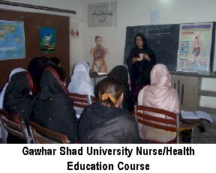
- Graduated 33 Afghan women as Nurse/health educators, all of whom will work in Afghanistan to improve the health of Afghan women
- Opened Gawhar Shad University’s College of Math and Computer Science and enrolled two classes of students. Currently 111 students are studying in this 4-year program.
- Graduated two Master Teacher Trainers from AIL’s post-secondary course in Education, in which 13 teacher trainers are currently enrolled. AIL’s top Master teacher trainers instruct, monitor, and supervise the practical and theoretical work of these 13 teacher trainers.

School Support: AIL has kept education alive for Afghan children despite the hardships Afghan families have endured during these last three decades of war, instability, and dislocation. During the Taliban regime, AIL educated 3,000 girls in underground home schools in Afghanistan. Today, AIL has brought these underground schools into the open and is offering a broad array of educational opportunities to young people that are designed to meet their unique educational needs. AIL’s program of school support includes materials, supplies, and regular supervision, monitoring, salaries and training for teachers and administrators. During 2003, AIL:
- Supported 3 schools in Jalalabad for 2,467 students
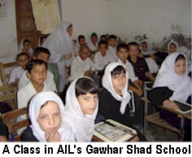
- Provided over 2,990 scholarships for students with financial needs to cover education-related costs including tuition, fees, supplies, and uniforms
- Supported 14 schools for over 12,000 Afghan refugee students in Pakistan
- Opened two home schools in Mir Bacha Kot, which offer first through third grade fast track education to 122 girls and 81 boys and provide an opportunity for education to young people who have no access to government schools
- Offered advanced classes in Mir Bacha Kot for 729 boys to help them catch up on their studies, earn grade certificates, and/or mainstream into government schools at grade levels appropriate for their ages.

One of the students of AIL’s advanced classes in Mir Bacha Kot said, “During Taliban’s regime we migrated to Iran to be safe and I worked to acquire bread for my family. There I used to sell biscuits and chocolates on streets. From morning to night, I was out. Hence, I couldn’t study and I remained back from education. After Taliban’s regime collapsed and we came back to Afghanistan, I wished to join school but my age didn’t allow me which made me so hopeless. One day my father told me, ‘I have heard that AIL has opened an Advanced course in our village. You can attend it.’ I got very happy and went there to be admitted. There I was registered gladly. Now I can take a promoted test and study in school. My family and I are thankful to AIL for it was AIL who stimulated me and made feel prosperous like other youths who study in high classes.”

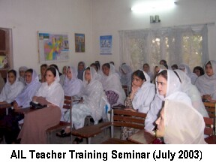
Teacher Training: The staff and teachers of the Afghan Institute of Learning believe that training teachers to use student-centered, interactive teaching techniques is the key to improving the Afghan educational system. For this reason, AIL continued to offer its acclaimed 24-day pedagogy seminar for Afghan teachers through 2003. Teachers who use AIL’s techniques are able to teach children to think critically rather than rely on rote memorization, the traditional teaching method in Afghanistan. Teachers and students have been energized and empowered by dramatic improvements in students’ performance when teachers use the new methods. During 2003, AIL:
- Trained 1,641 Afghan teachers in interactive teacher training methods through seminars in workshops
- Developed 8 new health and education training workshops including traditional birth attendant training and numerous lesson plans for university classes
- Developed and began publishing a quarterly Farsi-language magazine, called Voice of Education. AIL Teacher Training and School Support staff design and collect materials for the magazine, which includes contributions from people from every region of Afghanistan. The magazine is for AIL students and the general public.
- Offered teacher training seminars in the rural areas of Kalikhan and Mir Bacha Kot that upgraded the skills of these rural teachers who have had historically limited access to quality training opportunities. These seminars were also noteworthy because AIL’s female teacher trainers provided training to the region’s male teachers, an unprecedented and rewarding educational experience for these communities.
- Offered the first teacher training seminar in Herat in September after many months of coordinating with the Afghan government. The seminar was so well-received that AIL teacher trainers were immediately invited to return to Herat in December and train more teachers.

One participant in the Herat teacher training seminar commented, “AIL’s hard work and good faith is worthy of praise. If the whole oceans of the world turn into ink and the leaves of the trees turn into papers, they won’t be enough to write the efforts and good points of AIL.”

Building a Brighter Future for Afghanistan:

AIL is committed to bringing peace and dignity to Afghan people as they struggle to overcome oppression, devastation, and injustice wrought by the last quarter century of war and instability.
With the support of generous donors, AIL has been able to reach more Afghans than ever with vital health and education services during 2003. These important activities are improving the health and education of Afghan women and children, relieving their suffering after three decades of war and civil strife, and enhancing the quality of their lives. AIL is looking forward to continuing and expanding the reach of its important programs during 2004.

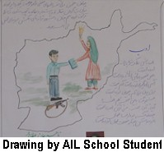

Background Information about Tailoring Classes for Afghan Women

Creating Hope International’s project partner, the Afghan Institute of Learning (AIL) was the first organization to start Women’s Learning Centers (WLCs) in Afghan refugee camps in Pakistan during 2002. Requested by the women in the camps, the WLCs are designed to meet the multiple needs of Afghan women and children. WLCs train teachers, provide health education, and offer preschool through university classes. Workshops that train women to be leaders and to advocate for their basic human rights are offered in the WLCs. Women also learn income generating skills like sewing and carpet weaving. Income generating skills training classes, like AIL’s 6-month tailoring course, continue to be very popular and women continue to request them. In the class, women learn to make clothes from a variety of patterns and a variety of stitching techniques. They learn to measure and they learn lessons about how to save money to buy a sewing machine and start their own business. Once they are able to start sewing clothes for non-family members, they are able to earn income to support themselves and their families. As of June 2004, AIL was teaching tailoring to about 500 women.

Afghan women are eager to return to school after years of having no opportunity to learn. After years of war, the literacy rate of Afghan females is among the lowest in the world. Widows and poor women wish to become literate. Older girls, who were prevented from attending school during the Taliban regime, want to learn on an accelerated basis and study with girls their own age. Women, who were forced to marry young and stop their schooling want to finish their education. In response to these needs, Women’s Learning Centers also offer women and girls literacy and Fast Track classes, in which women learn to read, write, and do basic arithmetic. The Fast Track Mainstream program allows older girls to finish grades 1-3 in one year, so that they can then enter regular school in the fourth grade. The Fast Track Certificate program allows older and married girls or women to continue their studies on an individualized basis with the goal of ultimately earning a 6th, 9th, or 12th grade certificate. Enrichment classes including English and Computers are also taught.

Additionally, basic health services are available through the WLCs, including medical examinations, midwifery and nursing services, vaccinations, and health education about hygiene and the proper use of medicine. AIL has also begun training traditional birth attendants to assist women during birth. AIL has 3 basic health clinics and mobile health clinics that serve 160,000 Afghan women, men and children annually. When the first WLCs opened in Pakistan and began providing education and health services, word about the success of the programs spread quickly. Soon, AIL was showered with requests from other communities for their own WLCs. WLCs have now been opened in Kabul, Herat, and Mir Bacha Kot, Afghanistan, at the request of these communities. AIL now has eighteen Women’s Learning Center locations, where there were none in December of 2001.

One of the striking impacts of AIL’s work with Women’s Learning Centers is that this model of providing health and educational services to women has been successfully expanded to hard-to-reach rural areas in provincial Kabul and Herat (e.g. Sar Asia and Mir Bacha Kot) at the request of those communities. Many of these rural communities have historically been resistant to women’s and girls’ education but through AIL’s principles of community involvement and cultural sensitivity, the organization has been able to reach women in these communities with critically needed services. In fact, AIL continues to be showered with requests for services from other rural communities who have learned about the quality of AIL’s work with women and girls and is working hard to meet this demand.

