The gentle revolution. Family farming and local consumption, at the roots of a renewed, healthy economy.

– by Rob Small, family micro-farming practitioner and co-director of Abalimi Bezekhaya (farmers of home) and Harvest of Hope vegetable box scheme in Cape Town. ABALIMI (est 1982) supports the unemployed to become productive micro-farmers, feeding thousands, at super low cost, while creating hundreds of permanent jobs, off tiny scraps of urban wasteland. The model is ready to be copied nationally.

Its not scientific. It cannot feed the world. The pests will destroy it.

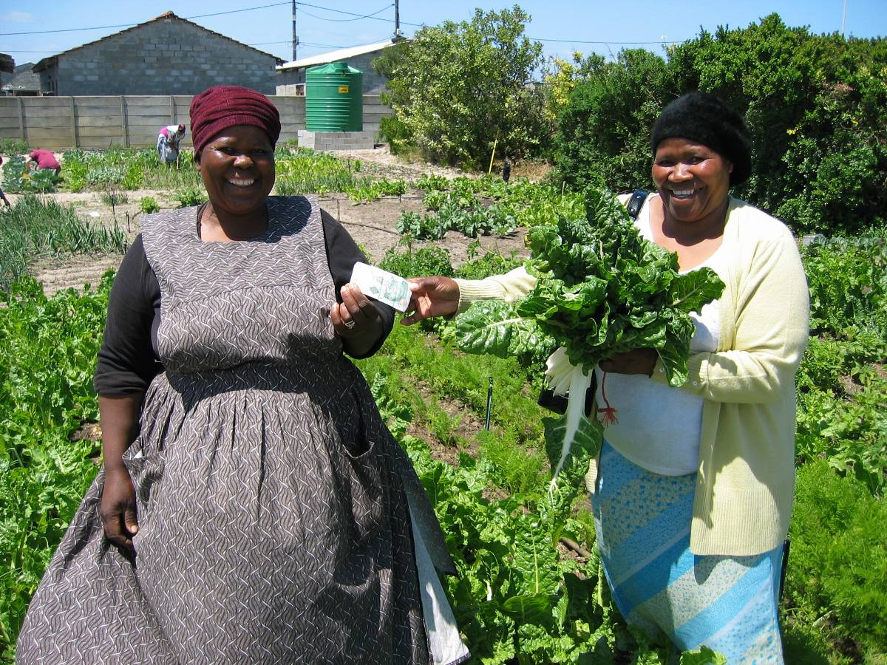

That’s what I heard from the “experts”, when I joined the work to revive family farming in South Africa, straight from my training in Bio-Dynamic farming in the UK, in Soweto in the early 1980’s. And then the so-called “neo-liberals” say: “ ambition & greed are the driving force behind progress and are harnessed for the good by competitive debt-capital, that generates trickledown to feed the world”.

But this is no longer true, if it ever was.

Firstly, the debt-driven economy is shedding more jobs than it creates, despite often healthy GDP. This is not changing.

Second, a fundamental insight, without which no new way is possible: people at heart are actually NOT greedy and competitive. Original economic impulses are actually driven by desire for the good (the source of ethics) , not greed. Otherwise there would be no loved children & caring families, no kindness or giving. The desire to develop culture drives us, not survival. Survival, like greed, is just a necessary obstacle on the way.

Thus, given ethical leadership, and very modest all-round assistance – at a cost of no more than R100 per micro-farmer per month – it is now possible to produce hundreds, thousands, millions, of food secure households , and uncountable thousands of self-help jobs worth R1000-R3000 p/m, after costs. All on pieces of wasteland no bigger than a classroom, 100m2 – or five classrooms, 500m2.

Everyone needs to eat. And all modern human culture grows around food consumption and production, for the good of all. Agri-Culture.

There are about 5 million taxpayers in SA, with regular incomes. They mostly buy cold-chain food , gassed-for-longevity, agri-poisoned and increasingly GMO infected. This killer food, more often than not, has been transported over hundreds – even thousands - of kilometres, at huge energy and climate change cost, to supermarkets.

Now what if I offer the above taxpayers the chance to collect international quality, un-poisoned, same day harvested, super fresh and healthy seasonal food at a good price? And what if I show that, along with ensuring unlimited sustainable jobs for local family farmers, this purchase directly enables community based nature conservation and climate change mitigation, while diminishing individual carbon footprint by at least 50%.? … because family farming is just as productive as, and 250% more energy efficient than agri-industrial food systems, which actually cause over 40% of the carbon pollution on the planet ! A recent 30 year study by the Rodale Institute, plus other studies, prove this. Such a product is surely getting easier to sell, because “the markets” (ie: human beings) largely WANT to get off the stupid and destructive path we are currently on.

So, how is it done? Simple…….

Buy all your fresh food from local family farmers! Invest directly in local family farmers and pay them a fair price. The super fresh produce makes you jump for joy, and they get enough cash to develop and send their kids to school.

The ‘middlemen’ , like the for-max-profit ‘food futures’ traders who drive the new food-war economy, by dictating via investments who eats and who does not, are smart and well resourced enough to adjust and find other things to sell.

The problem is that you will find that family farmers are few in South Africa.

Family farmers are not widely honoured and don’t get access to finance and support the way big agri-industry farmers do. They cant grow huge market volumes alone and cannot easily sustain all the work to create and supply a market.

This is where the all-important “new secret ingredient” changes the ‘failure game’: a modest and sustained subsidised support package (R100 per month per family farmer), supplied by honest agencies, that enable family farmers to access bulk farming inputs cheaply, get training, advice and mentorship according to their level of farming development, obtain monitoring and assessment assistance, and obtain guaranteed access to fair-pay (short value chain) neighbourhood markets via a local pack-shed, or secure farmers market..

I hear someone ask – “subsidy?....but this is unsustainable !”

But this objection is blind - please remember (for example) that our beloved world banking system has been subsidized to the tune of trillions, with more to come. Please remember that American, EU and Chinese agri-business is subsidized to the hilt, in billions, albeit many of their farmers are in debt to their eyeballs. But all that cheap imported food on our supermarket shelves comes from somewhere!!

And one of South Africa’s best exports are farmers, who have left SA in droves for countries where they are given decent subsidized support packages, while here in SA good money is thrown after bad into opening doors for subsidized food imports & exports and into our ever failing “silver bullet” land reform program. And of course, into energetically enabling GMO’s to be grown on a massive scale by a desperate and shrinking group of self-enriching debt burdened agri-industrial farmers. This doubtful crop is then forced down all our throats, since regulations are not strict enough, and particularly down the throats of the poor, via cheap (subsidized) bread and maize and soya meal, and via animal feed.

So why quibble about a measly R100 per farmer per month to create un-poisoned , non GMO, healthy food and livelihoods for millions? Until we are prepared to pay the true cost of good (and bad) food, subsidies are needed to produce food.

Its how subsidies are used that makes the difference.

“This wont work” , I hear someone cry. “Its too idealistic!!”

And that is why I write this article, because the above simple solution has at last been achieved, modelled and tested , once and for all, among the “unemployable”, in Cape Town, and is ready to be rolled out in every village, town and city- anywhere communities eat fresh food.

Around 2500 family micro-farmers directly feed a minimum of 15000 family members every year, off home plots. This home garden movement is the foundation of a thriving emergent community garden movement, involving another 500 family micro-farmers in about 100 community gardens. Of these, nearly 100 family micro-farmers in 20-30 community gardens are involved (since launch of the marketing scheme in 2008) in producing for the market to create permanent self-help jobs. All costing less than R100 per micro-farmer per month, or even better, R20 per family member per month, to keep the whole show on the road, and tummy’s full of healthy un-poisoned food.

And, if the above benefits are not enough, see how money has started to flow , a modest R1.2 million turnover last year, but increasing fast, into the hands of scores of previously unemployed micro-farmers, and it keeps coming! Take a look at how thousands in Cape Town already eat the freshest, most nutritious, un-poisoned food on earth, grown abundantly on little patches of wasteland. They eat better quality than most of the ‘rich’ who go to upmarket stores. Family farmers often assert that they have become healthy, positive and productive. Thousands of family micro-farmers collaborate peacefully and help each other, to feed uncounted sick and poor from their gardens.

Put a price on this and tell me if the ‘short value chain seed to table’ movement does not have the real practical potential to overcome poverty and provide innumerable jobs.
To collect a box of same day harvest, seasonal, un-poisoned veg in Cape Town, sign up at www.harvestofhope.co.za

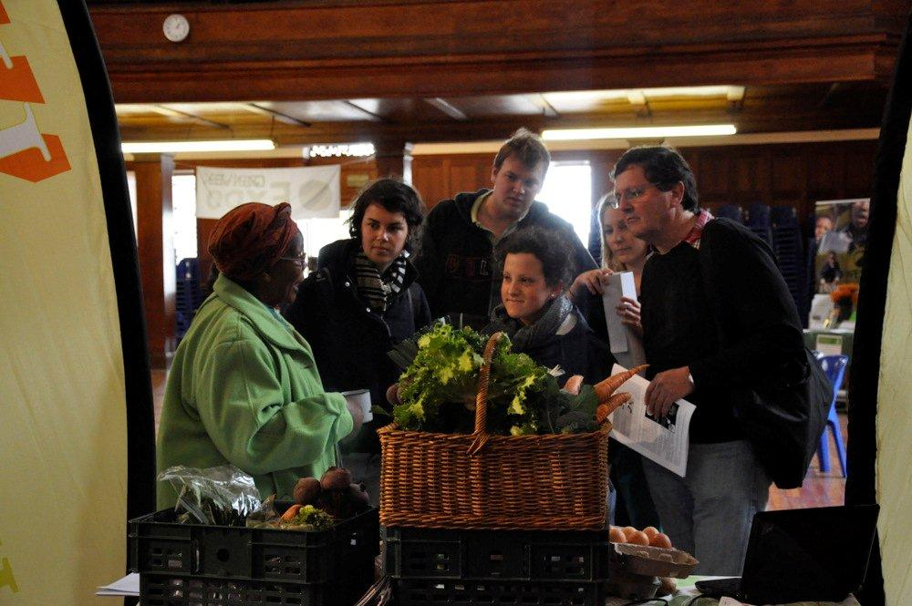

To find out how to set up your own ‘seed to table’ seasonal veg system in any village, town, city, send an enquiry to info@abalimi.org.za .

To find out more about Abalimi Bezekhaya, visit www.abalimi.org.za

