ABALIMI BEZEKHAYA- FARMERS OF HOME. Climate change mitigation impact of organic micro-farming among the unemployed in Cape Town

In Cape Town, over approximately 3000 family micro-farmers are Climate Change mitigation experts, every one- even if they have not heard of “climate change” . Cape Town is the world’s “climate change training ground” , since our weather has always been extreme - 40 degree drought with hot gale force winds in summer, floods in winter and gale force South Easter winds in between. On top of this our micro-farmers successfully grow abundant top quality organic crops year round in soil that is beach sand. These mostly “uneducated, unemployable” family micro-farmers can grow abundant healthy food successfully anywhere, anytime, under the worst conditions.

This micro-farming movement is supported by Abalimi www.abalimi.org.za (est 1982) to mitigate poverty and unemployment and the effects of climate change by establishing and/or continuing their micro-farming projects, which enable at least 15000 sub-economic family members to eat cheap, un-poisoned, organically produced, super high quality fresh food regularly, while building the natural and social environment in the townships, and reducing the carbon footprint of all related consumers, especially those (over 340 family members at this moment !) who buy their weekly seasonal vegetable box from the micro-farmers via our Harvest of Hope (HoH) vegetable box scheme www.harvestofhope.co.za .

We estimate that a minimum of 1 kg per m2 of carbon is “held” in the lifecycle of each square meter of every active micro-farm, taking also into account carbon “saved” by consumers who now buy from our micro-farmers and not from supermarkets.

That is, a minimum of 100m2 per farmer is under production x 3000 x 1 kg = 300 000 kg (300 tons) of carbon is being “ held” within 3000 township micro-farms, permanently. And as the movement grows, so do the tons of carbon which are held in the life cycle.

Of course, there are also uncalculated, social, health and economic benefits among the micro-farmers and their families, who feel massively empowered psychologically, who report huge health benefits and reduction in medical needs, along with steady reliable cash income from their own hands. Such benefits increase by the day, and if properly valued, would certainly amount to massive energy and carbon savings as well .

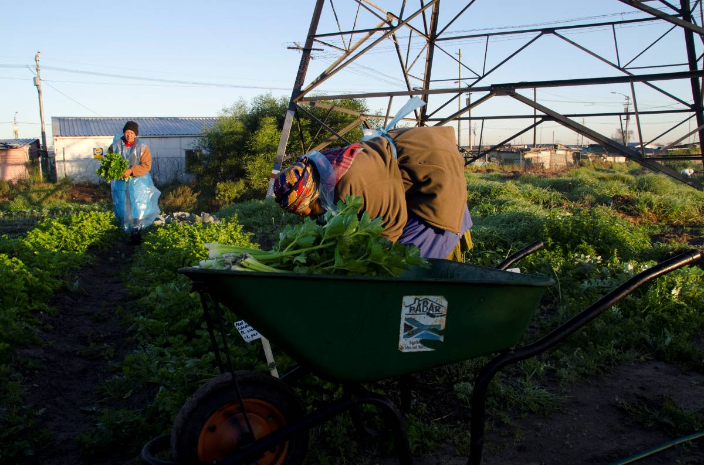

Photo by Ken Tran, Abalimi visitor-volunteer May 2011 : Mama Chaba and Mama Phillipina at Masicendane Community Garden in Gugulethu, harvesting healthy unpoisoned “carbon heavy” crops (under powerlines- symbolic!!) . These vegetables are being harvested for sale to paying member families in the cash-rich parts of Cape Town, via the Abalimi Harvest of Hope initiative. These member families, with their cars and fully electric houses, will thereby be massively reducing their carbon footprint by buying their fresh food from these local micro-farmers, instead of buying long distance chemical “killer vegetables” in the supermarket . Notice all the carbon heavy biomass growing in the garden. If you could see it, you would also notice the carbon heavy micro-organisms in the organically rich soil, which is filled with carbon-heavy manure, mulch, and fibre !! ☺ . Carbon, carbon, bound in the life cycle everywhere you look!!
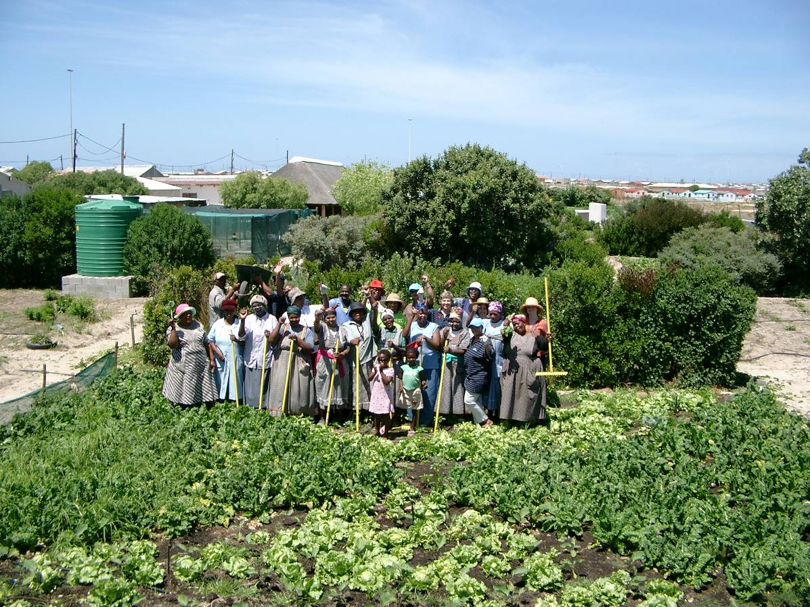
Photo: by R Small . Siyazama Community Allotment garden association Khayelitsha. “a Carbon Bank, in the Life Cycle, in the Sand” .

