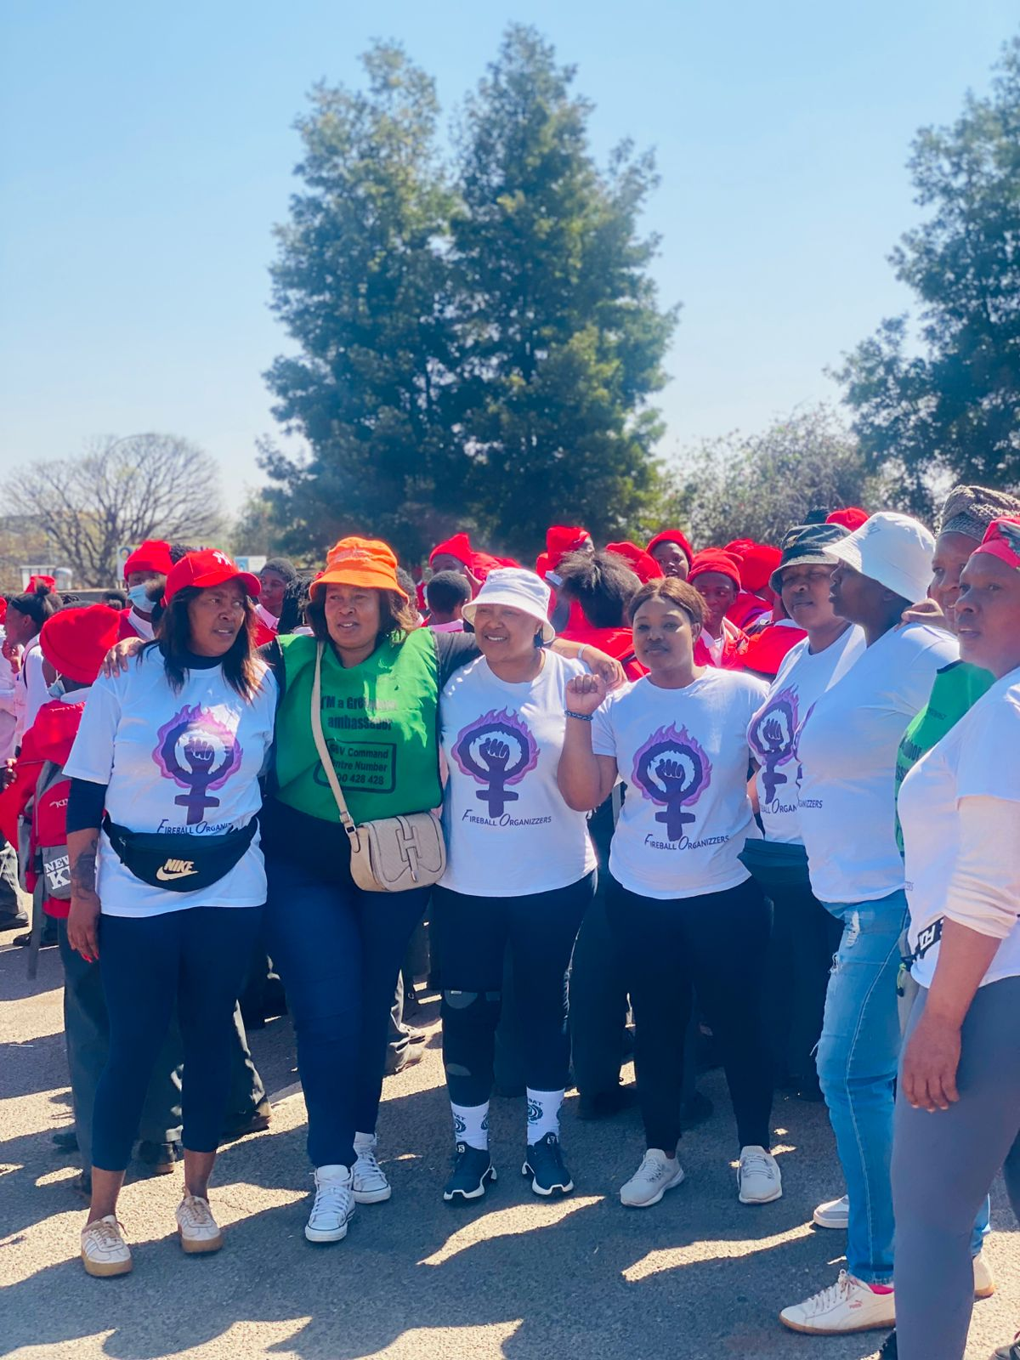
Figure 3/ Fireball team gathered outside the court with the learners from Sandi’s school to fully support her quest for justice – “GBV must end”. Fireball volunteers wearing fireball t-shirts from left to right: Nthabiseng, Mathabo Founder of Fireball, Zintle, Mantshadi, (Bukwela and Anna in solidarity)

