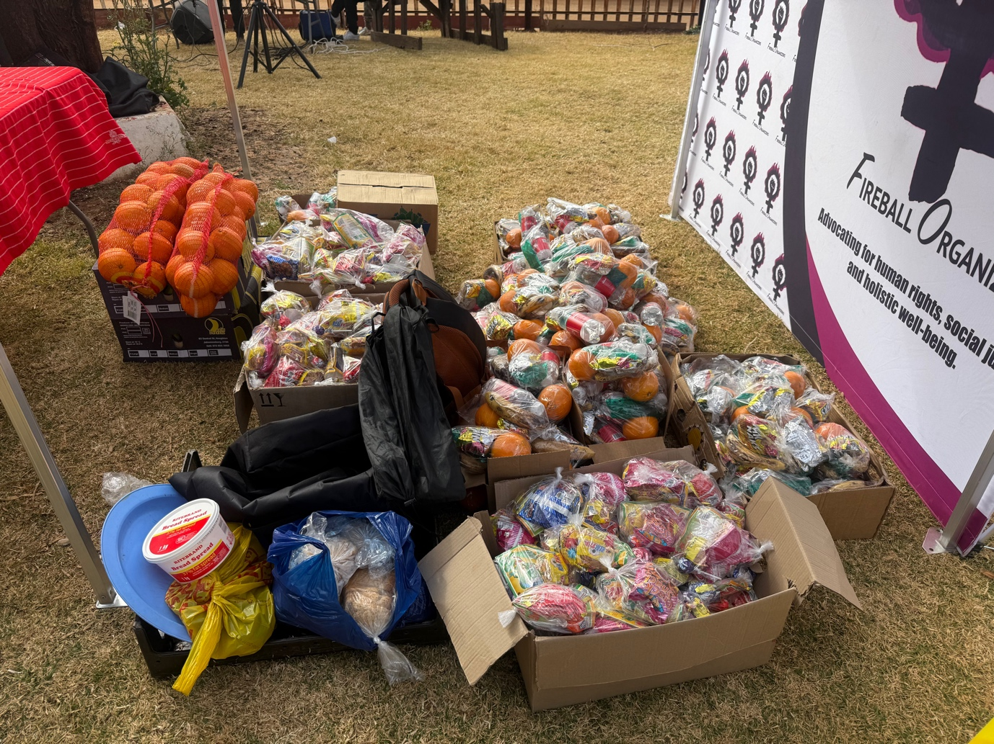
Figure 1/ Snacks donated for the school holiday program, served about 300 children in one day. These children typically rely on their schools’ feeding schemes for meals, and during the holidays, they often have no access to proper meals or may go without food entirely.

