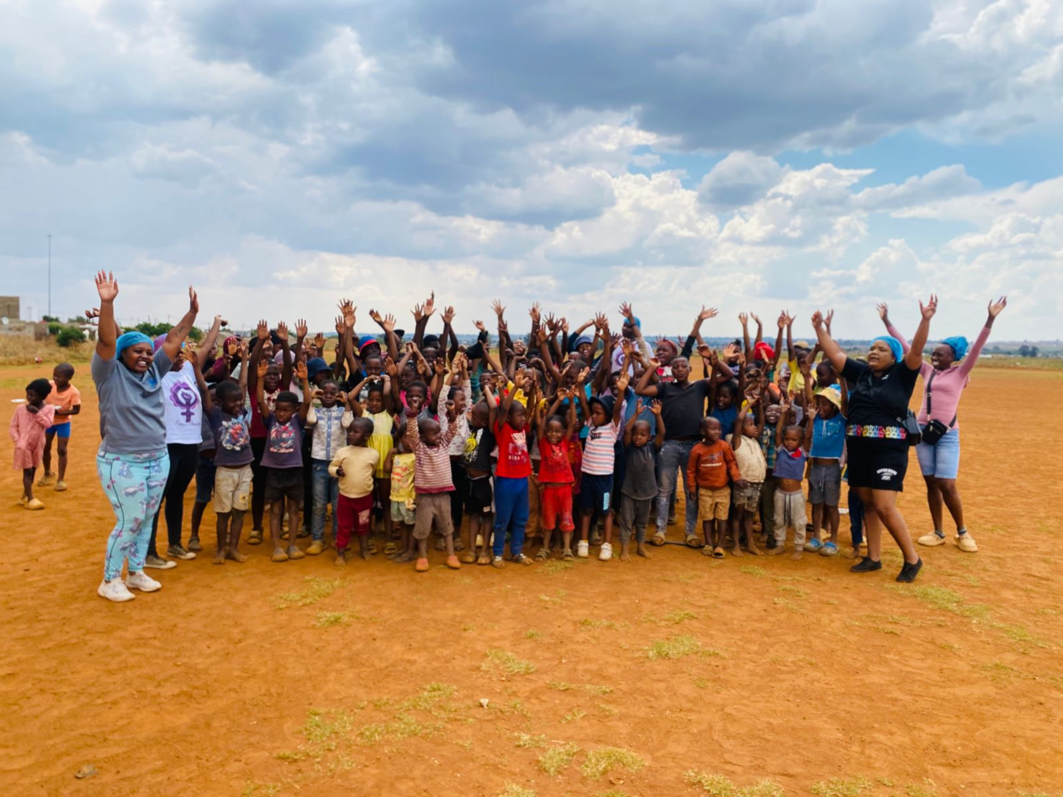
Figure 2/By feeding, loving, and caring for a child, you are nurturing the leaders of tomorrow.

