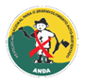
NATIONAL ASSOCIATION FOR SELF-SUSTAINED DEVELOPMENT – ANDA

A LIFELINE FOR VULNERABLE CHILDREN ON THE BRINK PROJECT
(ECONOMIC STRENGTHENING) – GLOBAL GIVING
Video of VSLA groups in their weekly activities

