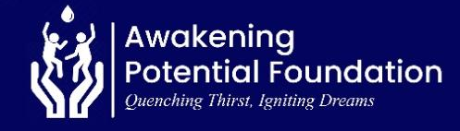
REPORT ON SUSTAINABLE SAFE WATER, TRANSFORMED RURAL LIVES (70726)

25 June 2026

Message from the Leadership
We appreciate the exceptional support that has enabled us to make a meaningful impact in the lives of many people in the world. Awakening Potential Foundation (APF) remains committed to transforming the lives of people in rural populations affected by limited access to water by providing clean and safe drinking water, particularly in Ghana’s Volta Region. This report outlines our key achievements and challenges over the past months and offers an overview of our planned initiatives.
Water Project:

Consistent with its commitment to addressing rural water poverty across the Volta Region, APF continues to pursue funding opportunities and mobilize resources to support the implementation of the Deve Community Water Project.

However, progress has been slowed by inadequate external financial support and limited resource mobilization. As a result, the acquisition of the other infrastructure and equipment needed to complete the water system has been delayed, preventing the project from delivering long-term, sustainable access to safe and clean drinking water for the community.

APF remains dedicated to overcoming these challenges and securing the necessary support to ensure the successful completion of the project and its intended benefits for the residents of Deve.

Population

Approximately 2,500 residents of the community are expected to benefit from the water intervention once the project is fully completed.

Outcomes & Impact when completed.
Once completed, the project is expected to deliver the following outcomes:
- Improved Access to Safe Water: Sustainable access to clean and safe drinking water for over 2,500 residents.
- Better Education Outcomes: Increased school attendance and participation among students.
- Enhanced Rural Livelihoods: Improved livelihood opportunities and resilience for community members.
- Women’s Economic Empowerment: Increased participation of women in income-generating activities.
- Reduced Waterborne Diseases: Significant reduction, and eventual elimination, of water-related illnesses.
Upcoming Projects
In the coming months, APF plans to:
- Apply for additional funding opportunities;
- Complete the ongoing water project, including the installation of a 3,000-litre water storage facility;
- Initiate new water projects in two additional rural communities within the Volta Region.
We remain deeply committed to driving sustainable change and invite stakeholders and partners to join us in empowering communities through improved access to clean, safe, and reliable water.
Acknowledgement
We extend our heartfelt gratitude to our donors, partners, and volunteers whose continued support enables APF to combat rural water poverty in Ghana’s Volta Region.

Richmond Elvis Arku.
Executive Director

