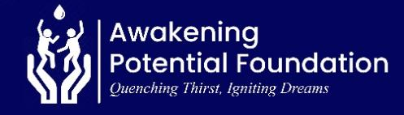
REPORT ON SUSTAINABLE SAFE WATER, TRANSFORMED RURAL LIVES (70726)

25 FEBUARRY 2026

Message from the Leadership
We appreciate the exceptional support that has enabled us to make a meaningful impact in the lives of many people in the world. Awakening Potential Foundation (APF) remains committed to transforming the lives of people in rural populations affected by limited access to water by providing clean and safe drinking water, particularly in Ghana’s Volta Region. This report outlines our key achievements and challenges over the past months and offers an overview of our planned initiatives.
Water Project:

In line with our mandate to holistically address rural water poverty in the Volta Region, APF continues to mobilize resources to advance the Deve Community Water Project. Although the project is not yet complete, a submersible water pump is still in place to provide temporary access to clean water.

Progress has been significantly constrained by limited external funding and insufficient resource mobilisation, which have delayed the procurement of the remaining system components required to deliver permanent and sustainable access to safe drinking water.

Population

Approximately 2,500 residents of the community are expected to benefit from the water intervention once the project is fully completed.

Outcomes & Impact when completed.
Once completed, the project is expected to deliver the following outcomes:
- Improved Access to Safe Water: Sustainable access to clean and safe drinking water for over 2,500 residents.
- Better Education Outcomes: Increased school attendance and participation among students.
- Enhanced Rural Livelihoods: Improved livelihood opportunities and resilience for community members.
- Women’s Economic Empowerment: Increased participation of women in income-generating activities.
- Reduced Waterborne Diseases: Significant reduction, and eventual elimination, of water-related illnesses.
Upcoming Projects
In the coming months, APF plans to:
- Apply for additional funding opportunities;
- Complete the ongoing water project, including the installation of a 3,000-litre water storage facility;
- Initiate new water projects in two additional rural communities within the Volta Region.
We remain deeply committed to driving sustainable change and invite stakeholders and partners to join us in empowering communities through improved access to clean, safe, and reliable water.
Acknowledgement
We extend our heartfelt gratitude to our donors, partners, and volunteers whose continued support enables APF to combat rural water poverty in Ghana’s Volta Region.

Richmond Elvis Arku.
Executive Director

