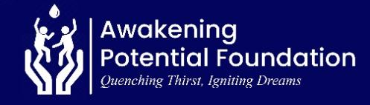
REPORT ON SUSTAINABLE SAFE WATER, TRANSFORMED RURAL LIVES (70726)

28 OCTOBER 2025

Message from the Leadership

We are sincerely appreciative for the extraordinary support that has allowed us to make a significant difference in the lives of countless people. Awakening Potential Foundation continues to transforming the lives of rural residents with lack of access to water through providing access to clean and safe drinking water, particularly in Ghana's Volta Region. This report highlights our accomplishments and challenges over the previous three months and provides a glimpse into upcoming initiative.
Water Project:
As part of our mandate to holistically address rural water poverty in Ghana’s Volta Region, Awakening Potential Foundation continues to mobilize resources to advance the “Deve” Community Water Project. Currently, the project remains incomplete, though a submersible water pump has been installed to provide temporary access to clean water. This is due to limited external funding and inadequate resource mobilization, which have hindered the procurement of the remaining water system components needed to ensure permanent and sustainable access to safe drinking water for the community.

Population
- About 2500 residents in the community will benefit from the water intervention once it is fully completed.

Outcomes & Impact when complement

When completed, the project is expected to achieve the following results:
- Access to Clean Water: Over 2,500 residents will gain sustainable access to safe and clean drinking water.
- Improved Education Outcomes: Student attendance in the community will increase.
- Enhanced Rural Livelihoods: The project will contribute to improving the sustainable livelihoods of residents.
- Increase in women in income generation activities.
- Reduced Waterborne Diseases: A significant reduction—and eventual elimination—of water-related diseases among residents.
Upcoming Projects
In the coming months, we plan to:
- Apply for several new funding opportunities.
- Complete the ongoing water intervention project, which includes a 3,000-liter water storage facility.
- Launch new water projects in two rural communities in the Volta Region.
We remain committed to creating meaningful change and invite more stakeholders to join us in empowering lives through providing access to sustainable clean ad safe water.

Acknowledgment

We extend our heartfelt appreciation to our donors, partners, and volunteers who are committed to support APF to reduce rural water poverty in Ghana Volta Region.
Together, we are awakening potential and transforming lives!

Richmond Elvis Arku.
Executive Director

