Celebrating 50 Years of Impact – Expanding Our Reach Campaign

For 50 years, Virginia Garcia Memorial Health Center has been at the forefront of providing high quality, culturally appropriate care to underserved communities in Washington and Yamhill counties. Our commitment to meeting the needs of migrant and seasonal farmworkers, as well as others with barriers to care, has remained the cornerstone of our mission.

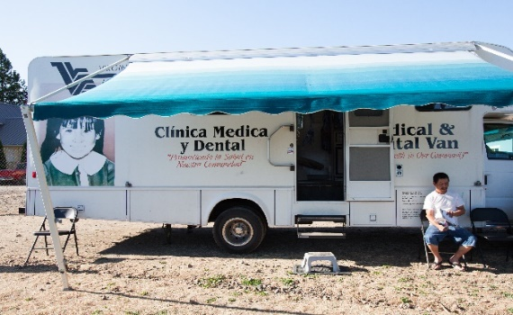
Celebrating this significant milestone goes beyond the many years of impact – it is about the daily lives we touch and our renewed commitment to this important work. In honor of this anniversary, we are excited to launch our special 50th Anniversary Campaign, aimed at expanding our Mobile Health Program and services. For 40 years, bringing essential medical and dental care directly to the communities that need it most, where they live, work, and gather, has been a critical component of our health care delivery. Our long-standing commitment to accessibility and care remains today, and our goal is to raise $1.5 million to reach more community members and bring the care they need to where they are.
Our original mobile clinic delivering care at a farmworker housing complex.

Building Trust and Connections through Mobile Health Care

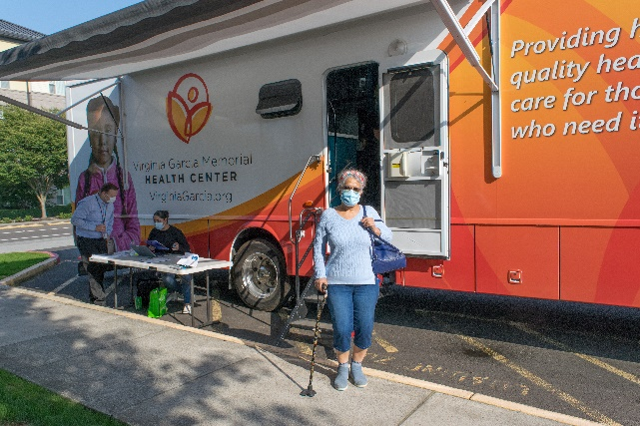
Taking health care directly into communities is not just about convenience; it is about building trust and forging meaningful connections that are essential for a positive patient experience. Over the past five decades, Virginia Garcia has committed to understanding the unique challenges our communities face, especially when it comes to health care access. By providing care in familiar, accessible locations, we ensure that individuals feel more comfortable, supported, and seen.
Our mobile clinic delivering dental services to community members at Orenco in Hillsboro in 2023.

During the pandemic, this work allowed us to take COVID-19 education, screening, and vaccination to targeted sectors of the community, in partnership with other organizations. This further helps us become a trusted health care provider for the community and those who call us their medical home.

Expanding Our Reach

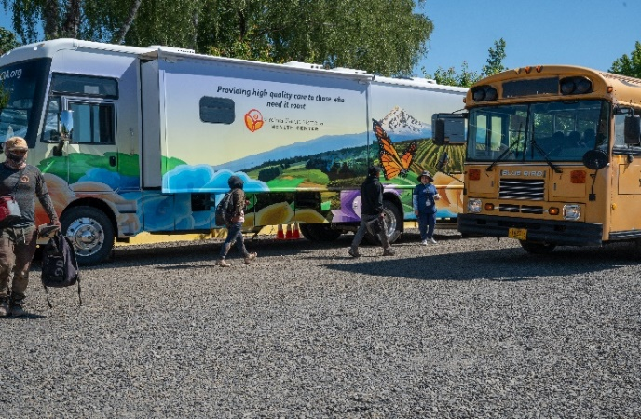
Responding to community need is at the core of who we are, and, as the needs of our community evolve, so must our services. Our Mobile Health Program is expanding to operate year-round to reach deeper into our communities, ensuring greater access to care. In partnership with community organizations, we will bring our mobile clinics and teams to apartment complexes, worksites, community centers, schools, and community events—making health care more accessible for many underserved, low-income populations. Increasing access to primary care will also contribute to a reduction in emergency department utilization and improve overall health outcomes for our communities.
Our second mobile clinic (2024) delivering integrated care at a farmworker housing complex in Washington County.

Currently, our two active mobile clinics deliver primary care and dental care. We are working to expand our mobile team to include a full care team (providers and support staff) and plan to renovate a mobile unit that was donated to us in 2024 to convert it into our third mobile clinic. These staffing and fleet additions will allow us to offer a broader range of services to our patients, including behavioral health, particularly in areas where health care access is limited.

This expansion will help us provide increased access to comprehensive care to rural communities in Willamina, Sheridan, Newberg, and neighboring areas to help close the growing gaps in access, ensuring that more people receive the care they need and deserve without having to travel long distances.

Looking to the Future

Our expanded Mobile Health Program is not just a celebration of our past—it is a commitment to continue to serve our communities, many of which face many challenges and fear of traditional health care settings now and into the future. Virginia Garcia remains steadfast in our mission, delivering essential health care services to all who need it, regardless of their race, language, gender, geographic location, or economic status. This expansion aligns with our vision of ensuring that all people in our service area have access to timely, high-quality health services, enabling them to achieve the best possible health outcome.

As we celebrate 50 years of service, we invite you to join us in this commitment and support our ability to meet the growing needs of our communities. The Mobile Health Program is a pivotal part of that commitment, and your gift will help us build a healthier future —one where high-quality, culturally appropriate care is available to all, no matter the circumstances.

