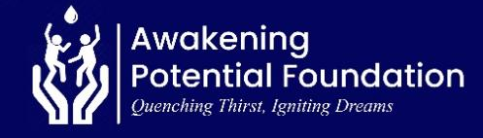
REPORT ON UNLEASHING POTENTIAL, EMPOWERING RURAL YOUTH GHANA (70514)

16 OCTOBER 2025

Message from the Leadership

We are deeply grateful for the incredible support that has empowered us to touch countless lives across diverse communities. At Awakening Potential Foundation, our dedication to transforming lives through education, healthcare, and humanitarian assistance—especially in Ghana’s Volta and Northern regions—remains unwavering. This report showcases our three months achievements, and upcoming events.
Dorfor Senior High School, Juapong, Ghana
As part of our educational development programs, Awakening Potential Foundation organized a capacity-building training session at Dorfor Senior High School. The event featured distinguished speakers from different part of the world, each bringing a wealth of knowledge and experience to inspire and guide students.
The main purpose of the seminar was to inspire, empower, and inform students on career development choices, mental health, sustainability, and leadership. This was part of our ongoing mission to invest in the potential of youth, especially within the Volta Region.

2. Speakers Topics
- Dr. Kenneth Gyamerah Defining your career path
Assistant Professor, Ontario Tech University, Canada
- Sandra Leyva Recycling waste and Leadership
Head of Sustainability, Americas – CHEP, USA
- Elvis Richmond A. Making the right Choices
Development Practitioner and Youth Advocate, The UK
- Nicole Kennedy Mental Health
Mental Health Specialist and Youth Advocate, Canada

3. In-person Team Members
- Norbert Avorgah
- Eunice Esinam

5. Audience
- 300 Senior High School students
- 10 Teachers and school administrators

6. Outcomes & Impact
- Students reported increased motivation and gained valuable insights into practical career development and mental health strategies during the feedback session.
- Participants enhanced their knowledge on making informed life choices and leveraging digital tools for personal and academic growth.
- Teachers expressed interest in future collaboration with the Foundation, reflecting the program’s positive reception and relevance.
- The event strengthened the Foundation’s presence and credibility in the Volta Region, fostering stronger community ties.
- The school management expressed deep gratitude to the team stating that this event is the first ever to happen in their school.

Photos

Attached are some photos from the event and the link to the google photos drive:
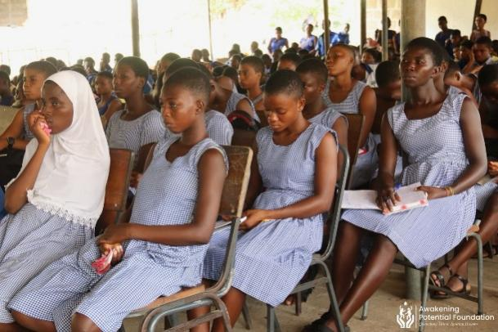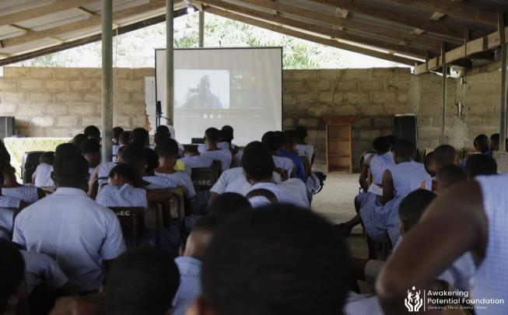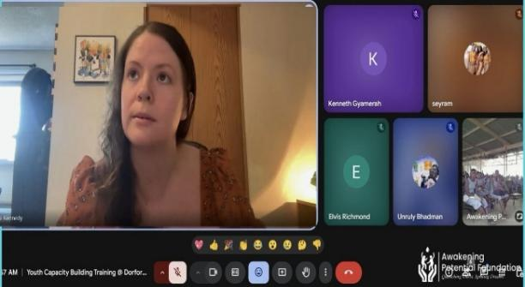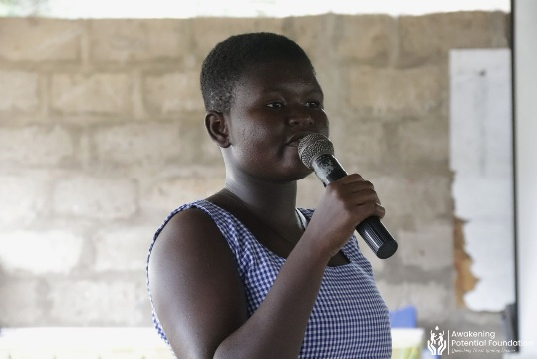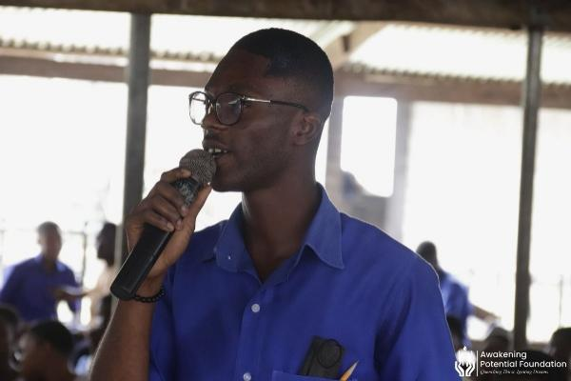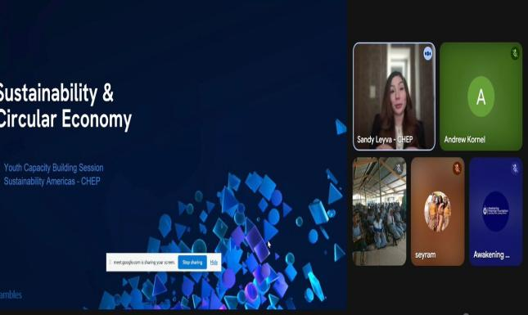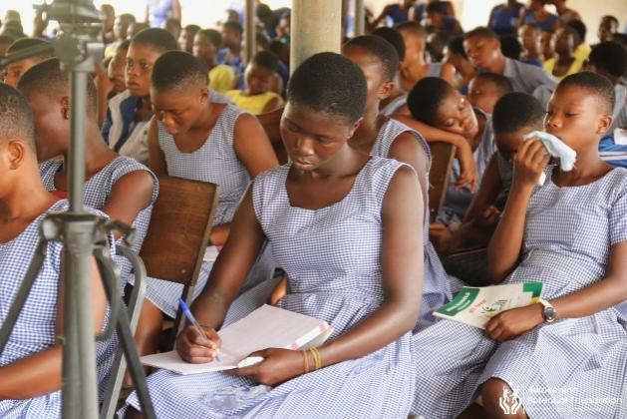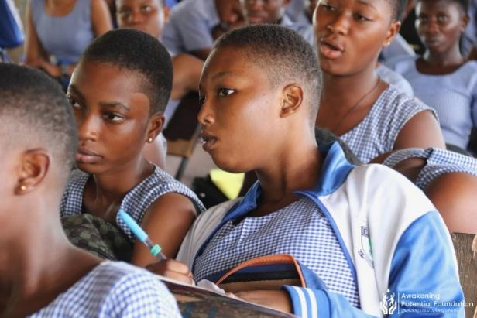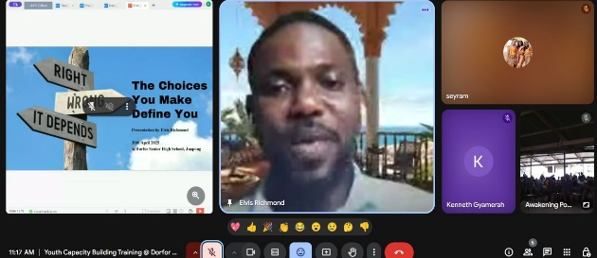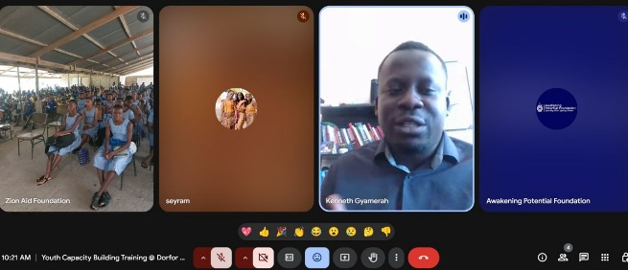

Upcoming Projects
In the coming months, we plan to:
- Provide a mini library for children in an orphanage in the Volta Region to promote reading and lifelong learning.
- Expand educational support programs in underprivileged schools, offering greater access to learning resources and mentorship.
- Establish long-term partnerships with key stakeholders to ensure sustained impact in our focus areas.
- Organise fundraising activities to mobilise resources and strengthen the foundation’s ability to deliver meaningful interventions.
We remain committed to creating meaningful change and invite more stakeholders to join us in empowering lives through education, healthcare, and humanitarian aid.

Acknowledgments: We extend our heartfelt appreciation to our donors, partners, and volunteers who have contributed to making the event successful. Your unwavering support has made a profound difference in the lives of many, and we look forward to achieving even greater milestones together.
Together, we are awakening potential and transforming lives!
Signed.

Richmond Elvis Arku.
Executive Director

