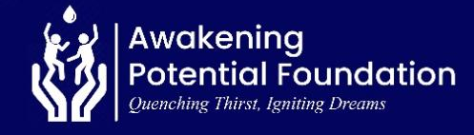
REPORT ON UNLEASHING POTENTIAL, EMPOWERING RURAL YOUTH GHANA (70514)

13 JUNE 2026

Message from the Leadership
We are deeply grateful for the generous support that continues to drive our mission and expand our impact across diverse communities. At Awakening Potential Foundation, we remain dedicated to transforming lives through education, healthcare, and humanitarian assistance, with a particular focus on Ghana’s Volta region. This report highlights the progress we have made over the past three months and presents our planned initiatives as we continue working toward sustainable and meaningful change.
DONATION TO ‘IN MY FATHER’S HOUSE ORPHANAGE’
As part of its educational development initiatives, Awakening Potential Foundation carried out a donation exercise. The purpose of this outreach was to support the educational and welfare needs of the children through the donation of books, bookshelves, food items, and toiletries. This initiative forms part of APF’s ongoing mission to transform lives in underserved communities, particularly in the Volta Region.
Items Donated
The following items were presented to the orphanage:
A. Educational Materials
- Over 700 assorted books to 86 children.
- Procured and installed two new bookshelves to ensure the proper storage, organization, and preservation of the books.

B. Welfare Support Items
- Groceries and toiletries worth $254 was provided to the orphanage home.
Outcomes & Impact
- The distribution of over 700 assorted books to 86 children will significantly improve access to learning resources, fostering literacy, reading comprehension, and academic development.
- The availability of diverse reading materials will encourage a culture of reading and self-learning among the children.
- The installation of two new bookshelves will enhance the organization, accessibility, and preservation of educational resources, creating a more conducive learning environment and ensuring the long-term sustainability of the library collection.
- The provision of groceries and toiletries valued at $254 helped meet the immediate nutritional and personal hygiene needs of the children at the orphanage.
- This support reduced some of the financial burden on the orphanage, allowing available resources to be directed toward other critical areas of child care and development.
- Access to essential food items and hygiene products contributed to the children's overall well-being, health, dignity, and quality of life.

Photos

Attached are some photos from the event.
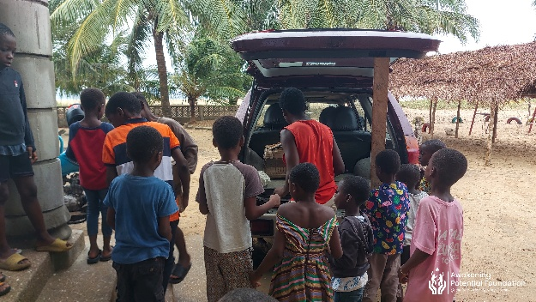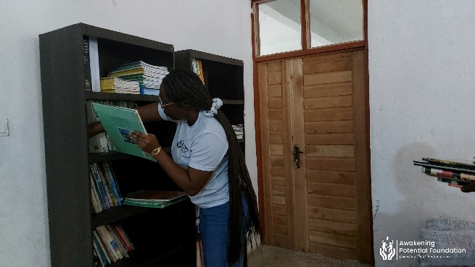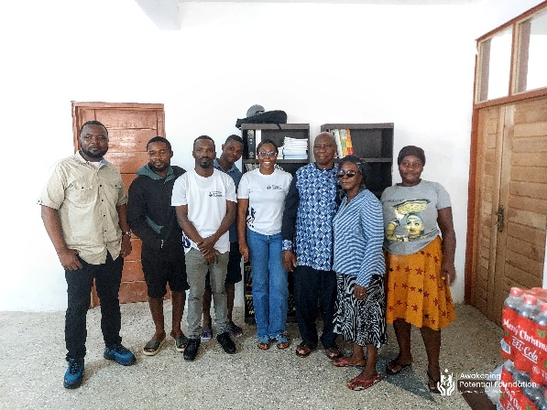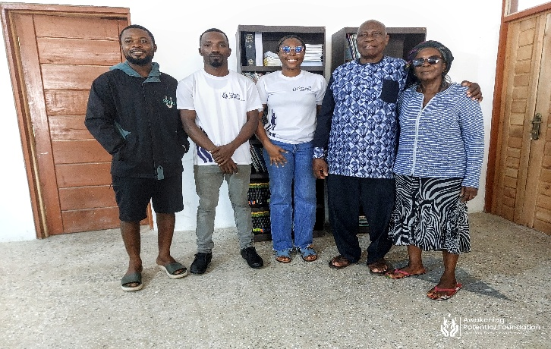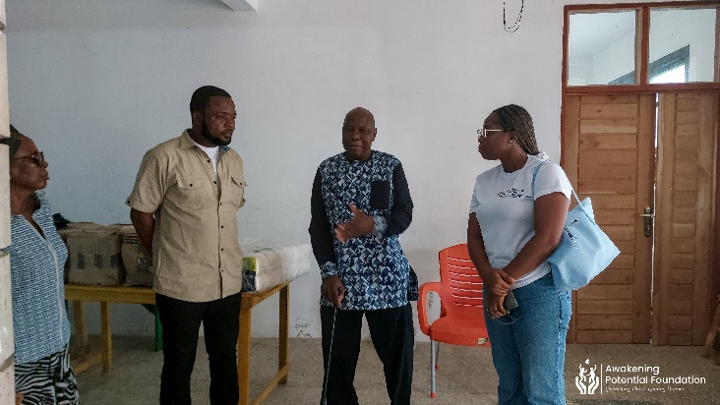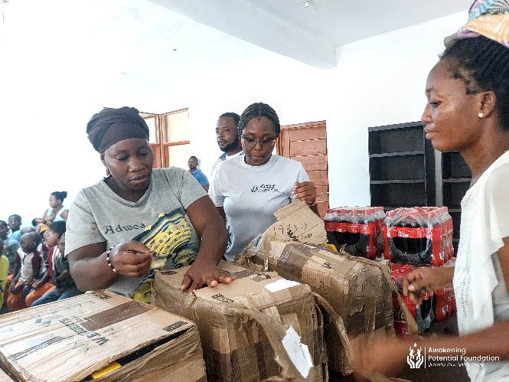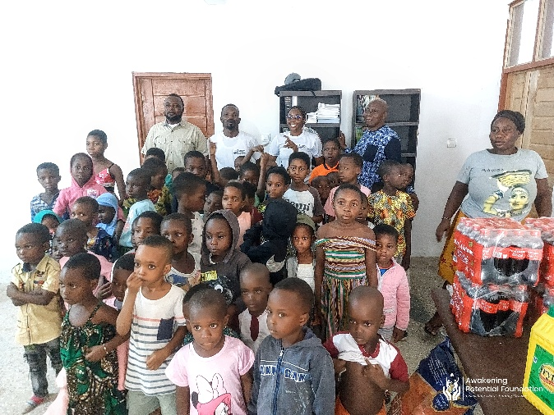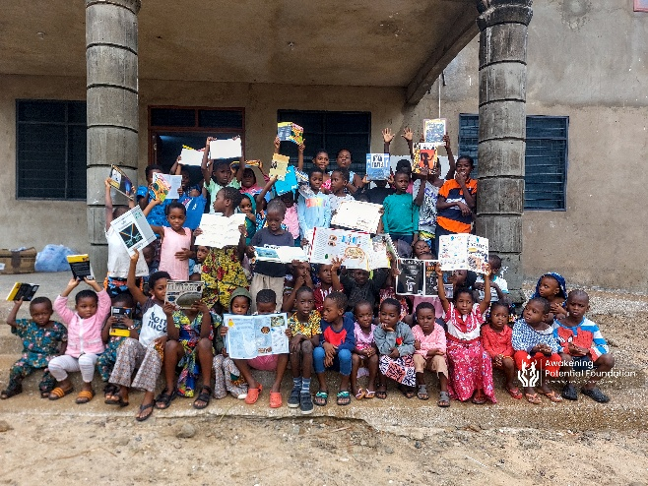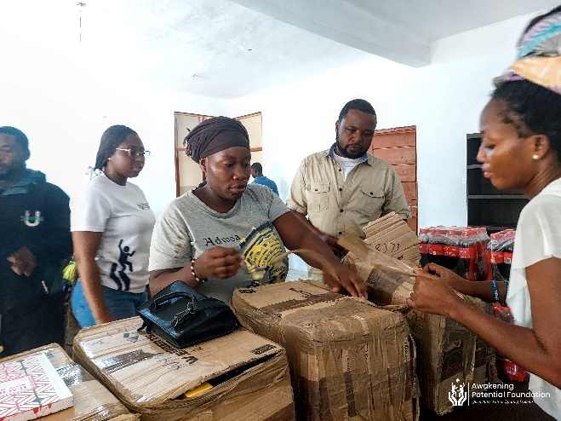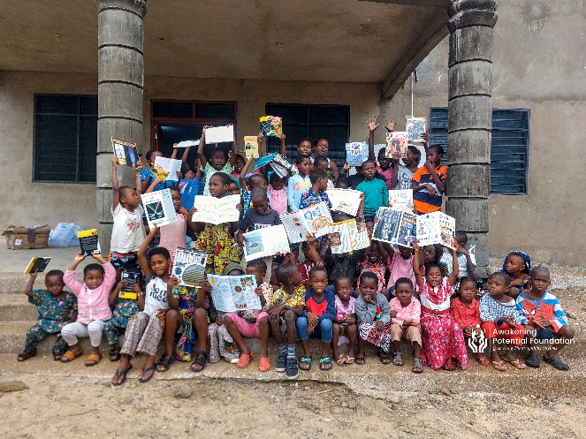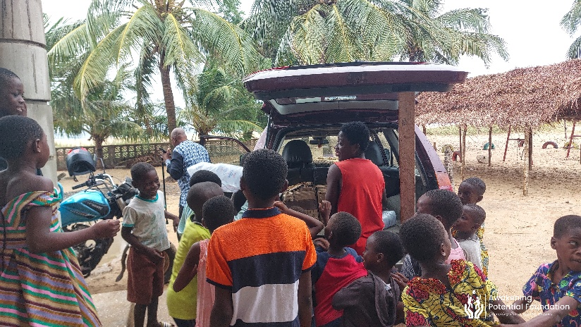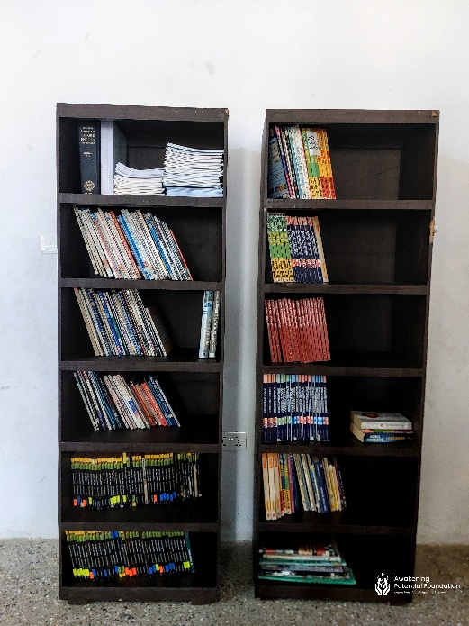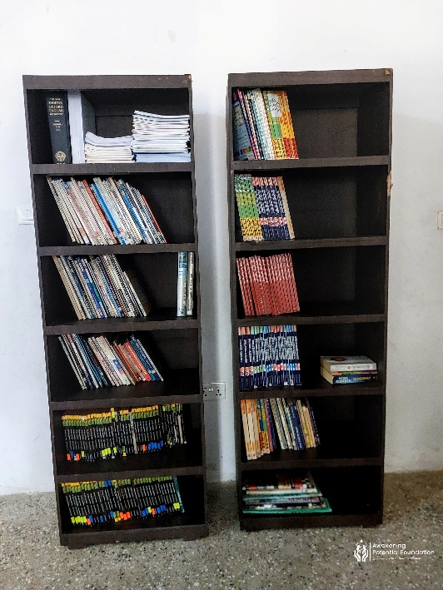

Upcoming Projects
In the coming months, we plan to:
- Scale up educational support programmes in underprivileged schools by increasing access to learning materials, mentorship, and capacity-building opportunities.
- Develop and strengthen long-term partnerships with key stakeholders to enhance collaboration, sustainability, and lasting impact across our focus areas.
- Organize targeted fundraising initiatives to mobilize resources and reinforce the Foundation’s capacity to deliver impactful and transformative interventions.
We remain committed to creating meaningful changes and invite more stakeholders to join us in empowering lives through education, healthcare, and humanitarian aid.

Acknowledgments:

We extend our sincere appreciation to our donors, partners, and volunteers whose dedication and generosity were instrumental to the success of this initiative.

Your continued support has created a meaningful and lasting impact in the lives of many individuals and communities. We are deeply grateful for your commitment to our shared mission and look forward to achieving even greater milestones together in the future.

Together, we are awakening potential and transforming lives.

Richmond Elvis Arku.
Executive Director

