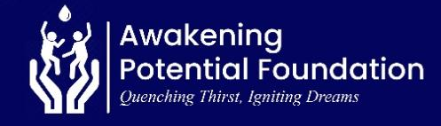
REPORT ON UNLEASHING POTENTIAL, EMPOWERING RURAL YOUTH GHANA (70514)

13 February 2026

Message from the Leadership
We are profoundly thankful for the generous support that continues to make our work possible, enabling us to impact lives across diverse communities. At Awakening Potential Foundation, our commitment to empowering individuals through education, healthcare, and humanitarian support—particularly in Ghana’s Volta and Northern regions—remains steadfast. This report reflects our achievements over the past three months and outlines our upcoming initiatives as we continue this journey of transformation.
Comboni Technical Institute, Sogakope, Ghana
As part of its educational development initiatives, Awakening Potential Foundation organized a capacity-building training session at Comboni Technical Institute, Sogakope. The programme brought together distinguished speakers from various parts of the world, each sharing valuable insights, ideas, strategies and experiences.
The capacity building aimed to motivate, empower, uncover talents, potentials and educate students on key areas including career development, mental health, sustainability, entrepreneurship and leadership. This activity forms part of our ongoing commitment to nurturing the potential of young people, particularly within the Volta Region.

1. Speakers
- Dr. Agyemang Okyere Darko – Project Management Officer & Youth Advocate (Ghana).
- Mr. Kwadwo Tieku – Soldier, Motivational Speaker & Content Creator (United Kingdom).
- Mr. John Richard Eperetun – Trade Specialist & Development Practitioner (The Netherlands).

Key Topics Covered
- Entrepreneurship and trade opportunities.
- Discovering purpose and talents.
- Building the right mindset for success.
- Taking responsibility for personal growth.
- Leveraging opportunities for global exposure.
- Discipline, service, and leadership.
- The role of technical/vocational skills in modern industries.

In-person Team Members
- Norbert Avorgah
- Eunice Esinam
- Ruth Okine (volunteer)

Audience
- Total student attendance: 1,500+
- 12 Teachers and school administrators
Outcomes & Impact
- Over 90 % of students reported heightened motivation and gained practical insights into career development pathways and effective strategies during the feedback sessions.
- Almost 95% demonstrated improved understanding of informed decision-making and the effective use of digital tools to support their personal, academic, and career growth through feedback session.
- Increased interest in technical and vocational pathways
- 21% showed a strong desire to be part of the APF mentorship program
- Teachers expressed strong interest in future collaboration with Awakening Potential Foundation, underscoring the programme’s relevance, impact, and positive reception within the school community.
- The initiative further strengthened the Foundation’s visibility, credibility, and trust within the Volta Region, contributing to deeper and more sustainable community relationships.
- School management conveyed profound appreciation to the Foundation’s team, noting that this was the first capacity-building programme of its kind ever organized at the school, and commended its quality, relevance, and impact on students.

Photos

Attached are some photos from the event.

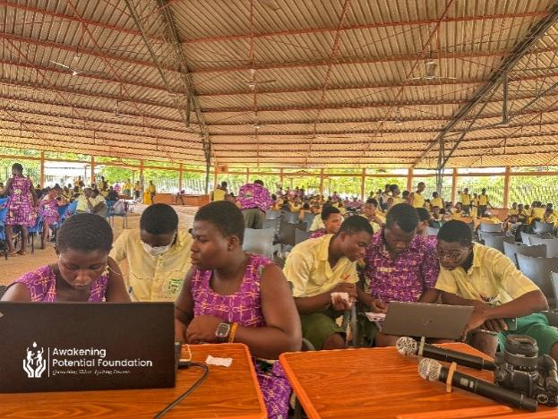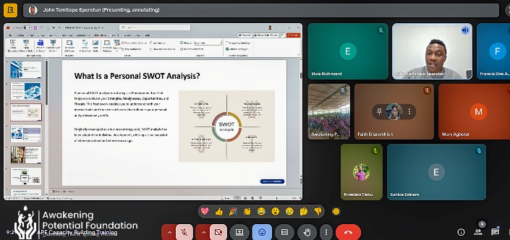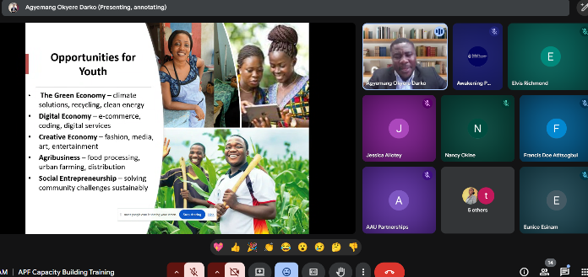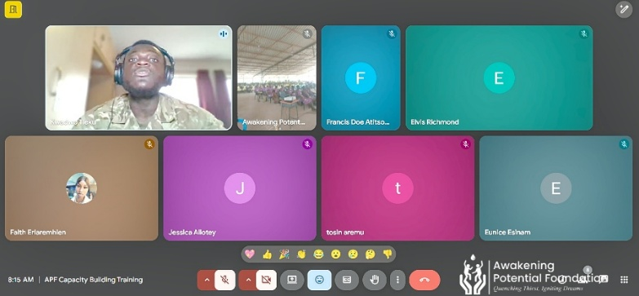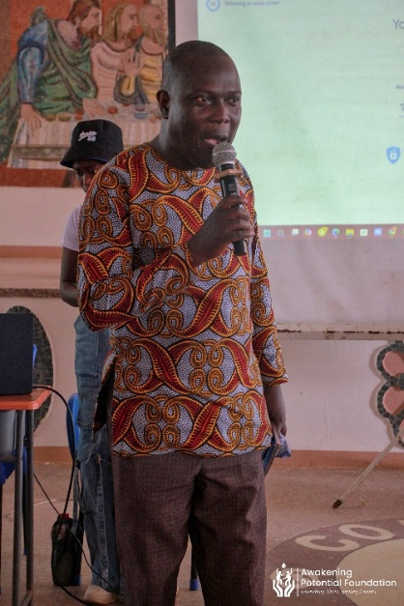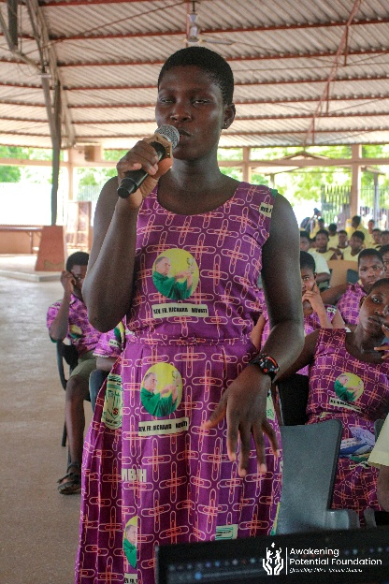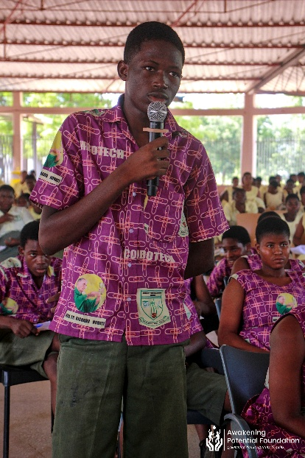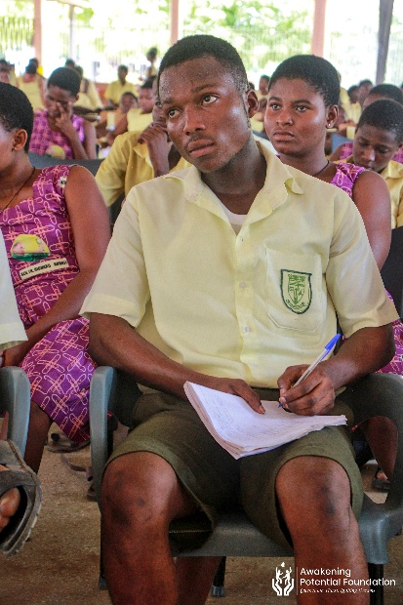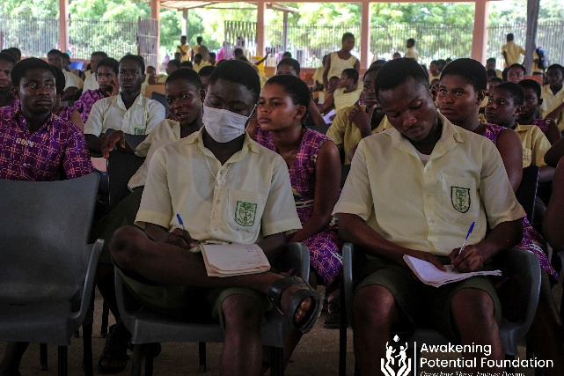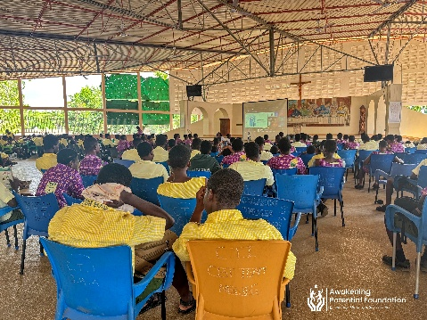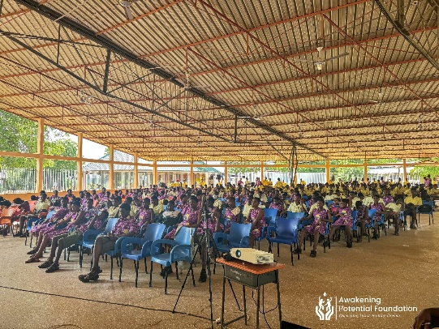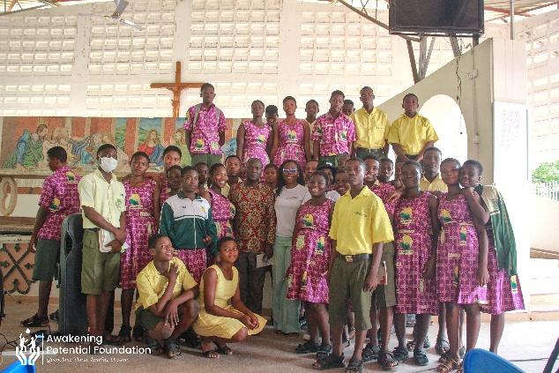

Tertiary Students Financial Support

Awakening Potential Foundation (APF) is providing continuous financial support to two tertiary students currently enrolled at the University of Professional Studies, Accra (UPSA) and Kwame Nkrumah University of Science and Technology (KNUST). This support is aimed at enabling the students to pursue their academic goals without financial barriers and reflects APF’s ongoing commitment to investing in higher education and youth development.
Upcoming Projects
In the coming months, we plan to:
- Establish a mini library for children in an orphanage within the Volta Region to encourage a culture of reading, curiosity, and lifelong learning.
- Groceries and educational materials for children in an orphanage.
- Scale up educational support programmes in underprivileged schools by increasing access to learning materials, mentorship, and capacity-building opportunities.
- Develop and strengthen long-term partnerships with key stakeholders to enhance collaboration, sustainability, and lasting impact across our focus areas.
- Organize targeted fundraising initiatives to mobilize resources and reinforce the Foundation’s capacity to deliver impactful and transformative interventions.
We remain committed to creating meaningful change and invite more stakeholders to join us in empowering lives through education, healthcare, and humanitarian aid.

Acknowledgments:

We extend our sincere appreciation to our donors, partners, and volunteers whose dedication and contributions were instrumental to the success of this event. Your continued support has made a meaningful and lasting impact on the lives of many, and we look forward to reaching even greater milestones together as we advance our shared mission.

Together, we are awakening potential and transforming lives!

Richmond Elvis Arku.
Executive Director

