Give Life with Your Eid-al-Adha Donation
Help us bring hope, healing, and nourishment to children with leukemia.
Every penny you donate has the power to change a life. This Eid-al-Adha, your generosity can bring not just meat, but life-saving support to children battling cancer and families living in poverty.
💛 Why Your Support Matters:
At LÖSEV, all of our services – from medical care to food support and education – are made possible by donations and the incredible strength of our volunteer community.
Among our year-round efforts, our Eid-al-Adha / Kurban Campaign holds special importance. With your Kurban donations, we distribute fresh meat and nutritious food supplies to children undergoing treatment and their families throughout the next 12 months.
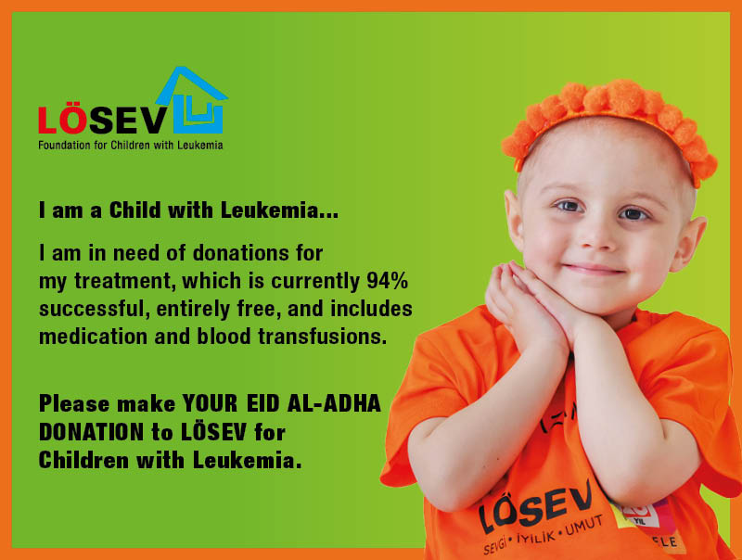

How You Can Help
Select a giving level that reflects your compassion and impact:
- $40 – Bayram Allowance for a Child with Cancer
Bring joy to a child this holiday with a small but meaningful gift that makes them feel remembered and loved.
- $100 – Holiday Gift Package
Give a child with cancer a warm and memorable Eid. Your donation covers clothing, toys, and festive meals.
- $415 – One Share of Kurban Donation
This is the cost of one full share of a Kurban sacrifice. With this amount, you help us provide 12 months of food support to a child in need. (important note: if you want to make a kurban donation by proxy and perform the sacrifice ritual please send an email to international@losev.org.tr mentioning your name and the receipt of your payment before 4 June 2025)
🌍 Your gift today helps us nourish over thousands of families across Turkey who rely on LÖSEV to get through the toughest time of their lives.
🕊️ This Eid, give more than meat — give life, hope, and dignity.

