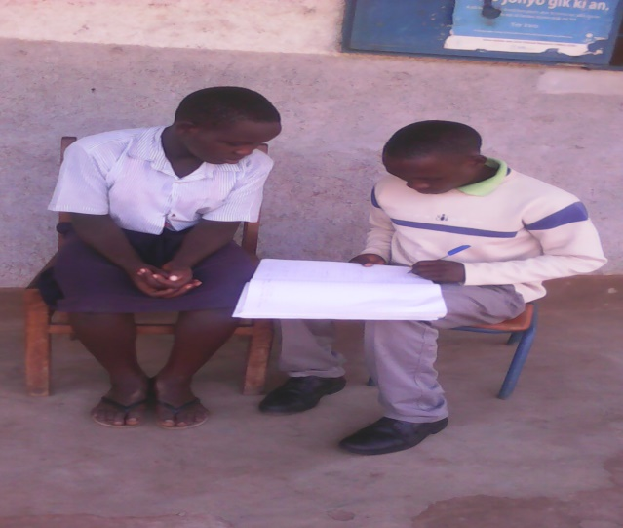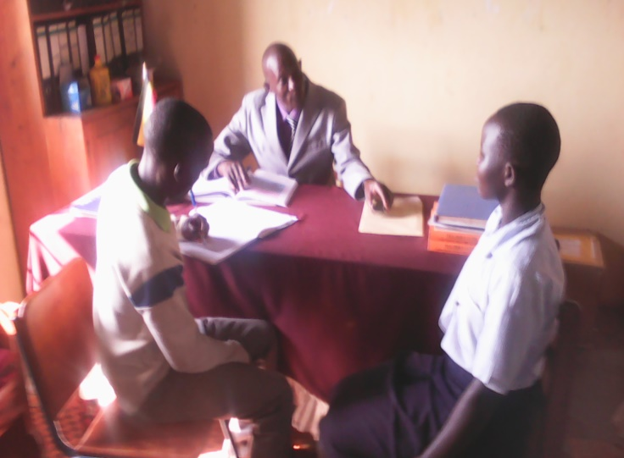
The Pictures Auma sharing her successful stories with Administrative Volunteer.

