PROJECT TITLE: EDUCATE 200 WAR AND HIV/AIDS ORPHANED UGANDAN GIRLS
PROJECT WEBSITE: http://www.globalgiving.org/projects/aids-education-uganda
LOCATION: LIRA DISTRICT NORTHERN UGANDA
REPORT PERIOD: QUARTERLY REPORT FOR MONTHS APRIL, MAY AND JUNE 2012
COMPILED BY SUSAN EJANG, LIRA FIELD OFFICER
Platform for Labour Action through the Global Giving donors has opened doors of hope to a better future to over 45 girls currently leaving in Lira district. The project provides support to war and HIV/AIDS orphaned girls in the form of school lunch, counseling and scholastic materials such as books, pens, pencils, rulers, rubbers and school uniforms.
Through the school authorities, Lira field officer monitors the school and class performance of the girls: assessment of their performance is provided after a written examination.
Currently, 5 girls are being supported by the project since 2008 and 40 new girls have been identified to be supported by the project.
In this quarter a number of activities were carried out that included payment of school lunch for the whole year, counseling and school and home visits to the beneficiaries. Below is a detailed report of the activities carried out in the last three months: April, May and June.
SCHOOL VISITS
11 school monitoring visits were held in the quarter; the visits were made to V.H Public school, Lango Quran primary school, Elia Olet primary school, Lira police primary school, Savor secondary school, Akia primary school, Jack and Jill primary school, Ojwina primary school, Adyel primary school, and Railways primary school.

The school monitoring visits are meant to check on the beneficiaries’ performance in school.

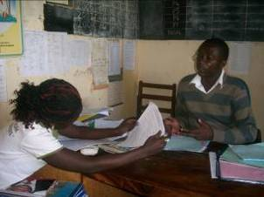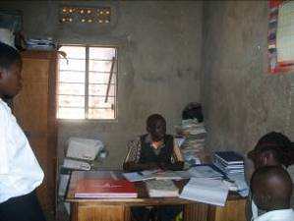
On the left is a picture showing Lira field officer Susan Ejang as she looked through the school performance of Lira primary school, aided by the head teacher. On the right is the field officer as she listened to one of the beneficiaries Abeja Eunice’s class teacher as he explained her performance at his office in Savior secondary school Lira.

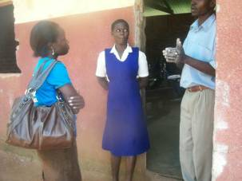
Above is a picture showing the field officer Susan Ejang with one of the identified girls Ouni Fiona as they talked about her performance in class with her science teacher Ocen Michael at Ojwina primary school

The school monitoring visits give the organization the chance to meet the beneficiaries’ teachers who spend so much time with them at school, and so have informed comments on their (girls’) academic and social progress. The school teachers also play big roles in shaping the beneficiaries better future especially when they get to understand the children’s circumstances.
During the school visits the beneficiaries are also monitored to see if they are getting school lunch and if they are properly using their scholastic materials which they receive once a year.
HOME VISITS
The home visits made by Lira field officer were meant to monitor living situations: how the girls live at home, to ensure that they are rightly treated by their guardians and also given time like all the other children to play and also revise their books for better performance and future.
A number of 3 homes visits were made to the girls, Ateng Rebecca, Awor Faith and Atai Sandra during the school holidays.
The visit made to Sandra was to ensure that the situation at home had changed; that her aunt was treating her better, and leaving her time to attend to her studies, instead of over laoding her with house chores. Unfortunately, the situation hadn’t changed.
Other visits were made to Awor Faith and Ateng Rebecca to ensure that they were effectively taking their medication and were on proper balance diet as required due to their status. Rebecca was connected to another organization called Cosbel by the field officer; Cosbel has started supporting Rebecca with food and other basic needs such as clothing.
During the home visits, the beneficiaries were counseled and monitored on the specific activities that they carry out when at home, for example home chores. The field officer also had a chance to monitor the scholastic materials that the beneficiaries had received; this was to ensure that they were being put to good use by the girls.
COUNSELLING SESSIONS
All the girls; both old and new beneficiaries, that Lira field officer was able to meet received counseling. The officer met and counseled 45 girls.
In-depth, Lira field officer discussed with them their future dreams, the need to move past their past; conflict and loss of parents and the need to study hard and become better people in life. The girls agreed to the proposal, and many needed the help of the organization to deal with their pasts, concentrate on their studies and move on.

PLA BENEFICARIES STORIES

ATAI SANDRA’S STORY

Sandra has been a PLA beneficiary since 2008 but has always had difficulty in concentrating and revising her books while at home, which negatively affected her performance in school. An example of this is failure for her to pass her primary leaving examination last year; she is currently redoing her primary seven.

“I want a better future that’s why I agreed to repeat primary seven when it was first suggested to me”, narrated Sandra.

Sandra is now in boarding school at Lira primary school and according to her, she is happy and can freely revise her books.

“We have teachers that help us in subjects that we don’t understand during prep time, this has helped me a lot to understand subjects especially in math”, mentioned Sandra.

In first term results, Sandra got 20 aggregates which showed great improvement compared to the 27 aggregates that she had got last year.

“Am going to concentrate and work hard, so that I can at least get a first grade,” said Sandra.

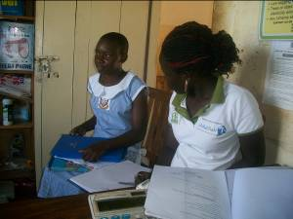
Picture showing Field officer Susan Ejang and Sandra as they discussed the latter’s performance in class

This second term of school, Sandra has been visited thrice to monitor her adjustment to boarding school since it was her first time to leave her uncle’s place for a long period of time.

“I feel free now and my mind is at ease since am away from my aunt who used to mistreat and give me a lot of house work,” happily narrated Sandra.
Despite the many times that Sandra’s aunt was talked to by Lira field officer and Sandra’s uncle Geoffrey, it made no difference instead it made it worse because to the aunt retaliated with threats such as, “since you have decided to keep reporting me to PLA, let me give you more work so that you can report even more, who do you think should do this work? My children?…….No!” narrated Sandra.
In school, Sandra has been supported to receive boarding, lunch and medical attention, which indeed she received after she fell sick with Malaria.
Because of her illness, the field officer ensured that she had a mosquito net that would prevent her from mosquito bites especially at night while she is asleep. During Sandra’s sickness, the school cooperated with the field officer, keeping her updated on Sandra’s medical condition, to improve her health, the field officer bought her juice which was required after she had taken quinine medication for malaria.
Sandra has now improved health wise and back in class concentrating to perform better so as to join secondary school and ultimately become a doctor.

“Am going to read so hard since now I have the time to revise and read my books,” mentioned Sandra during the school monitoring visit.

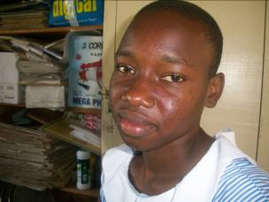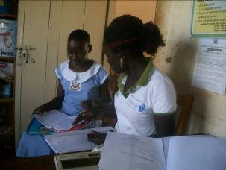
On the left is the face picture of Atai Sandra of Lira primary school, P.7 and on the right is the picture showing the field officer Susan Ejang as she looks through Sandra class books.

According to the teachers at school, Sandra gets to class early and concentrates in her studies, “this has really made us so happy, we were so worried about this girl, especially after we had talked to her and found out what she goes through while at home, we are happy for what Platform for Labour Action is doing for her,” explained the Deputy Head teacher Mrs. Odong.
ABEJA EUNICE’S STORY

18 years old Eunice is currently at Savior secondary school in senior three. Eunice is an average performer but she endeavors to revise her books to perform better.

As an offer by the school, Eunice is in boarding and gets to share the same privilege as the other children in personally meeting the teachers so that they can explain further what she didn’t not understand in class.

“During the night preps, the teachers move around asking us what we never understood while in class. I have taken great interest in biology and chemistry, so many times I have utilized this chance to get help,” mentioned Eunice.

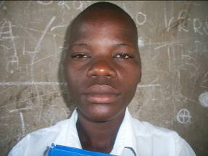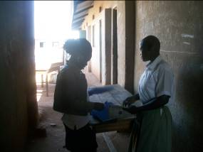
On the left is a face picture of Eunice and on the right is a picture taken of Susan Ejang Lira field officer as she looks through Eunice’s class books during the school monitoring visit.

“Eunice pays attention and also participates greatly, though now we are trying to find out why she doesn’t perform well in her written examinations like she does while in class,” explained Eunice’s Geography teacher, Mr. Omara Tom.

Eunice only managed to score 52 in the said subject and in addition to the other subjects, she got a division three which was not her best performance. PLA is very understanding and supportive of Eunice; she has potential and with counseling and provision, she is determined to improve.

“I didn’t perform so well because some of my books were stolen and I recovered them late with the help of the teachers, but I promise to perform much better than this since am also eager to become a nurse,” explained Eunice.

During the holidays Eunice stayed at home to help her uncle plant groundnuts and maize, “these will be sold probably in the next holiday and I will be able to get some pocket money to buy things such as sanitary pads and clothes for myself,” happily mentioned Eunice.

Eunice’s Uncle Tom came to PLA office to appreciate the fact that, this whole year her niece will not be sent away from school. “May the good Lord bless you for what you have done for my niece, I feel so happy and I have encouraged her to study so hard so that she does not disappoint both herself and the organization,” happily expressed Tom.

AWOR FAITH’S STORY

Faith, who has benefited from the project for 4 years, is in primary seven at V.H public school, Lira.

Though Faith reported to school late this term due to problems with her shoes which were torn, her teachers say that she was able to catch up with the rest of her classmates, “… you know in the first week, we don’t teach a lot as other pupils are still reporting. So Faith, being very interested in studies, was able to catch up with extra help,” explained Faith’s English Teacher Amongi Bright Mary.

A visit to Faith’s home was made to ensure that she had received her mediation on time and that she got a proper balance diet as required.
In the past years, Faith had constantly fallen sick and missed school because she never got her medication on time as expected but after a talk with Faith’s mother Grace, she promised to make time to pick Faith’s mediation and feed her right since she has a garden of greens and cassava.

“Am trying to study so hard to become an accountant like my late father,” mentioned Faith
Faith is an average performer as she was able to score 59% in her best subject math and got 22 aggregates in her first term report.

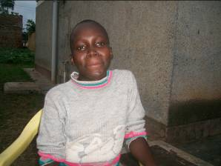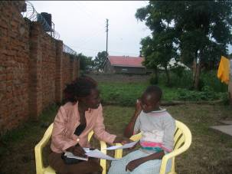
On the left is a face picture of Faith and on the right is Susan Ejang Lira field officer as she talked to PLA beneficiary Faith Awor about her class performance during home monitoring visit.

During the quarter, PLA was also invited to a workshop by an organization called UGANET with one of its beneficiaries to attend a workshop and community sensitization. This was because of PLA support to HIV/AIDS orphaned girls. Lira field officer Susan Ejang was therefore able to attend the workshop together with Faith who later recited a poem on property inheritance and life after HIV/AIDS

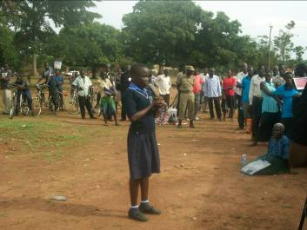
Faith reciting a poem during the community sensitization at Majors garden in Lira District on property inheritance and life after HIV/AIDS

Faith was able to recite a poem written by her, the field officer and UGANET officials at Majors garden in Lira town. At the end of the workshop, faith received a token of USD 20 from UGANET an organization that targets HIV/AIDS infected and affected people in Lira district.

PAYMENT OF LUNCH FEES

Pending Lunch fees for the worth USD 695 was cleared for former beneficiaries in the schools of V.H Public school, Savior secondary school, Elia Olet primary school, Almond college (2 beneficiaries), Lira police primary school, Lango Quran primary school, Erute primary school, Akia primary school, Ojwina primary school, Okwang secondary school, Wiobyek primary school, Aduku road primary school, Adyel primary school and Railways primary school.
Boarding, medical worth USD 125 and school uniform and USD 20 for worth of uniform was also paid for Atai Sandra who is currently repeating primary seven at Lira Primary School.
MONITORING VISITS FOR NEWLY IDENIFIED GIRLS
In this quarter, 50 girls were met during the monitoring visit to interface with the guardians and discuss the challenges that they face as they support the orphans.
All the girls were counseled and encouraged to have hope for a better future

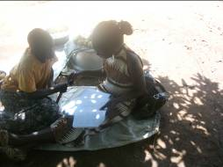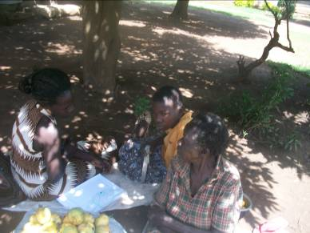
Left:Lira field office as she talked to Cinderella. On the right: the field officer talking to Cinderella’s grand mother
During the monitoring visits the field officer talked to the girls and some of their guardians who were home at the time of the visit. The girls’ ages ranged from 11 to 16 and classes from P.5 to P.7.

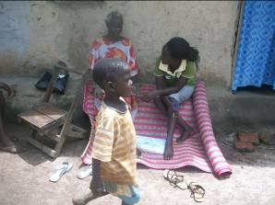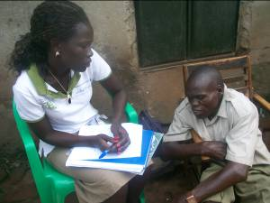
Left: the field officer talking to Amule Doreen’s grandmother during the monitoring visit in Ojwina division. On the right: the field officer listening to one the guardian of Ketty, one of the girls identified in Adyel division.

AWOR ASHA’S STORY
13-year old Asha was born to the late Medina Rashid and the late James, and she is now in the care of Ebong Rashid.
“My father died before my mother had given birth to me and then my mother died in 2010 leaving me in the care of my uncle Ebong Rashid”, narrated Asha.

Asha’s guardian is equally in a bad state as he cannot perform any duty, “I can hardly move without support. I even ease myself through a tube; this has made life very miserable for my late sister’s children. I can’t look after them now,” sadly mentioned Rashid.

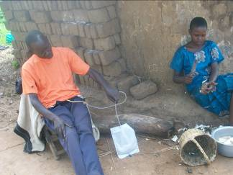
Above: Asha’s uncle as he shows his tube through which he eases himself and Asha as she peels cassava for lunch.

“At school the teachers know my condition so they let me seat examinations but I don’t get my reports at the end of each term,” said Asha
Much as Asha is allowed to study, she doesn’t get to have lunch at school or monitor her grades at the end of each term.
Asha has only one sibling, a 14 years old Emmanuel.
“I would like to become a doctor so that I am able to diagnose patients rightly, explained Asha, this is because of the conditions that most of the people around me have died, most of them always say they don’t know what they are suffering from and yet they take medicine,” further explained Asha.
Asha Uncle Rashid is in a terrible condition and at the end of the day; Asha takes care of the family as the oldest child around.
“Everyone has abandoned us, even the relatives don’t come home anymore and yet my uncle can hardly do anything now,” sadly mentioned Asha.
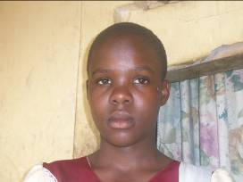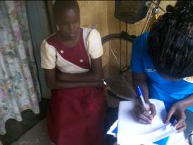
On the left is the face picture of Asha and on the right is the picture showing Asha as the field officer recorded her story.

The family is currently living in a semi permanet house in a place called Corner Kamudini in Teso bar village.

Asha is currently in primary six at Lira police primary school and her farvorite subject is Science.
“I want PLA to support me in school and at home, because I’m sure that the condition that my uncle is in will not change and our relatives don’t want to help,” sadly said Asha.
ZAITUN ACAN’S STORY
Zaitun is a 15-year old Muslim girl currently staying with her aunt, Akello Faridah. Zaitun’s aunt prefers to call her Zabueda.
She was born to Hussein and Viola Akullu and lost both her parents to HIV/AIDS in 2003.

She currently leaves in a place called Pipe, in Kakoge village near Shell Kwania Lira.
Her village is in Ogur Sub County near corner Ogur in Lira district.

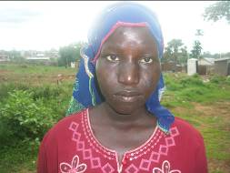
Face picture of Zaitun Acan

Living positively, life has been hard for Zaitun as she has faced insults from the community and especially her aunt Hadijah and some school children.
“Because of these abuses, I have tried to commit suicide twice, these people make it hard for me to live,” sadly mentioned Zaitun.
Zaitun continued to say that, “Am always covering myself because of the scars that are all over my body, the doctor told me this is as a result of the ARV medication that I receive from the hospital,” mentioned Zaitun.
In an attempt to reduce the insults, the field officer went with Zaitun to a medical doctor who recommended Dermizol, Dexa, and a tube for scars called No scars, the total cost of the medicine was USD 6. The medication was prescribed to be used on a daily basis for effective response and so far there are changes in Zaitun as she is developing confidence in herself.
Zaitun was also advised to live with another aunt, by her school teacher and hence she is now living with Akello Faridah instead of Aunt Hadijah, whose care she was left under.
She has got two siblings (Enon Hussein S.4 and Okodin Safi S.5) who are being supported by an organization in Lira called “Children of Hope”.
One of Zaitun’s interests is in playing games, preferably netball.
Zaitun is currently in primary seven at Lango Quran primary school in Lira district and her favorite subject is science in which she scored 75% at the end of term one . Her dream is to become a doctor so that she can properly treat and care for people in situations like hers. “I hate that am infected and I don’t like the fact that there is no cure for this disease, that’s why I want to study and become a doctor, so that I can make a difference in the lives of people like me,” Zaitun further elaborated.
Zaintun would like PLA to support her in education and continue counseling her so that she can attain her dream of becoming a doctor.
OUNI FIONA’S STORY
14-year old Fiona was born to the late Onui Geoffrey and the late Florence.
“My father died in 2007 and my mother later died in 2010. Since then, we have been by ourselves with no relative to cater and look after us,” explained Fiona.
Fiona has 5 siblings, 22-year old Ouni Moses who dropped out of school, 20-year old Andrew Ayo who is being supported in S.5 by children of Peace Lira, 13-year old Okabi Emmanuel, 11-year old Amongi Doreen in p.4 and Atofa Hudson in p.3 are at Lira primary school.

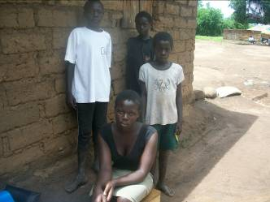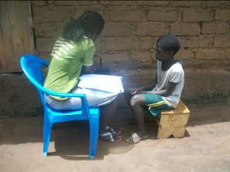
Left: Fiona’s sibilings that were at home during the monitoring visits. Right: the field officer inquiring from the 11-year old Doreen about her challenges of not having parents.

“Life was so good when our parents were alive. We could easily run to them and say we want a particular dress and they would buy them for us, but now we at times don’t have clothes to go with to church, this really makes me sad,” explained Fiona.

Fiona’s elder brother dropped out of school because of lack of fees to continue. At the time of the visit, Fiona’s brother had traveled to Western Uganda where a friend had promised to find him a job so he can look after his sibilings.
Fiona is now left with the responsibilty of taking care of other children since her brother left. The family now lives in a village calleged Kakoge near Intergreted primary school in Ojwina division.

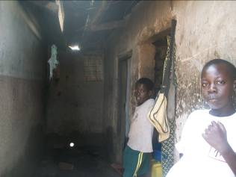
Above: the house which Fiona and her siblings live in

“Some of our property was grabbed by our realtives when our parents died, things like chairs were taken, we now only have very few things in the house,” Fiona Explained to lira field officer during the home visit.

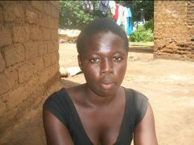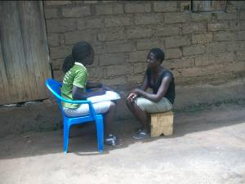
On the left is a face picture of Ouni Fiona and on the right is the picture showing Fiona as she shared her story with the Field officer

Fiona is going to write her primary leaving examinations this year at Ojwina primary school. “I study at jack and Jill primary school but as the other primary seven pupils at the school registered to seat for PLE, I was home sick, so I had to get a school that had not yet registered for the primary Leaving examinations and that was Ojwina primary school,” explained Fiona.

Fiona is a good performer who managed to stay in the 34th position out of 284 pupils in her class and her best subjects are English and social studies.

“I want to become a lawyer, so I can put all the guilty people in jail, like the people who mistreat children,” mentioned Fiona.
Fiona’s rural home is in Amogo near Ibule primary school in Alebtong district.

“At home, we survive at the mercy of some of the people that our father was good to, they bring us money and at times food, though there are times when we are not sure whether we will have food or not,” sadly mentioned Fiona.
Fiona has got high interest in school and because of that, she wants the organization to support her so she can become a better person in future.
HOILDAY EVENT
During the first term holidays, Lira field officer was able to mee with PLA beneficiaries to share ideas, life experiences and their future dreams.
One of the girls, Awio Cinderella of Adyel primary school, shared that she would like to be able to help the communities especially on things related to the society. “I want to help children like me, who have no parents,” explained Cinderella.

The activity that was carried out on 11th may 2012, saw a number of 45 girls attend and interact with each other. The girls were able to play games and share ideas as they also promised to help each other out during the holidays in subjects that challenge them in class.
The primary girls agreed to meet and revise their books and past papers during the holidays. This was after they had each shared the subjects that they have problems in and realized that they were strong at different subjects.

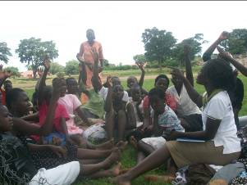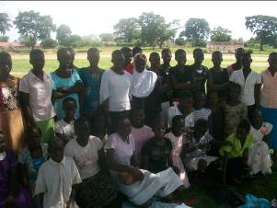
Left: is a picture of the field officer as she chooses the next girl to tell her story, on right is the group picture of the girls that were selected and visited by PLA

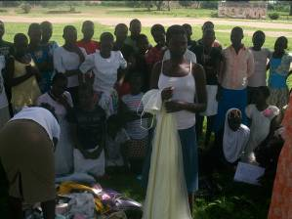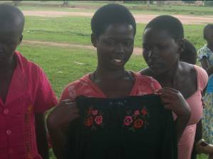
Above: the girls as they show off some of the clothes that they received from the field officer

During the school holiday, the girls will continue to have a holiday event with more games and receive materials such as clothes and sanitary pads from the organization. This will continuously be done to boost their self-esteem and confidence.

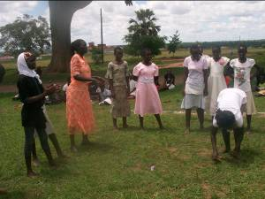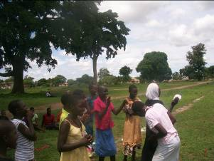

Left: is the field officer joins the girls in a game called ‘count’ while on the right is a picture of the girls as they cheer their teams in the count game.

ACHIEVEMENTS

The major achievement of the quarter has been the successful payment of the beneficiaries’ fees for the year 2012 and enrolling one of the girls Atai Sandra into Boarding school.

45 successful selection of more girls and Successful monitoring and counseling of 45 girls both at home and at school.

This year PLA has 3 P.7 candidates who will need constant monitoring and counseling so that they are able to perform better and join secondary school.

CONCLUSION

A number of activities were carried out in the three months of April, May and June that included payments of fees, counseling, school and home monitoring visits. The selected girls were given hope of a better future and the current PLA beneficiaries were appreciative that PLA still supports them in school.

The primary seven beneficiaries have agreed to meet during the holidays to study as a team and further explain to explain the subjects and topics that they never understood while in class.

In the next quarter, the beneficiaries will continue to receive counseling, there will be school and home visits and a holiday even where the girls will get to share their life experiences and what how the new beneficiaries feel now that they are part of the project.

