PROJECT TITLE: EDUCATE 200 WAR AND HIV/AIDS ORPHANED UGANDAN GIRLS
PROJECT WEBSITE: http://www.globalgiving.org/projects/aids-education-uganda
LOCATION: LIRA DISTRICT NORTHERN UGANDA
REPORT PERIOD: QUARTERLY REPORT FOR THE MONTHS JANUARY, FEBRURAY AND MARCH 2012
COMPILED BY SUSAN EJANG LIRA FIELD OFFICER

INTRODUCTION

Educate 200 war and HIV/AIDS orphaned girls is a project that is funded by Global giving. This project started as a result of the 21 years old LRA war that left so many children orphaned. As a result of the war there was need for rehabilitation and a better future for especially the girl child. The project is currently supporting 5 beneficiaries: Atai Sandra p.7 at lira primary school, Ateng Rebecca p.5 at Elia Olet primary school, Awor faith p.7 at V.H Public school, Akot Rebecca p.7 at V.H Public school and Abeja Eunice in senior three at Savior secondary school. The beneficiaries are being supported with school lunch worth USD 225, scholastic material worth USD 425 and counseling. During the month of February, the field officer also started to identify new beneficiaries; she made visits to the community. In the selection process the field officer Lira has been supported by other people and organizations in Lira district like the Community Development officer, local leaders of the different areas in Lira district like Ojwina division and Adyel divisions. So far 35 girls have been identified. The selected children are the needy girls affected or infected with HIV/AIDS. All 35 new girls have received counseling and are ready to be placed in schools in the next quarter.
ABEJA EUNICE
18 years old Eunice is currently in senior 3 at Savior secondary school in Lira district.
“Last year 2011 one of my best done subjects was Agriculture where I scored 61% followed by biology where I scored 50%,” Eunice narrated.
“When PLA started supporting me in primary 4, my life became better, I stopped missing class, since the school also stopped sending me away for not having books and unpaid fees. I appreciate what PLA has done for me and I pray that GOD richly blesses the people that support me in school,” mentioned Eunice

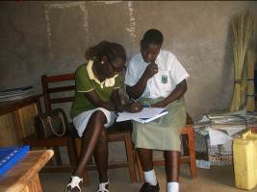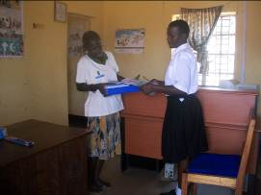
Photo showing the field officer Susan Ejang and PLA beneficary Eunice Abeja during the school monitoring visit. On the right is a photo showing Eunice receiving her scholatic materials from the field officer at PLA Lira office.
Eunice wants to become a nurse. “That’s why I am trying to perform better in biology; I want to be able to help the sick,” explained Eunice.
In her free time Eunice loves singing and joining her friends in discussion groups.
“During the holidays, I visited my village in Amugu for the first time with my brother Moses. We were able to find our uncle Johnson Ochieng whom we also helped in the farm as he continuously provided us with milk for breakfast. I was so happy there”, added on Eunice.

AWOR FAITH
14 Years old faith is now in primary seven at V.H public school.
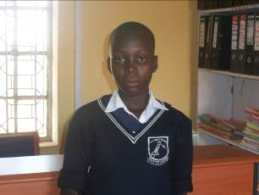
On the left is the face photo of Awor faith PLA beneficary

In her last performance, Faith was in the 142nd position out of 217 pupils of her class. “Last year in third term, I was frequently absent from school, I would continously fall sick and I therefore missed a lot of lessons, that’s why my performance was poor”, narrated Faith.

Faith is HIV postive but this year her health has improved since she has not missed any lessons. In one of her farvorite subjects, Faith scored 56 in english and 37 in maths, which she has promised to improve so as to become an accountant. “I remember when my father was alive, he advised me that I should perform better in maths to become an accountant, I miss him talking to me,” sadly mentioned Faith.

In a chat with Faith’s mother Grace, she mentioned that she was very grateful for the support that PLA continues to provide to her daughter. She narrated, “I was left with 4 children by my late husband and they are all hard to take care of especially since they are all infected.”

THE RESULTS OF PLA beneficiaries who did final exams in 2011.
AGUTI DORINE
15 years old Aguti Dorine sat her Primary leaving Examinations at Aduku road primary school. Her performances have been good at school and it kept her hopes high of becoming a minister or an accountant one day. Dorine scored 18 aggregates: 4 in English, 4 in Science, 5 in SST and 5 in math. Dorine now studies at St Catherine secondary school in Lira. Dorine will continue to receive counseling from PLA in the holidays since she is already in school and being supported by her guardians.
AKELLO MARGRET
17 years old Margret sat her O’level examinations in the year 2011 at Okwang secondary school.
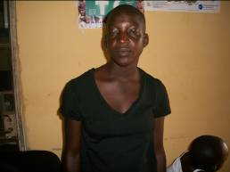
Face picture of Margret Akello
Margret scored 33 for the 8 best subjects and the breakdown of her results is as follows
- English 4
- Math 3
- Geography 4
- Physics 4
- Biology 6
- History 4
- Commerce 4
- Chemistry 7
- CRE 6
- Fine art 4
Margret has now been admitted at Dr Obote College in Boroboro and will be studying a combination of Physics, Economics, Math and Computer science. With continuous support from PLA Margret hopes to attain her dream becoming an engineer.
IDENITIFICATION OF NEW BENEFICARIES
During the month of February, the field officer also started to identify new beneficiaries for the project. In the selection process the field officer Lira has been supported by other people and organizations in Lira district like the Community Development officer, Organizations like Atin Afrika foundation and local leaders of the different areas in Lira district like Ojwina division and Adyel divisions. So far a number of 35 beneficiaries have been identified and soon final ones will be selected according to PLA’s selection criteria and therefore be supported by the project.

STORY OF HOLGA APIO

14 years old Holga is in primary six at Lira police primary school. She stays in Ojwina division with her aunty Nakibule Betty who she has gotten used to as her mother. Holga’s father was killed during the LRA war in Lira district and her mother died of HIV/AIDS. She stays in Alito camp.

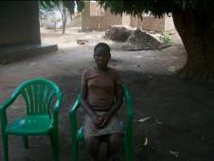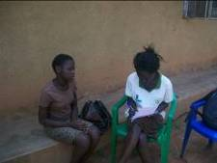
On the left is the face picture of Holga Apio and on the right is the photo of the field officer as she talked to Holga in Ojwina division.

Holga would like to become a doctor in future.

“I love science and I want to make a difference in people’s lives while I discover different medicines,” happily mentioned Holga.

In her mid-term examinations, Holga scored 92% in science and she was in the 18th position out of 245 pupils of her class.
During the holidays Holga likes playing netball and helping her aunty with the house chores.
“I would like Platform for Labour Action to help me attain my dreams,” mentioned Holga.

At lunch time Holga watches her friends eating as she stays in her class. “At times I decide to put my head on the desk because of hunger and yet the teacher wants us to look at him while he is teaching,” sadly mentioned Holga.

