Akullu Said that she wants to be a teacher he most liked subject is Social Studies

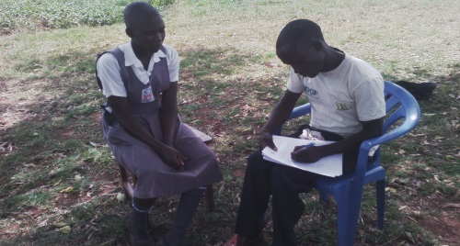
The above photos showing Administrative Volunteer sharing with Akullu ’s life experience bot at home and school

