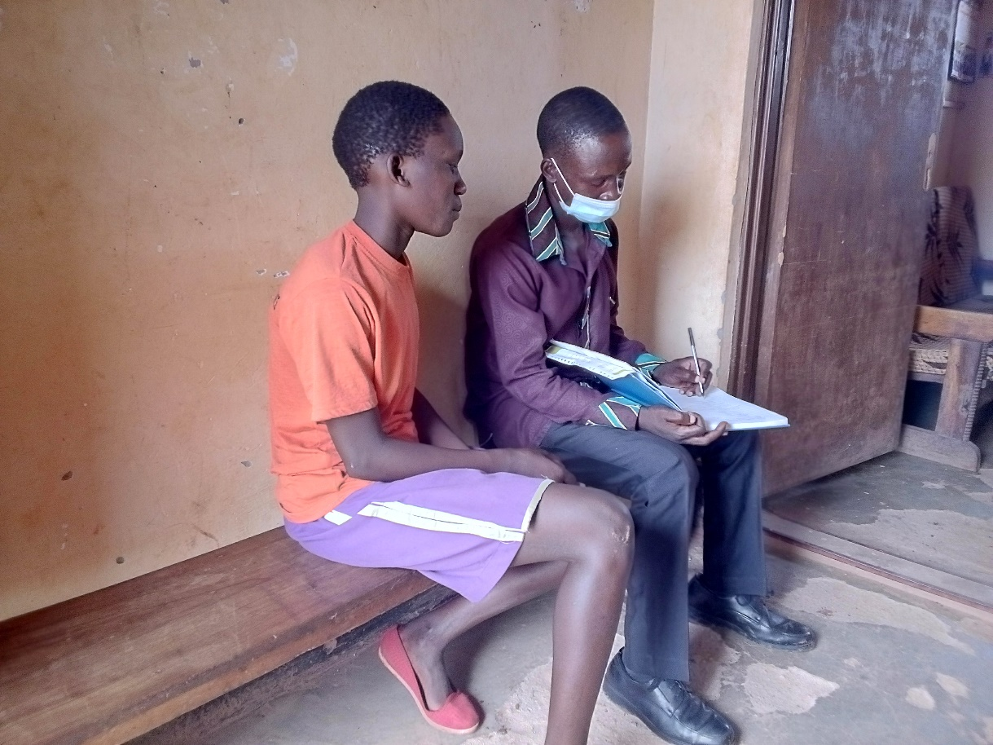
The above photo showing PLA Administrator with facemask with Akullu primary seven beneficiary during school monitoring visit `

