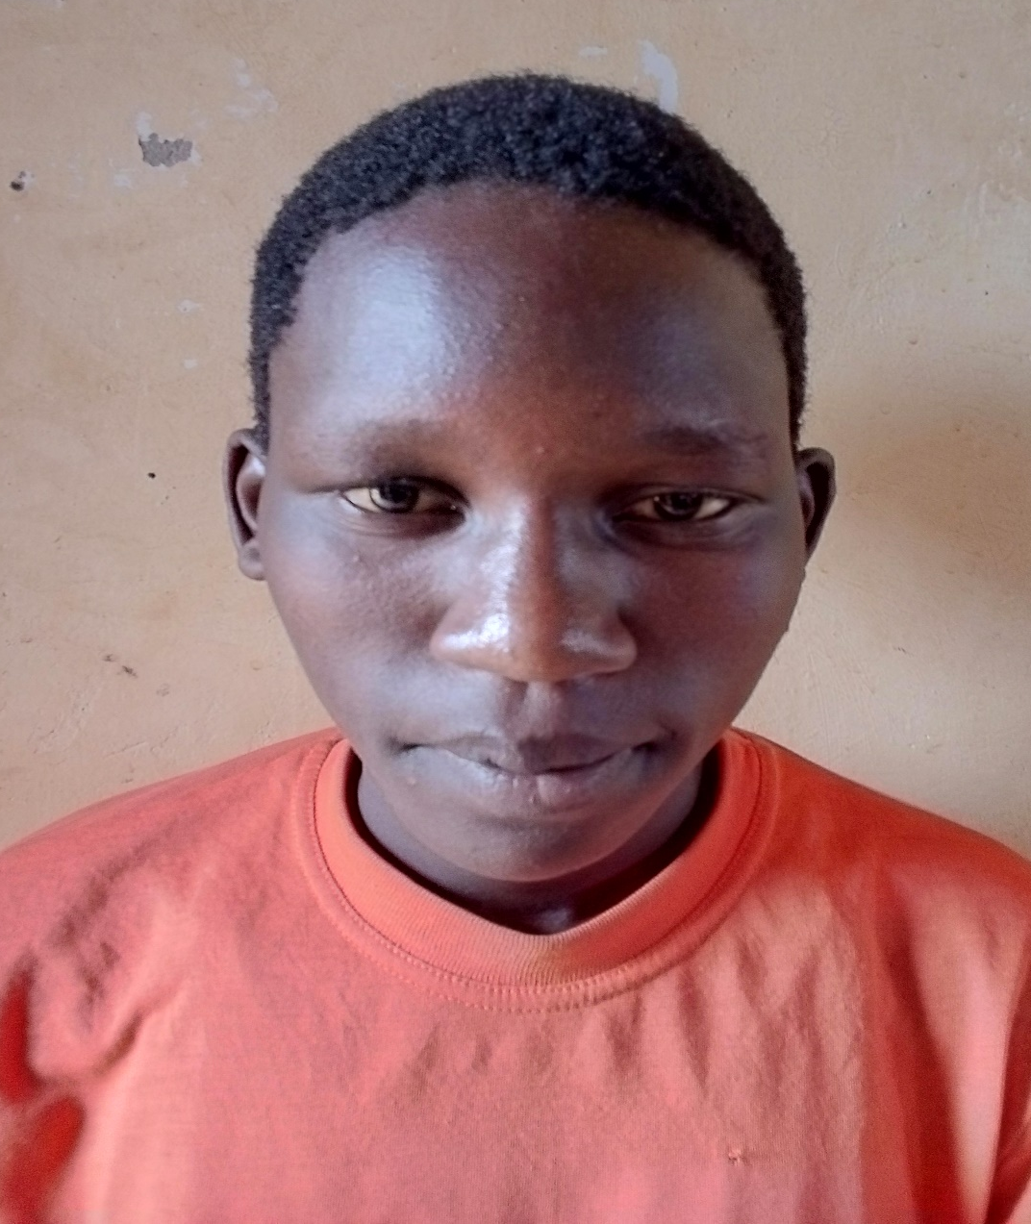
Caption above shows PLA Beneficiary Akullu Primary Seven proud to be supported by PLA

