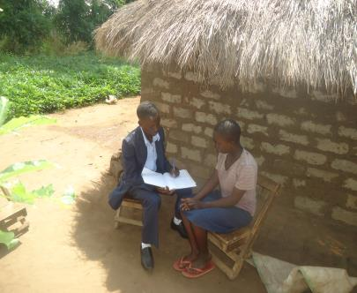

Above is a picture showing PLA administrative Volunteer Odong as he notes down some of the issues that PLA beneficiary Obii undergoes both at home and at her school.

