Morine`s photo

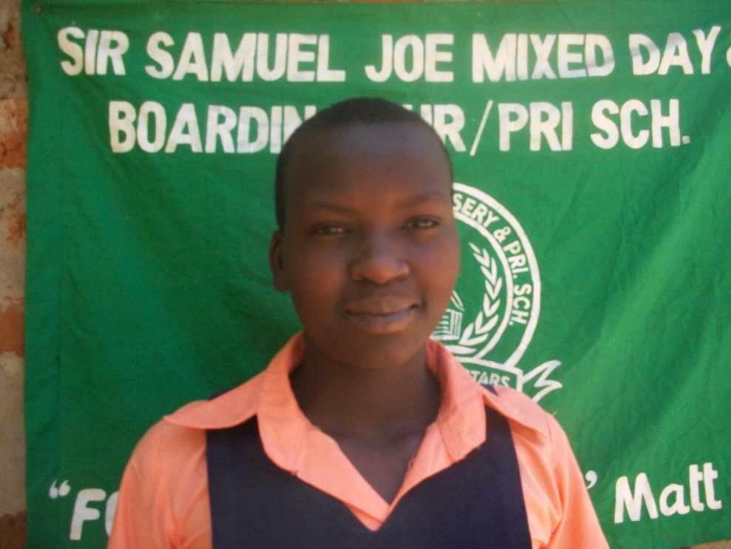
Above is a face picture of PLA beneficiary Morine

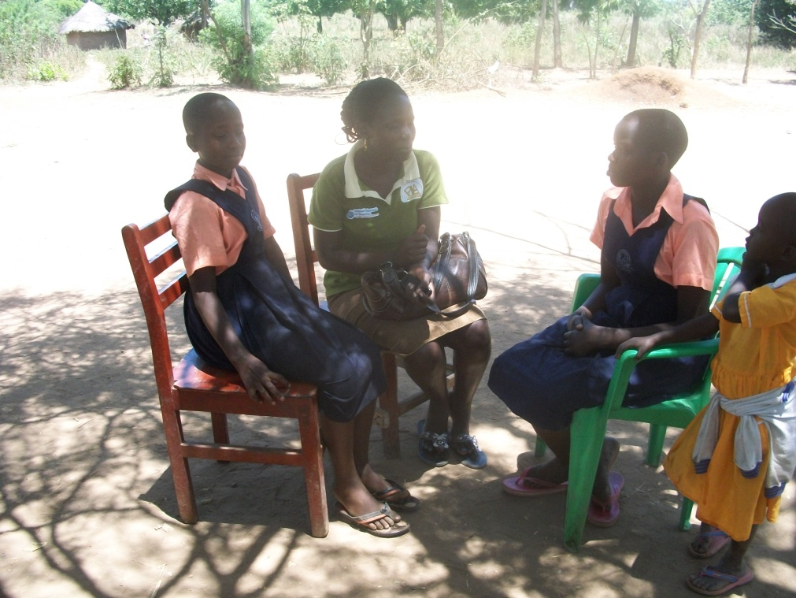
Above is a picture showing PLA staff Susan Ejang as she talks to PLA beneficiaries Morine and Fibby during the school monitoring visit at Sir Samuel Joe Nursery and primary school in Lira district.

