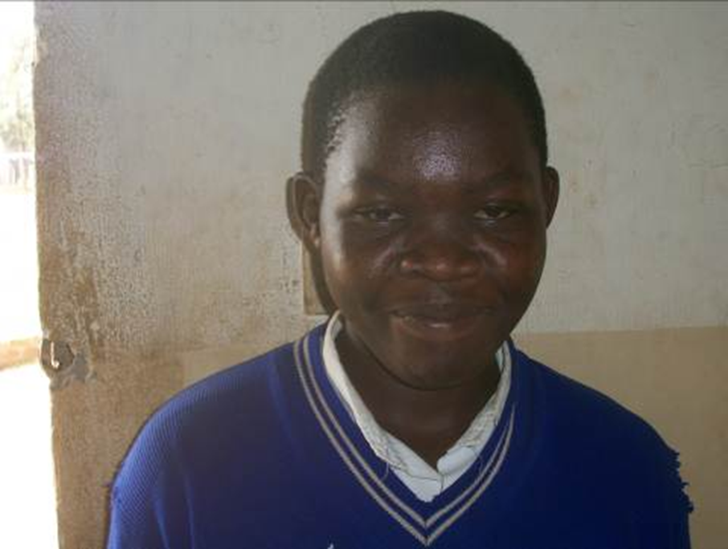
Above is a face picture of PLA beneficiary Sandra Amodo
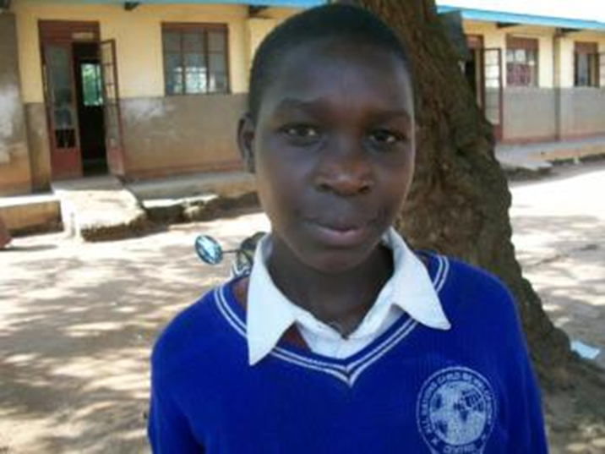
Face photo of Among Emily.

