Partners Across the Ocean, NFP
A recognized public charity under section 501(c) (3) of the IRS Tax Code
Tax ID Number EIN: 33-1145646
www.partnersacrosstheocean.org

A Proposal to Transform Ten
High Schools in
South Africa through
International Collaboration

Sisonke Sakha Ingomso: Building Tomorrow Together!

Organization Mission Statement

To improve the education of students in the impoverished townships of South Africa

Project Objective Brief

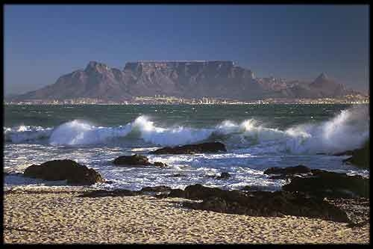
Partners Across The Ocean is designing a project in partnership with the Western Cape Education Department, which will transform ten impoverished high schools in Khayelitsha Township, near Cape Town, South Africa. Together we can make a difference for ten high schools; improving the education of approximately 12,000 South African students!
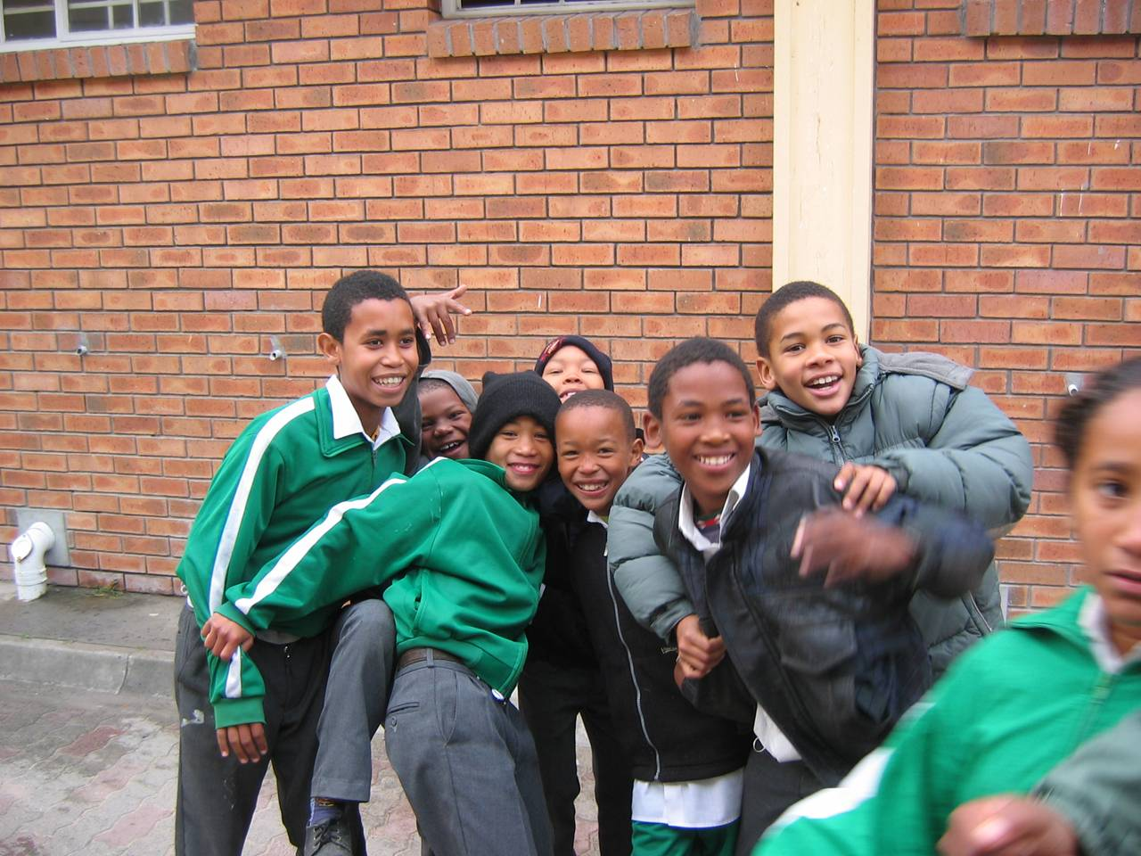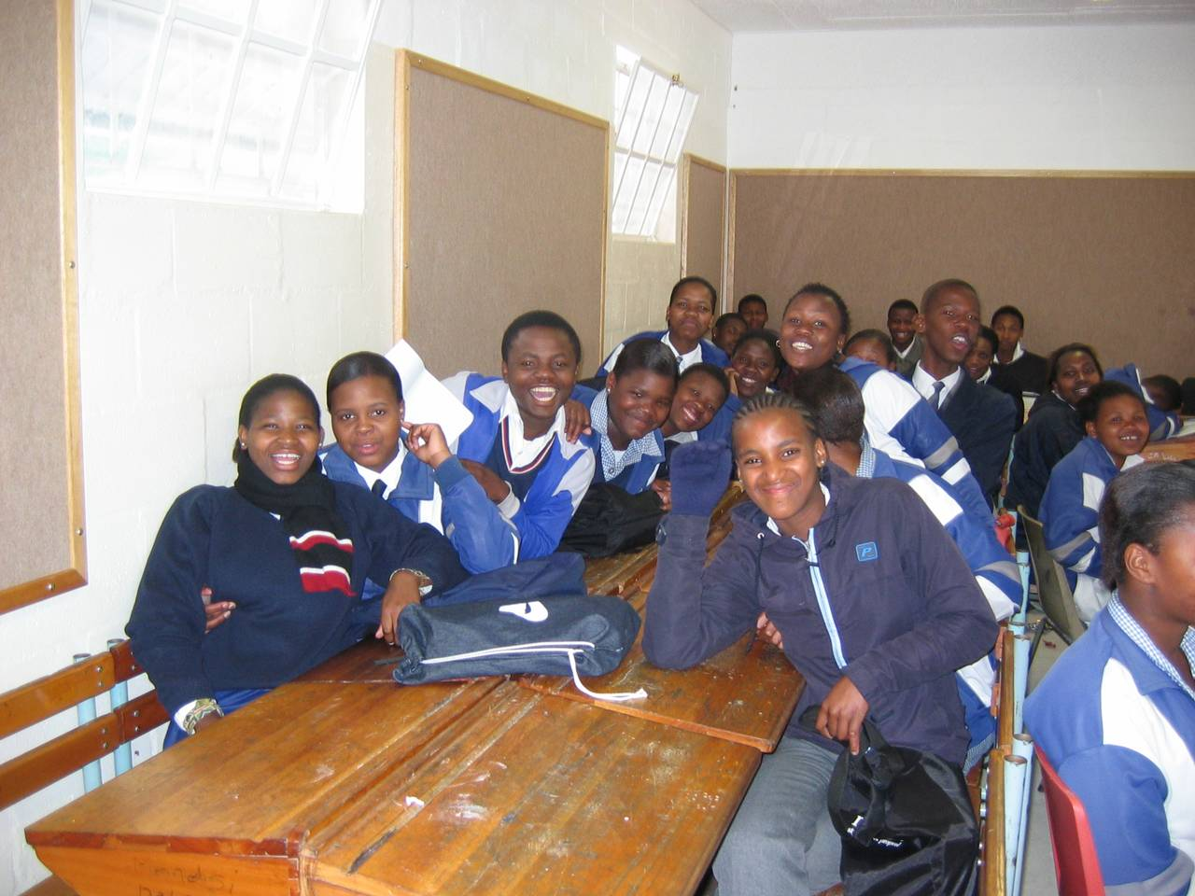

Contents:
Executive Summary Page 3
Program Overview Pages 4-5
Partner Organizations Page 6
School Profiles Page 6-9
Budget Page 10
Khayelitsha Township Page 11
Contact Information Page 12

Executive Summary

Transforming Ten High Schools in
South Africa through
International Collaboration

In an international effort to strengthen schools in Khayelitsha, one of the most impoverished townships of South Africa, Partners Across The Ocean is requesting funding to build an international school improvement network involving ten high schools. The three-year project will improve the education of approximately 12,000 South African students!

The program will feature education professionals, school improvement experts, motivational speakers and facilitators from both the United States and South Africa. The network will be created through execution of an intensive two week program and the on-going utilization of technological resources. The program will be supervised locally through a partnership with the Western Cape Education Department.

The primary goals of this action plan would be:

1. To improve the knowledge and skills of high school teachers in the township of Khayelitsha.

2. To provide leadership development opportunities for the learners of Khayelitsha schools to advance their leadership qualities.

3. To strengthen the leadership capacity of Khayelitsha high school principals.

4. To offer the opportunity for each participating school to develop an original plan of school improvement.

5. To allow each participating school the on-going support and collaboration with international partners including Partners Across The Ocean, Zion-Benton Township High School and other international agencies to be identified.

Program In-Depth Overview:

- "Partners Across The Ocean Teacher Council"
Educator Focus—Teacher Development---The school principals would select a core group of teachers from each of the schools who desire to improve their instruction and further their individual schools development. The central focus would be on teacher empowerment activities and would be advanced through open discussion. The lead categories to be explored are:
a. Best practices in the classroom
b. Curriculum and syllabus development
c. Access to resources
d. The integration of curriculum across all disciplines
e. Applying technology to engage learners in course material
Back in their home school the teacher would be given time to implement the ideas and access to email for communication with partners. Furthermore, each teacher would be assigned a partner across the ocean; a teacher from the USA who shares the same teaching discipline for correspondence. Please note that the full agenda of the “Teacher Council” sessions would be developed with the input of all partners, through two way electronic communication.

- "Partners Across The Ocean Youth Leadership Academy"
Learner Focus—Creating Youth Leadership---The learners selected from targeted Khayelitsha schools would attend a leadership academy and develop skills to help them succeed. The program would center on 10th or 11th grade learners selected by principals or their designees. The sessions would feature both American and local facilitators, serving on a volunteer basis, providing different instruction, team building activities and would include many leadership development opportunities as well as outings. Each student would also be assigned an email pen-pal adult mentor from the USA and/or South Africa.

- “Partners Across The Ocean Principal’s Forum”
Principal Focus—Strengthening School Leadership---The Principals from the selected schools would gather for a series of activities conducted by both local and international professionals, serving as volunteers. The local component would focus on a review of successful case studies in school improvement and the development of the total school curriculum. Internationally, the integration of curriculum across all disciplines will be outlined as well as applying technology to engage learners in course material. In addition, strengthening a school through international collaboration will be a key area of discussion. Like the Teacher Council, the full agenda of the “Principal’s Forum” would be developed with the input of all partners, through two way electronic communication.

Program Overview: (continued)

4. School Improvement Planning
Upon completion of each mornings activities the Principal, educators and learners of each respective school would gather together for a “School Team” discussion. Each session would be facilitated by a trained room supervisor but the actual areas of discussion would be designed to address the needs of the particular school. Attention would be devoted to developing and implementing a School Improvement Plan based on resources available as well as the needs and wants of the respective school. Upon completion of these discussions within the “school team” each school improvement plan would be computer generated and presented to the respective school governing body at their building.

On-going project management would be provided by Partners Across The Ocean but the plan would be driven by the Principal, educators and learners of the school. Local management of the plan would be provided by the Western Cape Education Department.

5. iNet Partnership
Each school engaged in the Partners Across The Ocean network will be connected to American schools such as Zion-Benton Township High School by utilizing the Western Cape Education Department’s iNet initiative. The use of iNet technology would allow planning to be conducted in advance thereby maximizing the relevancy of the sessions to the needs and wants of the school as well as developing a deeper understanding between the American and South African partners. Furthermore, the iNet would be crucial to sustaining the developments made during the training sessions described above. The iNet was created to allow international networking between schools.

Organization Partners for the Project
- Western Cape Education Department (South Africa)
- Specialized Schools Trust (United Kingdom)
- Zion-Benton Township High School (United States)
- Shades Multicultural Club (United States)

Overviews of Partner Schools
The schools chosen for this project were selected because they serve extremely impoverished communities but offer strong leadership and a history of successful school results.
- Zola Senior Secondary School
School Details: (as of 2009)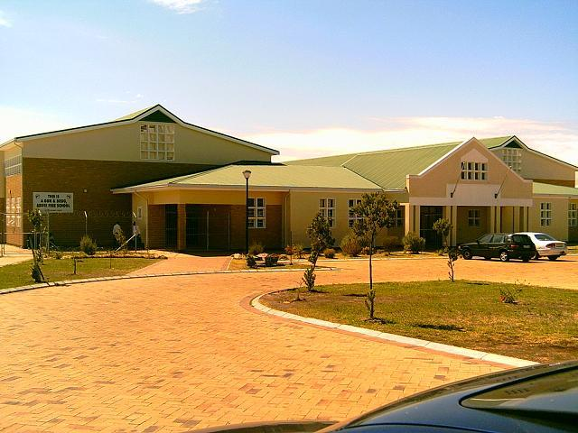
Number of PCs: | 169
Educators: | 34
Learners: | 1094
Learner/PC Ratio: | 6:1
- Matthew Goniwe High School
School Details: (as of 2009)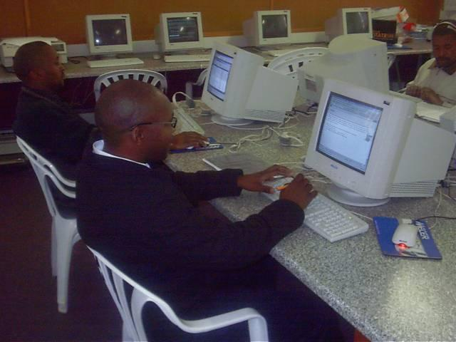
Number of PCs: | 45
Educators: | 48
Learners: | 1649
Learner/PC Ratio: | 37:1
- COSAT College of Science and Technology
School Details: (as of 2009)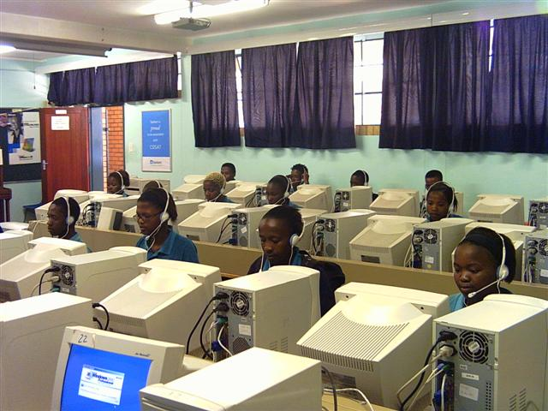
Number of PCs: | 59
Educators: | 8
Learners: | 140
Learner/PC Ratio: | 2:1
- Chris Hani High School
School Details: (as of 2009)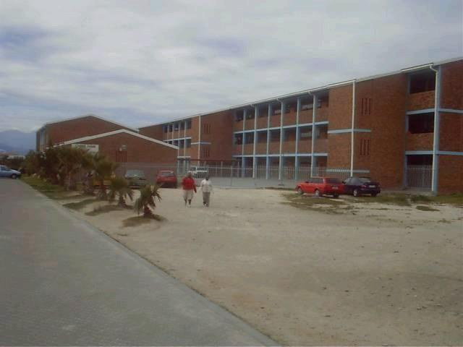
Number of PCs: | 64
Educators: | 52
Learners: | 1676
Learner/PC Ratio: | 24:1
- Hector Peterson Secondary School
School Details: (as of 2009)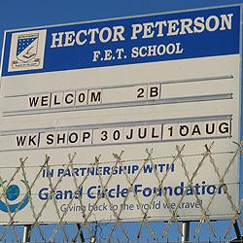
Number of PCs: | 50
Educators: | 45
Learners: | 1500
Learner/PC Ratio: | 30:1
6. Khanyolwethu Senior Secondary School
School Details: (as of 2009)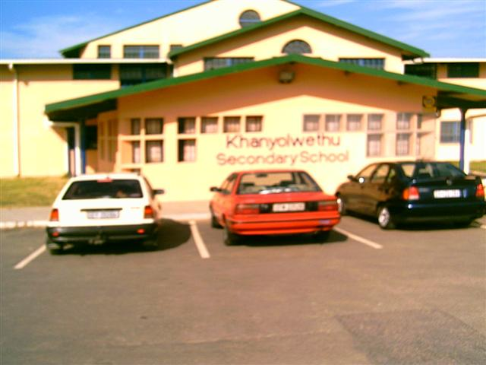
Number of PCs: | 36
Educators: | 38
Learners: | 1421
Learner/PC Ratio: | 39:1
7. Usasazo Secondary School
School Details: (as of 2009)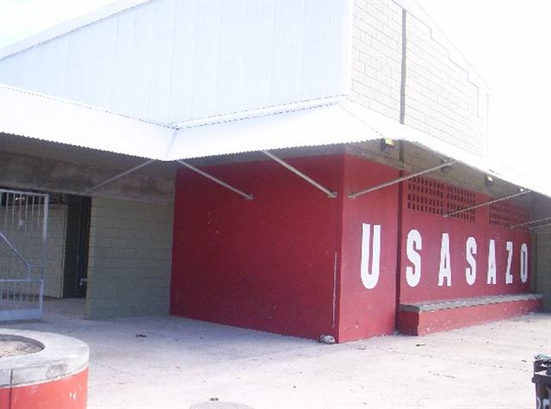
Number of PCs: | 28
Educators: | 26
Learners: | 1263
Learner/PC Ratio: | 45:1

8. Uxolo Secondary School
School Details: (as of 2009)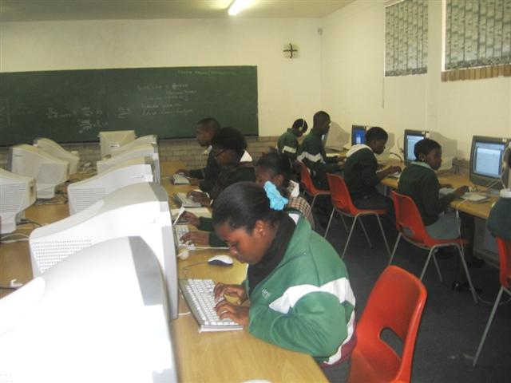
Number of PCs: | 50
Educators: | 50
Learners: | 1509
Learner/PC Ratio: | 30:1
9. Masiyile Secondary School
School Details: (as of 2009) 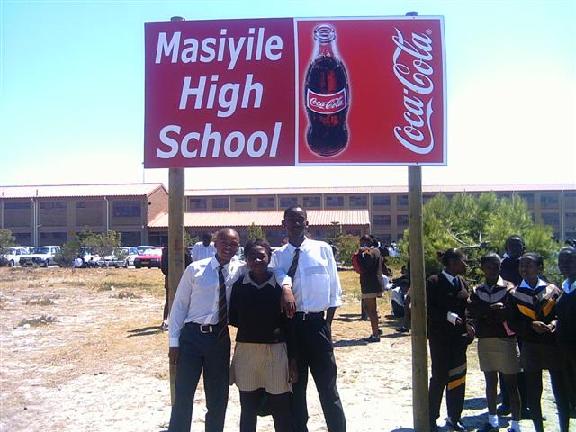
Number of PCs: | 50
Educators: | 49
Learners: | 1702
Learner/PC Ratio: | 34:1

10. Luhlaza Secondary School
School Details: (as of 2009)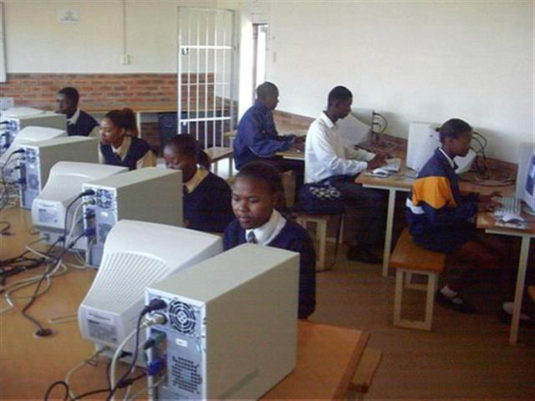
Number of PCs: | 41
Educators: | 45
Learners: | 1548
Learner/PC Ratio: | 38:1

Budget
Source | Year One | Year Two | Year Three | Total
Funding Requested | $36,500 | $25,000 | $25,000 | $86,500
Partners Across The Ocean | $3,500 | $5,000 | $7,500 | $16,000
Volunteer Contributions | $12,000 Estimated | $6,000  Estimated | $6,000  Estimated | $24,000 Estimated
Western Cape Education Department | $2,000 Estimated In-Kind contribution | $2,000 Estimated  In-Kind contribution | $2,000 Estimated  In-Kind contribution | $6,000 Estimated  In-Kind contribution
Total | $54,000 | $38,000 | $40,500 | $132,500

Year One Projected Annotated Budget $54,000
Item | Projected | Annotation
Volunteer Airfare | $22,500 | Twelve economy class flights at $1875 per flight.
Volunteer Accommodations | $ 7,200 | Secure accommodations are important as the crime rate in Khayelitsha is significant. (Twelve at $600 per person)
Technology Hardware | $1,600 | Products will be used exclusively on the project and donated to a South African school after the three year program. (one lap top computer, one projector, one digital camera, eleven flash drives, and one web cam) All purchased at deeply discounted prices. http://www.charityadvantage.com/
Software and Materials | $1,400 | Necessary software, instructional documents, handouts, certificates and supplies needed.
Volunteer Training | $500 | Training of the USA team to maximize effectiveness of time spent on the ground.
Estimated Volunteer Spending | $12,000 | Volunteers will cover their own meals, all travel documents, immunizations, entertainment expenses, tours, tips and any additional amounts over budget for airfare and accommodations.
Estimated School Expenditures | $2,000 | Estimated amount to be provided by the WCED and the individual school budgets
Web Hosting | $500 | Eleven schools to have complete access to the program for communication between students, teachers and principals.
Transportation | $2,500 | Transport American volunteers and South Africa students, teachers and principals to meeting venues and events in Cape Town. (50 People over 12 days )
Facilities | $1,500 | Rental for meeting facilities (10 days at $100 per day)
Catering | $2,000 | Lunch service for meeting attendees, local officials and speakers (40 people at 10 days. $5 per person)
International Telephone Charges | $300 | To allow full communication between participants prior to the training and to arrange volunteer speakers as well as presenters.
Salaries | $0 | PATO is an all-volunteer organization. We are attempting with this initiative for the first time to support our volunteers with travel expenses, as a compensation for their donations of time, skill and education expertise to the schools of Khayelitsha Township.  If the educator-volunteers were paid as school improvement consultants the project would cost a minimum of $30,000 in consulting fees/salaries.

The Township of Khayelitsha

This educational project primarily serves the township of Khayelitsha, near Cape Town. Once a symbol of the oppression of apartheid these townships and their residents are the hope of the "New" South Africa. The home to people with great energy and a vibrant culture, but also a place with a very high rate of violent crime. It contains both squatter camps, with metal shacks and water taps but also more permanent brick homes. Its population, which is almost entirely from the Xhosa group, has been estimated at approximately 1.5 million.
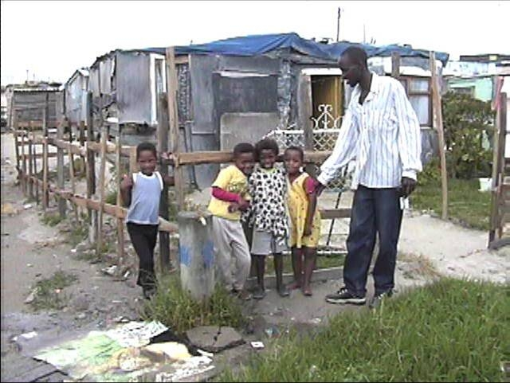
According to Mr. Cameron Dugmore, the former Western Cape Minister of Education, conditions at most Western Cape schools are "very dismal and hopeless". Furthermore, Mr. Dugmore added that “there is a critical need for a very targeted and directed strategy to develop our human resources."
Children play near a communal water tap in the Greenpoint squatter camp of Khayelitsha. Located near Cape Town, South Africa
Children play near a communal water tap in the Greenpoint squatter camp of Khayelitsha. Located near Cape Town, South Africa

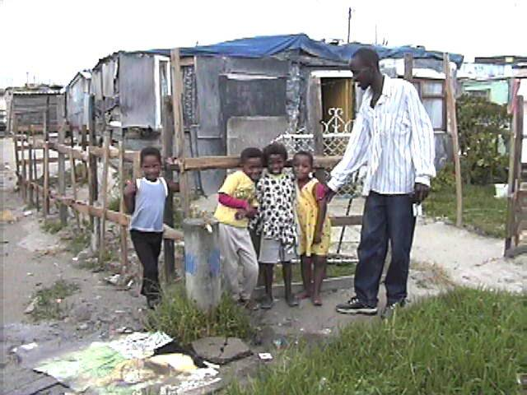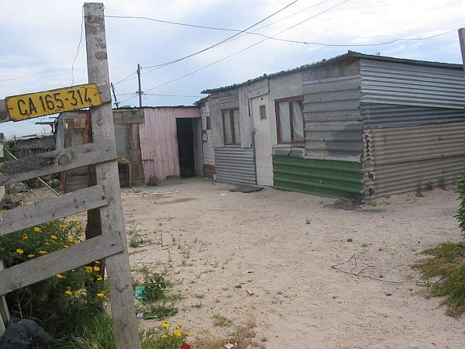

Inside of Khayelitsha, the Partners Across The Ocean technology initiative has shipped and built computer laboratories in the township and provided them with updated educational software. The organization has also sent groups of Zion-Benton teachers to the township to work with their South African partners across the ocean. South African educators have also been brought to the United States. In addition, the organization has brought exchange students from the township to the United States for one year at Zion-Benton Township High School. Upon retuning to South Africa the students are placed back into school and then proceed to the university level. The American organization also assists the funding of their university education and provides mentorship to them.

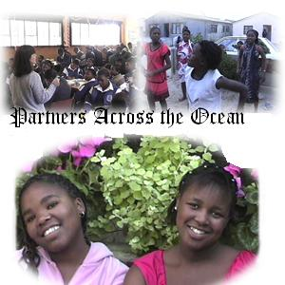
Contact Information

Partners Across The Ocean
Andrew Gomez, President
2103 Ezekiel Avenue
Zion IL 60099
USA

Phone: (847) 731-9548
Mobile: (224) 321-3492
Fax: (847) 731-4441
E-mail: gomeza@zbths.org
Web Site: www.partnersacrosstheocean.org

