ADDRESSING POVERTY AND HUNGER WITH EDUCATION & AWARENESSI

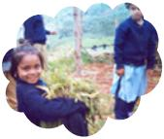

1. Children’s school gardens for health & nutrition
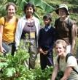

2. Childrens Home garden with
Herbs & vegetables & fruits & flowers

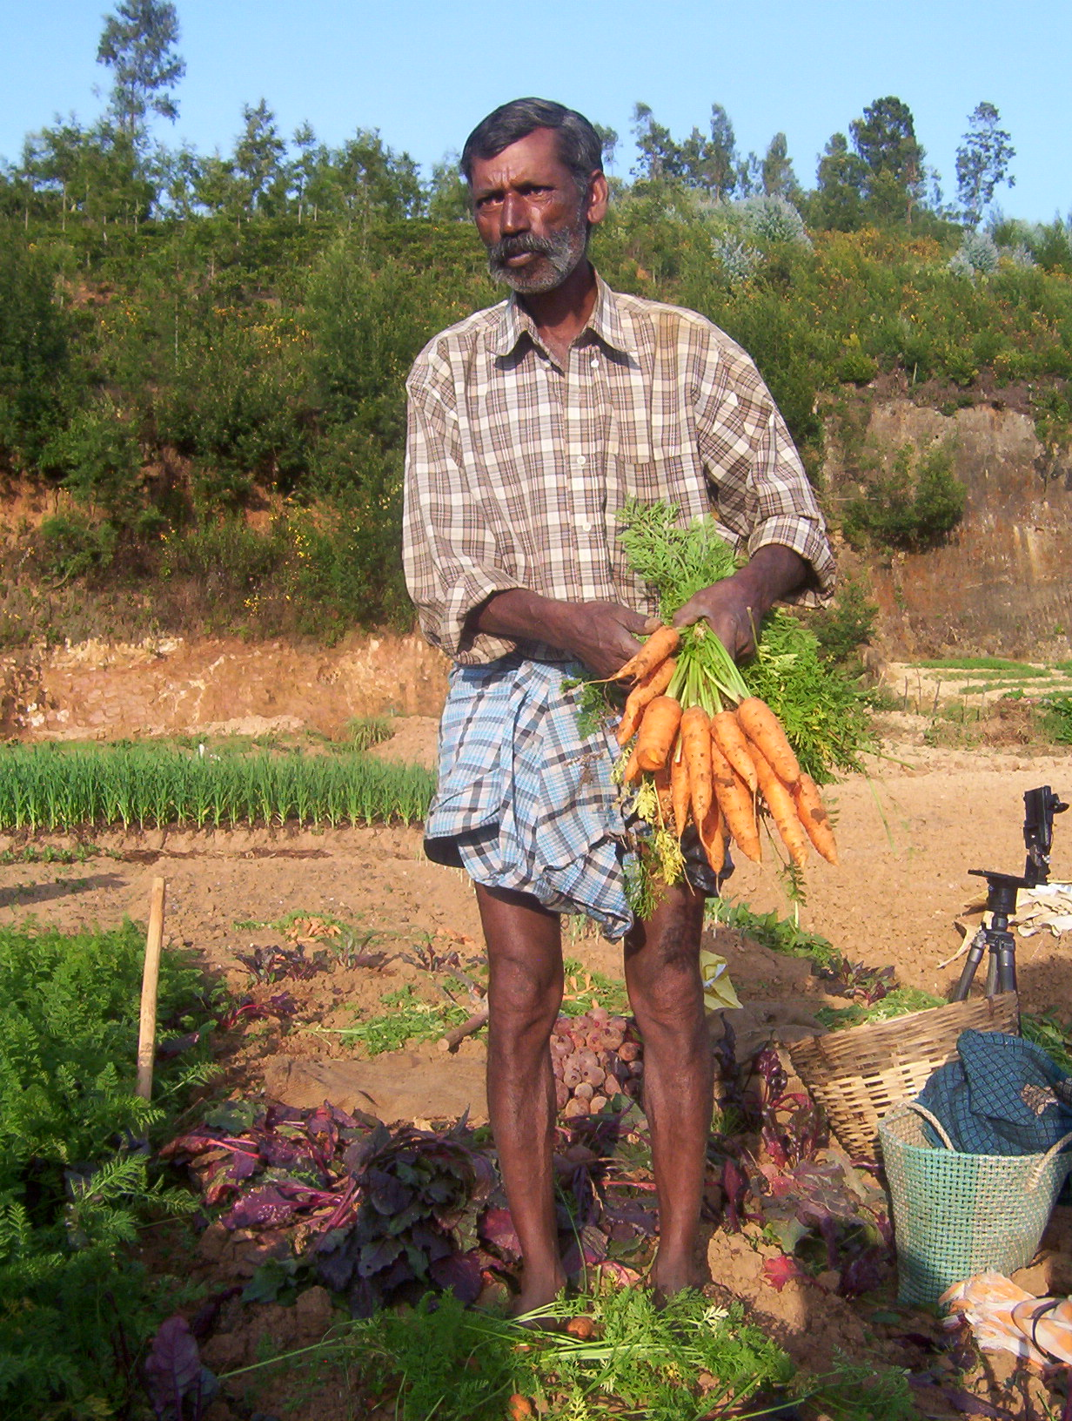
3. Organic farm produce :
Community benefit,
Regeneration of land &
sustainable production

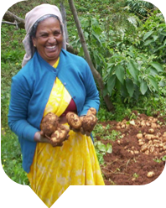

2. Children’s Home herbal kitchen Garden
With herbs, vegetables, fruits & flowers

