Kil kowatty School Seedlings planting school Organic Garden
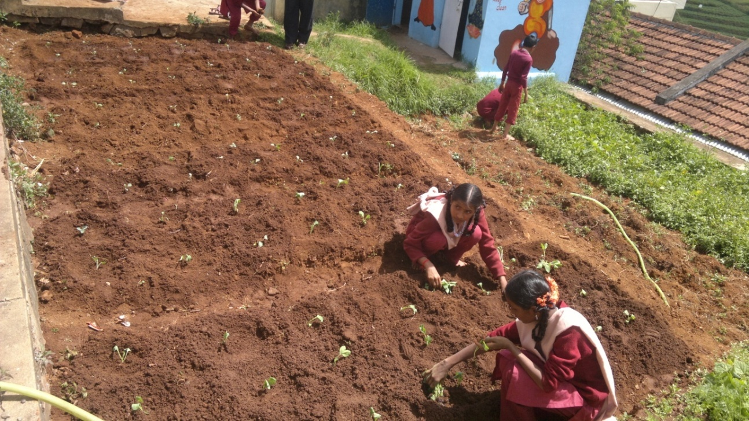
Kil Kowatty school Organic Class Taken
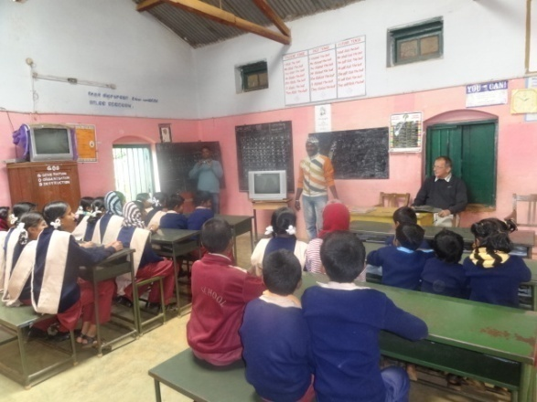

Bikol village – Krishnan Field
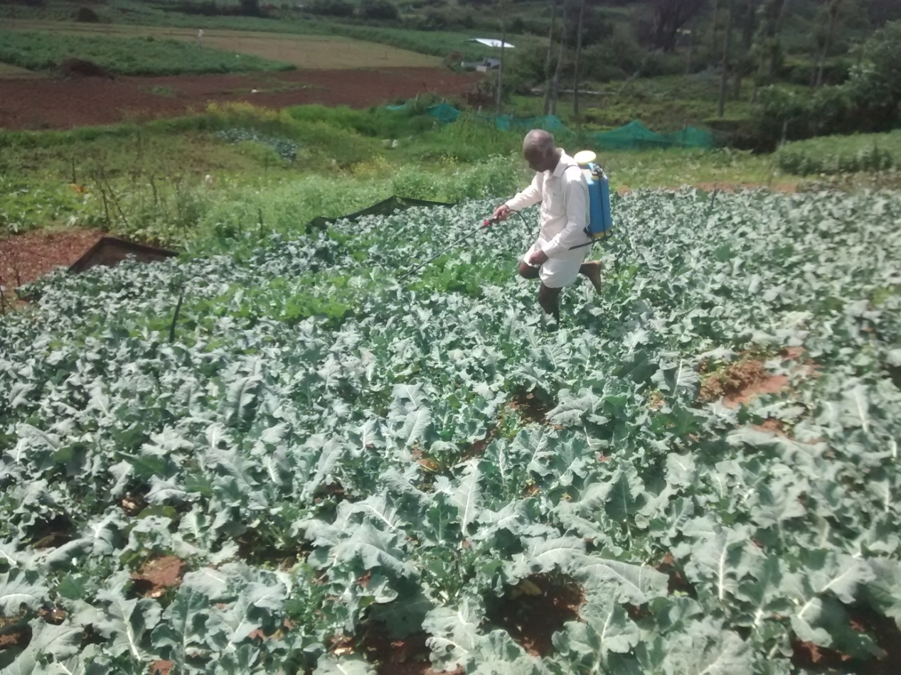
Suresh Field - Kanneri Mandanai village
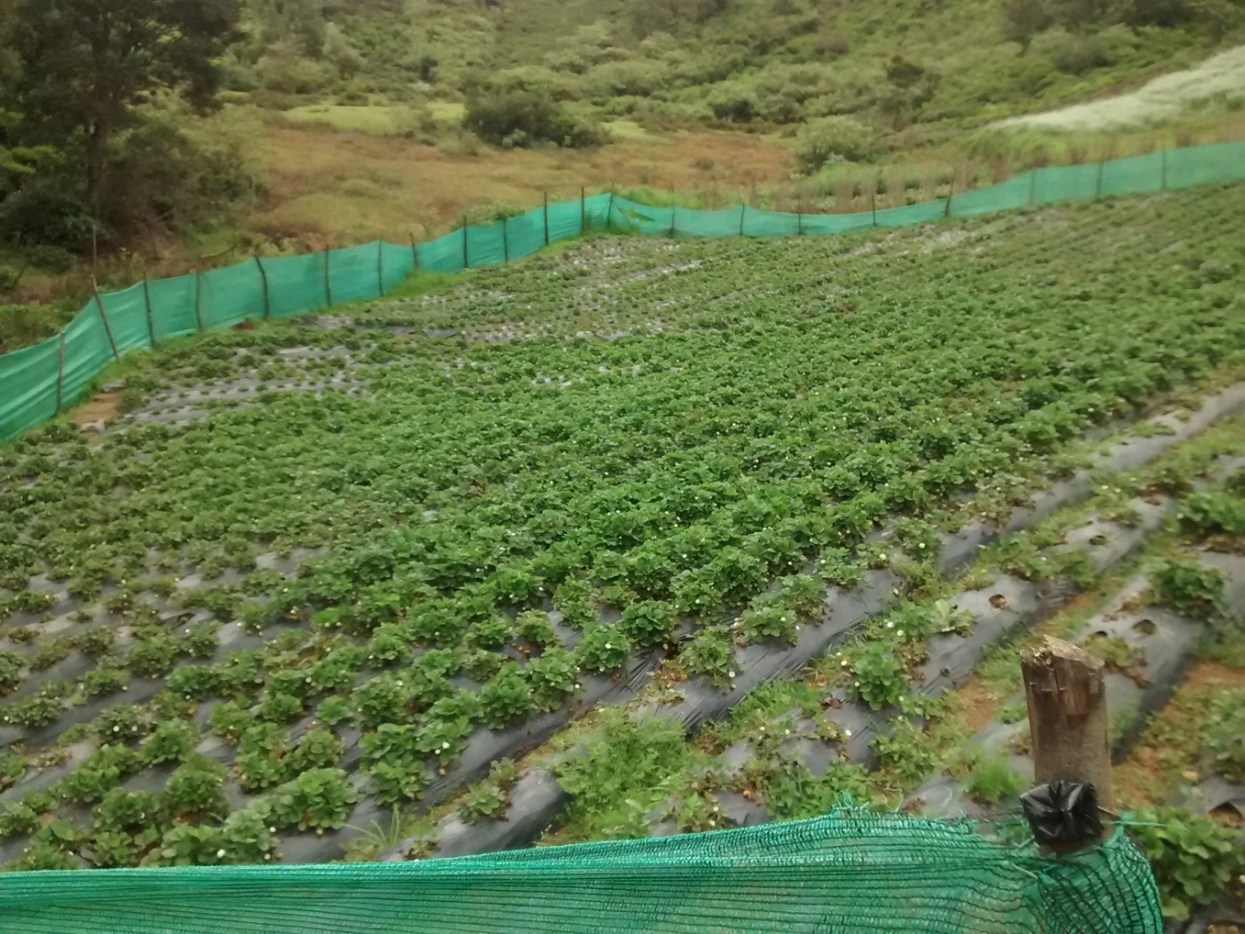
Koderi Village IGP Certification Program
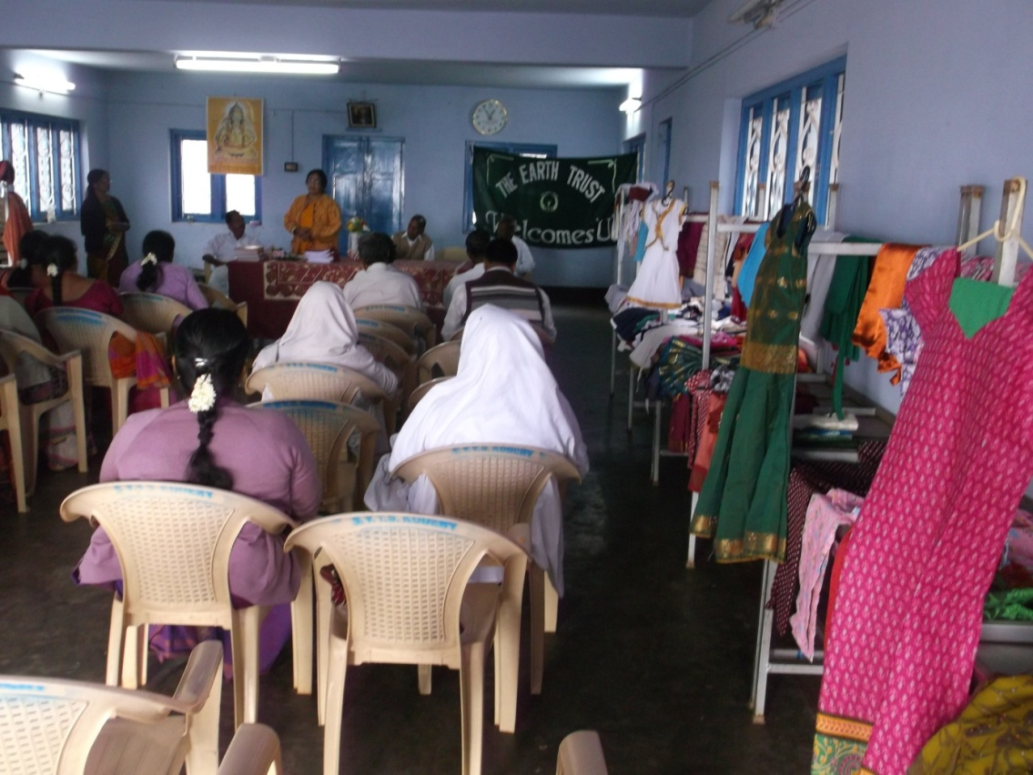
Kenthala Village – Income Generation Program Class

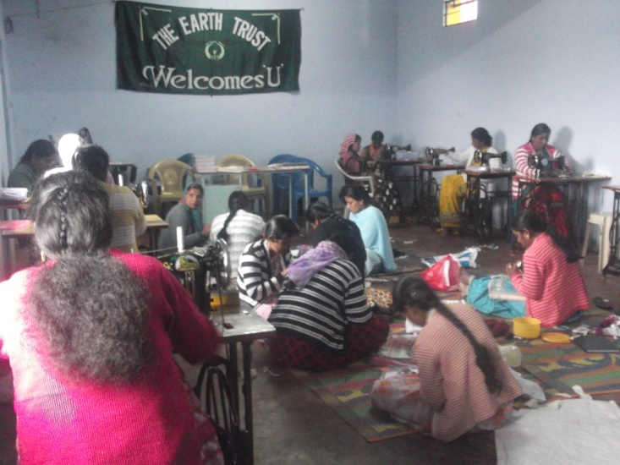

Dhoddany Village Primary Health care Training Program
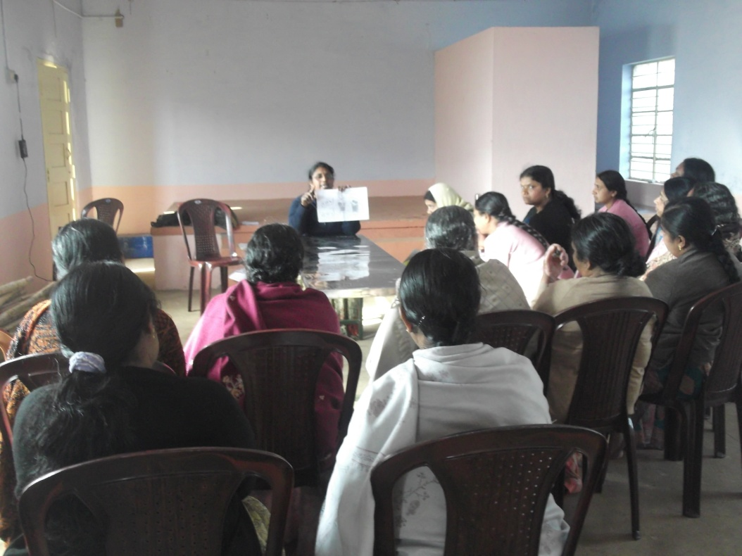

Dhodanny Village Practical session Primary Health Care Training
