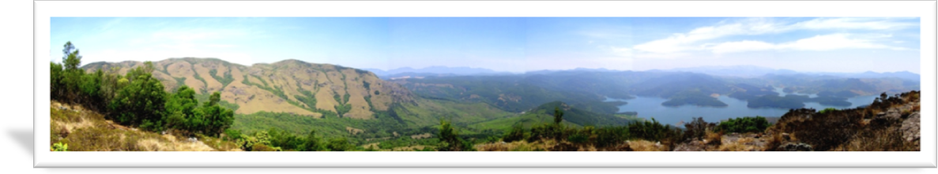EARTH TRUST NILGIRIS

HEALING PEOPLE AND EARTH

The Earth Trust works directly with villages and the tribal people of the Nilgiris Biosphere Reserve helping to reconnect, heal and preserve indigenous knowledge systems and environments. Earth Trust (ET) works in a holistic manner at each level of the rural population; with the farmers, the women & the children, engaging the community as well as working directly with environmental issues. Education plays a vital role and is the keystone of ET’s activities. The programs and projects of Earth Trust are making great strides in their efforts to ensure the health, livelihood and sustainability of these people and of this rich and diverse landscape.
THE NILGIRIS LANDSCAPE
The Nilgiris Biosphere Reserve in the Western Ghats of South India stretches across the states of Karnataka, Tamil Nadu and Kerala. It is one of the most diverse eco systems in the world, home to hundreds of thousands of rare and endangered species of flora and fauna including the tiger, elephant and Nilgiri Taur. This biosphere is made up of evergreen forest, indigenous shola forests, grasslands, dry deciduous forest, and rainforests.
Nearly 70% of India’s medicinal plants are found in the tropical area of this biosphere. According to the World Health Organization, nearly 80% of people in the world today rely on traditional systems of medicine for their primary health needs.
The Nilgiris region is in great danger due to overpopulation, industrialization, and chemical farming. The indigenous people are losing their sustenance; eroded soil and overpopulation drives others off the land and into the cities and without the proper skills to survive there, many end up in slums.
The Nilgiris districts harbor various tribal groups, the Todas, Kurumbas, Kotas, Irulas & Badagas. Medicinal plants constitute a vast, undocumented and overexploited economic resource. These plants are the principle health care for tribal wellbeing. Habitat degradation due to increased human activities, disorganized trades, loss of regeneration potential in degraded forests has accelerated the current rate of extinction of medicinal flora. Such valuable plants need to be documented carefully and protected.
Earth Trust understands the people’s dependence and connection to this sacred landscape and provides effective solutions and simple interventions for re-establishing the vital natural balance.
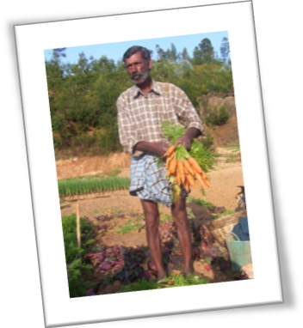BIODYNAMIC FARMING
In the agriculture sector Earth Trust provides education, hands-on training, and support to farmers wishing to convert to organics. By forming an Association of Organic Farmers called BiOGAiN (Biodynamic and Organic Growers Association in Nilgiris) a store front has been established as an outlet for BiOGAIN members to distribute and market their organic vegetables throughout South India. So far the farmers who have joined the group supply 3-4 tons of organic/biodynamic produce per month.
Plans are underway to increase the members and set up a Producer Company, which will benefit the small marginal farmers by selling their value added farm products. This includes forest communities who grow indigenous high value herbs who supply their local Herbal Health Units as well as the public market.
ECO CLUBS FOR CHILDREN
In rural India, Eco Clubs are not only teaching the next generation of farmers sound organic biodynamic practices and care for the environment, but also giving them a new sense of confidence and self worth. The eco-club members can easily grasp the parallels between shola forest and organic farming, between exotic forest and conventional farming.
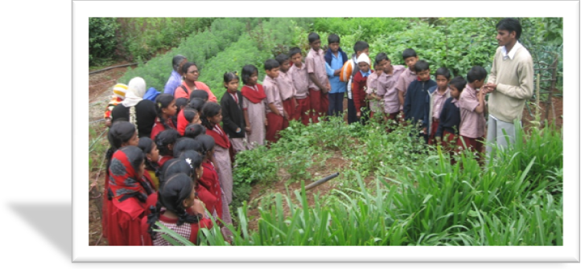Over the last 6 years, Earth Trust has established Eco Club programmes in 16 government middle schools across the Nilgiris.
The Eco Club school gardens are becoming a primary base for educating villages in nutrition and organic farming, waste management and basic health issues. They supply fresh & organic food for the school meals as well as medicinal herbs for everyday health issues. Children 9-12yrs old (6-8th Standard) have shown impressive improvements as a result of these eco clubs in their academics. School gardens are not only providing these children their nutritional needs but also providing rural skills, knowledge, resources and motivation for the future generation of land stewards.
Each school participating has different environmental issues. One is surrounded by highly chemicalized farming. Earth Trust helps them to document the chemicals used and the health issues present in that region. Another school near an eco tourist spot, Lamb’s Rock, has a lot of accumulated litter and plastic trash thrown about. The eco club collected 2500 plastic bottles which they washed, cut and used to construct a poly house. Another school with a monkey menace set up a shade house for indigenous tree species. In Glenmorgan School the Toda tribal children are collecting and documenting their medicinal herbs and learning how to protect and resurrect their ancient shola forests. These children are the farmers of the future!
VILLAGE HEALTH TRAINING PROGRAMME
Earth Trust has developed a comprehensive training programme, which is not just providing health care but training village women in skills for taking responsibility for their family health themselves… This is the only locally sustainable way forward for rural health.
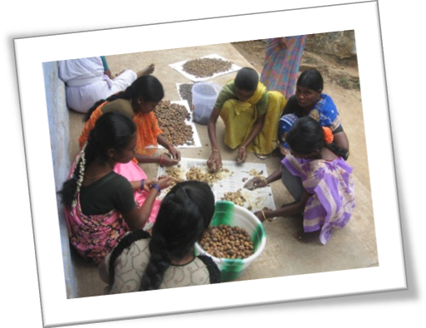Earth Trust has established a 12 module basic training programme followed by a 12 course senior training and advanced course. To obtain a certificate women have to present six herbal medicines and explain their preparation and value. Earth Trust’s health team is also being requested by other NGOs to train their Village Health Workers who are often severely under qualified in their activities. The emphasis is on capacity building within families themselves. Training in stress management and touch therapies such as Reiki, quantum touch, massage and reflexology, meditation & yoga all contribute to happy families and peaceful villages.
The Health team also works in schools and with youth groups. This is an area sadly neglected. It gives them tools to deal with stress and creates an informed base for their understanding of health & nutrition. This capacity building creates resources for managing life and taking responsibility for themselves.
HERBAL KITCHEN GARDENS, FOREST GARDENS & FARMS
One of the important aspects in Earth Trust’s Education programme is the setting up of kitchen and herbal home gardens. In tribal areas, forest gardens are being promoted which use indigenous knowledge and indigenous plants to ensure nutrition and health. This is much more satisfactory than the ration white rice which has recently replaced their nutritional food of forest tubers, herbs and fruits to one which has no calorific or 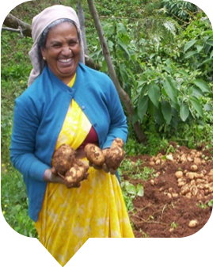nutritional value at all.
By training people in organic production of food on a small scale it becomes possible to provide easy, non-toxic food for entire communities. It reduces hospital and health care bills as Earth Trust has seen with the Herbal Production Unit at Kolikarai. It improves incomes, reduces water consumption and safeguards health. Earth Trust encourages the collection and saving of local varieties of farm produce which is vital for future resources in local areas during times of change. It allows people to have sovereignty over their food, their health, and their lives.
HERBS, HEALTH AND INCOME
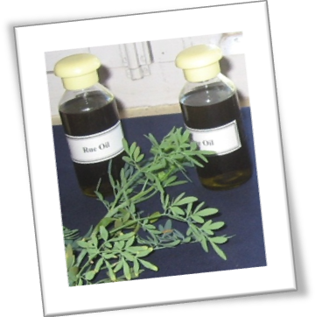In Kolikarai a Self Help Group/Enterprise Group of village health workers from 12 tribal villages have set up a Herbal Medicine Production Unit. They are producing herbal powders, creams and infused oils for home remedies. In the traditional Indian Medicine System many simple preparations help health conditions, which are intractable in the modern system. Great relief can be achieved for people with sickle cell anemia, psoriasis and eczema. Even in HIV+ conditions, patients are getting relief from symptoms using traditional medicinal herbs which boost the immune system.
In the first instance this is being used for families and their local communities but there are many requests and orders coming in from outside agencies, which are boosting income potential. In planning for a new local hospital discussions are underway to create a high tech unit for using these simple herbs for Ayurvedic and Siddha preparations, which will give the hospital itself an extra income as well as benefit the people with low cost effective medicine.
By multiplying these herbs in the genepool nursery at Kolikarai, Earth Trust is able to supply forest people who have little land with resources for health, food and income as they can supply the growing needs of the Herbal Preparation Unit. At the same time, they create pools of biodiversity, which provide future resources for the forest and future generations.
RESEARCH AND DOCUMENTATION

Ongoing meetings with a group of 20 local traditional healers, all respected members of their communities, are being organized and conducted by Earth Trust. These healers are sharing their knowledge to set up a Federation of Traditional Healers, which will be affiliated with the Tamilnadu State Federation. Their knowledge is being documented and used as a resource for the future. The Federation of Healers has requested Earth Trust to help them set up their own herbal gardens.
MOVING FORWARD
In order to expand Earth Trust’s outreach and education programs to support the farmer in his uphill struggle to restore the living soil, a model for local energy production is in the works. It will include wind, waterwheels, solar and biogas resources with the aim to showcase a shining sustainable rural world, which will be the basis & backbone of the economy.
Plans for constructing a sustainable eco building to house this Centre, which will empower and demonstrate these technologies is underway. The eco centre will create opportunities to up-skill youth in the poorest areas who have no foreseeable future. This Eco Institute will not only give professional, practical & ecological training in skills to the rural youth but also provide capacity building for rural families in health, organic farming and traditional crafts.
Earth Trust needs your support. Reach us at earthtrust@gmail.com and check our website at www.earthtrustnilgiris.org

