Creating Opportunities Beyond Her Own Success: Angie’s Story
At the beginning of my journey, I worked as an artisan within a limited scope in Minya Governorate, relying on a small circle of customers. My sales were largely seasonal, tied to events and occasions, and I faced clear challenges in pricing my products and communicating their true value—especially since hair accessories (“hair pieces”) require refined taste and competitive designs tailored to brides’ needs.
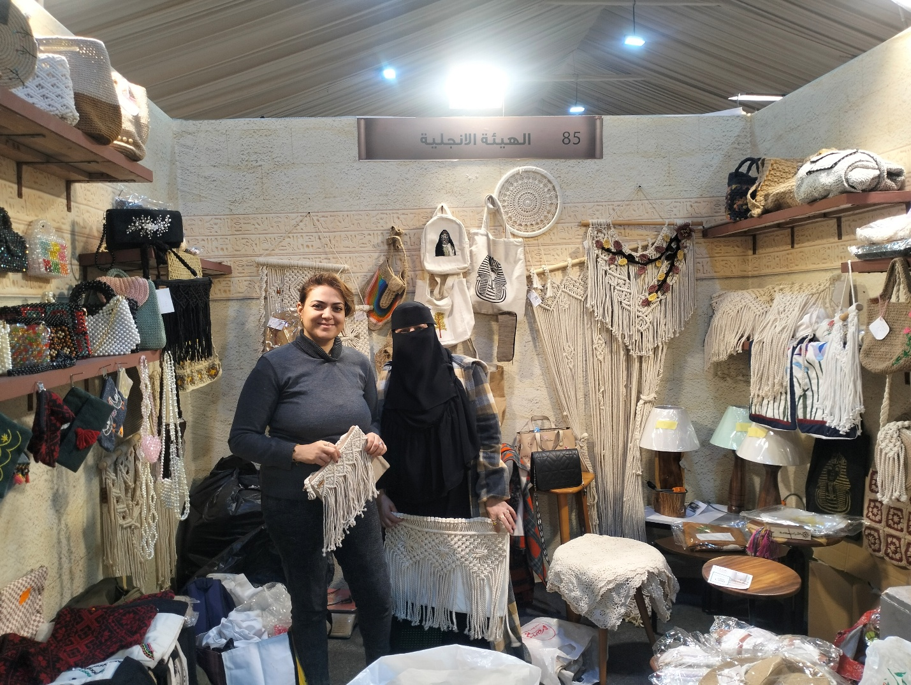
Angie (on the left), together with another program participants, Shaimaa, proudly displaying her hand-made products in one of the local exhibits.
At that time, I lacked a clear vision for growing my business or accessing wider markets. My work followed a seasonal pattern, with no structured plan for growth or sustainability.
My participation in the YEP program provided a valuable opportunity to receive a comprehensive package of specialized training that marked a true turning point in my professional journey. Through training in marketing, pricing, export readiness, and both practical and online learning, I developed a deeper understanding of the market. I came to realize that customers do not simply buy a product—they buy value, quality, and distinction.
I began refining my products - especially my hair pieces - to match the diverse tastes of brides and introduced bundled offers and packages. I also established my own brand, giving my business a clear identity and positioning it for growth at both the local and national levels. At the same time, I expanded my macramé product line - such as curtains and bags - while maintaining a strong focus on high quality as a key factor of making my products stand out in the market.
Participating in exhibitions such as Turathna and Dreya was a major milestone in scaling my business. These platforms allowed me to showcase my products to broader audiences and connect with new customers beyond Minya.
With the professional use of social media, my customer base expanded to include Cairo alongside Minya. I began receiving orders from segments I had never reached before.
This growth had a direct and measurable impact on my life. My business income increased by approximately 50%, contributing to improved living standards and greater financial stability for my family. My husband also became actively involved—supporting product delivery across Minya and coordinating with shipping companies for orders outside the governorate.
I also gained strong confidence in myself and in my ability to make informed decisions regarding production, pricing, and marketing. I no longer work seasonally; instead, I strategically plan for the future and pursue sustainable growth.
One of the transformations I am most proud of is entering the field of training. Through CEOSS (our local partner on this program), I was given the opportunity to serve as a trainer in accessories, hair pieces, and macramé. I have already trained around 60 women, equipping them with the skills needed to start their own businesses. My role goes beyond training—I continue to mentor and support them to ensure their continuity and success. This experience has not only enhanced my skills but also given me a deep sense of purpose and impact within my community.
Like many entrepreneurs, I faced multiple challenges, including limited market access, difficulties in pricing, and weak marketing tools. However, through training and participation in exhibitions, I was able to:
- Develop my digital marketing skills
- Improve my pricing strategies
- Build a network that contributed to increased sales and product visibility
Today, I approach expansion with a more professional and strategic mindset. I leverage my knowledge of marketing opportunities to scale production and reach new markets, while continuing to support other women in their journeys.
If I have to summarize everything in a short statement:
“I had the talent, but I didn’t know how to turn it into a real business. Today, I am more confident in myself and in my products—and my success is no longer mine alone; it has grown to create a meaningful impact in the lives of other women.”

