A Single Click, A New Beginning: Kamar’s Journey to Growing Her Business
I am Kamar from Beni Suef, and I run a small business making handmade beadwork products. When I first started, I relied mainly on my skills and passion, but my sales were limited to family, friends, and occasional events. The biggest challenge was not making the products—it was finding customers.
A major change happened when I decided to create a Facebook page for my business. At first, it seemed like a small step, but it made a huge difference. Through the page, I started sharing photos of my products, connecting with new people, and reaching customers outside my usual network. Over time, Facebook became an important tool for promoting my work and communicating with customers.
Digital marketing also changed the way I interact with customers. Instead of only meeting them during events, I could stay connected, share new products, and learn more about what they liked. This helped me build trust and create stronger relationships with customers.
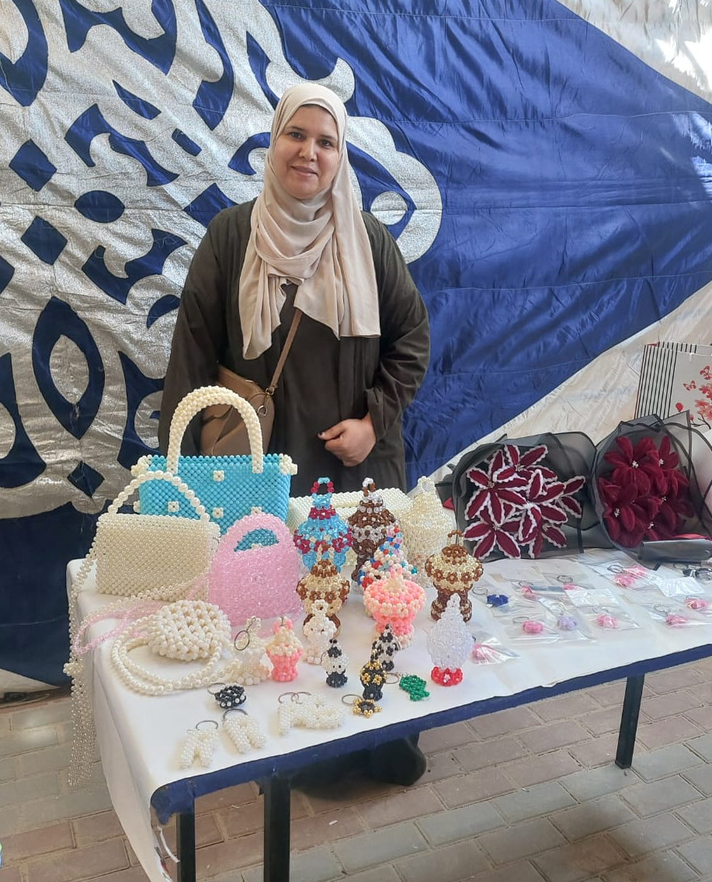
Like many small business owners, I faced difficult periods. At one point, demand for my products dropped, sales decreased, and I felt discouraged. Participating in the YEP program helped me through this challenge. The training sessions and the experiences shared by trainers and other entrepreneurs encouraged me to keep going and look for solutions instead of giving up.
Through the program, I learned how to organize my business better. I improved the way I manage costs, look for quality materials, and plan my work. These changes helped make my business stronger and more sustainable.
Today, my business is more stable than before. I no longer depend only on events or seasonal sales. Through digital marketing, I have a continuous way to reach customers and promote my products. I also feel more confident in my ability to adapt, solve problems, and grow my business.
Summary in my own words:
“Creating a Facebook page seemed like a simple step, but it changed everything. It helped me reach more customers and gave me confidence to keep moving forward. Today, I know that every challenge has a solution, and I believe my business can continue to grow.”

