AFRICA INTERCULTURAL DEVELOPMENT SUPPORT TRUST
AIDEST

“We Build on Skills that make us Grow” together

P.O. BOX 1102, Kampala – Uganda
Tel: +256 414 378619
Mob: +256 714 112509
Email: africaidest@yahoo.co.uk

OFFICE LOCATION
AIDEST Office is located in Mukono
Municipal Council in Mukono District, 20km
from City centre.

Programme Areas
AIDEST operates MASAKA District of Uganda,
120 Km South West of Kampala City Centre.

Vocational Training
Post Vocational Support
Support orphans to acquire skills
Equipping with relevant tools and capital
Provide both open courses: Education, Tailoring house, Leather working, Shoe making, ICT Training Program, and Tree planting & Livestock husbandry project

Educational Program
- Behavior change
- Youths Forum
- Community youths sensitization Program

Support to Needy Groups
- Income Generating Projects
- Material Assistance
- Counselling
- School fees
- Educational materials.

Other services
Vocational Business & Technical training pack.
Youths school dropouts, Women children working & Self-employed persons.
Entrepreneurs.
Vulnerable Youths / women self-sustenance.

How could you help AIDEST by;
- Financial support.
- Provision of Material and Technical assistance to Needy Youths / Children.

- Volunteer or participate directly in AIDEST programmes.

For more information contact

Executive Director AIDEST Tel: +256 414 3781619
P.O. Box 1102, Mob: +256 714 112509
Kampala Email: africaidest@yahoo.co.uk
Uganda.

AIDEST Bank Account:
3020051019
CENTENARY BANK LTD
KAMPALA CITY BRANCH.

Background
AIDEST was initiated in 2008, in response to the increased number of Young people arising from AIDS – elated death and poverty. The Organization directly helps Disadvantaged groups of Young Women, Men and Children in addition to Formal Vocational Training.

Today, AIDEST has benefited over 450 people, where Participants and Beneficiaries originate from communities of Masaka and Mukono Districts. These are being Empowered in Lifeskills, support Disadvantaged Children. As well as their families, as means of becoming Self-reliant.

AIDEST Goal
The program aims to Improve the living standards of Vulnerable Locally owned Ventures and participate in Self-innovated Projects, Support Capacity Building programs and introduce Demonstration, Urban Iinstitutional and Community use and Development including Education Support for Needy Children (Able & Disabled)

AIDEST Mission
Making our Community and Economy more Productive and Competitive that requires Practical Innovation Skills, Education and Development: by raising the level Social, Economic and Cultural fields, Vocational Training as a Tool, conserving Environment through Planting Trees and Livestock husbandry, investing in young People.
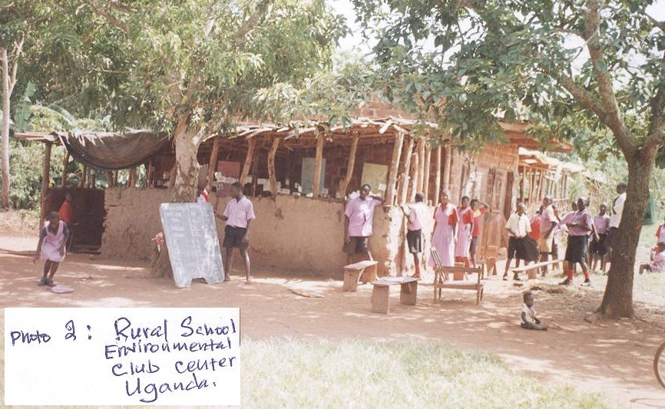

Objectives
- Improve the Living conditions of Vulnerable Groups & Children; by Building on Sustainable locally owned Ventures.

- Making the Economy more productive, competitive that requires Knowledge of what works, including Lobby, Advocacy and Campaigns.

- To promote the use of Information and Communication Technologies for Rural, Institutional and Community use.

- To ensure that Nutrition, Education and Training is incorporated in formal and Informed training in order to improve the Knowledge and Attitudes for Behaviour change of communities in Food and Nutrition related matters.

- Offering Technical services and Educational Centres construction including Guidance to communities through Poverty eradication and Health care programmes.

- Encourage Farmers take Tree planting Livestock raising as Business including Village co-operatives become more Productive by Increasing production, raise Incomes as important to fight Poverty.

- To create Employment opportunities for Rural population especially Youths, including Tailoring, Leather works and Shoe making training projects.

Vocational Training Educational Support Programs
- Availed to Youths and Older orphans, and those who have dropped-out of school to enable them acquire skills to help them earn a living, sustain their families not always depend on charities.

- In Post Vocational Support; those groups are provided with Tools / Equipment relevant to the Skills acquired at the centre plus Initial capital

to start individual / Group projects or Businesses.

- Health Education Skills and Resources should first be directed to the most Needy and Vulnerable Households, ideally, should be focused on Youths and Children.

- Behavior Change Programmes to create AIDS awareness among the Youths and Children of people living with the epidemic as to live safe lives. Self-awareness is our Recognition of ourselves, our Character, our Strengths, our Weaknesses and our Desires and Dislikes.

- Develop Self-esteem is important as good emotional Health, helps them feel confident that have Ability to do things well and value who they are and do.

- To enable Youths develop Friendship offer emotional Support and Counselling, Capacity Building and participate in Group projects set-up by themselves or supported by the Organization.

