
RADIOS NEEDED TO BOOST LITERACY IN MOZAMBIQUE

Despite a protracted civil war, devastating floods, cyclones and drought, Mozambique is fighting back to become a success story in the making. With peace sustained for the last 12 years, the economy has one of the highest growth rates in Africa and the country is once again on the map as a tourist destination.
Nonetheless, it remains one of the poorest countries in the world and is still coming to terms with the effects of war, which meant that many Mozambicans could not attend school. The result is a generation that is illiterate and ill prepared for the challenges of putting the country back on its feet. It is also a young society, with more than half its population under 18 and with low adult literacy levels of 44 per cent.
The Ministry of Education recognized the importance of education in reducing poverty and encouraging economic growth and is initiating a ground-breaking national literacy and adult education radio campaign. The broadcasts will develop reading and writing skills in the national language, Portuguese, as well as offer training and information on the prevention of malaria, TB, cholera and HIV/AIDS.
Mozambique is dealing with an AIDS epidemic that, if not halted, could have calamitous social and economic repercussions. Incidence rates are as high as 20 per cent in some regions.
Most of Mozambique’s 18 million inhabitants live in extreme poverty in rural communities. The poorest of the poor are women, who, as they are less likely to have radios or money, also have the lowest literacy rates.
The success of the literacy campaign depends on access. To ensure that the Ministry of Education’s campaign reaches those who need it most, it has requested thousands of solar powered, wind-up Lifeline radios from the Freeplay Foundation. The radio needs no batteries, so it provides continual access to education and is designed to be easily heard by groups of up to forty.
Lifeline radios will be distributed to women’s listening groups as a priority in three provinces designated as most vulnerable: Cabo Delgado, Manica and Maputo. The Ministry also is training literate “mentors” to assist the groups and is providing individual learners with workbooks.
Footnote: The Freeplay Foundation has been working in Mozambique since 2000, when in response to an urgent plea from the government, it distributed 7,200 wind-up Freeplay radios to flood-stricken communities. To rebuild a sustainable future, these communities were in urgent need of reliable information and education. The Foundation is proud to have been part of what it believes to be the first comprehensive communications initiative of its kind in an emergency situation where sustainability of information was assured.

PLEASE SCROLL DOWN FOR MORE INFORMATION:

EXECUTIVE SUMMARY:

OVERVIEW OF THE FREEPLAY FOUNDATION

AND THE LIFELINE RADIO

Description of the Organization

The Freeplay Foundation is unlike any other nonprofit humanitarian organization in the world, as its sole mission is to provide radio information and education to the most vulnerable populations via self-powered radios.

The Foundation is committed to promoting the importance of radio as a vital medium in the developing world. Through the use of self-powered Freeplay Lifeline radios, it also advocates the necessity of ensuring access to broadcasts and sustainability of programming, especially for the most vulnerable groups, women and children.

In communications projects, the Foundation can ensure that information is delivered the “last mile” to populations in the most inaccessible locations. It can serve as the final point in a seamless line of communication -- from satellite and internet-based information, through television and published information -- all the way to Lifeline self-powered radio access in the poorest, most remote villages and refugee camps. At six years old, the Freeplay Foundation works in a dozen African countries and is on the cusp of becoming a major force within the humanitarian development world, because no one else can offer what Freeplay can. In a global communications campaign, the Foundation is the final step.

In developing countries, especially in areas with large, non-literate populations, radio is the primary means of communication. In sub-Saharan Africa, for example, it is estimated that there are up to 75 times more radios than televisions. However, in most of the developing world, electricity is non-existent and the high cost of batteries makes them unaffordable on an ongoing basis, especially to women and children. Millions of dollars are spent worldwide each year to produce excellent radio programming for development purposes, yet the poor may never hear it. They are unlikely to receive critical information that can help them prevent deadly diseases, improve hygiene, raise agricultural productivity, learn English and math through radio distance learning, or enjoy any educational instruction that could help lift them out of abject poverty and lower mortality rates. Lifeline radios can solve the problem of access for these audiences.

Established in 1998 in the UK by the Freeplay Energy Group as a separate entity, the Freeplay Foundation is a tax-exempt 501(c)(3) charitable organization in the USA, with its senior consultant working from Savannah, Georgia. Additionally, it enjoys Section 21 charitable status in South Africa and is a registered charity in the UK. The Foundation’s main office is in Cape Town and it also maintains a small office in London.
Description of the Work

The Foundation’s goal is to utilize radio to ensure that as much accurate information is disseminated to the widest possible population. To this end, the Foundation works with international and local NGOs in a structured distribution methodology of radios to rural communities. The Freeplay Foundation team includes experts that can survey and assess target populations’ radio information needs, work with local broadcasters to set up appropriate content and structure, assess and determine radio distribution criteria, implement radio distribution, form listening groups and focus groups, and monitor and evaluate the impact of the process. Radios are never “just given away.”

In addition, the Foundation has devised unique ideas for delivery and packaging, such as the creation of “health boxes.” The radio boxes can contain other health-related items and print materials to form a complete community package. For instance, supplies could include malaria nets, information booklets, rubber gloves and water purification tablets. Health messages that support a particular project can be printed on the boxes. For example, HIV/AIDS prevention messages are relevant to the entire world, while malaria treatment messages are relevant only to some countries.

The Foundation also supports project partners through the sharing of best practices and experience. For example, the Foundation has experience in how to most effectively introduce radios into communities and address potential issues regarding community listening behavior. For many projects, a listening group format is adopted, whereby 10-20 people gather to listen and to discuss or debate a radio program. Freeplay radios are designed for group listening - they are large and robust with excellent speaker quality – accommodating up to 40 listeners.

The Foundation also creates project-specific cartoon instruction sheets showing how to use the radio correctly and how it is used in a community setting. The cartoonists are hired locally, wording on the cartoons is printed in vernacular or the national language, and the cartoons are pre-tested first. Oftentimes, the reverse sides of the instruction sheets are also used to augment the program’s key messages and to advertise the program’s station and broadcast time.

The Lifeline Radio

The Lifeline radio is the first radio ever produced solely for humanitarian use.
After extensive fieldwork during the first two years of the Foundation’s existence, the executive director determined a real need expressly for the humanitarian sector, especially children living on their own. The idea for the Lifeline was born.

In 2001, the Freeplay Foundation received the $50,000 education award, underwritten by NASDAQ, as the winner of the Tech Museum of Innovation Awards -- Technology Benefiting Humanity. The Foundation allocated the award money to seed the research and development of the Lifeline radio. All funding needed to bring the Lifeline radio to fruition, including tooling and testing, was received from donors in October 2002. The other donors included the Body Shop Foundation, Anglo American Corporation, the Vodafone Group Foundation, Vytek Chairman Leonard Fassler, and well-known technology entrepreneur Bradley Feld.

Exactly two years after the concept paper for the Lifeline was written, the new radio was launched in April 2003 in a Voice of America (VOA) sponsored project benefiting Burundian youth living in refugee camps in Tanzania. The United Nations High Commissioner for Refugees (UNHCR) was the implementing partner. VOA has deemed the project to be so successful that they have funded a major expansion of the initiative into the camps.

It is important to note that while the Freeplay Foundation is an organization wholly independent from the Freeplay Energy Group (FEG), with its own boards of trustees, it does enjoy a supportive relationship with FEG, especially as regards research and development. The research and development of the Lifeline radio was undertaken in Freeplay Energy’s research facility in Cape Town, Freeplay Technology.

Sampling of projects that include the Lifeline radio:
South Africa – Lifeline radios are being integrated into the youth radio programme Soul Buddyz. The radios will be used to augment Soul Buddyz listening clubs. Some of the radios will be given in support of the Nelson Mandela Children’s Fund’s Goelama Project, which supports child heads of households in the Kwa-Zulu Natal province.
South Africa – Lifeline radios are being included in the expansion of the radio version of Sesame Street, called Takalani Sesame, and will be distributed to teachers in early childhood learning centers in rural areas.
South Africa – Kidzpositive, a Cape Town-based NGO, is using Lifeline radios for HIV positive mothers involved in an income-generating beadwork project at Groote Schuur Hospital.
South Africa – The Media Monitoring Project is using Lifeline radios to monitor the listening habits and preferences of child heads of households. UNICEF is the project’s primary funder.

Tanzania – Lifeline radios are being used in six different projects in Tanzania, all funded by the Vodafone Group Foundation: The African Youth Alliance (AYA) radio program called Mambo Bomba; a primary school education initiative that offers English, math and social studies via radio; a Ministry of Labor, Youth Development and Sport-sponsored youth sports and HIV/AIDS awareness campaign; a project that supports youth development through a variety of media, including radio; a Ministry of Health initiative where Lifeline radios will be placed in prenatal clinics where women gather; and a community radio station/telecenter near Lake Victoria where the radios are used for primary education and to teach children about various technologies.

Zambia - Lifeline radios are being incorporated into a highly successful distance education project, Learning at Taonga Market, which provides English, math, and life skills training to orphaned or other children unable to attend formal school. Rotary UK and Rotary Ireland are fundraising for the project.

Madagascar – Lifeline radios will be used to support a major national radio-based health and HIV/AIDS campaign.

Zimbabwe – A health radio drama, called Mopani Junction, funded by the Centers for Disease Control and Prevention (CDC) will be supported by over 2000 Lifelines which will be distributed by NGOs and faith-based organizations.

Afghanistan – Lifeline radios have been distributed to female teachers in remote areas, enabling them access to teacher training programs. This groundbreaking project is coordinated by Media Support Solutions.

###

PLEASE SCROLL DOWN FOR FURTHER INFORMATION:

Sept. 29, 2003

Tom Hanks Assists World’s Poor
As Freeplay Foundation Ambassador

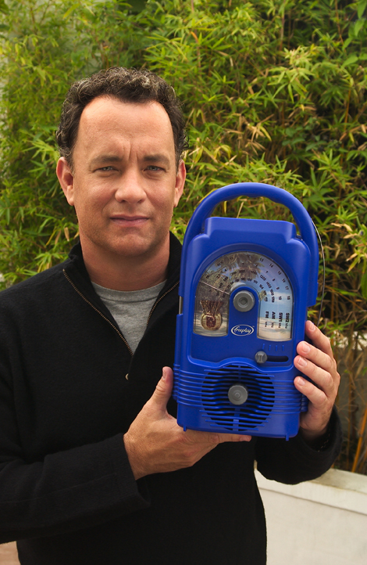

Cape Town, South Africa....The Freeplay Foundation today announced that two-time Academy Award® winner Tom Hanks has become their American ambassador. In this advocacy role, Mr. Hanks will help gain support for the Foundation in the U.S. and promote understanding of the Foundation’s work.
Using Lifeline radios, which do not require batteries or electricity, the Freeplay Foundation provides sustained access to information to the world’s poorest populations, especially children living on their own.

“The extraordinary technology of the Freeplay Foundation’s Lifeline radio can bring vital information to isolated people all over the world,” said Mr. Hanks. “For example, right now there are more than 13 million children orphaned by AIDS. Most can’t attend school and can’t afford batteries or electricity to power a radio. The Freeplay Foundation can hand these children a lifeline to the outside world by giving access to radio programs that teach them how to grow their small garden plots to feed themselves, take care of their chickens or goats, and prevent deadly diseases like malaria and AIDS.”

Freeplay Foundation Executive Director Kristine Pearson said, “We are deeply grateful that Mr. Hanks has chosen to serve as our American ambassador.
By lending his voice in support of the most vulnerable people, especially orphans and other children living on their own, Mr. Hanks will help bring them critical, even life-saving information and education.”

In developing countries, radio is the primary means of communication. The Lifeline radio plays non-stop using wind-up energy and solar power and is the first radio ever produced solely for humanitarian use. Using a structured methodology developed by the Freeplay Foundation, radios are distributed to youth, community health workers, village chiefs, listening groups, teachers, and informal classrooms in the developing world, primarily in Africa. Recipients are trained in how to most effectively listen to radio programming and transfer knowledge they gain to others in their community.

Mr. Hanks joins humanitarian Terry Waite, who serves as the Foundation’s European ambassador. Mr. Waite is well known in the U.S. as the special envoy to the Archbishop of Canterbury in the 1980s. While negotiating the release of U.S. hostages in Lebanon, Mr. Waite was himself taken hostage, serving most of his five years in captivity in solitary confinement.

The Freeplay Foundation works in more than a dozen African countries. It is a fund seeking, U.S.-registered 501 (c) (3) tax-exempt charity. It works with governments, international agencies such as the United Nations Development Program, non-governmental organizations (NGOs), and local communities. With offices in Cape Town, South Africa and London, the Foundation also enjoys charitable status in South Africa and the UK. Learn more at www.freeplayfoundation.org.

###

Freeplay Foundation contact in USA:
Michelle Riley (912) 898-2195 or email: tggw-michelle@msn.com.

PLEASE SCROLL DOWN FOR MORE INFORMATION:

Key Design Features and Benefits of the Lifeline Radio

Below describes the features and benefits of the Lifeline Radio. Orphaned children in South Africa, Rwanda and Kenya were consulted throughout the design and development process. The size and shape of the Lifeline Radio is a result of focus group research. The more it is wound, the longer it will play.

Children can grip the handle without difficulty. While the Lifeline Radio is large, it is lighter than other Freeplay radios used in development projects.

The antenna is an ordinary piece of wire, which can be replaced with any piece of wire. It can be taken off and put back on at will as antennaes break easily on radios.

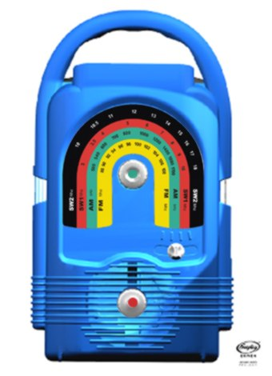

The solar panel is housed in a detachable waterproof casing on a three-metre lead with magnetised clips on top to hold it securely in place. The Lifeline Radio operates in the harshest of conditions in extreme temperatures, rain, moisture, dust, sand and humidity.

The rainbow shaped dial scale has large print making it easy to read even for the visually impaired. As AM/FM/SW is difficult to understand for some, each band is colour coded.

The winding handle (on back) can be turned in either direction to charge the radio. Earlier Freeplay models could only be wound clockwise. Fully charged, the Lifeline Radio can play for many hours.
The dial scale and Lifeline Radio can be custom produced in any combinations of colours, which cannot reflect political parties.

Four-band coverage, AM/FM/SW1/SW2 ensures access to many channels and perspectives. For example, in Zimbabwe where programming is government controlled, SW broadcasts can be received.
The sound quality is excellent enabling up to 40 people to hear it clearly.

Each knob is purposely a different shape.

