========================================
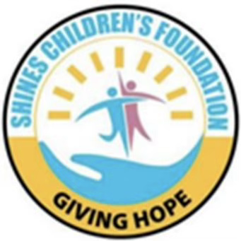
==============================
Shines Organization Profile 2025
“Where Every Child Can Shine”

LOCATION AND CONTACTS
Plot 59, Muganwa Road,
Masindi Municipality
Email: shinescf.uganda@gmail.com
Tel: +256-786085109
www.shinescf.org
========================================
OUR PARTNERS IN DEVELOPMENT
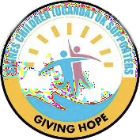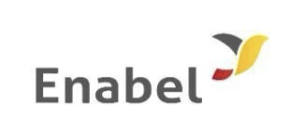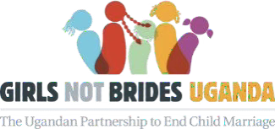

- Background:
Shines Children’s Foundation - Uganda (SCF-Uganda) is a registered Ugandan Non-Governmental Organization (NGO), founded in 2013 by visionary youth Denis Kiirya (Mr). The organization is committed to fostering sustainable development through active community engagement and aims to address the critical challenges facing vulnerable communities in Uganda.
SCF-Uganda works to empower communities by ensuring access to essential human needs such as education, healthcare, food security, and economic opportunities. Its efforts are closely aligned with the United Nations Sustainable Development Goals (SDGs), with a strong focus on building resilience among vulnerable populations. Much of the organization’s work is supported by Shines Children (Uganda) UK Supporters.
Currently, SCF-Uganda serves as the Regional Coordinator for Girls Not Brides Uganda (GNBU) in Mid-Western Uganda, covering seven districts. Girls Not Brides is a diverse global network of over 1,600 civil society organizations (CSOs) working to end child marriage across more than 100 countries. Since its establishment in Uganda in 2016, Girls Not Brides Uganda has grown into a dynamic network of over 140 member organizations across all regions of the country.
- Our Vision, mission and values:
Vision: A society where children, women and youth have equal access and opportunities to reach their full potential.
Mission: To socially and economically empower communities to better observe and protect their rights for sustainable development.

Values: At SCF, we have fundamental principles, beliefs and standards that guide our culture, decisions and actions. These are:
- Child Centeredness: We prioritize children’s best interests, ensuring their rights and dignity, promoting safe and nurturing environment, fostering family involvement, and practicing transparency, integrity and accountability.
- Transparency: We believe in openness and honesty in our engagements with different stakeholders
- Accountability: We take responsibility for all our actions and decisions.
- Team Work: We believe in collaboration with different stakeholders to achieve SCF goals
- Respect: we value diverse perspectives and treat everyone with dignity
- Innovation: We have a commitment to new ideas, creativity for continued program improvement
- Integrity: We believe in honesty and uphold good ethical conduct in all our dealings with different stakeholders

- Our Governance Structure:
Our governance structure provides a framework for achieving goals by defining different roles, responsibilities, communication channels, and decision-making processes at different institutional levels. It also guides us in resource allocation, facilitates effective collaboration, and helps ensure strategic alignment, ultimately leading to increased productivity and success.

  - Organogram: 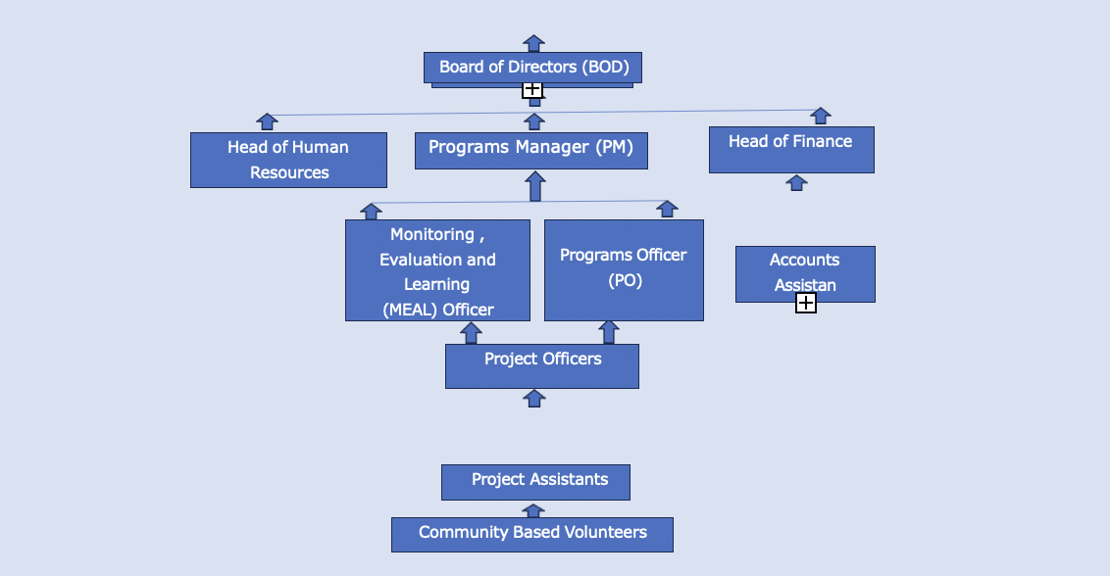
Image 1: Shines Foundation Governance Structure

Position definitions are as follows:
Board of Directors (BOD): This is composed of seven members (5 Male and 2 Female), and headed by the Board Chairperson. It plays an oversight role of SCF interventions
The Senior Management Team (SMT): This comprises the Executive Director (ED) who heads the Secretariat, Programs Manager (PM), Head of Human Resources (HHR) and the Head of Finance (HoF). This team provides strategic direction, makes key decisions and oversees the general management and long-term vision of SCF.
Programs Officer: Responsible for implementing, coordinating, and overseeing specific programs within SCF. He/ She manages budgets, engages stakeholders, monitors progress of programs, and ensures projects align with SCF strategic goals.
Monitoring Evaluation and Learning (MEAL) Officer: Designs and implements Monitoring and Evaluation (M&E) systems for programs and Projects to track progress, assess performance, and generates data driven insights for decision making and reporting.

Project Officers: They Organize, plan and oversee specific project activities to ensure they meet set objectives within defined scope, budgets and timeline. They are assisted by Project Assistants, and Community Based Volunteers (CBVs)

  - Members of SCF head office secretariat, and international volunteers 2025
SCF currently has five full time employees, who provide essential support and infrastructure for Shines governing body, as well as ensure programs operate effectively. Their names and positions are as here under:

No. | Names | Designation
 | Denis Kiirya | Executive Director (ED)
 | Bosco Nek | Programs Manager (PM)
 | Joan Nyamaizi | Programs Officer (PO)
 | Sylvia Nganjani | Head of Finance (HoF)
 | Wilfred Othieno | Head of Human Resources and Resource Mobilization
 | International Volunteers
 | Rihoko Hiranuma | JICA Volunteer
 | Michelle Bontrager | Peace Corps Volunteer
Table 1: SCF governing body

- Our Development Partners:
  - Shines Children (Uganda) UK supporters
  - Government of Uganda specifically Masindi District Local Government
  - Uganda National Non-Governmental Organizations Forum
  - Girls Not Brides Uganda (GNBU)
  - Enabel Uganda
  - Tools With A Mission (TWAM) England
  - Peace Corps Uganda
  - Japan International Cooperation Agency (JICA)
  - Forum for Education NGOs in Uganda (FENU)

- Our Thematic Areas and Achievements
At SCF, we take pride in the impact we create. Over the past couple of years, we have made remarkable milestones that showcase our commitment to achieving institutional mission and purpose. These are laid per thematic area as under:
  - Education and Sponsorships
We provide education and sponsorships as a foundation for lifelong learning, giving vulnerable children an opportunity to become self-reliant and prepared for future further education, work and active participation in society. Under this thematic area, we have registered the following achievements: -
- Constructed Shines Children’s Foundation Nursery and Primary School in Miirya Sub County Masindi district, with classes running from Nursery to Primary seven
- Currently providing formal education to over 320 (Three hundred) children (195 Boys and 125 girls)
- Directly supporting 105 vulnerable children (62 boys and 43 girls), with free education, uniform, and meals served each school day
- Providing free basic health care to 105 children under sponsorship
- Providing employment to 22 teaching and non-teaching staff (14 Male and 08 Female)
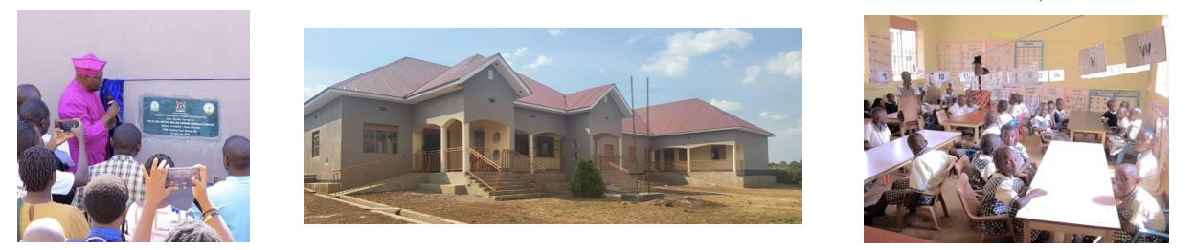
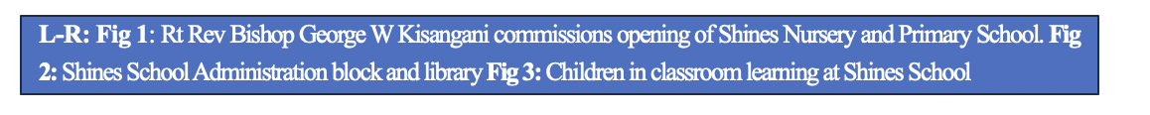
  - Social Economic Empowerment and Livelihoods Support
We empower the communities we serve to increase control over their lives, resources, and decisions leading to improved quality of life; achieve greater gender equality, and stronger and more stable communities. Our interventions under this thematic area foster household economic independence, reduce poverty, promote social justice and inclusivity in society. Under this program, we have registered the following achievements:-
- Cumulatively Trained over 450 community members aggregated as 237 women, 143 men and 70 youth (Mobilized in 15 groups) in the Village Savings and Loans Association (VSLA) Model
- Trained 15 groups above in the Savings with a Purpose (SWAP) model to increase their purchasing power for tools of production at household level
- Trained these groups in Enterprise Development Skills in areas of Enterprise Selection, Planning and Management (SPM)
- Trained 78 Women, Men and Youth in making of liquid and bar soap, hair shampoo, and vegetable growing
- Linked 11 groups (7 Women and 4 Youth groups) to benefit from government economic empowerment programs i.e Operation Wealth Creation (OWC) and Parish Development Model (PDM)
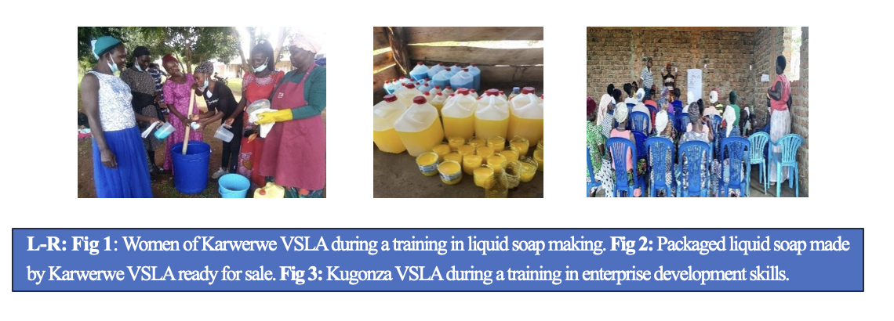

  - Health and Nutrition Interventions
SCF implements health and nutrition programs to address the urgent needs of communities lacking access to basic food and healthcare. Particularly, we focus on improving community health (Water, Sanitation and Hygiene), address malnutrition and its associated health issues, and support to address Sexual and Reproductive Health Rights (SRHR) challenges for adolescent girls; while working towards broader goals of global health and development. We largely deliver these interventions in collaboration with Masindi District Health Department, other private health providers and international Doctors. Under this thematic area, we have the following achievements: -
- Cumulatively reached 3,240 Men, Women, Youth and Children through two annual medical camps, by providing accessible and free healthcare. Under this, we facilitate early disease detection and diagnosis, offer health education, and provide immediate treatment for common illnesses and emergencies, and conduct referrals.
- Acquired and distributed 1,200 Insecticide Treated Mosquito Bed Nets to over 700 local households. These nets are crucial for preventing mosquito-borne diseases like malaria
- SCF with support from Peace Corps Uganda conducted malaria mural paintings at Masindi Secondary School. These paintings improve community understanding of malaria dangers through visual education and encourage active participation in control programs, making them a powerful tool for fighting the disease.
- Trained 215 community members (159 Women and 56 Men) in vegetable gardening at household level. This initiative has improved food security, promoted healthy eating and better nutrition, fostered community building and social connections, as well as created economic opportunities among households.
- Delivered Sexual and Reproductive Health (SRH) messages to 4,376 adolescents in 12 Primary and 08 Secondary Schools. These messages are crucial because they provide vital information and resources to prevent Sexually Transmitted Infections (STIs), unintended pregnancies, and gender-based violence, thereby protecting adolescents' physical and mental well-being
- Conducted 01 Annual Regional Girls Not Brides Summit with 125 participants (Children and Adults); and 06 members engagement meetings, involving community leaders, policymakers, healthcare providers, students and individuals. These engagements have been crucial in building consensus, addressing barriers, developing culturally appropriate strategies, ensuring accountability, and improved access to information and services for universal SRHR
- Trained 05 Primary Schools in making of re-usable sanitary pads for girls
- Implemented Water Sanitation and Hygiene (WASH) interventions in 18 Primary Schools in Masindi district
- Constructed 2 boreholes in Kigulya division to increase community access to safe water for domestic use
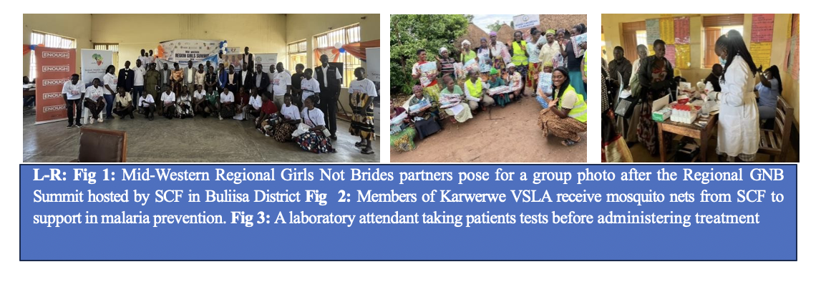

  - Environmental Conservation, Protection and Sustainability
We implement environmental conservation programs to protect ecosystems and natural resources, contribute to mitigation of climate changes, ensure long-term human well- being, and foster sustainable economic development. Our conservation efforts create jobs, support local communities, and promote a global responsibility for environmental health. Under this thematic area, we have achieved the following:-
- Commemorated annual National Environment Days
- Raised and cumulatively distributed 25,000 indigenous tree seedlings to selected Primary and Secondary Schools, Churches and the local communities in Masindi
- Championed the dream school program under the Theme “Building greener and sustainable environment for our future”, implemented in 06 Primary Schools in Masindi Municipality
- Trained 05 community women and 04 Youth groups with total membership of 243 in construction of energy efficient cooking stoves
- Trained over 80 women and men in organic farming. This was intended to build sustainable agricultural systems that enhance soil health, protect the environment, and reduce reliance on costly artificial pesticides and fertilizers
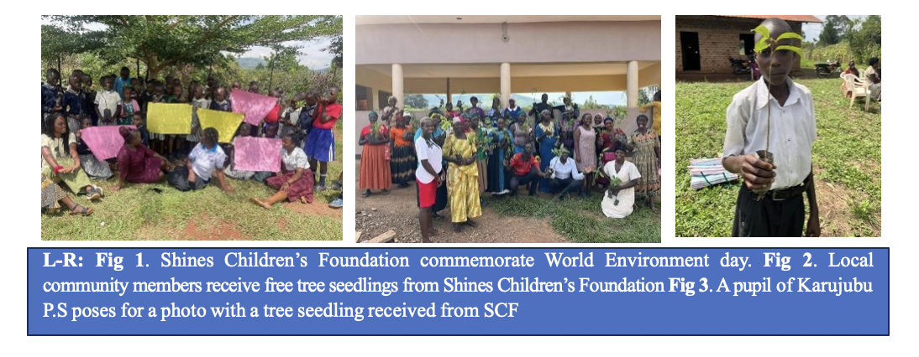
  - Digital Literacy
Digital literacy refers to the ability to use digital technologies effectively and responsibly. We believe training young people in Information, Communication Technology (ICT) is crucial for enhancing their career prospects, fostering entrepreneurship, and preparing them for a digital-driven economy, while also empowering them to participate actively in civic life and access better educational resources. ICT bridges the digital skills gap, promotes innovation, improves access to information, and supports social and economic development by equipping youth to be active contributors to society. Under this thematic area, we have been able to achieve the following:-
- Established a computer training centre, at Shines school with internet connected and 15 computers installed
- Cumulatively advanced free computer training to 52 youth (28 Male and 24 Female), with certificates for completion of training awarded
- Trained packages such as Micro Office Word, Excel, Power Point, Access/ data base, Publisher and use of internet responsibly

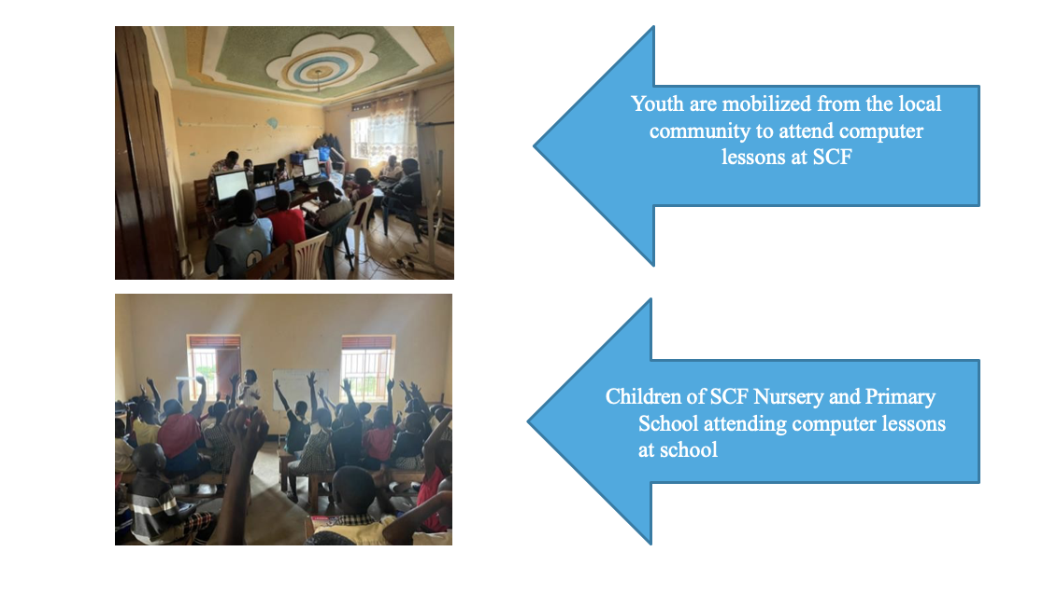
  - Healthy Sporting
SCF runs a Sports academy, a specialized training wing for identifying, nurturing and improving sports talent for young boys and girls, especially in football. The academy provides structured, high-quality training for boys, fostering physical health and skill development while also promoting mental well-being, discipline, teamwork, and academic success through a balanced curriculum. Our Academy currently has a total of 28 registered sports boys.

We also conduct sporting activities for out of school girls, identified from within the local community. This is meant to foster gender equality, promote women's empowerment and leadership, enhance physical and mental well-being, build social skills and a sense of belonging, as well as support broader community development and social cohesion. This program offers opportunities and role models for girls who might otherwise lack access, challenging societal norms and building confidence to participate fully in society

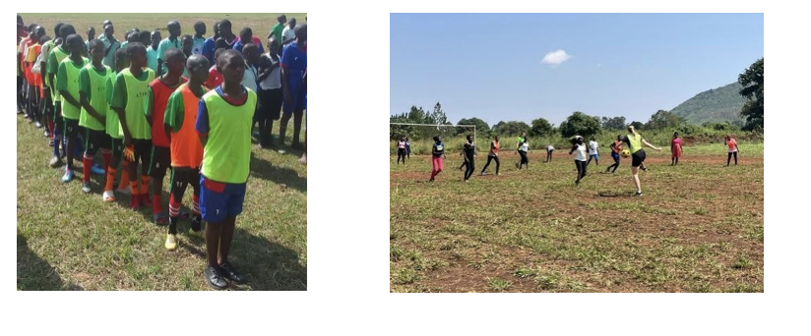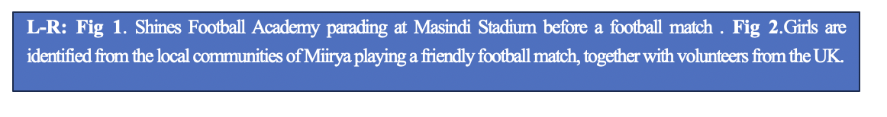
  - Community Land Rights Program
SCF conducts Community land rights activities with focus on empowering local and indigenous communities to secure, manage, and conserve their land through legal frameworks, participatory planning, and community-led advocacy.
Between April and August 2025, SCF in partnership with Shines U.K organized community land rights activities in Miirya Sub County and Kigulya Division in Masindi District. This intervention supported 187 people, aggregated as 105 Male and 82 Female to start the processes of titling their land. Several sensitization sessions were conducted with technical support/ partnership with Masindi District Local Government staff (Chief Administrative Officer, Lands Officer, Environment Officer, District Surveyor, Legal Aid Clinic, Area Land Committee Chairpersons for Kiguulya and Miirya, Political leadership, religious leaders, SCF Community Volunteers, among others. SCF with financial support from Shines UK will drive this entire process until all qualifying applicants obtain their land titles.
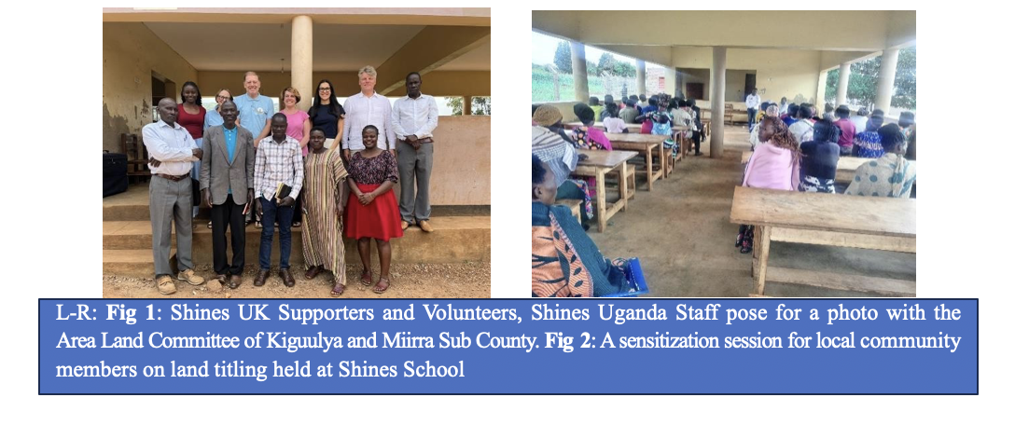

- Individual Stories
SCF has registered lots of successes over the past years of operation. We share two among the many successes registered, as follows:

Story 1: Education and Sponsorships

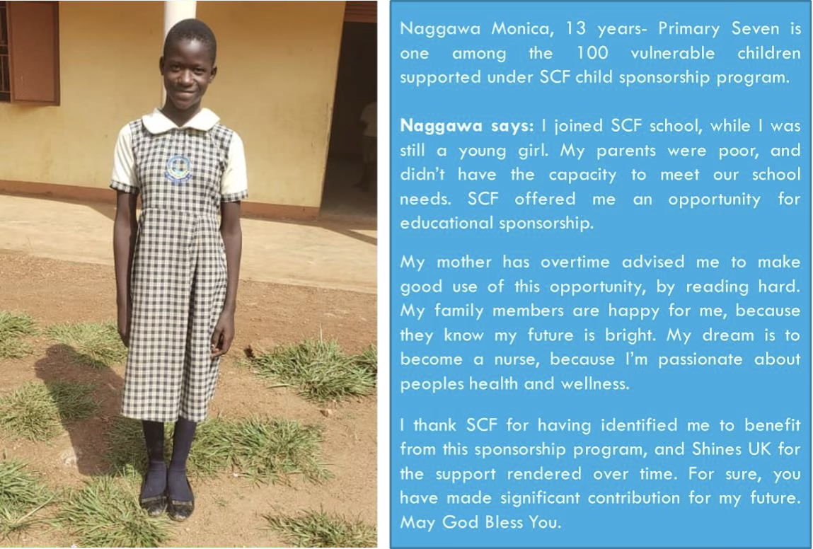
Figure: Shines Student Maggawa Monica pictured.

Story 2: Health

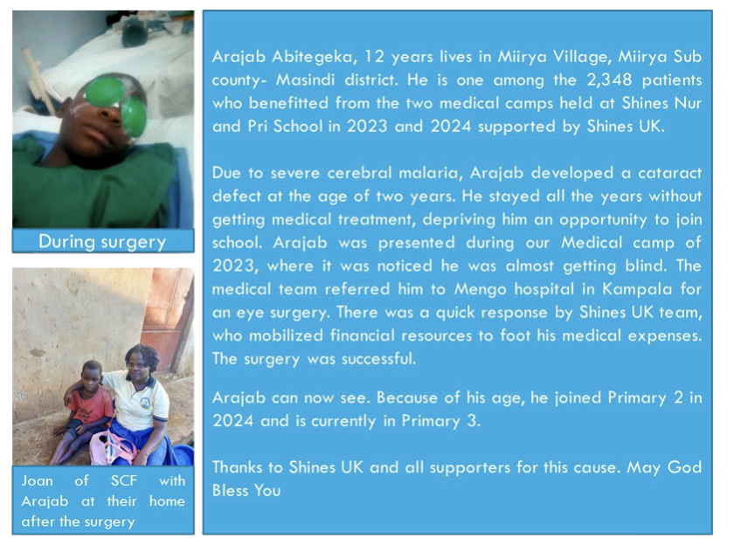

Photo gallery
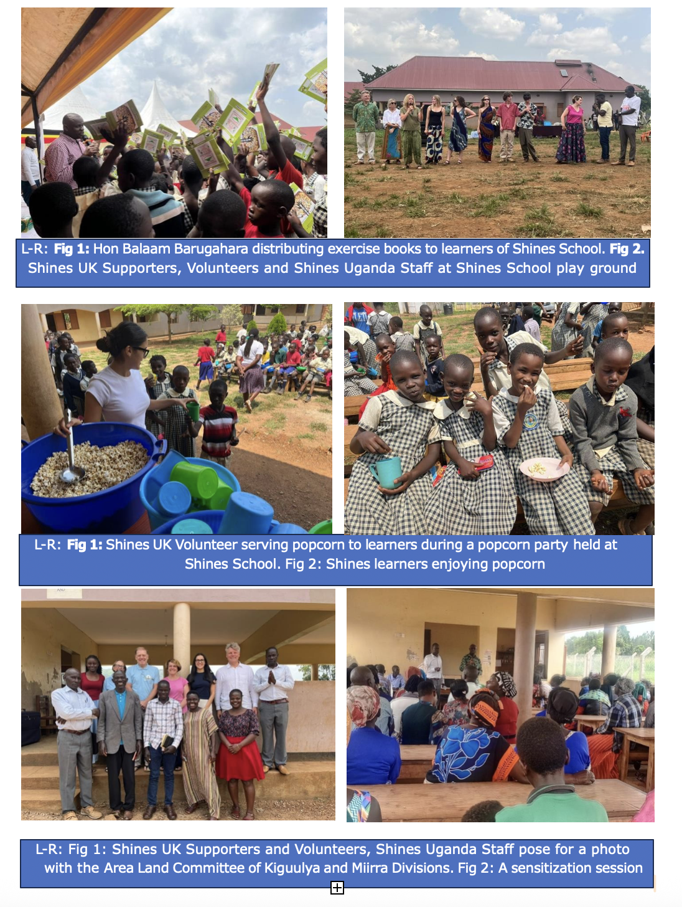

Contact person:
Name:Denis Kiirya
Position: Executive Director
Email address: kiiryaden@gmail.com
contact:+256786085109.
www.shinescf.org

