School children at play during break time at Mafabi Bright Stars Christian School.
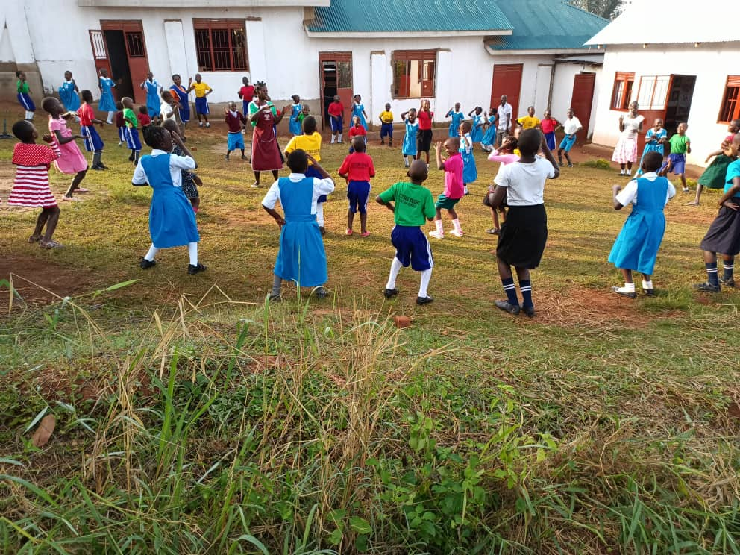

Children at Mafabi Bright Stars Christian School fetching water from a community water source.
