
2025 Maya Jaguar Graduation
Another successful school year has come to a close at the Maya Jaguar Private Technical Institute, a transformative secondary education program made possible through your generous support.
During last week’s graduation ceremonies, students, their parents, and school staff gathered to celebrate remarkable achievements and bright futures.
Despite the challenges faced during the COVID years (especially 2020), three high school students completed their studies and are now well-prepared to pursue meaningful employment opportunities.
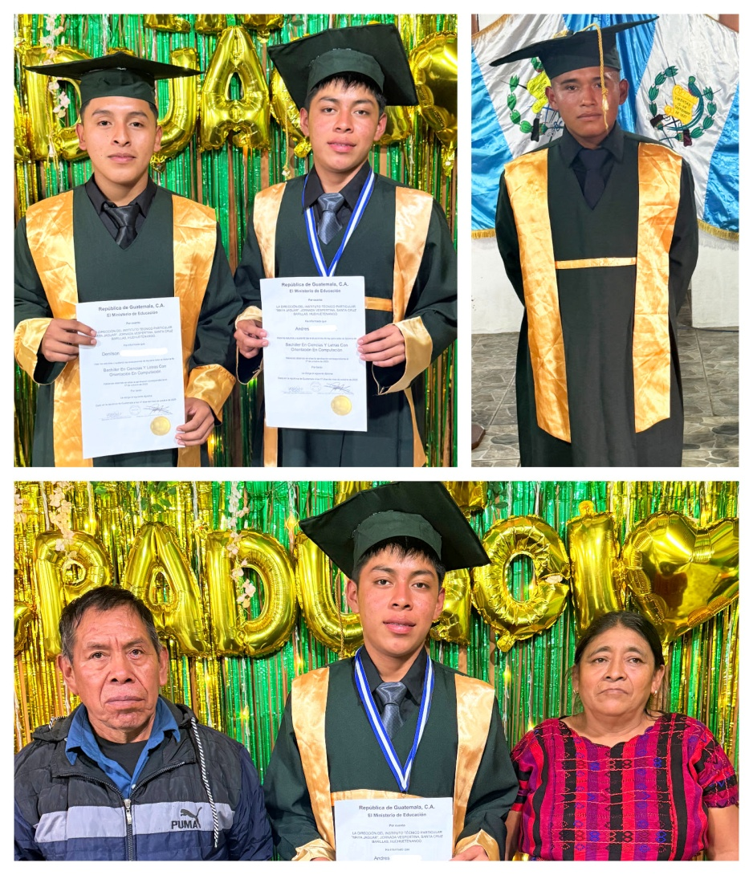
Top: Andrés, Denilson, and Gaspar
Bottom: Honor Graduate Andrés and Parents
In addition, nine middle school students graduated successfully and will advance to high school next school year (January–October).
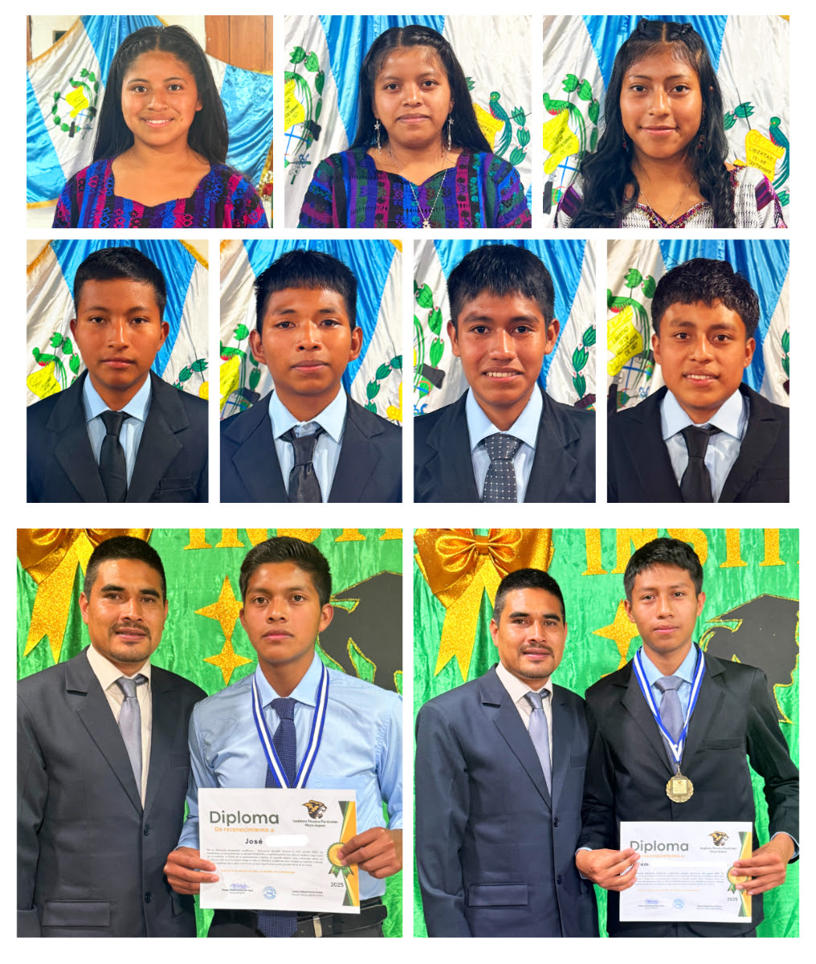
Top: Angelina – Maruca – Reyna
Middle: Néstor – Pedro – Santiago - Yeri
Bottom: Honor Graduates José and William
Although Indigenous Maya make up over 40 percent of Guatemala’s population, their literacy rate remains far below the national average. Most Maya children come from impoverished, often illiterate families, and few continue schooling beyond sixth grade.
Your continued support helps change that tragic reality. Each graduate represents a powerful step forward — not only for themselves, but for their families and communities.
Your generosity is transforming lives — one Maya child at a time.
Thank You!
Emily Francona
President, Adopt-a-Village in Guatemala
Adopt-a-Village in Guatemala - PO Box 698, Grants Pass, OR 97528
info@adoptavillage.com · 1-541-450-9375 · adoptavillage.com

