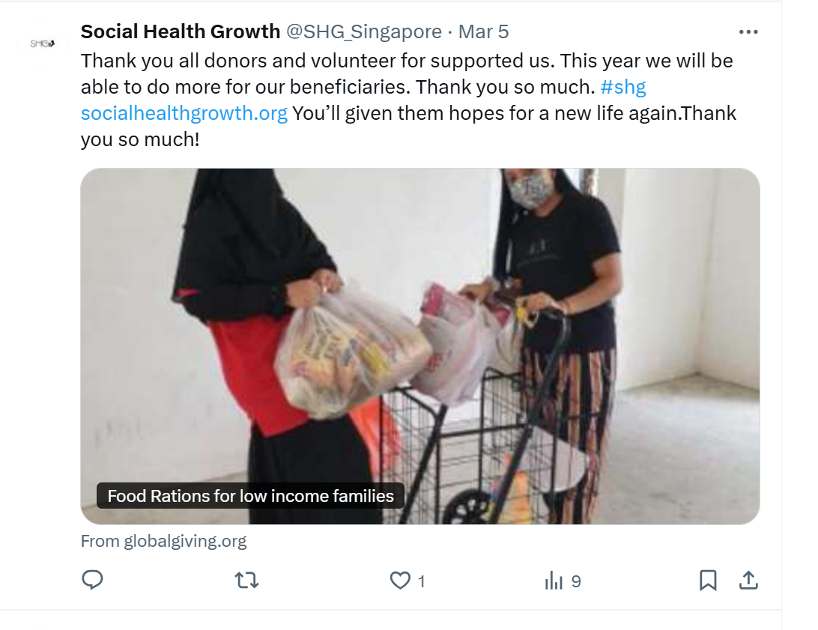
instagram

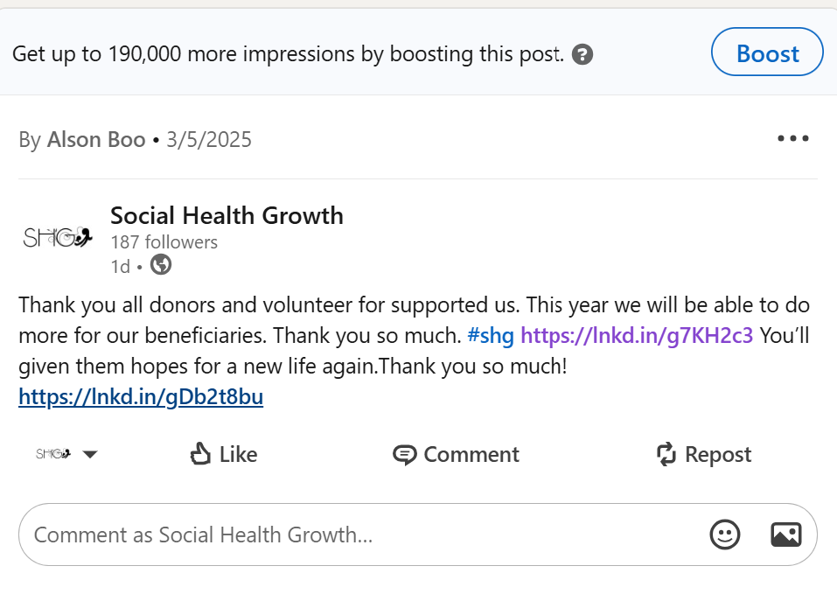
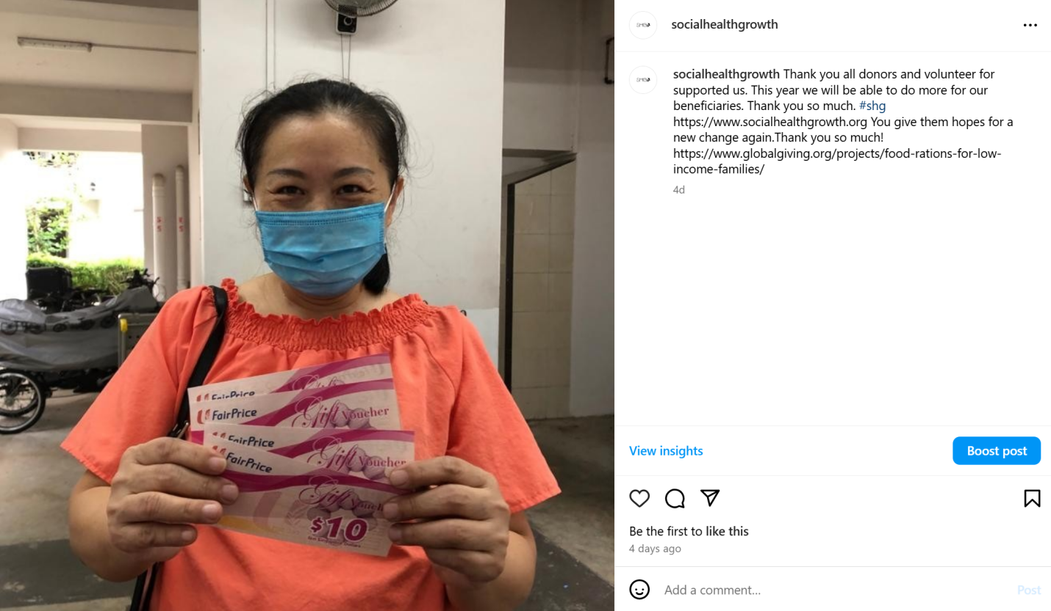
2/3/2025 twitter

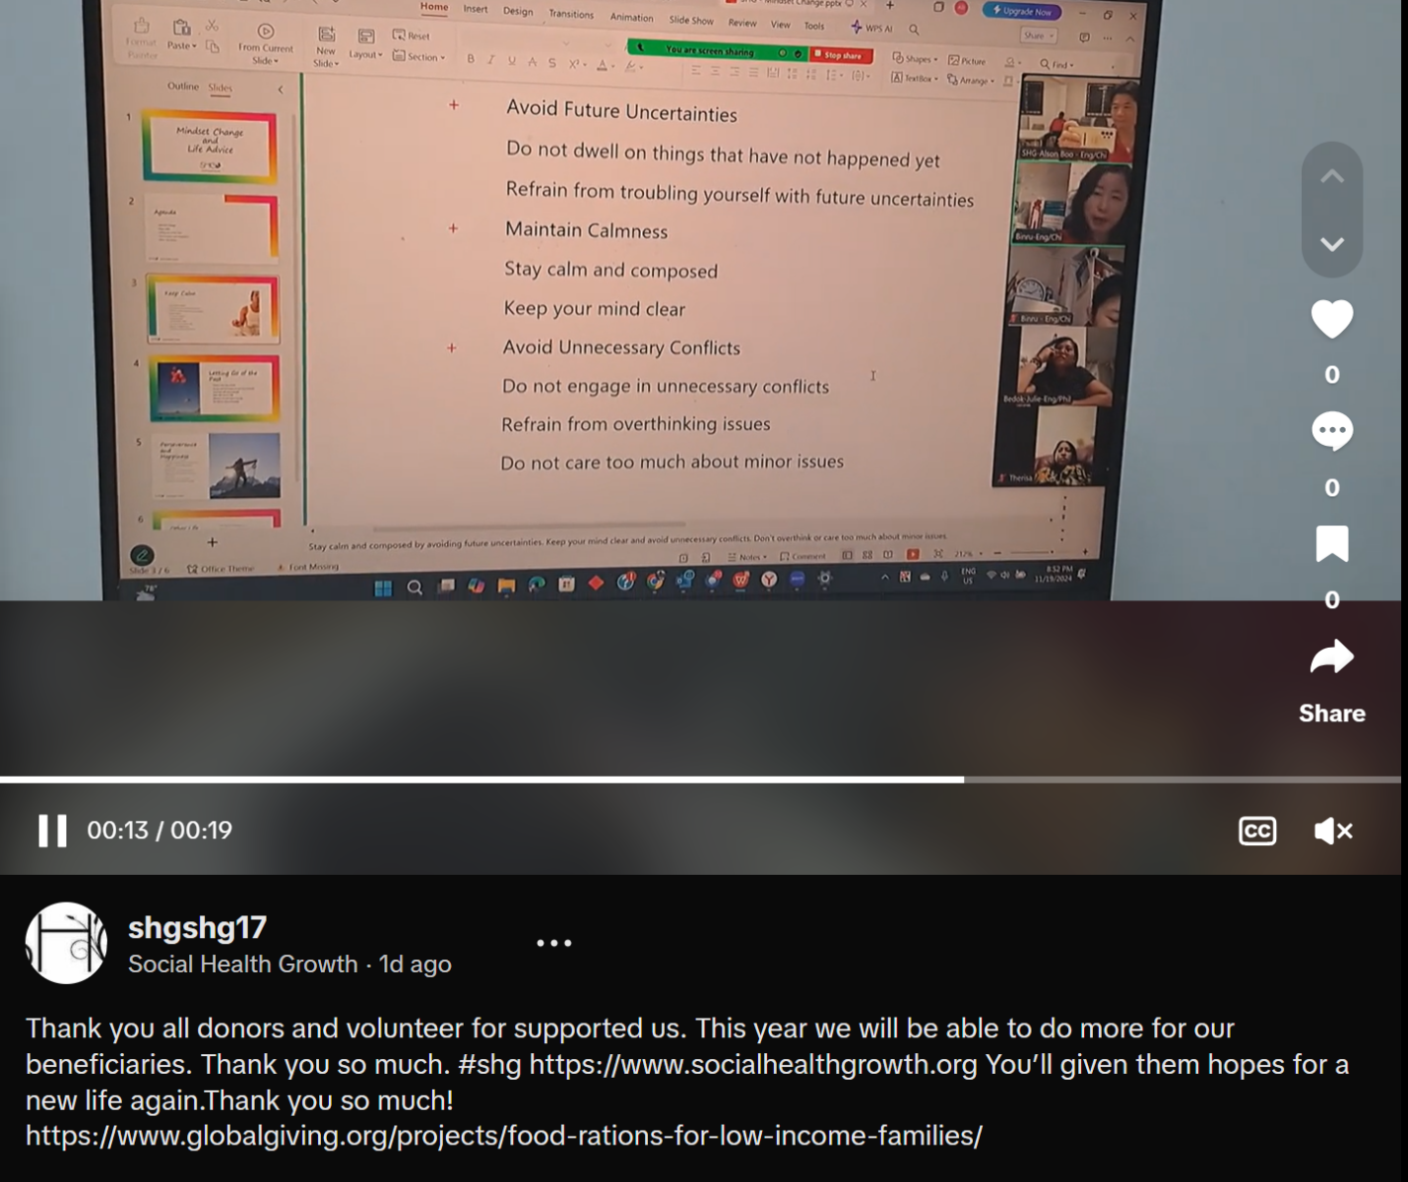
5/3/2025 tic tok

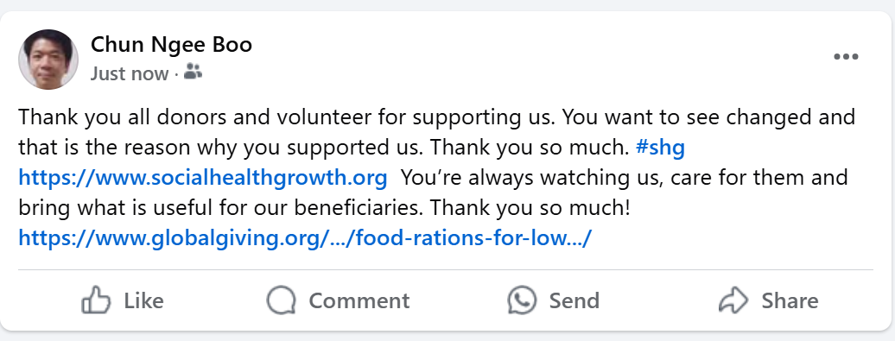
5/3/2025 facebook

Grow Our Network

Network Map
- List the names of about 4-8 people in each category below who already know and love your work. They may not be potential donors, but they could give in other ways (see step 2). Do not use full names when sharing your workbook.
- Tag each name with one (or more) of the following ways they can support your work:
- (D) Donation: Who could give money but isn't already donating?
- (C) Connections: Who could amplify your message or introduce you to potential funders or other partners?
- (V) Volunteering: Who could give their time to help you spread the word and grow your network?

Friends & Family  - Friend A - Mr Tan  Do NOT use full names when sharing your workbook. | Staff, Volunteers, Board  - Rush  Do NOT use full names when sharing your workbook.
Mission-Aligned Organizations  - St James place  - Blackstone  - MS  - Nomura  Do NOT use full names when sharing your workbook. | Community Members  - Alex  - Mrs Goh  Do NOT use full names when sharing your workbook.
KEY
D = Donation | C = Connections | V = Volunteering

 Grow Our Network

Targeted Messages
Once you've identified your supporters, it's time to ask them for what you need– whether that’s funding, connections, or volunteering time.

Donation | Connection | Volunteering
Call to Action:  Donate $__200,000_______ | Call to Action:  Introduce us to ____  OR  Share our message with your network  Introduce your partners and clients to support our programs | Call to Action:  Help us by sharing your skills in …  Their able to get a job and feed themselves and their families.
Key Message  We need your kind continous donation so that we could help more beneficiaries. Their children able to study well at school. The mothers would be able to have energy to work and think well. Improved their personal wellbeing. | Key Message  Ex: Could you like and re-share our Instagram post on your account?  We need your support to help us spread the words and report our msg to your friends and customers. | Key Message  Your kind donation will help a lot of beneficiaries. Their venerable and you step forward and support them. You created that impact and meaningful with positive mindsets. You give them hope to change to be better.

Campaign Title: Food Ration for Low-income families

Target Audience
- Donor Persona: Single mother and low-income families

Activated Channels
- Channel Name: Facebook, twitter, instagram, telegram, wechat, tic tok, linkedin

Overview of Existing Resources
- Graphics, articles, and other inspirations Youtube videos, Picture and photos

Goals + Objectives
- What do you want to achieve on social media? (Increase community engagement through social posts) More impression, re-post and influencing
- What do you want to achieve with this campaign? (What should the focus be?) New donors and monthly recurring donors, CSR partners

Channel | Campaign Goals |  | Current Campaign Actuals
Facebook | Impressions:  Engagements:  Link clicks: | 500  100  50 | Impressions:  Engagements:  Link clicks: | 250  50  25

Key Messaging
What should be the theme of your captions, and what message should current and potential audiences receive after reading the caption?

- Key message #1: Your kind donation give them hopes. And positive change in their life

Tactics

What tactics will your team implement to reach the intended objectives?
- Summary
  - Twitter: Post 2 times aday. Lunch time and evening time
  - Facebook: Post 2 times aday. Lunch time and evening time
  - Instagram: Post 2 times aday. Lunch time and evening time
  - Linkedin: Post 2 times aday. Lunch time and evening time
  - Tic Tok: Post 2 times aday. Lunch time and evening time
  - Wechat: Post 2 times aday. Lunch time and evening time
  - Telegram: Post 2 times aday. Lunch time and evening time

Deliverables

Social Media
Lead: Who is leading the campaign? (Who will they need support from?) : Chief Fundraiser
- Who and what are they responsible for? (Example: Graphic creation or caption writing): Contents storytelling, videos and photos posting

Social Posting Schedule
Month | Day (MON) | Day (TUE) | Day (WED) | Day (THU) | Day (FRI)
X (Twitter) | 12PM SGT and 8PM SGT | 12PM SGT and 8PM SGT | 12PM SGT and 8PM SGT | 12PM SGT and 8PM SGT | 12PM SGT and 8PM SGT
Facebook | 12PM SGT and 8PM SGT | 12PM SGT and 8PM SGT | 12PM SGT and 8PM SGT | 12PM SGT and 8PM SGT | 12PM SGT and 8PM SGT
Instagram | 12PM SGT and 8PM SGT | 12PM SGT and 8PM SGT | 12PM SGT and 8PM SGT | 12PM SGT and 8PM SGT | 12PM SGT and 8PM SGT
LinkedIn | 12PM SGT and 8PM SGT | 12PM SGT and 8PM SGT | 12PM SGT and 8PM SGT | 12PM SGT and 8PM SGT | 12PM SGT and 8PM SGT

Notes:

Project Appeal Worksheet
An appeal is a fundraising email you can send to all donors who have contributed to your organization through GlobalGiving. It may seem obvious that an individual who has donated to your organization before is more likely to contribute again. However, you may not have realized that 10% of online donations are made in direct response to project appeals!
Click on the steps below to go to that section of the worksheet
- Step 1: Define and understand your audience.
- Step 2: Craft an engaging and effective message.
- Step 3: Send your appeal at a relevant time and day.
Additional Resources
- Sample project appeals
- How to use GG appeals video tutorial
- Nonprofit Handbook: Appeals

General tips when writing an appeal
- Tell a compelling and emotionally resonant story that illustrates the impact of your work.
- Provide data to demonstrate results. Donors want to see evidence of effectiveness and accountability!
- Create a sense of urgency to motivate immediate action. Highlight any time-sensitive needs or opportunities, such as matching gift challenges or upcoming deadlines.
- Be transparent and concrete about how donations will be used and the impact they will have.
- Personalize your appeals to make donors feel valued and appreciated. Address donors by name, reference past contributions or interactions, and demonstrate that you understand their specific interests and concerns.

Step 1: Define and understand your audience.
- The first thing you need to do is define who will receive your project appeal.
- Then, clearly articulate what you know about your target audience. What you know about your audience can help you craft a personalized appeal that resonates with donors, captures their attention, and inspires them to take action.
Activity 1. Use the table to define your target audience and identify what you know about it.

Define your audience | All donors
Understand your audience | What characteristics of the audience could inform our appeal?
Understand your audience | Business man, Leaders, Business women, Executives, Middle management
Understand your audience | What are the motives your audience has for donating to your organization?
Understand your audience | - A lot of them received the foods ration  - Received education  - Received milk powder  - Received diaper

Step 2: Craft an engaging and effective message.
- Tell your audience the importance of your cause and why they should support it.
- Project appeals are sent to donors by email. You want your audience to open the email, so make sure you write attention-grabbing subject and preview lines!
- Your appeal must include one clear and specific call to action. Whether it's making a donation, volunteering, or spreading the word, clearly outline what you're asking for and how donors can contribute.
- It is highly recommended that you include a visual in your project appeal to enhance your message and capture donors' attention. We recommend a high-resolution, text-free, close-up, and hope-filled photo at the top of your appeal.
Activity 2. Use the table below to draft your project appeal

Project Appeal Subject Line (limited to 50 characters).
Your kind donation keep them at ease
Project Appeal Preview Line (limited to 140 characters).
Your donation help impacting more then 500 beneficiaries. They will be self-sustainable in a long term. You give them hope for changed. And your donation transformed their life with positive mindsets change and total changed spending behaviour in their daily life.
Image | https://youtube.com/shorts/3madISMMKsQ?feature=share  https://youtu.be/CXDp8eIXChA  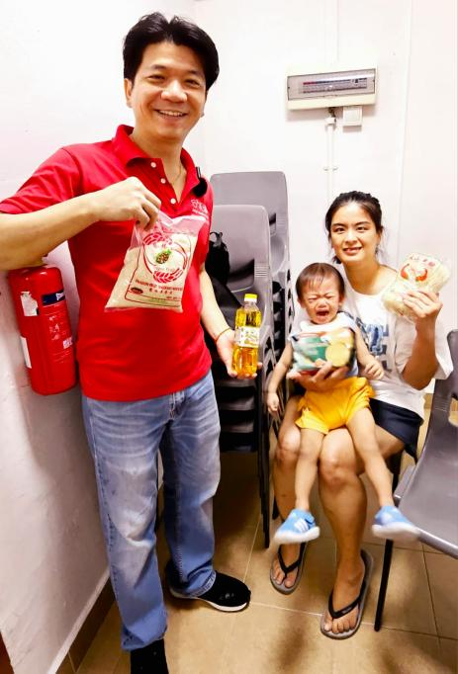
Text area 1. | Being good to them so that they could see hope for themselves
Call to action (limited to 30 characters). | Food ration for a sustainable future
Text area 2 (optional).

Step 3: Send your appeal at a relevant time and day.
Select when you want to send your project appeal. When defining the time and date for sending a project appeal, you might want to consider:
  - Audience Preferences. Remember to use what you know about your audience to inform your project appeal. If your audience consists of working professionals, you might consider sending emails during evenings or weekends when they are more likely to have free time to engage with your message.
  - Past Performance. Analyze data from previous fundraising campaigns to identify patterns and trends in email open rates, click-through rates, and donation conversions.
  - Consider the overall email volume your audience receives on different days and times. Avoid sending appeals during peak times when inboxes are likely flooded with messages. We recommend focusing on quality over quantity. Our data says if you send more than 12 project appeals in a year, donors are 30% less likely to click on them. Aim to send just 1 project appeal per month, which you may choose to send to all or a segment of your donors, to keep them interested. During Little x Little, we recommend sending 2 appeals: one at the start of the campaign and one toward the end.
  - Campaign Goals. Align the timing of your fundraising appeal with your campaign goals and objectives.

Activity 3. Fill out the following table to determine the time and date your appeal will be sent.

Date and Time: 25 March 8pm SGT and 28 March 8pm SGT | Appeal 1: yap_tiansun@yahoo.com.sg  Appeal 2: phoons@singnet.com.sg

Pre-Campaign Social Messaging
X (Twitter)
Mark your calendars!
March 25-28, we’re celebrating the BIG difference little acts of kindness can make! When you donate up to $50, @GlobalGiving will match your generosity while matching funds remain. Together, we can help Social Health Growth #LittleByLittle #shg

Facebook:
Donation match alert!
From March 25 until matching funds remain, when you give up to $50 to support Social Health Growth, @GlobalGiving will match your generosity at 50% for the Little By Little campaign.
Help us spread the word: share this post with your family and friends to let them know that BIG change can come from little acts of kindness!

Campaign Launch Social Messaging
Tuesday, March 25, 2025
GlobalGiving Tip: (TIP: To insert a short link for your project, click on the “Share” tab on your project page. Click here for an example)

X (Twitter)
Little acts of kindness can make a BIG difference—that's what @GlobalGiving's #LittleByLittle campaign is all about! From TODAY until matching funds run out, give up to $50 & receive a 50% match on your donation.
Give to Social Health Growth - Food Ration for Low-income families and get matched now: https://www.globalgiving.org/projects/food-rations-for-low-income-families/

Facebook:
Alone Social Health Growth mission may seem impossible, but we can accomplish anything together.

Starting March 25, join us for the @GlobalGiving Little By Little campaign. With 50% matching on all donations up to $50, BIG change can come from lots of little acts of kindness! Give while matching funds remain.
Support SHG-Food Ration for Low-Income Families by giving today: https://www.globalgiving.org/projects/food-rations-for-low-income-families/

Midweek Social Messaging
Wednesday, March 26, 2025
X (Twitter)
Little actions have BIG results! You have until matching funds run out to donate up to $50 in support of Social Health Growth @GlobalGiving will match your generosity by 50% for the #LittleByLittle campaign.
Give SHG get matched now: https://www.globalgiving.org/projects/food-rations-for-low-income-families/

Facebook:
No matter our challenges, positive change is possible when we all come together.
SHG have been helping more then 9000 beneficiaries since 2012. 90% had achieved their outcome.
For the rest of this week, little acts of kindness will have an extra BIG impact. During the Little By Little Campaign, get a 50% match on donations up to $50 from @GlobalGiving while matching funds remain! Help us to help our beneficiaries to overcome healthy food security by donating today: https://www.globalgiving.org/projects/food-rations-for-low-income-families/

Campaign Close Social Messaging
Thursday, March 27, 2025
X (Twitter)
You still have time to get your donation of up to $50 matched by 50% during @GlobalGiving's #LittleByLittle campaign.
Don't miss out—matching funds are running out!
Help us Food Ration for Low-Income Families now: https://www.globalgiving.org/projects/food-rations-for-low-income-families/

Facebook:
Don’t miss out on this donation match!
You still have time to get your donation of up to $50 matched at 50% by @GlobalGiving.
Help us support single mothers/children/elderly and celebrate the power of small acts of kindness with a donation before matching funds run out https://www.globalgiving.org/projects/food-rations-for-low-income-families/

Project Appeals
GlobalGiving Tip: Want to make sure your emails are read? Grab your audience’s attention with a short, powerful subject! Check out this article from Classy.org for tips + examples.

Campaign Launch
Tuesday, March 25, 2025
Dear Mr/Ms,
This week, we're/I’m inviting you to join us in celebrating the power of small acts of generosity for GlobalGiving's Little by Little campaign. From today until matching funds run out, GlobalGiving will match ALL online donations up to $50 at 50%.*
Your $10 donation turns into $15.
Your $30 donation turns into $45.
Your gift today will support Single mothers/Children/Elderly: https://www.globalgiving.org/projects/food-rations-for-low-income-families/
When we all work together, there’s no limit to what we can do—but don’t take our word for it.

Ms Li and Ms Siti were very thankful for your kind donation. You really help them a lot.
We can raise USD200,000 with your generosity.
Thank you for helping us Single Mothers and Low-Income Families!
Warmly,
Social Health Growth
*Terms and conditions apply. https://www.globalgiving.org/leaderboards/march-2025-little-by-little/terms/

Campaign Close
Thursday, March 27, 2025
Hello Mr/Ms,
It’s your last chance to get matched 50%!
If we come together to raise just USD200,000 this week, Social Health Growth will be able to purchase more then 500 packets of food ration. You still have time to help us reach this goal and get matched at 50% when you give up to $50*—but don’t delay. The Little by Little campaign ends FRIDAY at 11:59 pm EDT!
Help Social Health Growth today: https://www.globalgiving.org/projects/food-rations-for-low-income-families/
Ensure all our beneficiaries could afford to pay for their food and healthy food security won’t go away overnight—but together, we know we can make a difference for Social Health Growth.
Forever grateful,

Social Health Growth

Campaign Follow-Up
Monday, March 31, 2025
Dear Mr/Ms,

No words can capture how much your generosity means to Social Health Growth, but we’ll start here: thank you.

Last week, you played a vital role in Achieve Health Food Security by joining 300 donors to support Social Health Growth.

Thanks to your donations during the Little by Little campaign, we’ll be able to purchase more then 500 packets of food rations.

Thank you for helping create big change!

With gratitude,
Social Health Growth

Goal Setting Worksheet (basic)
Purpose: We are raising money for single mothers, elderly and children. It is important because they cannot afford healthy foods.  Need: We need more donors making donation and continuous to make donation do that we could help our beneficiaries and other new beneficiaries. | Past Performance:  How much have you been able to raise in past campaigns?  $_1,000,000________ from #__35_____ donors |  | Goal:  How much are you trying to raise this time?  $_200,000________ from #___10____ donors  Aim for 10% more than past performance. If this is your first campaign, start with a goal of $1000 from 10 donors.
Capacity: What assets can you leverage to meet your goal?  Team: Volunteer, Board member, community members, SMEs and member of public could help us meet our goals.  Network: Company with CSR or company would be interested to create impact and influence member of public. Individuals whom are willing to give back to the community and support those less fortunate.  Budget: We could thanks them and make a video from our beneficiaries to thanks all donors for their kind donations.  Visibility Opportunities: Using social media influence to expand my donor base. |  | Strategy: What are you going to do in order to meet your goal? I intent to create meaning social media post and post it 3 times a day. Morning, afternoon and evening. Post on different social media platform. Tell a story and update the current status about our donation progress. Also to post what are our current beneficiaries conditions. Ask our beneficiaries to share about their current situation that their facing. How could donors help them at this challenging time. Then post what has improve along the way to all donors.

Goal Setting Worksheet (detailed)
- Reflect on purpose, past campaign performance, current contacts, and capacity (team and resources).
- Set campaign goals and contact goals.
- Chart progress with progress points 1 and 2.
- Reflect on strategy.
Purpose: Food Ration for more then 500 beneficiaries. Enable them to be able to access to healthy foods. Ensure that they’re able to eat well. Ensure that their able to afford certain meats, seafoods, fruits and vegetables.

1
Past Campaign  Total Raised: $1,000,000___  # of Donors: __35______  # of New Donors: __20___ 2 | Progress Point 1: Date: Jan - March 24  Mailing List: __1000________  Social Media: __300______  Direct Call: ___100_____  Events: ___3______  Send _200__ emails  Share _20__ posts  Call _10__ persons  Attend _1__ event  Recruit _2__ fundraiser  9 |  | Progress Point 2: Date: April - June 24  Mailing List: __1500________  Social Media: __350______  Direct Call: ___200_____  Events: ____3_____  Send _250__ emails  Share _30__ posts  Call _20__ persons  Attend _2__ event  Recruit _2__ fundraiser  10 |  | Campaign Goals  Total Raised: $___200,000_____  # of Donors: __10______  # of New Donors: ___40_____ 7
Current Contacts  Mailing List: _2000_________  Social Media: _500_______  Direct Call: __100______  Events: __5_______  Fundraiser ___3_____ 3 |  |  |  |  | Contact Goals  Mailing List: __2000________  Social Media: __400______  Direct Call: __280______  Events: ___3______  Fundraiser ___3_____ 8
Capacity: Team  (Volunteers, staff, board members, etc)  Volunteer, staffs, CSR partners and board members, committee members  4 |  | Capacity: Resources  (Time, budget, materials, etc)  1 months, USD20,000 , Social media contents  5 |  | Strategy  - What has worked in the past? Consistant posting on social media. Enagement donors daily, send snail mails donation letter  - What hasn’t worked? Volunteer engagement  - What new ideas do you want to try? Engaging company for sustainably monthly awareness building. And influencing  6

