Monthly Report: Protect Sri Lanka's Street Dogs: Rescue & Rehome – #68774
Project Title: Protect Sri Lanka's Street Dogs: Rescue & Rehome
Reporting Month: January – April
1. Introduction
During the reporting period from January to April, Save a Life continued its efforts to improve the safety and well-being of street dogs in Sri Lanka. While large-scale rescue operations remained limited due to financial constraints, we focused on preventive initiatives to reduce road accidents and protect stray dogs in high-risk areas.

2. Key Activities
• Street Awareness Billboard Campaign:
We designed and installed a street billboard to raise awareness about the increasing number of road accidents involving stray dogs. The billboard highlighted the importance of careful driving, especially in areas where street dogs are commonly found. This initiative aimed to educate the public and encourage safer driving behavior, ultimately reducing injuries and fatalities among stray dogs and public.
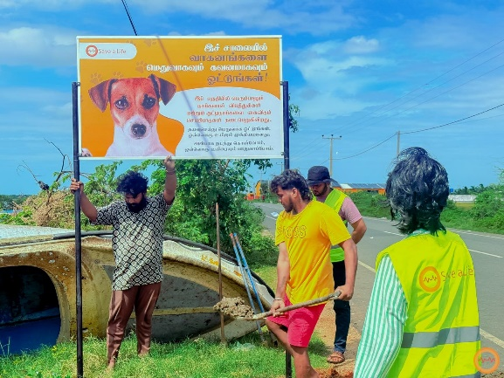
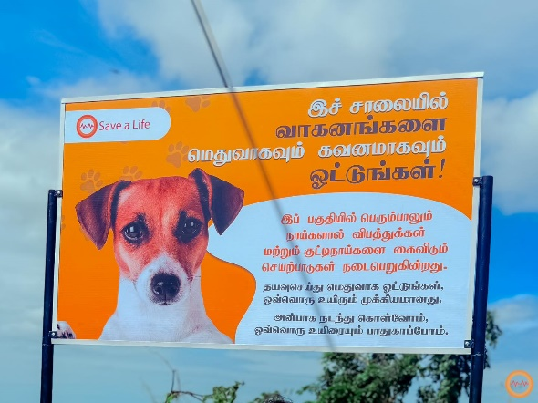

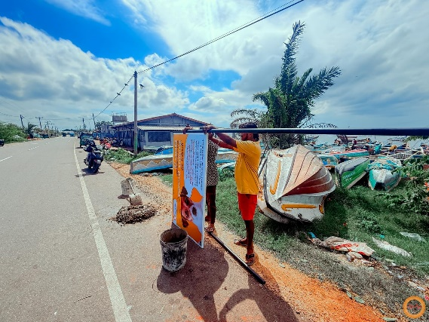

• Reflective Collar Distribution for Street Dogs:
As a proactive safety measure, we distributed reflective collars to street dogs in selected areas. These collars improve visibility at night, helping drivers spot dogs from a distance and avoid accidents. This simple yet effective solution plays a crucial role in preventing road-related injuries and saving lives.
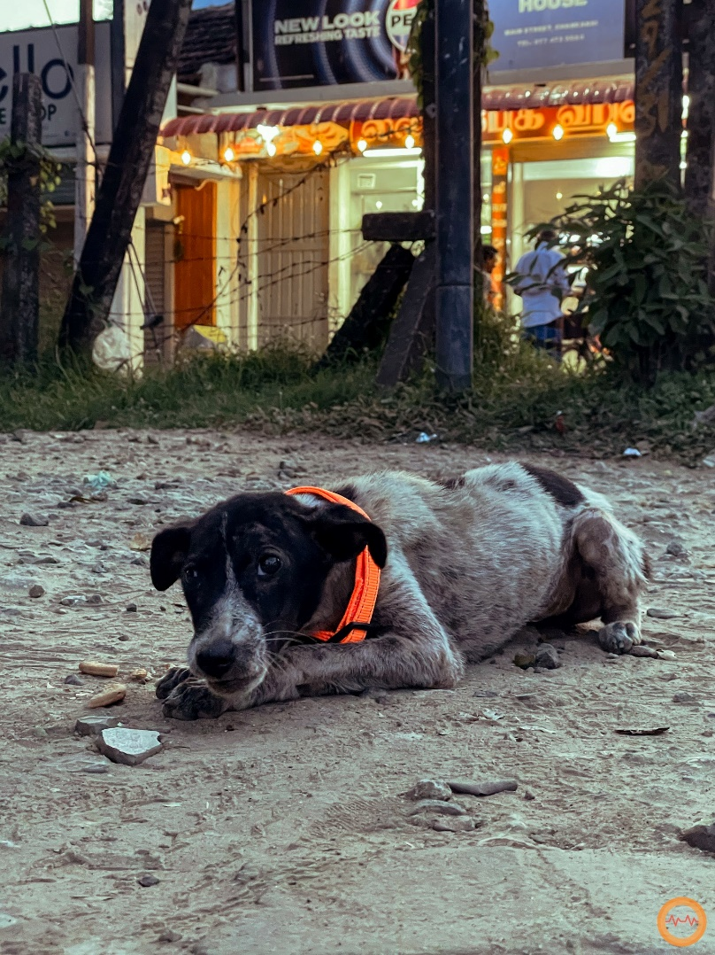
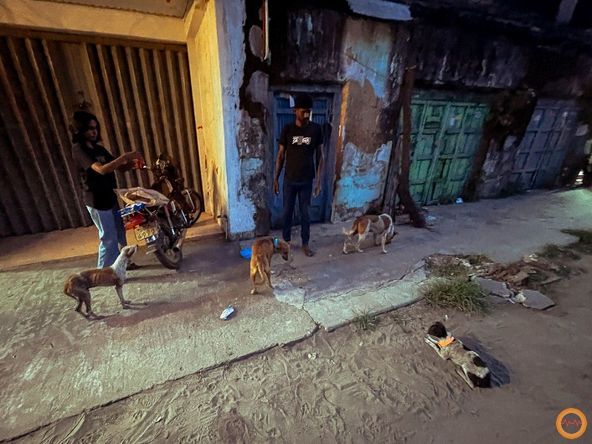

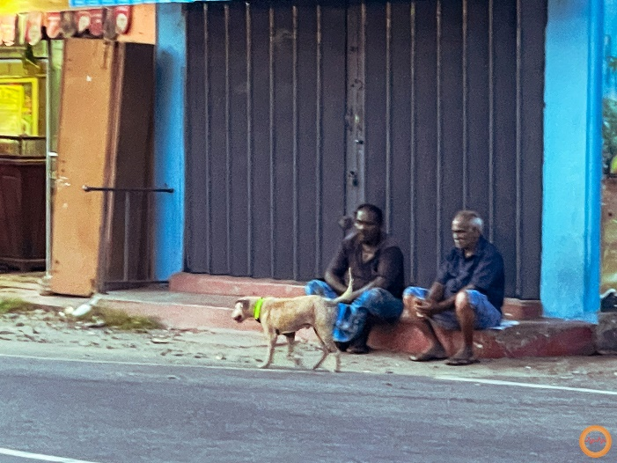

3. Challenges Faced
• Limited Funding:
Financial constraints continued to restrict the scale of our activities, limiting the number of collars distributed and awareness materials produced.
• High Risk Areas:
Many street dogs live in busy road zones, increasing their vulnerability to accidents. Covering all high-risk areas remains a challenge with limited resources.

4. Impact on the Community
• Improved Road Safety Awareness:
The billboard campaign helped bring attention to an often-overlooked issue, encouraging drivers to be more cautious and responsible.
• Increased Protection for Street Dogs:
Reflective collars have significantly improved nighttime visibility for street dogs, reducing the risk of accidents and helping both animals and drivers stay safe.

5. Plans for Next Phase
• Expand the reflective collar initiative to cover more high-risk areas
• Seek funding to resume rescue, medical care, and rehoming activities
6. Thank You
We sincerely thank GlobalGiving and our supporters for their continued encouragement and belief in our mission. Even small initiatives like awareness campaigns and reflective collars can create meaningful change. With your support, we hope to expand our efforts and ensure a safer environment for Sri Lanka’s street dogs.

